Aero2Astro
Panneerselvam N
(25/08/2021)

I had trained Faster Rcnn model upto 36499 iterations. And also evaluated with both train and test dataset.
Model -1 (PP-yolo v1)
ins = 1000
bs = 8
lr = 0.0002
Training Data:
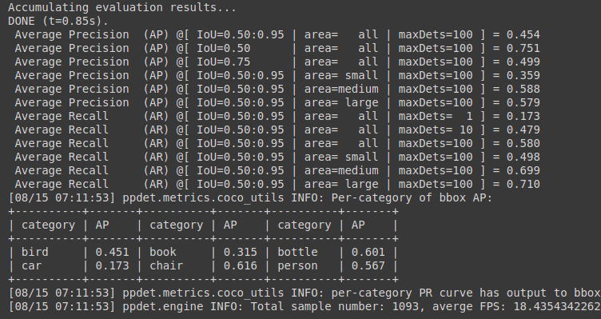
Test Data:
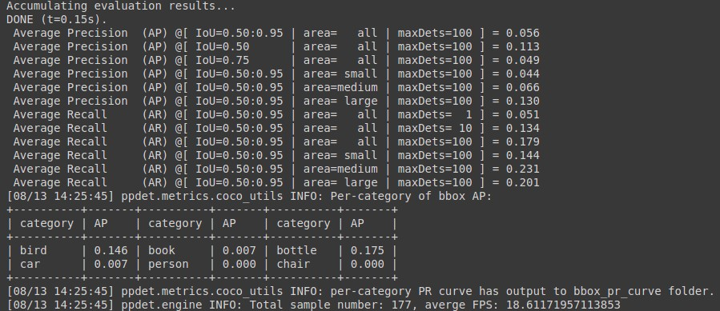

Model – 2 :(PP-Yolo v2)
ins = 500
bs = 8
lr = 0.0002
Training Data :

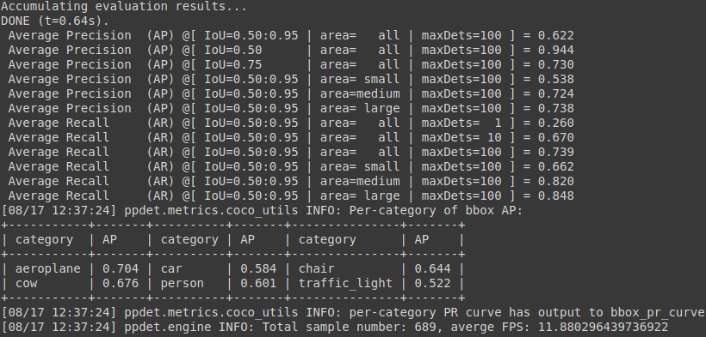

Test data :

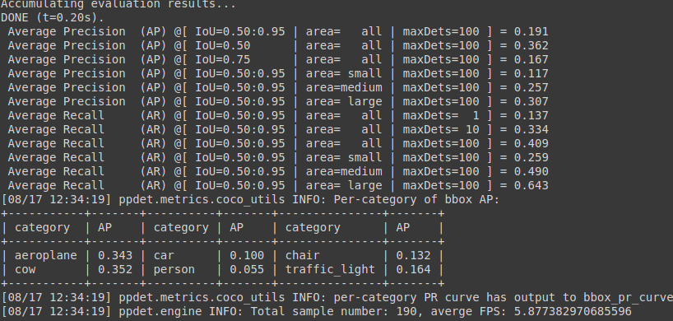

Current Model:(Faster Rcnn)
Backbone = Faster_rcnn_X_101_32x8d_FPN_3x
bs = 4
lr = 0.001
ins = 500
Previous Checkpoint : 32500 its
Threshold = 0.65
Test :

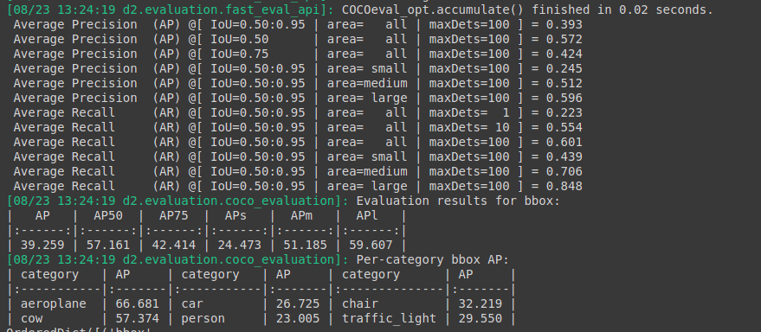
Train :

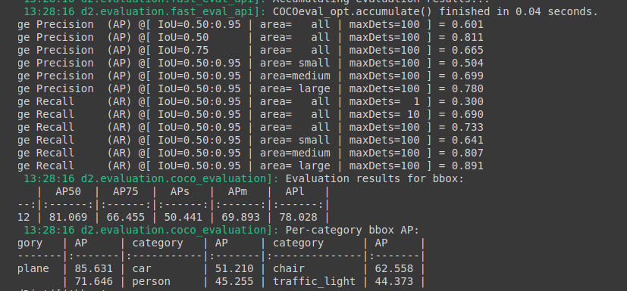
Threshold : 0.85

Test :

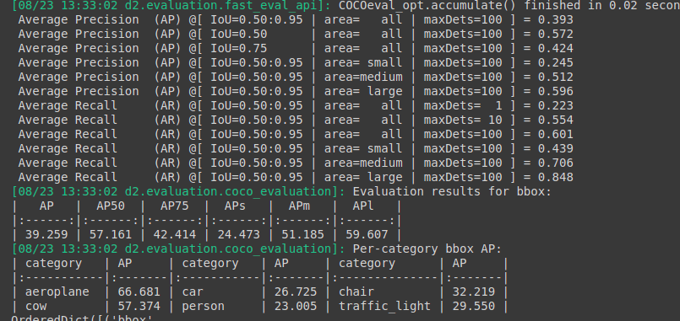

Train :

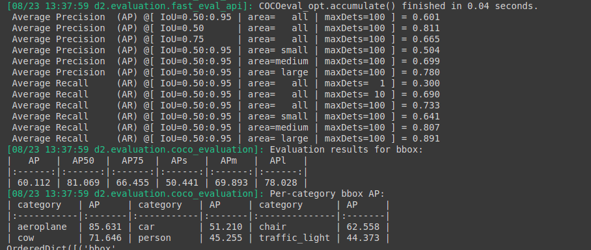

Current Checkpoints : 36500
Threshold : 0.65
Test :

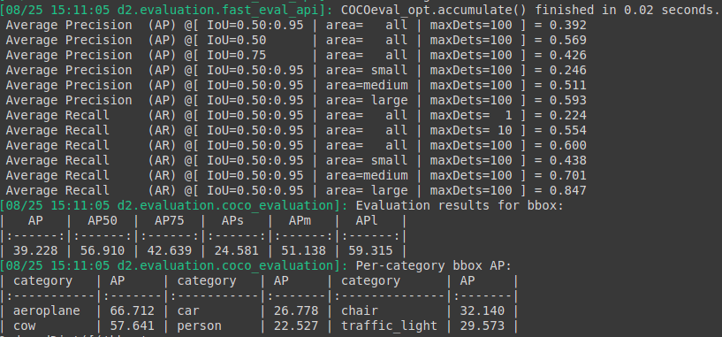
Train :

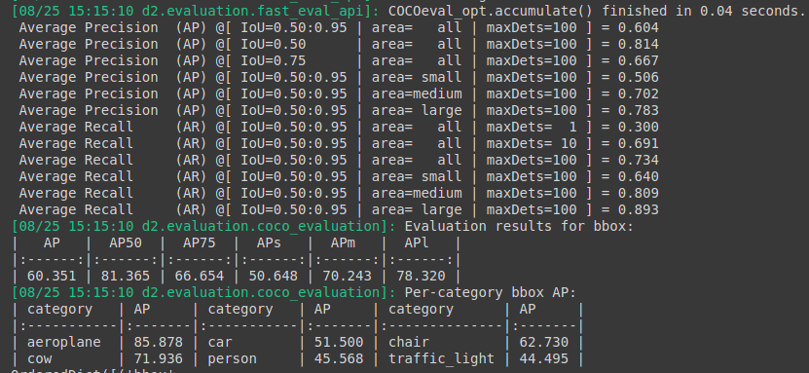

Threshold : 0.85

Test :

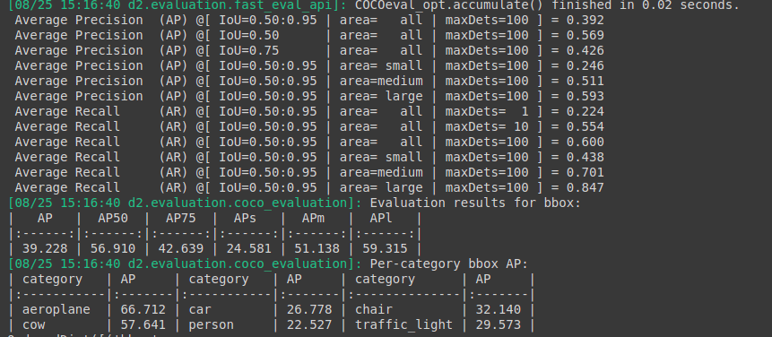

Train :

