Panneerselvam N
(03/08/2021)

I had trained pp yolo v2 upto 550 epochs. The loss fluctuates in between 28 to 40. Minimum loss is 28. And also performed evaluation , accuracy was improved with compared previous result.

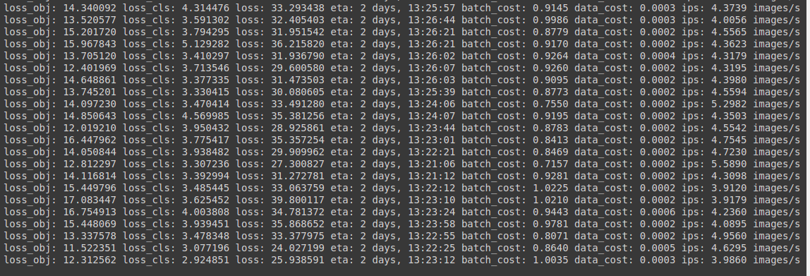

Evaluation(Test data)

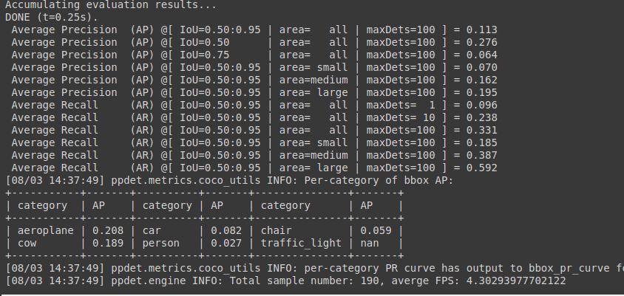
Traffic light class gives nan error , so I cross checked training data that gives normal AP values . So the problem is in test dataset, Now I am trying fix that.

Evaluation (Training dataset)

