Aero2Astro
Panneerselvam N
(30/08/2021)

I had trained Faster Rcnn model upto 63000 iterations. And also evaluated with both train and test dataset.
Model:(Faster Rcnn)
Backbone = Faster_rcnn_X_101_32x8d_FPN_3x
bs = 4
lr = 0.001
ins = 500
Previous Checkpoint : 53499 itrs.
Threshold : 0.85
Test :
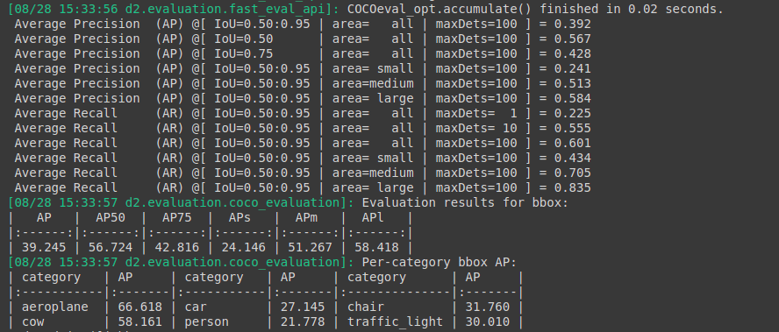
Train :
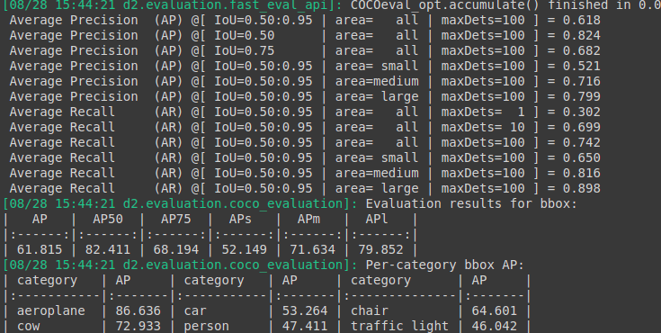

Threshold : 0.65
Test :

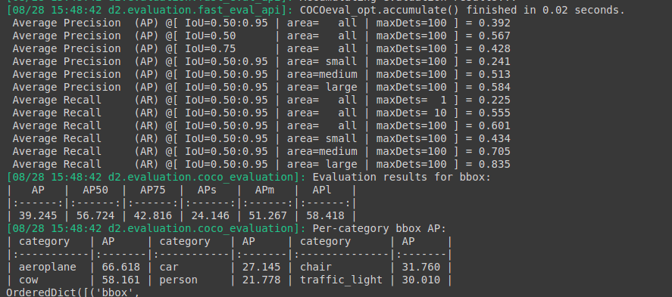
Train :

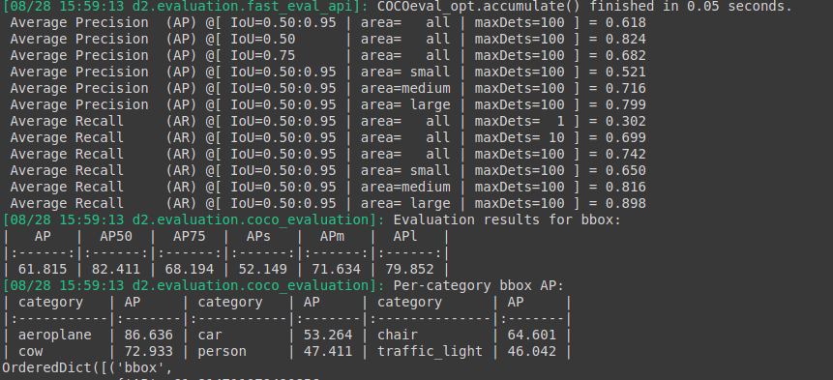

Last Checkpoint :

Threshold : 0.65
Test :

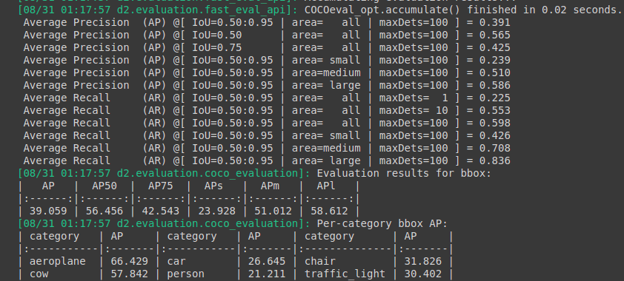
Train :

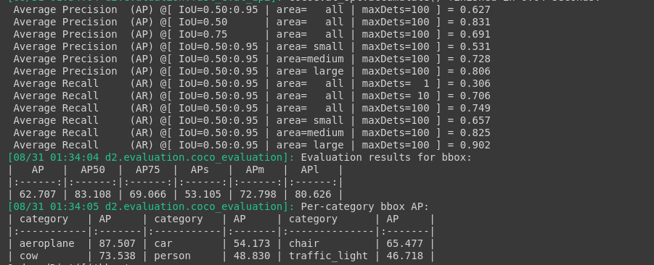

Threshold : 0.85

Test :

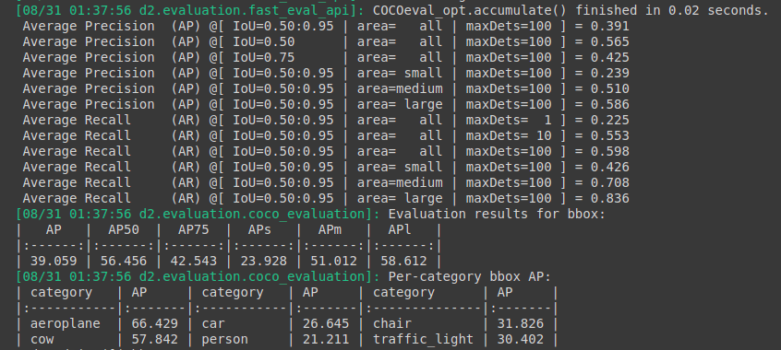

Train :

