Panneerselvam N
(06/08/2021)

I had trained PP-Yolo v2 model upto 800 epochs. The minimum loss is 22 and fluctuates in between 20 to 35. Evaluated with both training and test datasetset. Resuts are good with compare to previous checkpoints. But it gives only 4 to 5 FPS,and also model try to overfit little bit.

Evaluation Training :
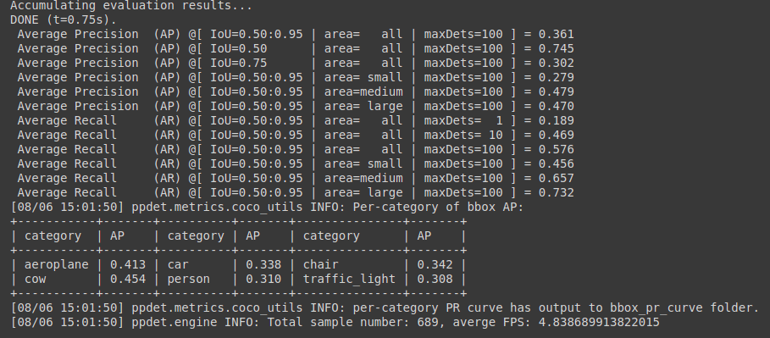
Evaluation test :
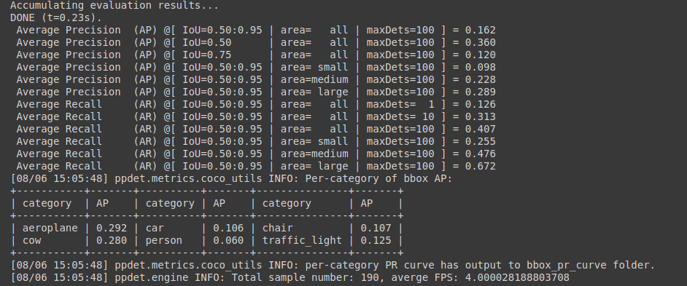
corrected 500ins json link (test): https://drive.google.com/file/d/1WJxlhhb-fYf6YxXPkuWbxeuFF1kyn4QR/view?usp=sharing

