Panneerselvam N
(09/08/2021)

I had trained PP-Yolo v2 model upto 959 epochs. The minimum loss is 21 and fluctuates in between 20 to 33.

Evaluation Training :
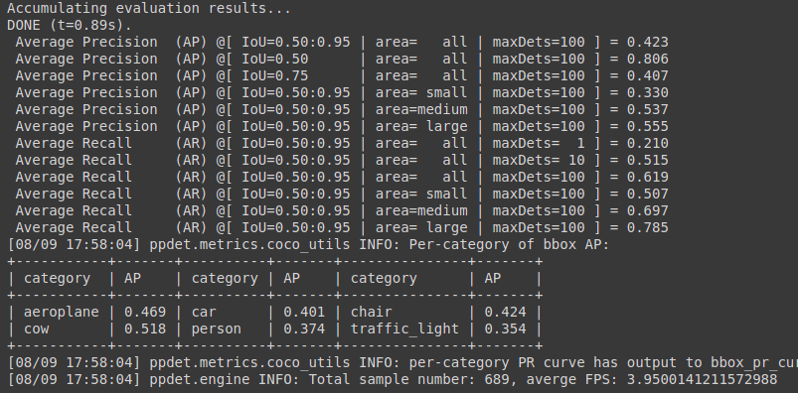
Evaluation test :

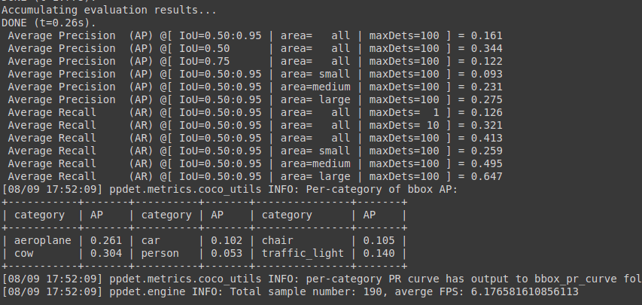

FPS (test data):

