Panneerselvam N
(July 31.2021)

Today i had trained pp yolo v2 model upto 295 epochs. The loss is fluctuating between 42 to 60.And also tried to detect objects training dataset , model detect nothing when even in threshold 0.1.So tried with test dataset. The folllowing image shows evaluation result.

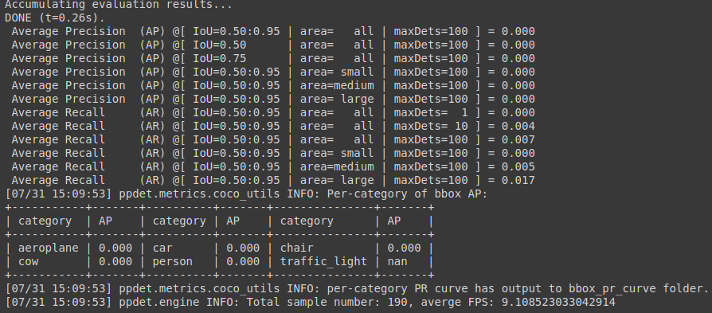

Threshold = 0.1


Threshold = 0.01

