Aero2Astro
Panneerselvam N
(06/09/2021)

I had trained Faster Rcnn model upto 1020000 iterations. And also evaluated with both train and test dataset.
Model:(Faster Rcnn)
Backbone = Faster_rcnn_X_101_32x8d_FPN_3x
bs = 4
lr = 0.001
ins = 500
Previous Checkpoint : 83500
Threshold : 0.85
Test :
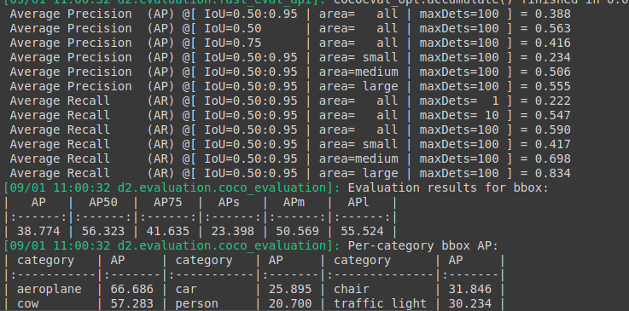
Train :
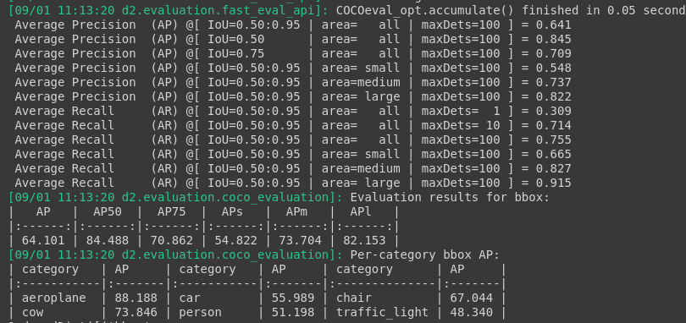

Threshold : 0.65
Test :

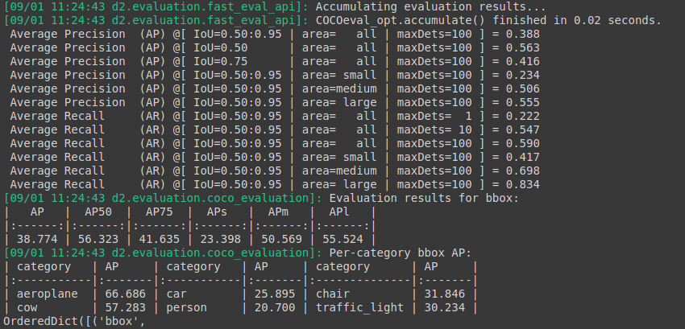
Train :

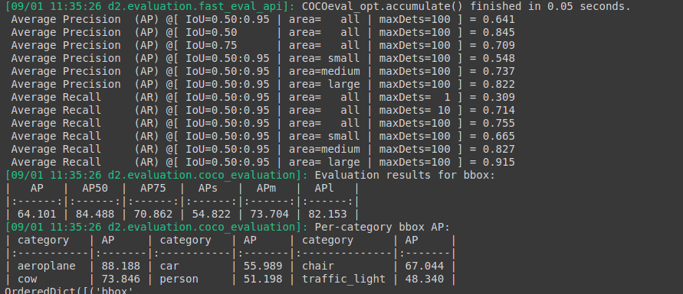

Previous checkpoints : 109999 itr (with Horizontal flip augmentation)
Threshold : 0.85
Test:

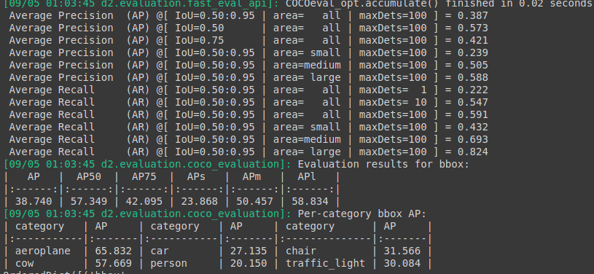
Train :

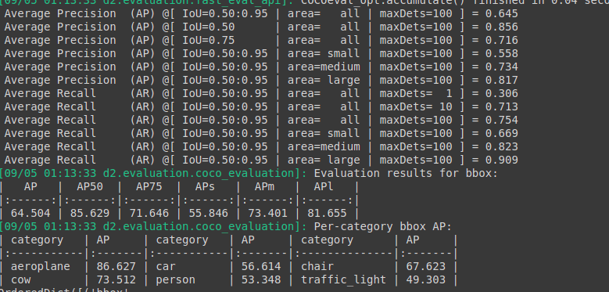

Threshold: 0.65

Test:

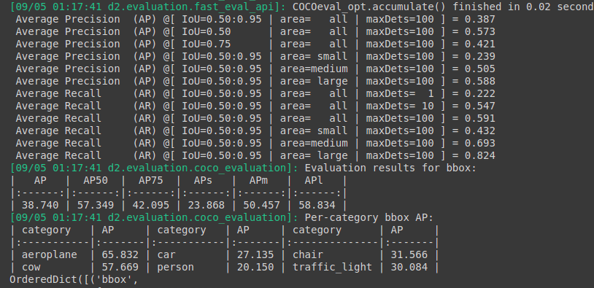
Train :

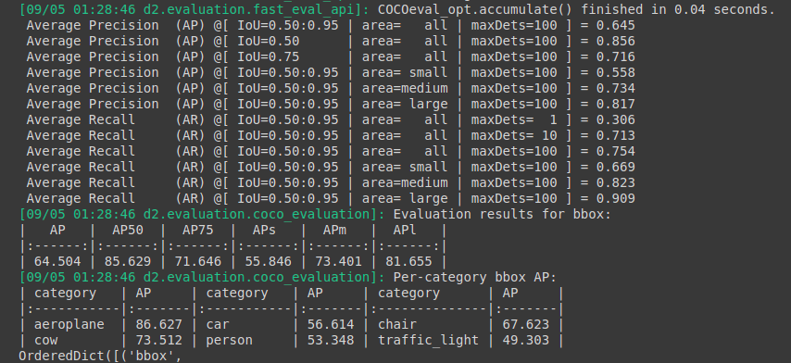

Last checkpoints : 120000 itr
Threshold : 0.65
Test :
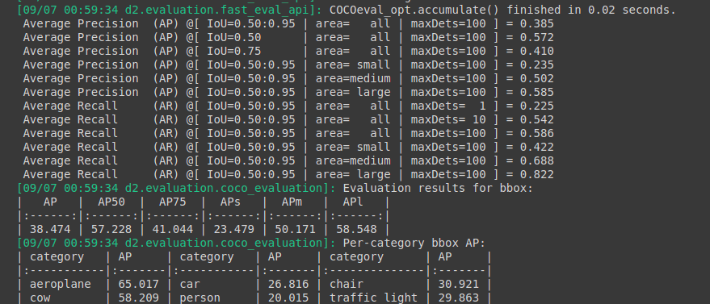
train :
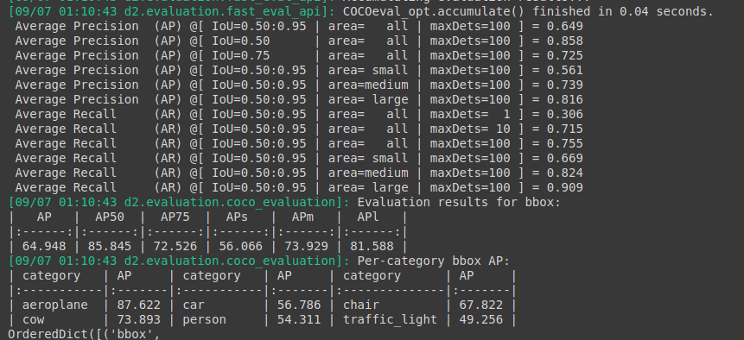

Threshold : 0.85
Test :
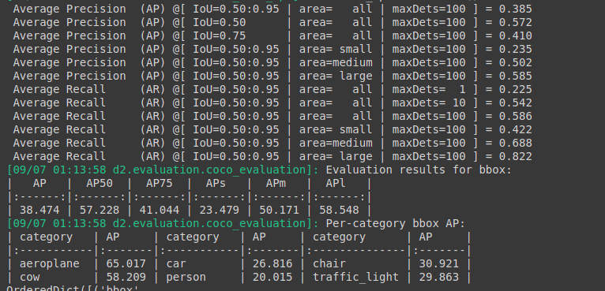
Train :

