Aero2Astro
Panneerselvam N
(07/09/2021)

I had trained Faster Rcnn model upto 133000 iterations. And also evaluated with both train and test dataset.
Model:(Faster Rcnn)
Backbone = Faster_rcnn_X_101_32x8d_FPN_3x
bs = 4
lr = 0.001
ins = 500
Previous checkpoints : 120000 itr
Threshold : 0.65
Test :
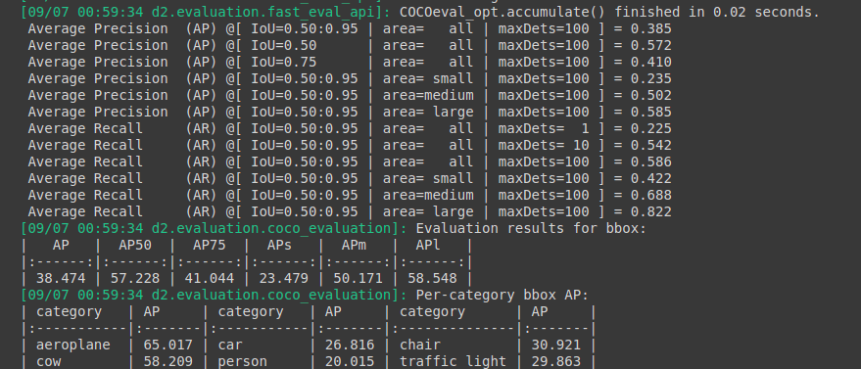
train :
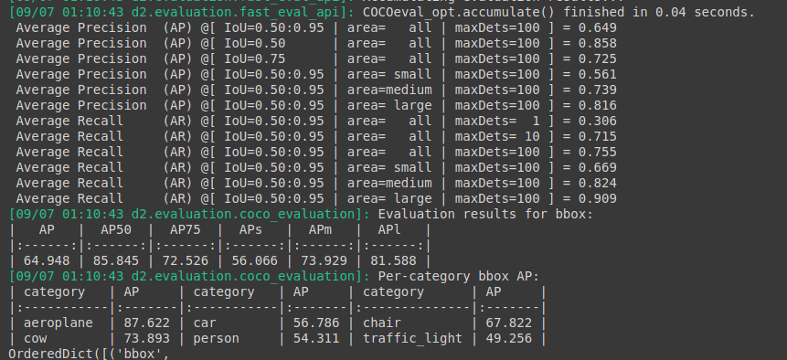
Threshold : 0.85
Test :
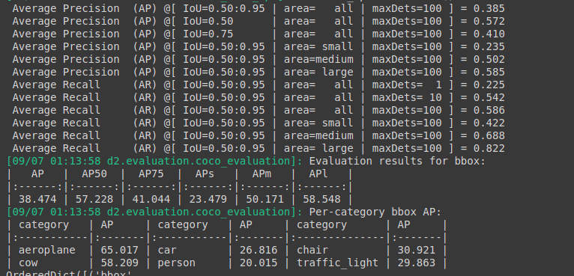
Train :

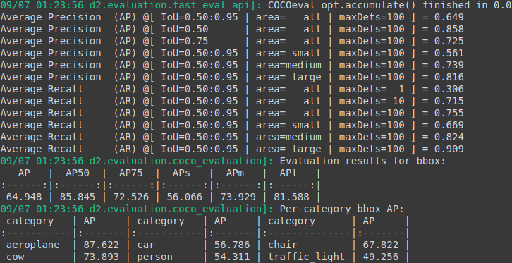
Last checkpoints : 133000 iterations
Threshold : 0.85
Test :

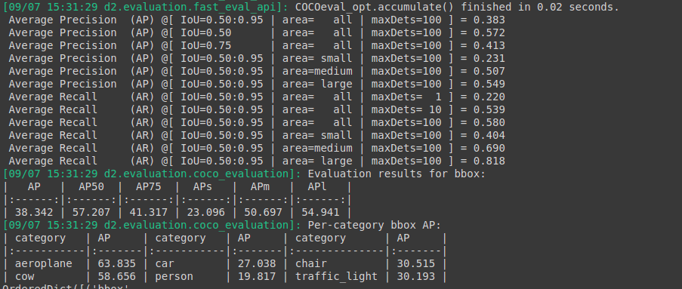

Train :
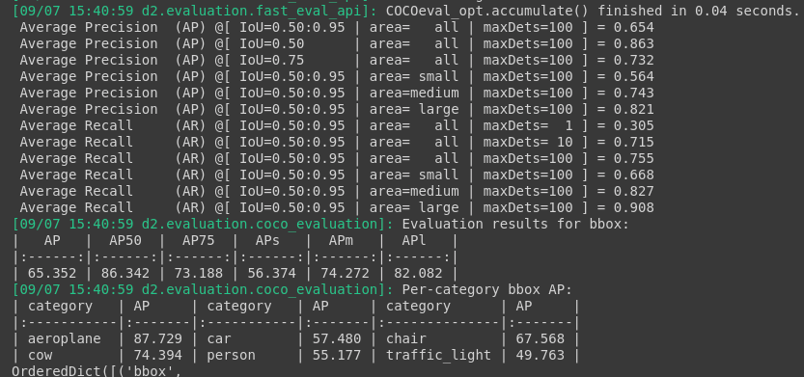

Threshold : 0.65

Test :

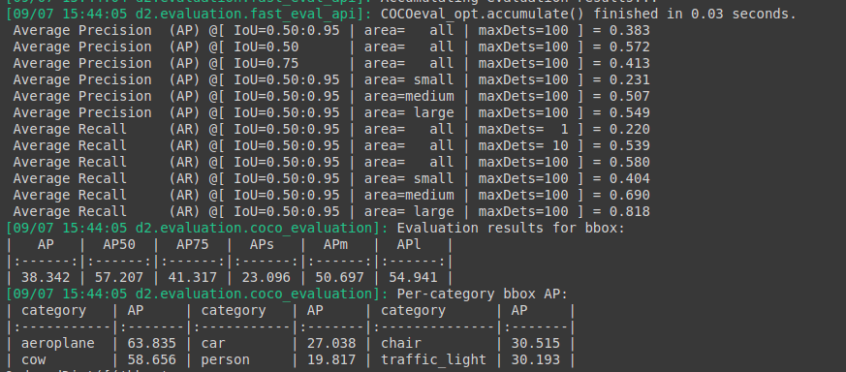
Train :

