Panneerselvam N
(08/09/2021)
Today i had trained faster rcnn model upto 138499 iterations.

Test :
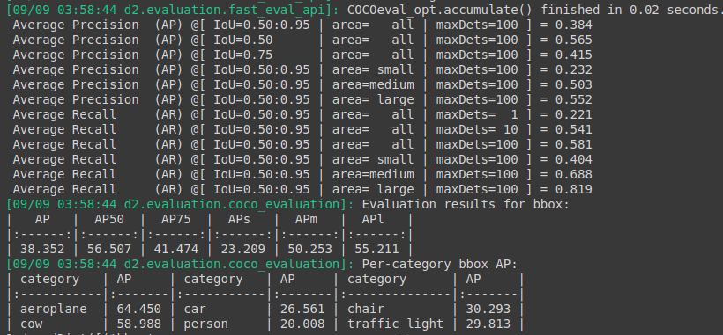
Train :

