Panneerselvam N
(09/09/2021)
Today i had trained faster rcnn model upto 149499 iterations with more augmemtation.

Previous Checkpoint: 138000
Test :
Augmentation : Resize(1024), HFlip
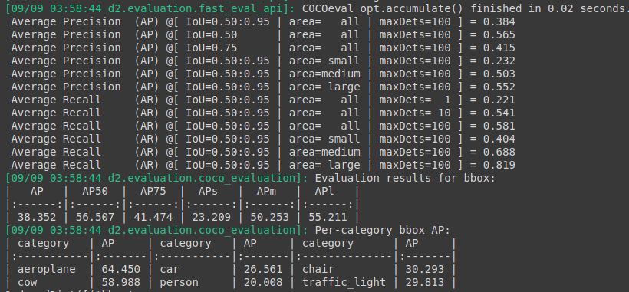
Train :

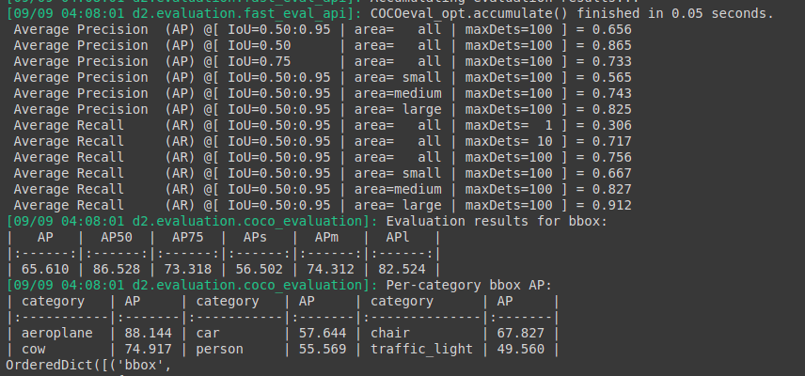
Current Chechpoints : 149500 itr
Augmetation : Resize(1024),Hflip ,Random brightness , Random Rotation , Random crop

Test :

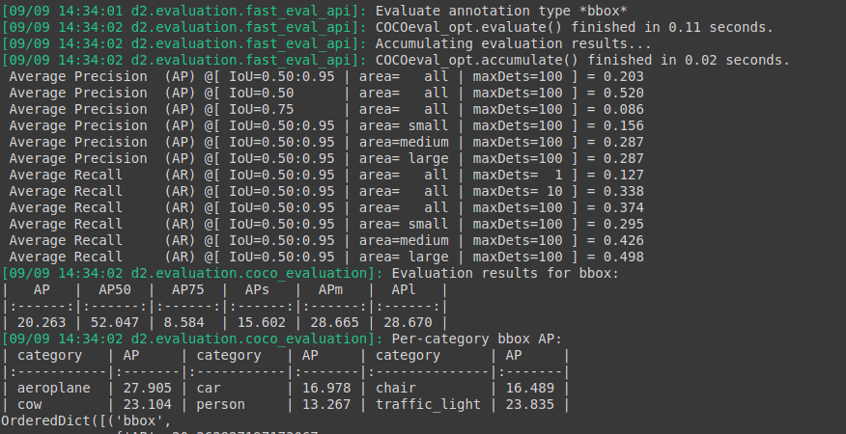
Train :

