Name : Panneerselvam N
Role : Research Intern – Inspect
Date : 01/07/2021

Today I had worked with both Pre-trained and custom model of PP-Yolo. First I had tested PP-Yolo’s pre-trined weights with Paddle paddle framework. It works fine .

Output of pre-trained model :
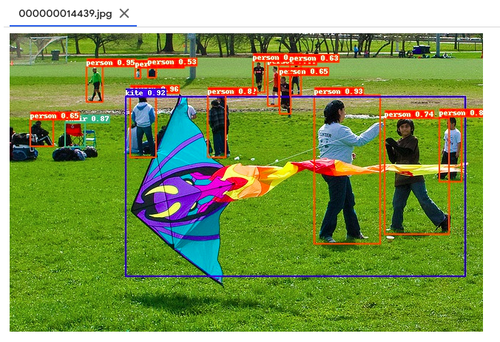
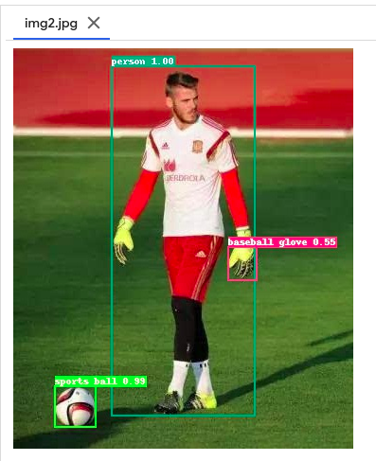

Custom model Training :

For Yolo v4 custom training ,I have used Coco dataset, which is annotated by myself and my teams.
But that is in the form of Yolo , for PP-Yolo need to convert coco json format . So , I had referenced the following link for convention . While converting I had faced many errors , after fixing them ,finally converted to json format.
https://www.programmersought.com/article/43131872583/

I had used my Colab and drive for custom model training. I had changed some training configurations in the directory of configs/detections/coco_detection.yml and chooses
ppyolo_r50vd_dcn_2x_coco.yml as my model .

While beginning of training , GPU error was occurred . I had fixed with changing the batch size to 8. After some epochs it stores checkpoints in output folder.

GitHub link : https://github.com/Panneer003/Aero2astro_code.git

Training screenshot :

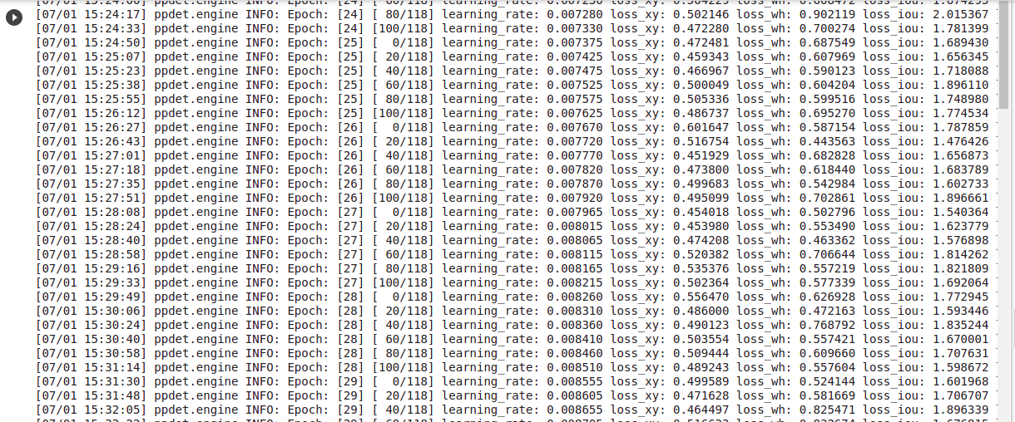
Checkpoints screenshot:

