Name : Panneerselvam N
Date : 12/07/2021

In today morning I had attended team meeting . In team meeting we discussed previous weeks work and upcoming works. After meeting I had tried to download coco dataset with Pycocotools API. First I had tired to download Motorcycle class, but it has only 371 mages. So changed dataset class to car . I had downloaded 500 images and corresponding annotations in json format.

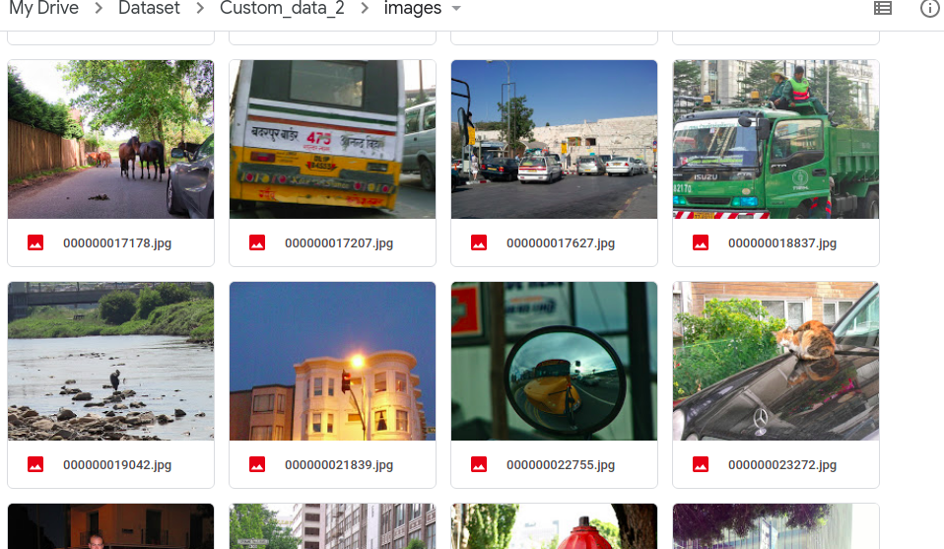

Dataset link : https://drive.google.com/drive/folders/1o01LcZ5Tea-XM20k6Vn3tYaGXsTLiCJ4?usp=sharing

GitHub link : https://github.com/Panneer003/Aero2astro_code/blob/main/PP_Yolo_with_official/Coco_data_download.ipynb

