Name : Panneerselvam N
Date : 13/07/2021

Today i had updated custom dataset(class car) with 500 instances from coco dataset. After tried to combine all dataset into single dataset with json annotations. For that I had created python script.

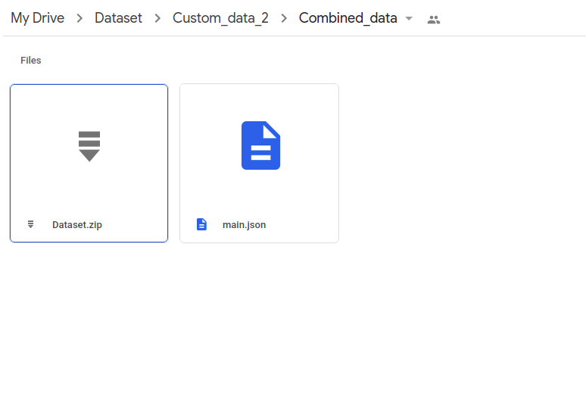

GitHub link (Combined_data_creation) : https://github.com/Panneer003/Aero2astro_code.git

Combined dataset : https://drive.google.com/drive/folders/1yBjFEzXtF9qt1-1eoUhBP03k8ACwqTV3?usp=sharing

