Panneerselvam N
(14/07/2021)

Today i had trained PP_yolo with 287 epochs , but loss still between 37 to 48. After team discussions , then tried with 1000 instances dataset. I had combined all dataset into single .Then trained PP_yolo with new dataset and json. At first, I had set lr = 0.001 and batch size = 4, it’s gives nan loss from 13th epochs ,so changed to lr = 0.0002.

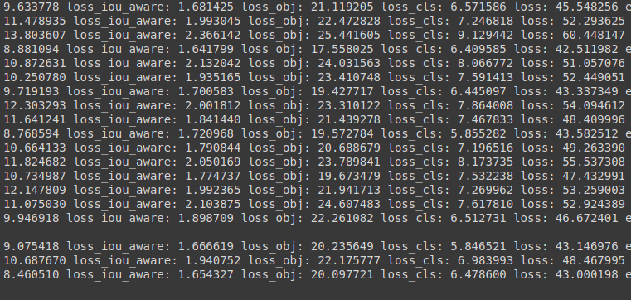

link (500 instances): https://github.com/Panneer003/Aero2astro_code/blob/main/PP_Yolo_with_official/PP_Yolo_custom_500_instances.ipynb

link (1000 instances) : https://github.com/Panneer003/Aero2astro_code/blob/main/PP_Yolo_with_official/PP_Yolo_custom_1000_instances.ipynb

