Panneerselvam N
(15/07/2021)

Today i had trained PP_Yolo Model with 110 epochs . At the 70th epochs , i had faced GPU timeout, so changed to another google account and started to training. The minimum loss is 36, and loss fluctuates in between of 30 to 45.

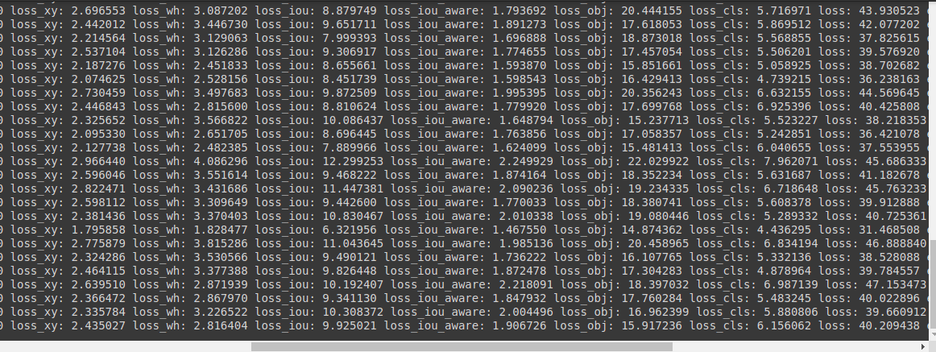
Link : https://github.com/Panneer003/Aero2astro_code/blob/main/PP_Yolo_with_official/PP_yolo_1000_instance_2.ipynb

