Panneerselvam N
(16/07/2021)

Today i had trained PP_yolo custom model upto 303 epochs with colab . The minimum loss is 28 . But loss is continuously fluctuating in between 28 to 53.

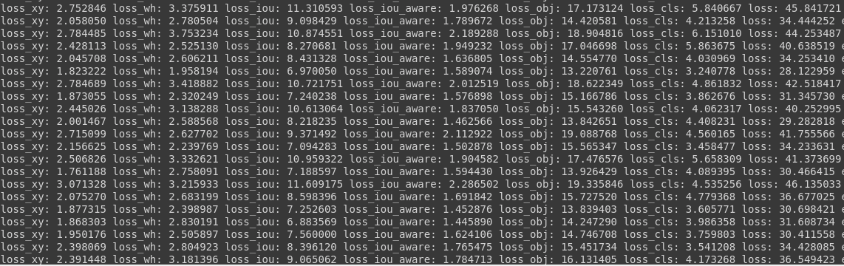

Link : https://github.com/Panneer003/Aero2astro_code/blob/main/PP_Yolo_with_official/PP_yolo_custom_1000_instaces_3.ipynb

