Panneerselvam N
(17/07/2021)

Today i had trained PP_yolo custom model upto 511 epochs with colab . The minimum loss is 24 . But loss is continuously fluctuating in between 21 to 40.

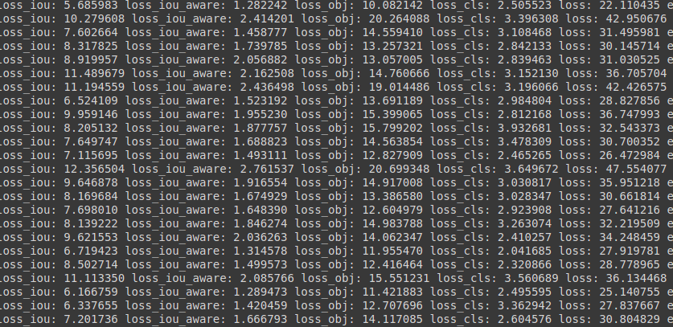

Detection Result :

