Panneerselvam N
(19/07/2021)

Today i had trained PP_yolo custom model upto 719 epochs with colab . The minimum loss is 26 . But loss is continuously fluctuating in between 21 to 42.

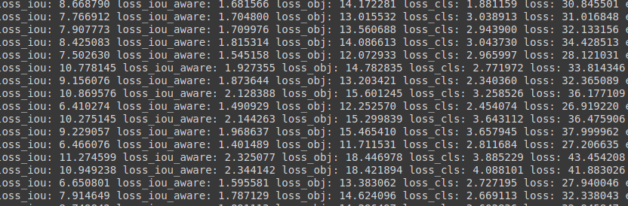

Detection Result :

