Name : Panneerselvam N
Role : Research Intern – Inspect
Date : 02/07/2021

Evaluation of Custom model:

In Today morning , i had tried to evaluate yesterday’s trained checkpoints . But the object is not detected . Because while training the loss remains same , and returns Nan value also.

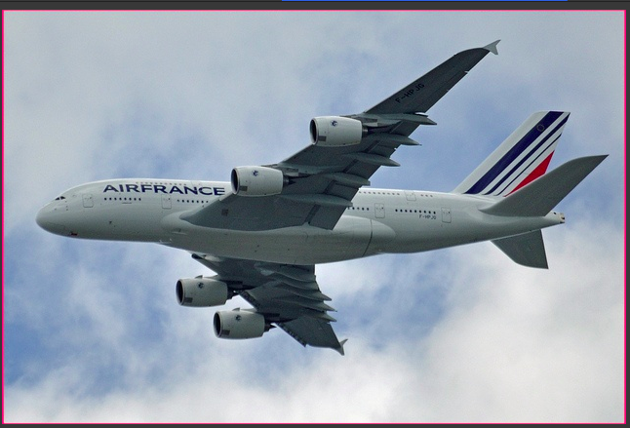
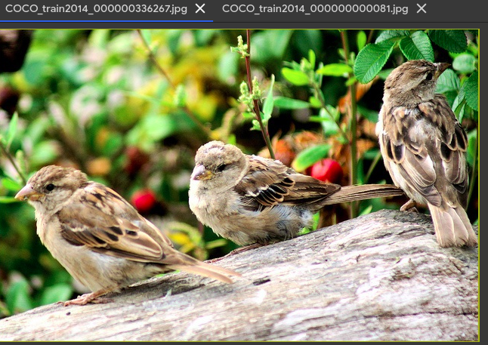

Above two images is output of custom model , object is not detected.

So, i had tried to fix Nan loss.

Tried Methods :
method 1:
I had converted json file again and verified information is correct or not.

Method 2:
Yesterday i had used opencv’s imread and imwrite to copy image file from drive to my work location . While doing that , in default it stores in BGR format. So , i had changed BGR to RGB and copied files again .

After modifying above two things , again tried to train my model. But error is not fixed .

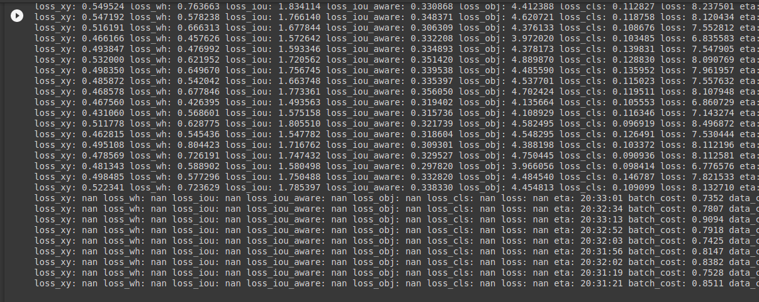
Solution :
Finally I had found the solution from official documentation .

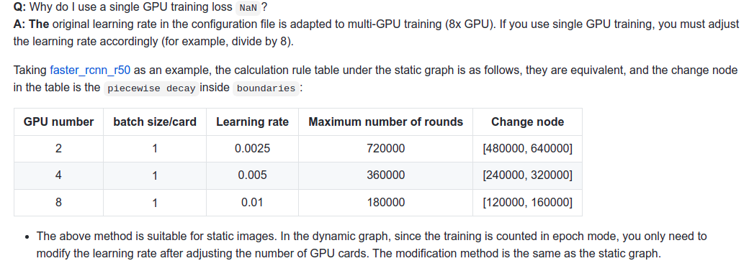
Problem is due to learning rate configurations , we need to divide the default learning rate by 8 .

After above modification ,tried to train my model ,but GPU limits are over. So ,
I will check it tomorrow and update it.

