Panneerselvam N
(20/07/2021)

Today i had trained PP_yolo custom model upto 900 epochs with kaggle . But after 9 hrs of continuous training, the kaggle kernel automatically disconnected, so I had lost weights from 800 to 900 epochs. Previously I had downloaded the weights of 800 epochs.The minimum loss is 26 . But loss is continuously fluctuating in between 21 to 42.

Detection Result:

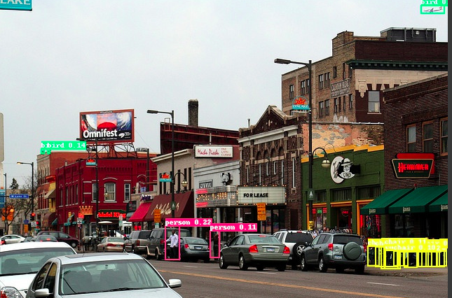
Threshold= 0.1

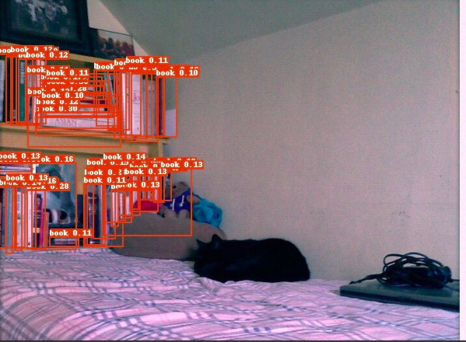


Threshold = 0.3

