Panneerselvam N
(23/07/2021)

Today i had trained PP_yolo custom model upto 1231 epochs with colab . The minimum loss is 22 . But loss is continuously fluctuating in between 20 to 38.

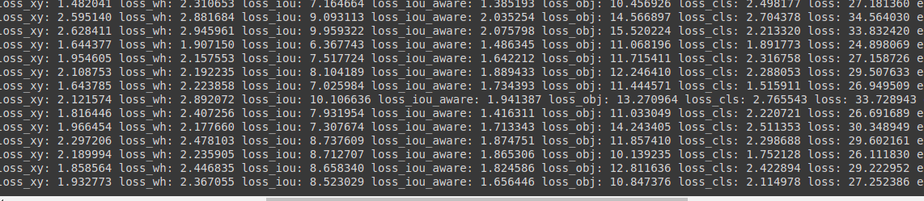

Detection Result :

Threshold = 0.3

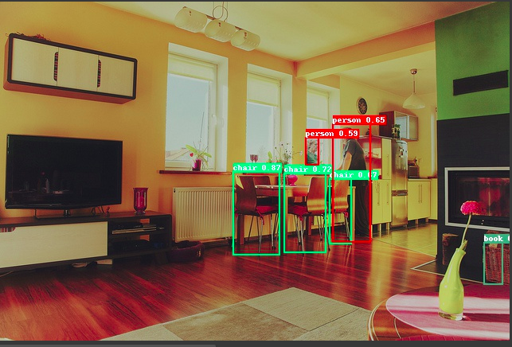

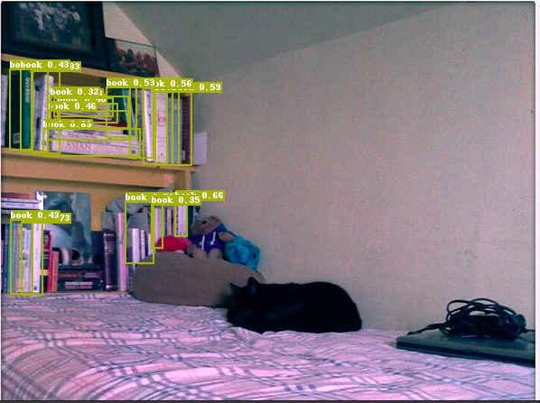

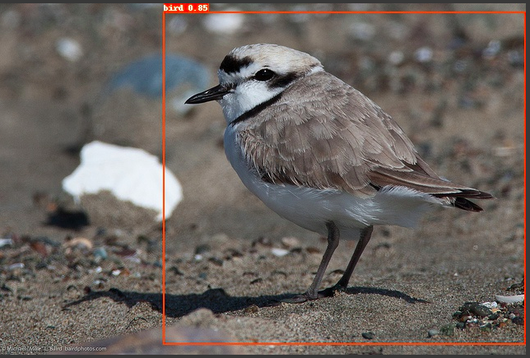

Threshold = 0.1




