Panneerselvam N
(26/07/2021)

Today i had trained PP_yolo custom model upto 1611 epochs with kaggle . The minimum loss is 20.

Evaluating Result :

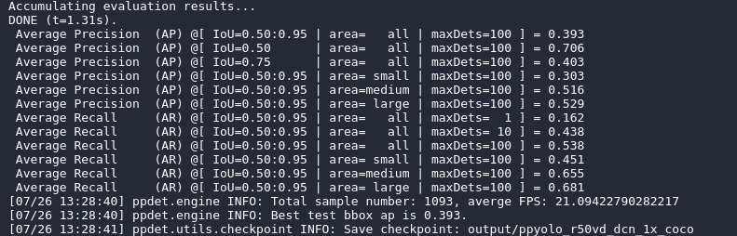

Detection Result :

Threshold = 0.3

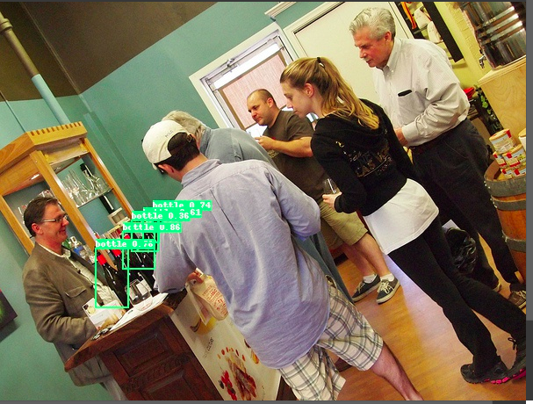

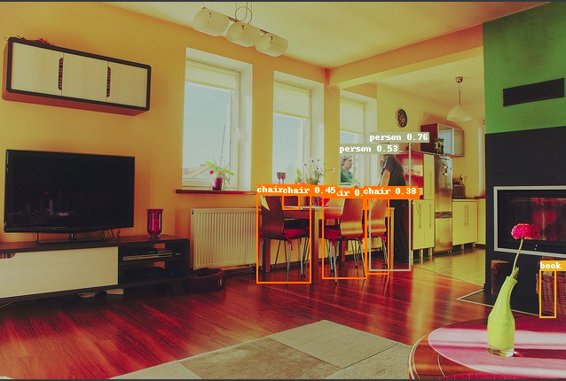

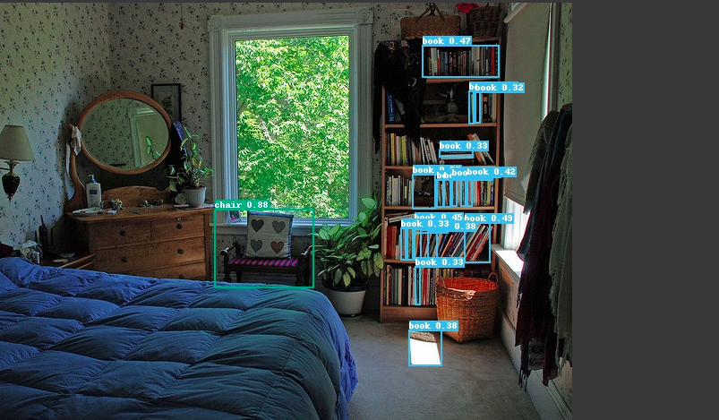

Threshold = 0.1

