Panneerselvam N
(28/07/2021)

Today i had trained pp yolo model upto 2000 epochs with coalb.

Evaluation Result : (Test Dataset)

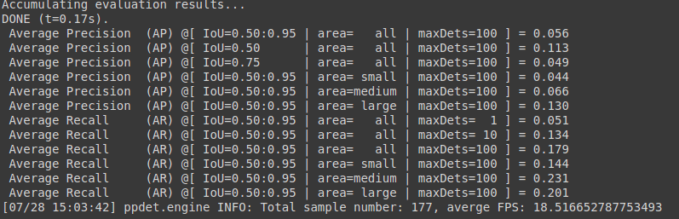
Detection Result :

Threshold = 0.3

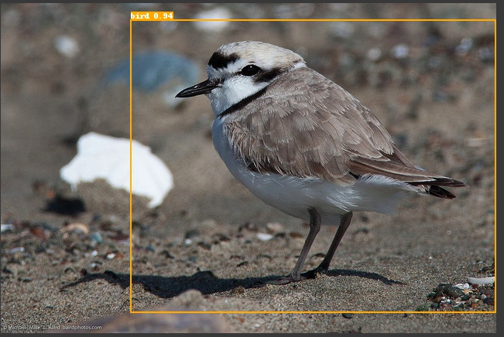

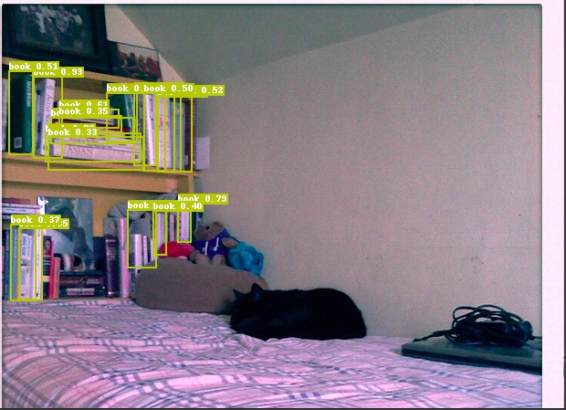
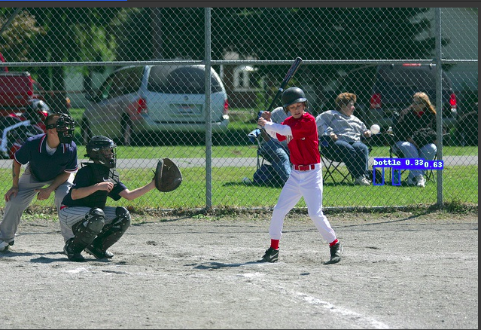

Threshold = 0.1

