Panneerselvam N
(July 29,2021)

Today i had trained PP Yolo v2 model upto 91 epochs. With compare to pp yolo v1 , v2 gives only 4 to 5 ips. The loss fluctuates between 95 to 140. The minimum loss is 95.

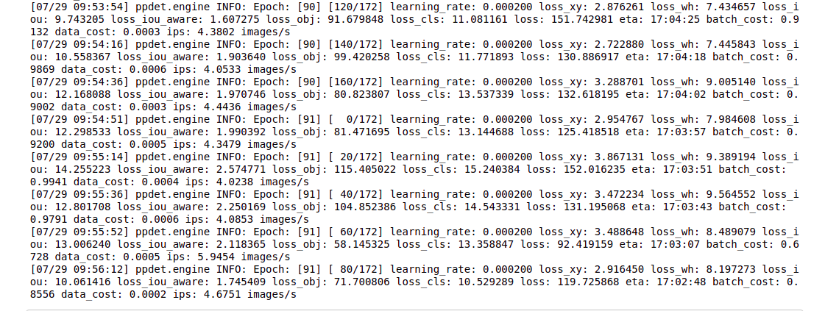
Link : https://github.com/Panneer003/Aero2astro_code/blob/main/PP_Yolo_with_official/pp_yolo_v2.ipynb

