Name : panneerselvam N
Date : 03/07/2021

Today i had tried to optimize PP-Yolo with lower learning rate . First I had tried learning rate with 0.00125 . In starting the loss is 16 and it decrease to 6. But it fluctuating in between of 6 to 8. Tried epochs is 61.

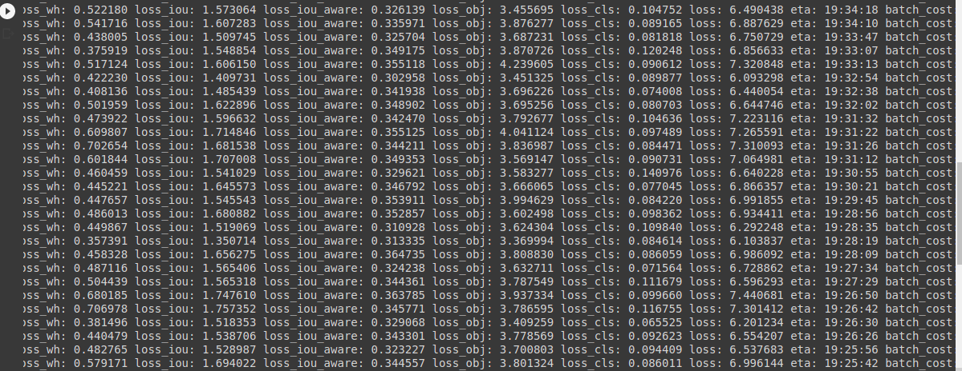
Next , I had tried to detect objects , but it not detected.

After further I had decreased model learning rate 0.000156245 , initial loss is 509 and decreased to 6 in time of 98 epochs. This method also fluctuating it’s loss in between of 6 t0 7. Next I had tried to detect objects , as usual it not detected.

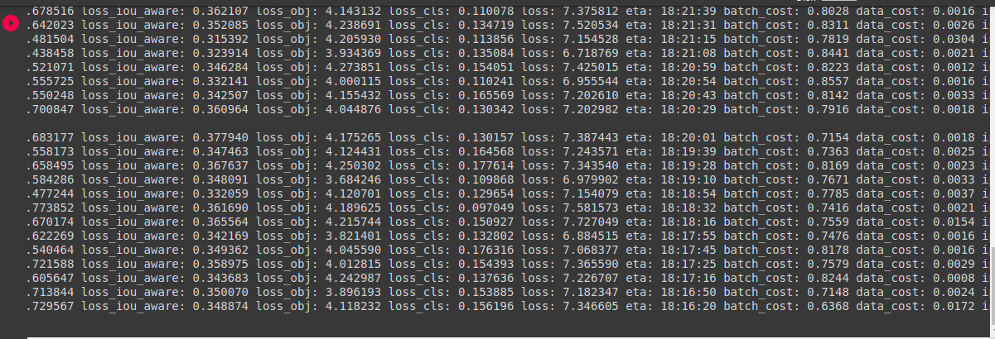
So , I am decided to take another one dataset and to chech model is forming good on that data. For that I had downloaded chess dataset from roboflow . It was already annotated with coco format. But while try to train, colab shows GPU timeout. But I am not used GPU for 12 hrs continuously. Next tried train with CPU , but It take very long time for single epoch.

Dataset link : https://public.roboflow.com/object-detection/chess-full

