Name : Panneerselvam N
Date : 05/07/2021

Today i had tried to fix model training problem in PP-Yolo with following methods .

Method – 1:
Modified Super category in Json files .

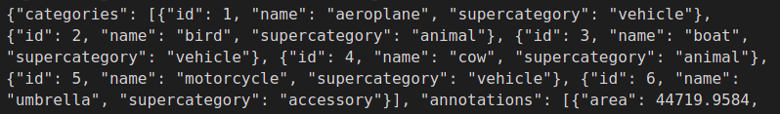
Method -2 : (Verifying Json file)
I had verified my json files with online coco convertion tool roboflow. I had taken three images from my annotation(Yolo ) and converted with roboflow to coco format and verified with previous json file. Almost bbox coordinates are same.

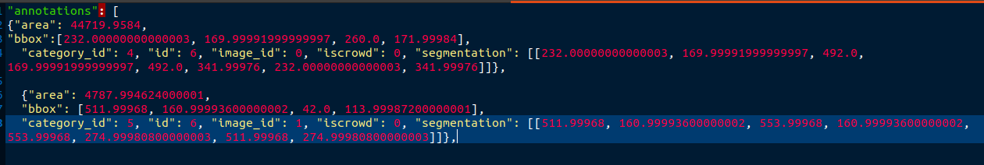
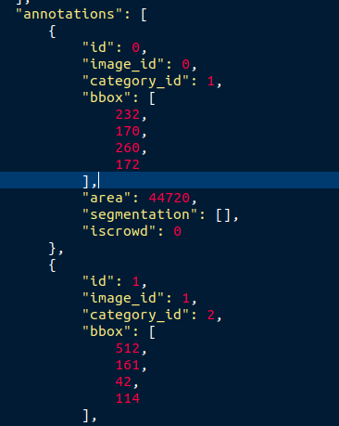

Tried with modified json , but no improvements happen.
Method -3 :
Changed datasets to verify whether configurations are correct or not. But in new dataset also fluctuation of loss happened in between 65 to 80. So , json format of ours is correct. I think we need to increase epochs, that’s only gives good result.

Dataset link : https://public.roboflow.com/object-detection/chess-full

