Name : Panneerselvam N
Date : 06/07/2021

Today i had trained pp-yolo with 111 epochs . First 60 epochs,i had trained with learning rate of 0.001. In this time loss fluctuates in between 6 to 8. So , i had changed my learning rate to 0.0001 . so it reduces in between 5 to 6.

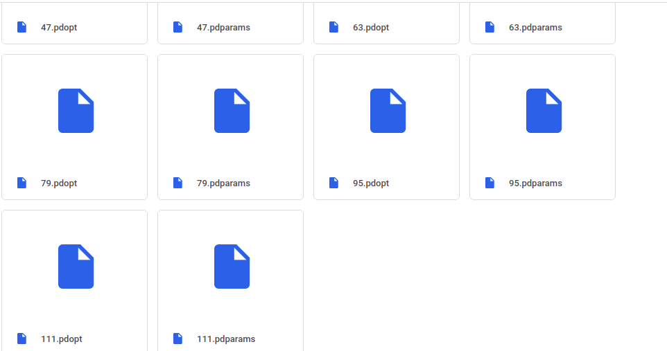

After 111 epochs GPU got disconnected . But I am used 5 hrs only today, but GPU was timeout. so , tried to detect objects with checkpoints in CPU. But it’s not detected.



