Panneerselvam N
July 7 , 2021

Today i had trained PP-Yolo model to 250 epochs , But loss doesn’t decreased. It is still maintaining 6 – 5. So i had compared my teams loss , it is very high(my loss) . I think I need to look data-sets , because some images doesn’t contains annotation files.

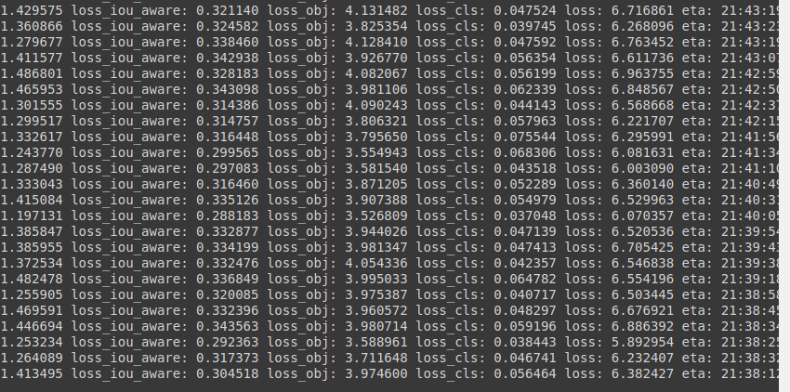
I had tried to detect objects , but it not detected.

