Panneerselvam N
09/07/2021

Today i had trained PP-Yolo model to 435 epochs . After training , tried to detect objects with checkpoints. But it detects only persons not other objects.

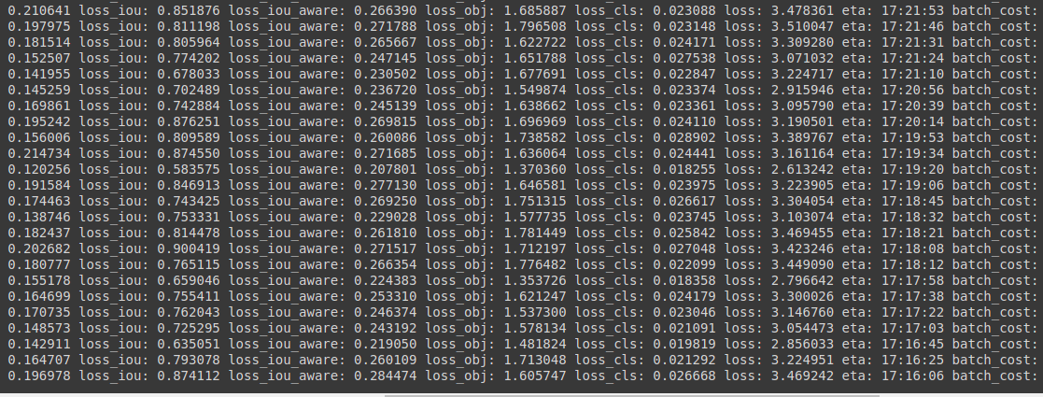

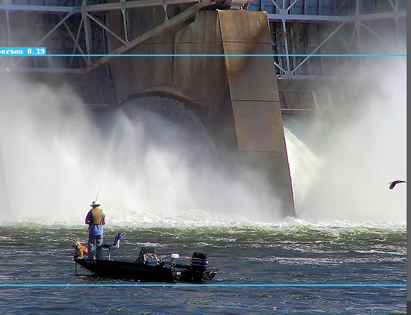
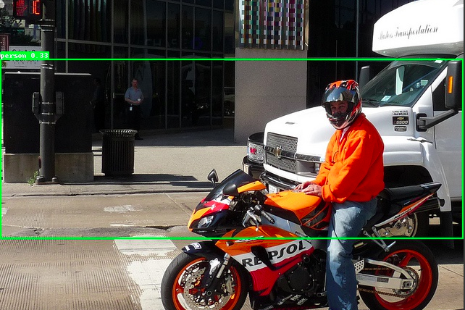

GitHub link : https://github.com/Panneer003/Aero2astro_code.git

