Name : Panneerselvam N
Role : Research Intern – Inspect
Date : 19/06/2021

Task : Dataset Collection (Tower Inspection)

I have continued my work on data collection in insulators and bolts. Because insulator is very important part in Power line inspection. More data gives more accuracy.

I had downloaded video which contains insulator inspection from youtube and some websites.

Next, I had used my python script for extract images from video using opencv and also cleaned unwanted images.
Totally collected further 550 images in today.
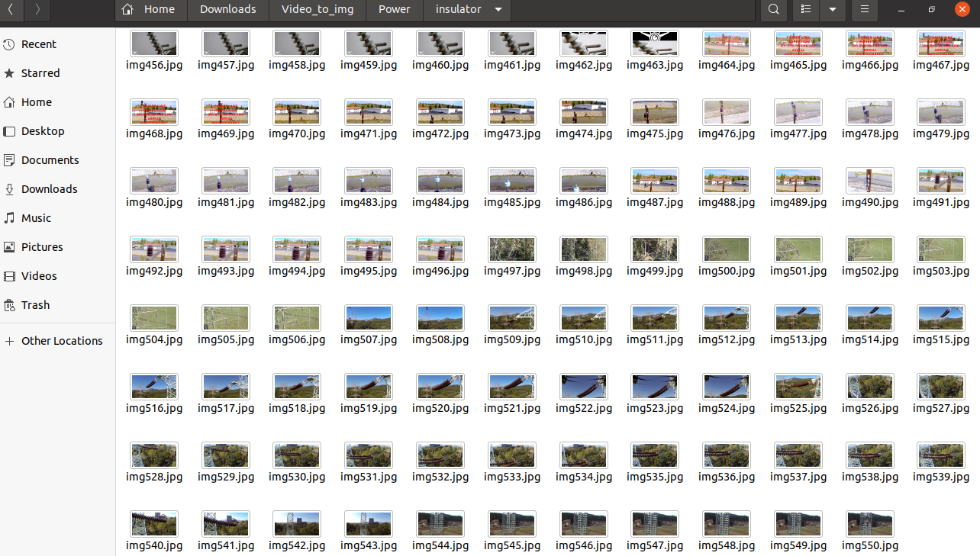
Also I have collected Bolts datasets from Public repository and web scrapping.
Link : https://www.kaggle.com/krishna8338/mechanical-parts-data

Found new repository:
http://www.dee.eng.ufba.br/dslab/index.php/opdl_dataset/
Above dataset has many insulator images with various types .But For download we have to mail the authors to get link.

TensorFlow Learning :
Today learned Callbacks and worked with some of the callback methods in TensorFlow Keras.

