Name : Panneerselvam N
Date : 21/06/2021
Task : Custom Yolo v4 Model Testing

System Specifications :(Colab)
Disk : 30 GB
RAM : 13 GB
GPU : Tesla K80

Testing method :
For image :
I have taken 150 images with various augmentations and calculated Mean Average Precision and Recall using Colab.

For video :
I have taken some video from youtube and tested in my custom model to calculate Frame per second.

Resize – (224x224):
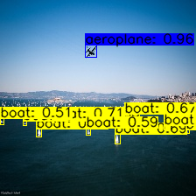
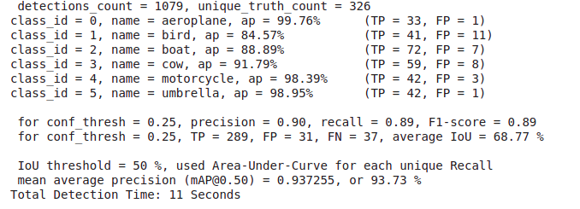

Resize – (608x608):
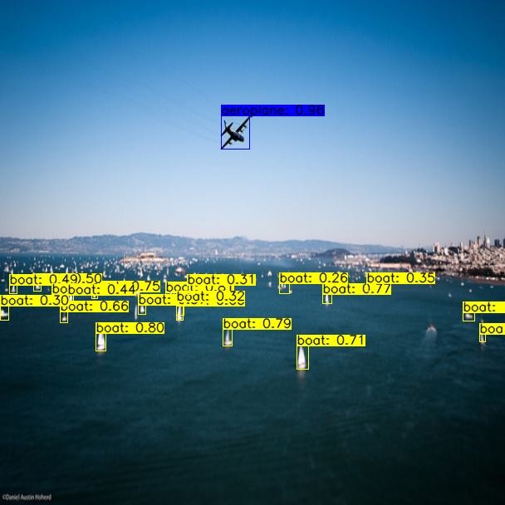
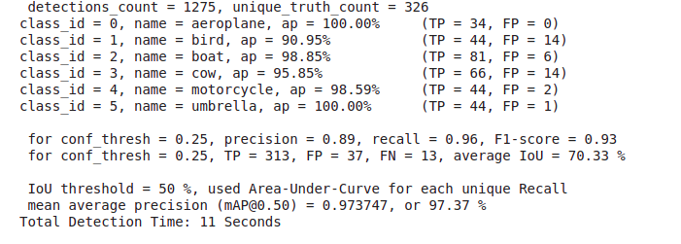

Blur with Kernel size (10x10):
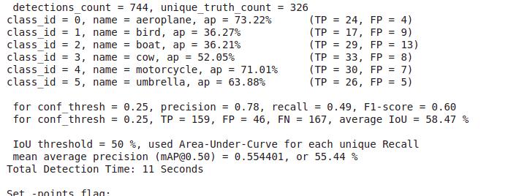
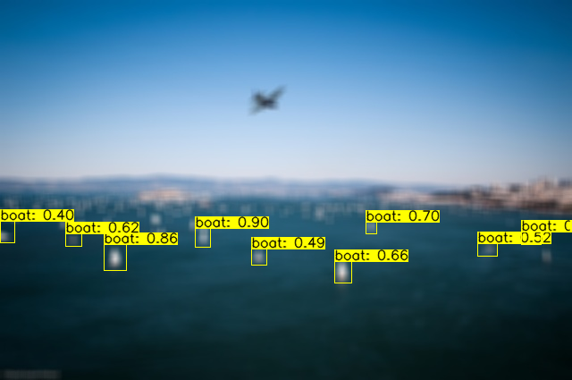

Rotation – 180 degree:
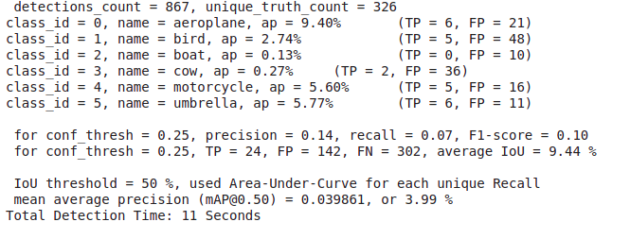
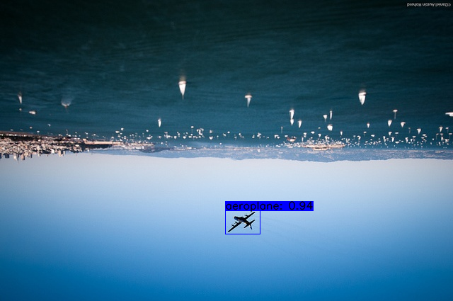

Graph :
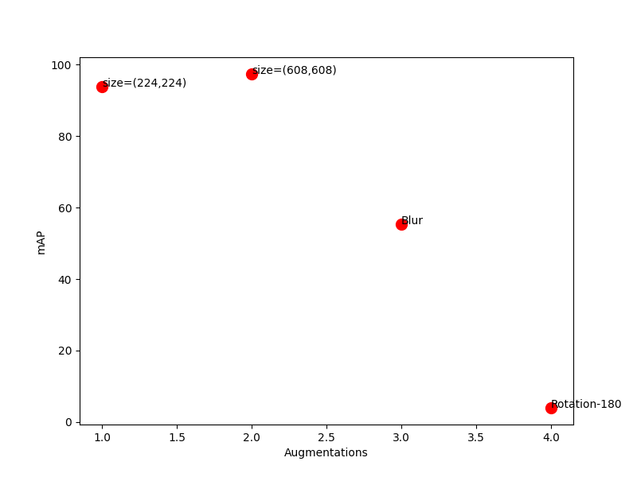

Above graph shows the Mean Average Precision with respect different image augmentation methods.

Video Testing :

In Colab :
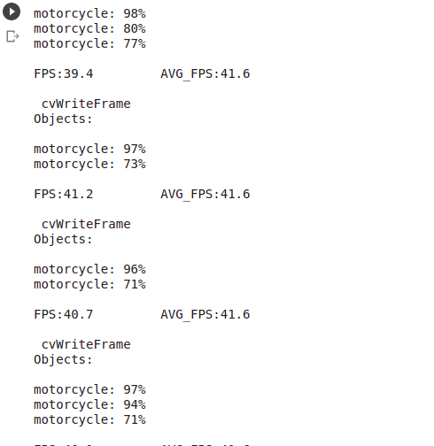

In Local Machine :
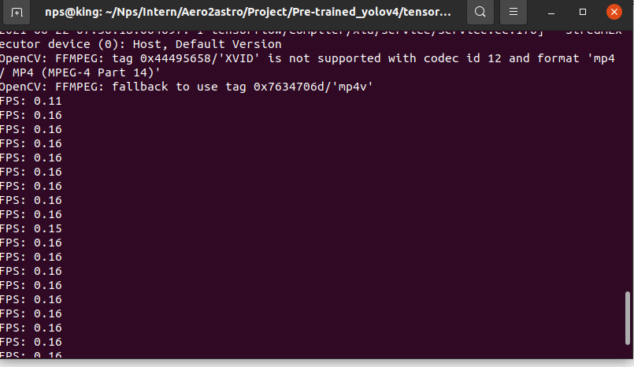

Graph :
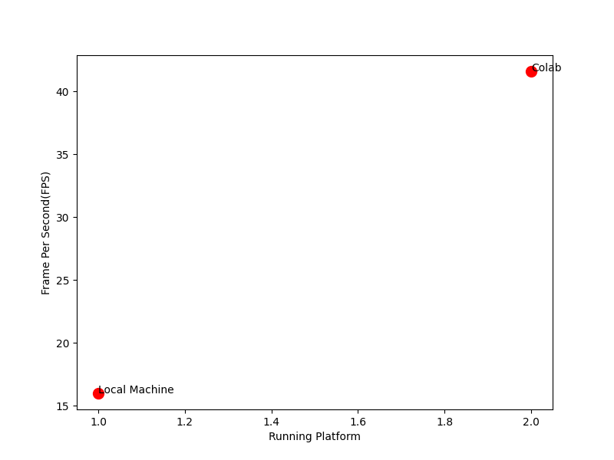
Above image shows the graph of FPS with respect different running machines.

Conclusion :
My model performs well in trained data, but when comes to new data, it’s mAP is much less compred to trained data mAP.
Model gives good FPS (41.6) in GPU colab .

Above analysis shows that my model was over-fitted . Because of less data and less augmentation.

