Name : Panneerselvam N
Role: Research Intern - inspect
Date : 25/06/2021
Task : Yolo v4 Repository Optimization
Today I made some changes in repository and tried to training with colab. Initiall I got GPU error due TensorFlow version conflicts. I fixed with commenting that unwanted line . After I got file missing error. I have used try and except concept to handle such type error.

I have changed sigmoid activation to Tanh activation in bounding box prediction layers. I noticed that it take long time for training and computation .
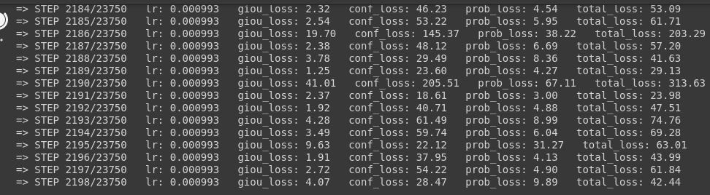
And also loss changing continuously like (34,67,144,56,99,179,31). it’s not stable.

Screenshot at steps : 2198 (Tanh activation function)

After I have changed Tanh to Sigmoid , It starts loss from 322 and gradually decrease to 4.

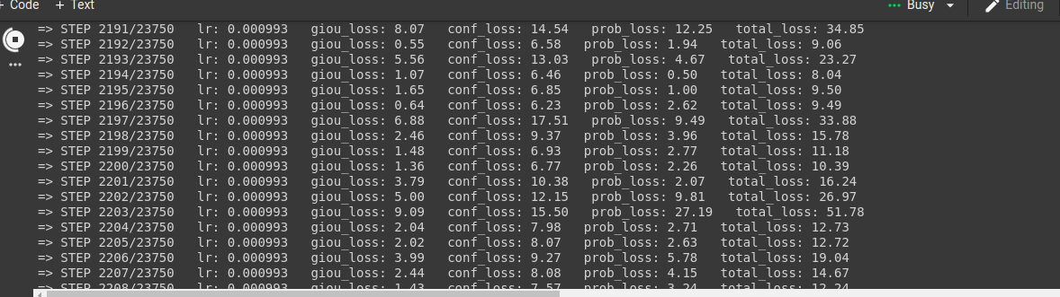
Screenshot at steps : 2198 (Sigmoid activation function)

Comparison of above two images shows that sigmoid is better than Tanh. Tomorrow on words I will try to change others like batch size , image size , layers and cost function to optimize model more.

