Panneerselvam N
(June 26, 2021)

Task : Yolo v4 optimization

Today I had tried to detect object with yesterday’s trained weights. For detection I had tried lots of methods files like json , h5 , .data , .index .
Because while training TensorFlow Yolo v4 model it producing checkpoints only. So try to modify code to save weights. But it didn’t work. It produces lots of error due to model architecture conflicts.

Finally I tried replacing checkpoint weights to previously converted weights in variables folder. It works well.

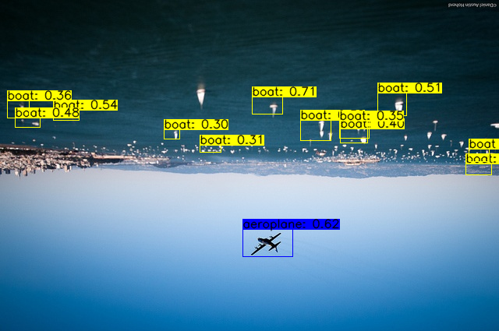

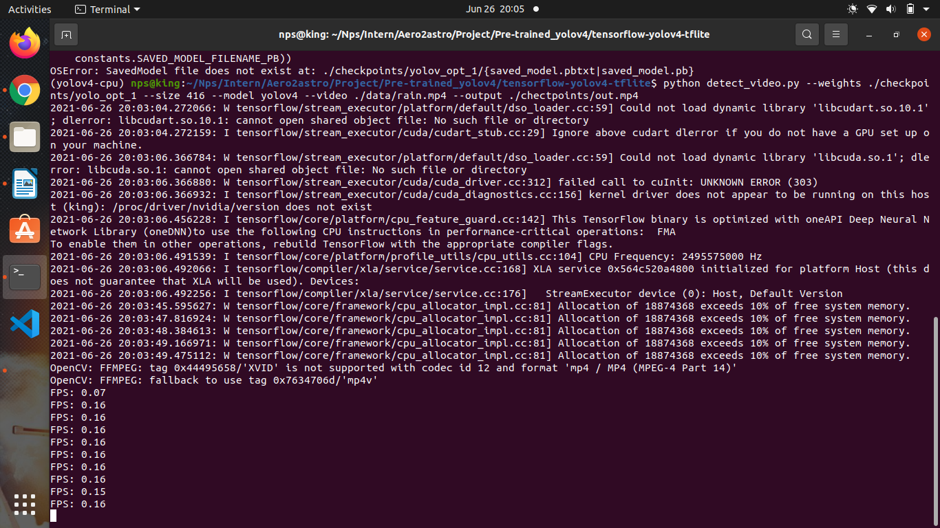
I have tested new model with cpu , it give more accuracy and same FPS than previous one .

