Panneerselvam N
(28/06/2021)

Today i had tried to optimize FPS of yolo v4 with Opencv’s DNN module. Because i had readed one article thst opencv’s DNN module best and efficient for loading and predicting Deep learning models. But for that require .pb file and .pbtxt file. Pb file contains signatures of model and pbtxt file contains name of layers. Tensorflow in default gives pb file .

So tried to generate .pbtxt file from pbfile. It produces following error , but I not able to fix this.

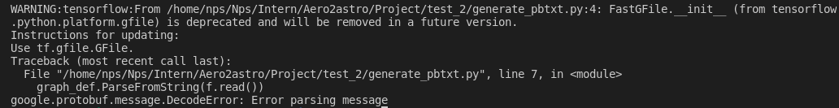

Also today I refreshed following architectures to work with pp-yolo,

Feature Pyramid Network(FPN)
Path Aggregation Network(PANet)
Spatial Pyramid Pooling (SPP)

