Panneerselvam N
(29/06/2021)

Today i had tried to fix yesterdays error . I have converted Tensorflow’s saved model format to protobuf(pb) file . After I had created .pbtxt file from that protobuf file. While loading above two file in Dnn module again I got another error . I had tried to fix it , but not able to fix.

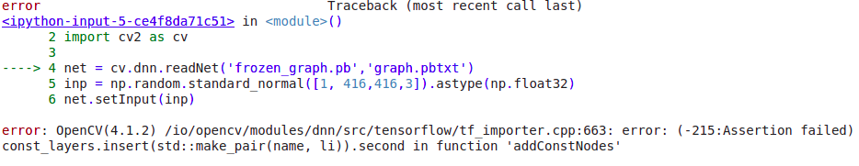
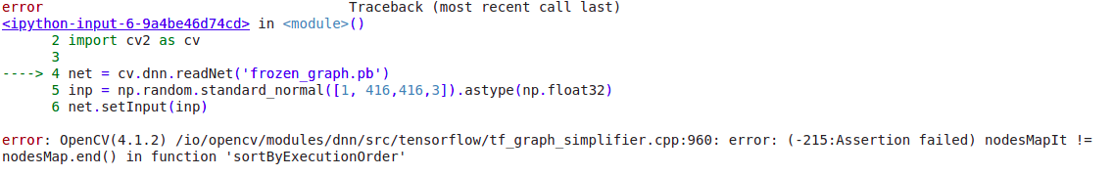
I had referenced following links :
https://github.com/opencv/opencv/issues/16155
https://github.com/opencv/opencv/issues/11452
https://jeanvitor.com/tensorflow-object-detecion-opencv/
https://stackoverflow.com/questions/62288678/save-pb-and-pbtxt-file-from-keras
https://www.programmersought.com/article/29994911524/

Also today studied PP-Yolo’s Backbone ResNet-50 and Neck FPN.

