Semiconductor Process/Device Simulation (EEE533)

Assignment 5

1D Drift Diffusion simulator for modeling pn-junction Diode

Due date – October 13 2008

Dr. Dragica Vasileska

Student

Pinakpani Nayak (995030989)
TABLE OF CONTENT

1 Equilibrium Solver 2
1.1 NA = 10¹⁶ and ND = 10¹⁶ 2
1.2 NA = 10¹⁶ and ND = 10¹⁸ 4
1.3 NA = 10¹⁸ and ND = 10¹⁸ 6
2 Non–Equilibrium Solver 8
2.1 Objective 8
2.2 Specifications 8
2.3 Methodology 8
2.4 Flow chart for 1D Drift Diffusion Solver 10
2.5 Finite Difference Representation of Linearized Poisson’s Eqn 11
2.6 Scharfetter – Gummel Discretization Scheme 11
3 Simulation Results 13
3.1 Conduction Band vs Device Length 13
3.2 Electron and Hole Densities vs Device Length 14
3.3 IV Characteristics 15
3.4 Electron and Hole Quasi Fermi Levels 16
3.5 Electric Field 17
3.6 Equilibrium Condition 17
4 APPENDIX A 19
4.1 Results from Larger Bias steps = V_{T}. 19
5 APPENDIX B 20
5.1 Matlab Code for 1D drift Diffusion simulator for modeling pn-junction (diodes) 20

Equilibrium Solver

NA = 10¹⁶ and ND = 10¹⁶

POTENTIAL

MATLAB NanoHub

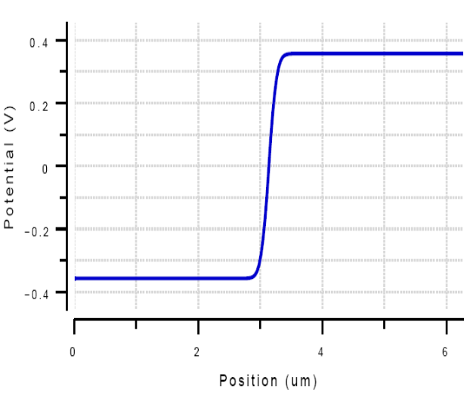
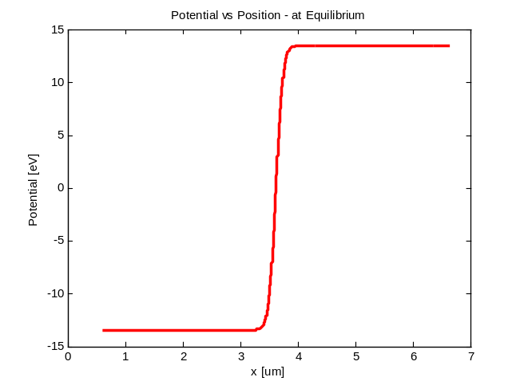

ELECTRIC FIELD

MATLAB NanoHub

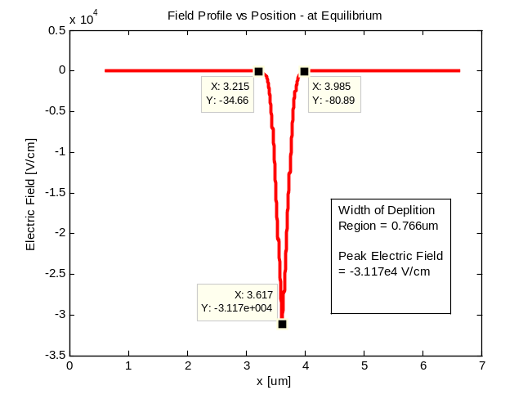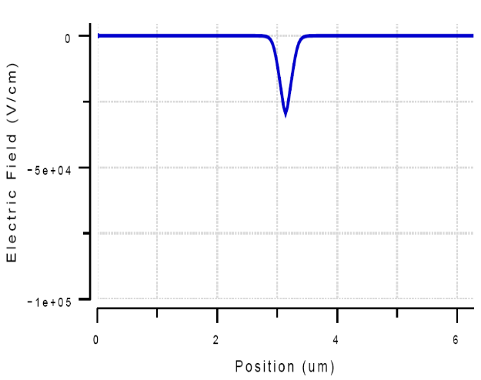

Width of Depletion Region = 0.766um and Peak electric field = - 3.117E4 V/cm
ELECTRON AND HOLE DENSITIES

MATLAB NanoHub

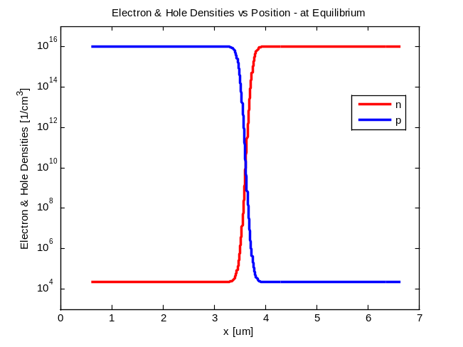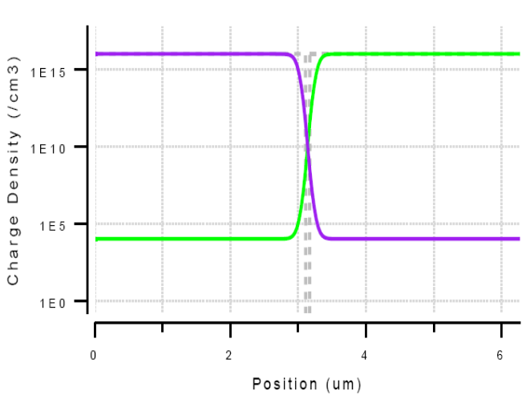

TOTAL CHARGES

MATLAB NanoHub

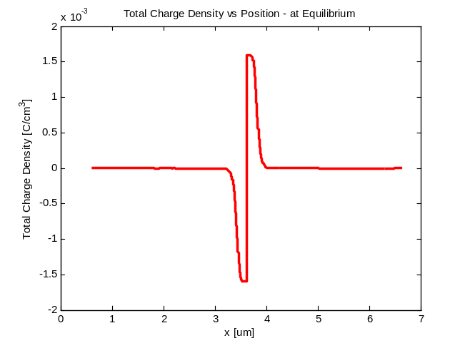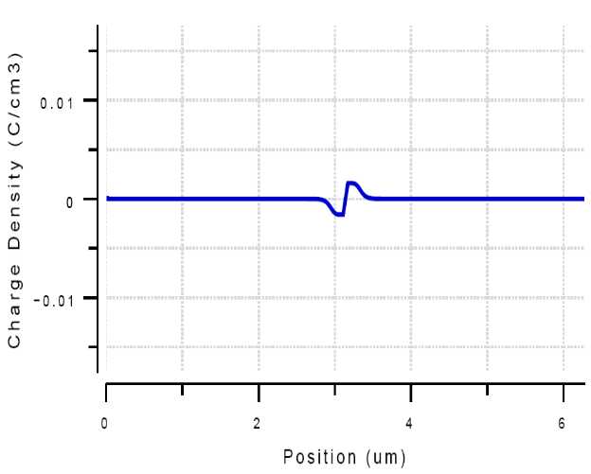

Thus Nanohub and Matlab results match.

NA = 10¹⁶ and ND = 10¹⁸

POTENTIAL

MATLAB NanoHub

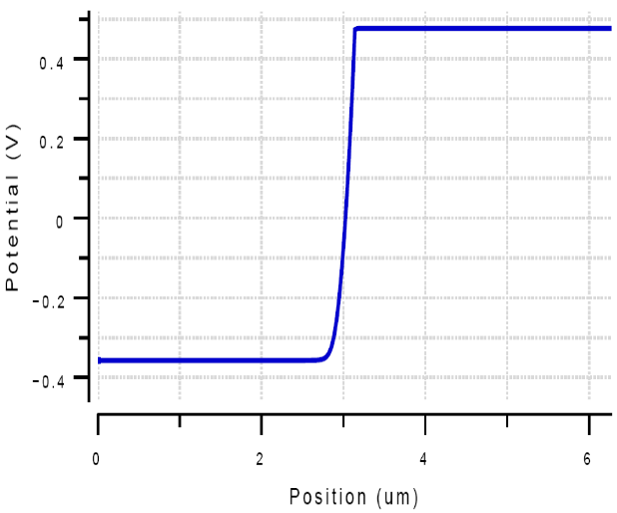
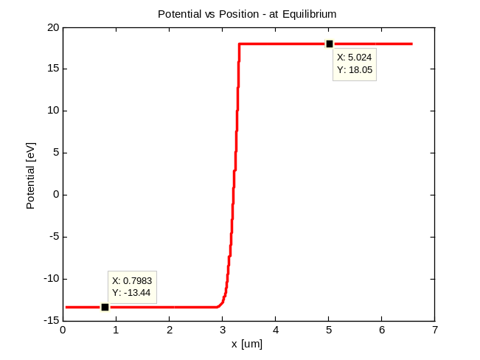

ELECTRIC FIELD

MATLAB NanoHub

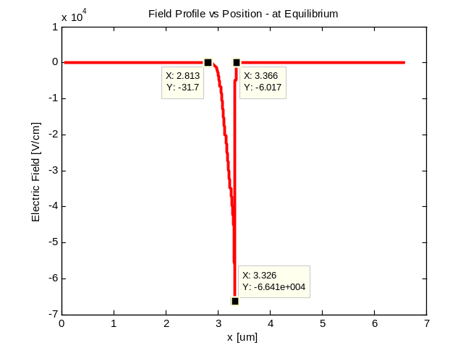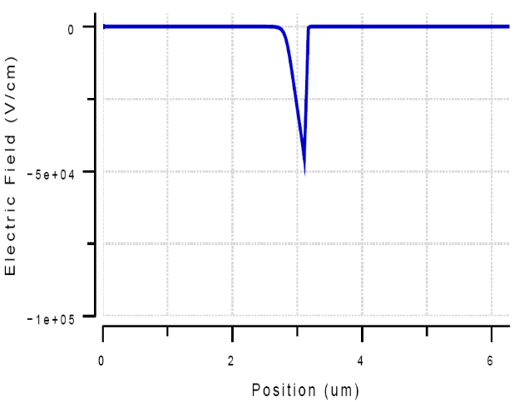

Depletion region = 0.553 um
Peak Electric Field = -6.641x10⁴ V/cm

ELECTRON AND HOLE DENSITIES

MATLAB NanoHub

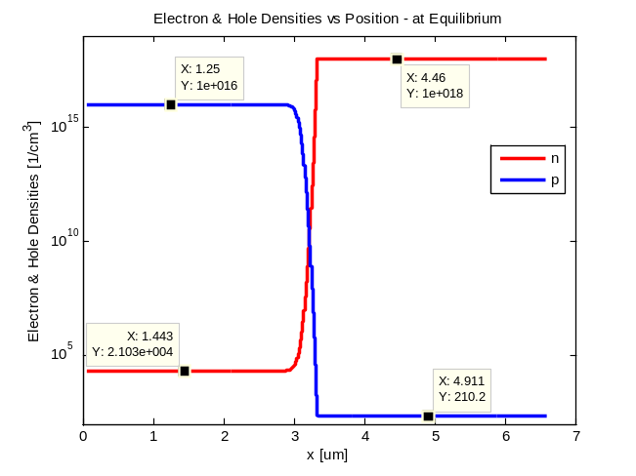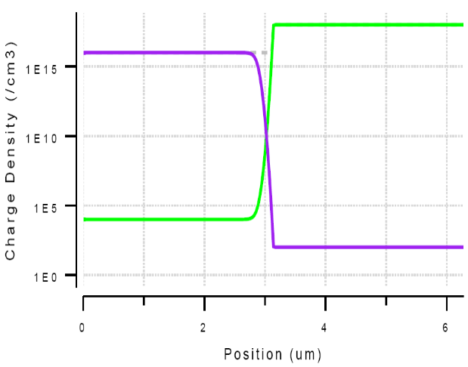

TOTAL CHARGES

MATLAB NanoHub

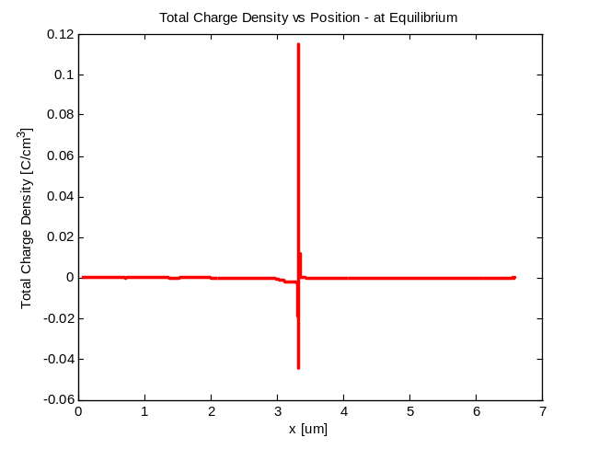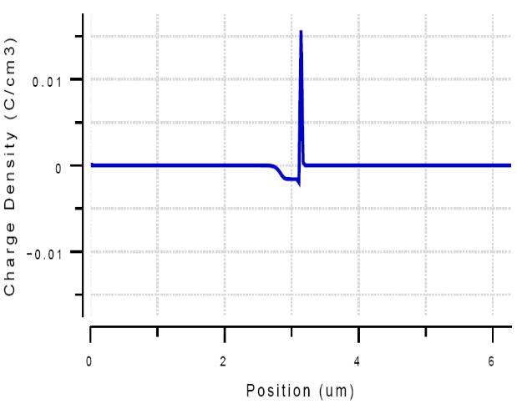

NA = 10¹⁸ and ND = 10¹⁸

POTENTIAL

MATLAB NanoHub

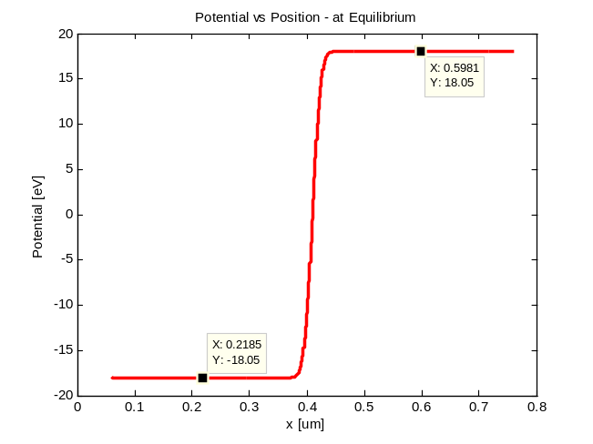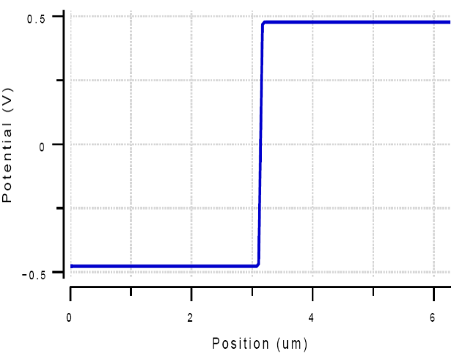

ELECTRIC FIELD

MATLAB NanoHub

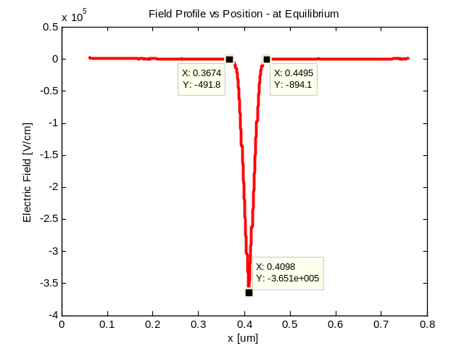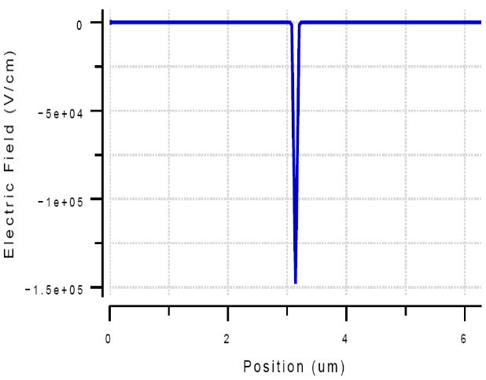

Width of Depletion Region = 0.0821 um
Peak Electric Field = -3.651E5 V/cm
ELECTRON AND HOLE DENSITIES

MATLAB NanoHub

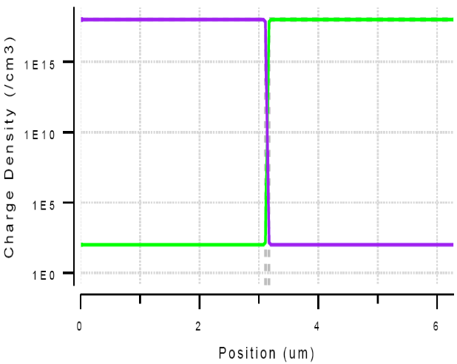
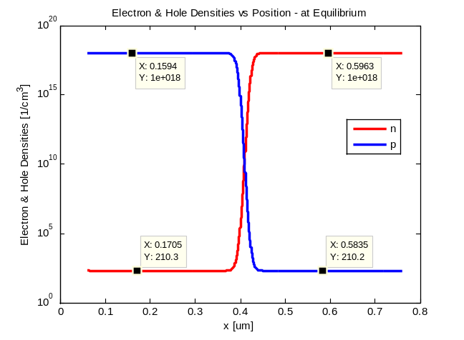

TOTAL CHARGES

MATLAB NanoHub

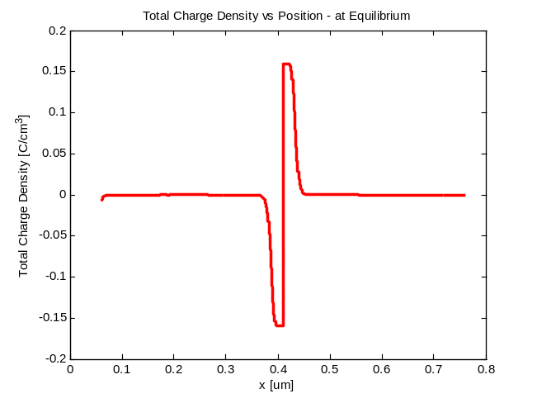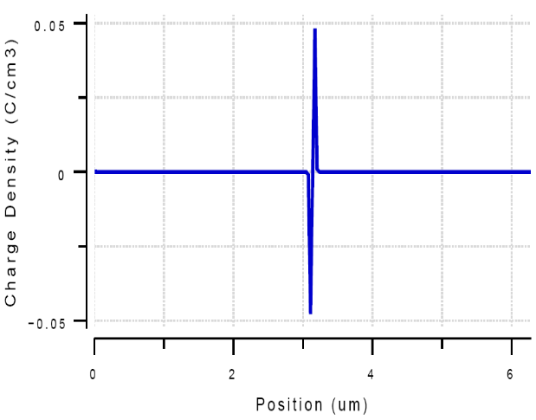

As Doping density of a particular section increases the depletion region in that section decreases.

Non–Equilibrium Solver

Objective

Goal of this project is to develop a one-dimensional (1D) drift-diffusion simulator for modeling pn-junctions (diodes) under forward bias conditions. Both types of carriers have to be included in the model (electrons and holes). Finite-difference expressions should be used for the electron and hole current continuity equations using Sharfetter-Gummel discretization scheme.

Specifications

ε_{sc} = 1.05x10⁻¹⁰
ni = 1.5x10¹⁰ cm⁻³ , T = 300K.

Electron mobility = 1500 cm²/V-s
Hole mobility = 1000 cm²/V-s

Doping : N_{A} = 10¹⁶ cm⁻³ for p-region and N_{D} = 10¹⁶ cm⁻³ for n-region.

Numerical Methods used – LU Decomposition method for the solution of 1D Poisson and 1D electron and Hole continuity equation.

Methodology

The flow chart explains the methodology followed. Following steps were followed to simulate the non-equilibrium condition of a 1D pn-diode.

- Calculate the equilibrium condition of the diode by solving the linearized Poisson’s equation.

- Define an initial Mesh, which should be fine enough to give correct result. If the Mesh size is too large then the results obtained will not be correct. The mesh size is less than the Debye Length.

- Initialize all discretization co-efficients, doping density and potential based on charge density.

- Solve for the updated potential using LU decomposition method.

- Update coefficient of the linearized Poisson’s equation.

- Check for convergence against a predefined error value(10⁻⁵).

- Equilibrium solution gives electric field, electric potential and net doping values (n and p concentration) to be used as the initial values for the non-equilibrium solver.

- Based on the equilibrium values we solve the continuity equation for electron and holes to get the current.

- Calculate the low field mobility. mun0 = 1500 cm²/V-s and mup0 = 1000 cm²/V-s. Store the mobility values in an array for each node points.

- Calculate the field dependant mobility based on the local filed at each node. mun(E) for electron and mup(E) for holes. (FDM)

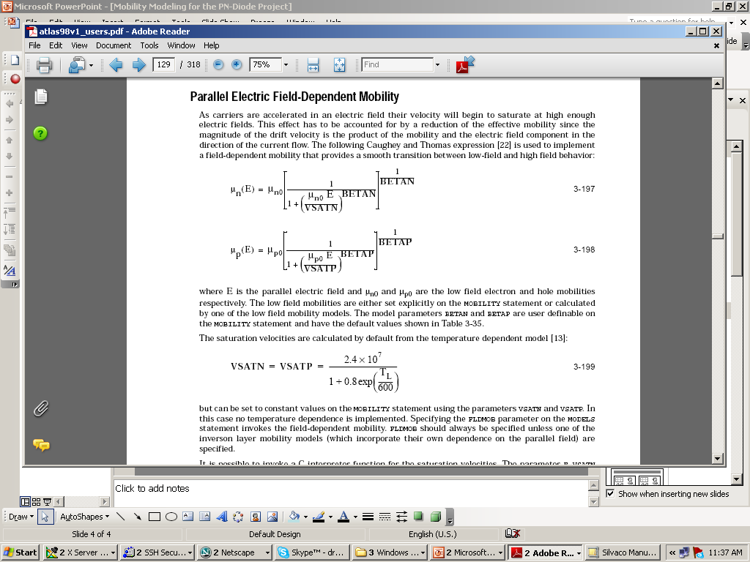

- Calculate Bernauli’s function that depends on potential. (BF)

- Determine the discretization coefficients (product of FDM and BF) of continuity eqns for electron and holes.

- Update the generation and recombination rate i.e. the forcing function of the continuity equation.

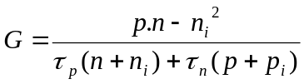

- Solve electron continuity eqn using LU decomposition and we get “n”.

- Solve hole continuity eqn using LU decomposition and we get “p”.

- Update central coefficient and forcing function in Poisson’s equation (now use n and p instead of e^{φ} and e^{-φ}).

- Solve Poisson’s equation using LU decomposition.

- Check tolerance, if not valid then go to step 9 and repeat (as we have updated the potential the field dependant mobility has changed).

Flow chart for 1D Drift Diffusion Solver

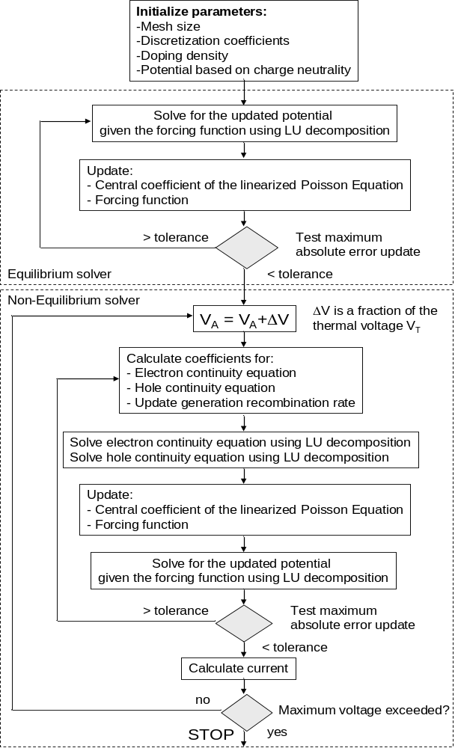

Finite Difference Representation of Linearized Poisson’s Eqn

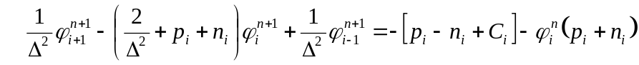

At Equilibrium : n_{i} = e^{φ} and p_{i} = e^{-φ}

Scharfetter – Gummel Discretization Scheme

Electron Current is given by

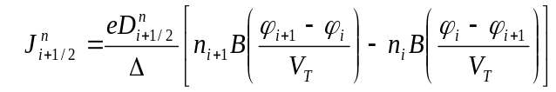
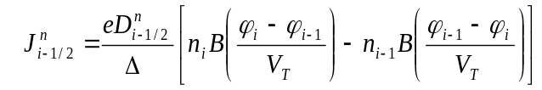

Hole Current is Given by

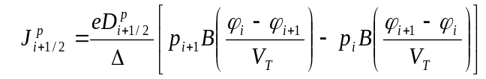
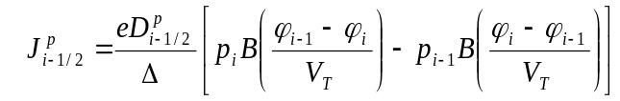

The electron Continuity equation is given by

The hole Continuity equation is given by

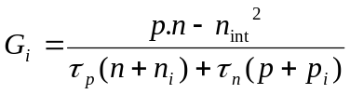 , 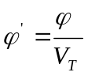 , 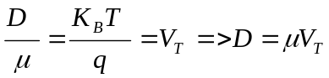
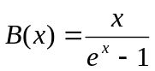 , x = normalized, n_{int} = intrinsic carrier concentration, Δ is normalized by L_{Di}
For electron

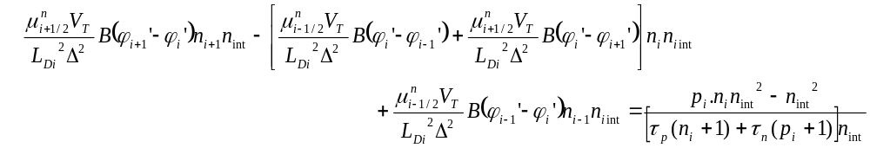

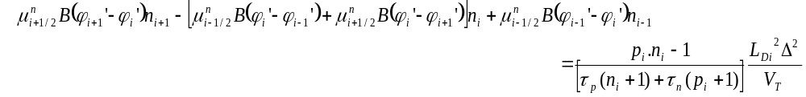

So the coefficients of electron Continuity eqn are

n_{int} = Intrinsic carrier concentration
L_{Di} = Intrinsic Debye Length
Δ = normalized mesh
V_{T} = Thermal Voltage
n_{i} p_{i} = electron and hole
concentration at node i

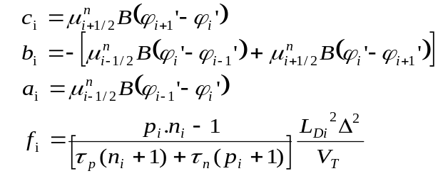

Similarly for Holes the coefficients can be determined as

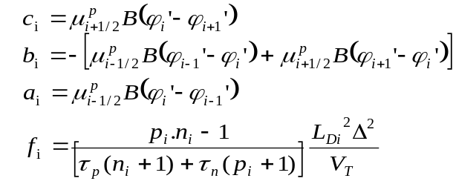

The simulation was performed by varying Anode voltage from 0 to 0.625V in 0.33*V_{T} steps. All the results were plotted as mentioned below.

NOTE :

It was observed that by varying the DC voltage from 0 to 0.625 with smaller bias steps like 0.33V_{T} gives better results compared to larger bias steps like V_{T} . The results obtained from smaller bias steps exactly matche with NanoHub plots.

Appendix A contains the graphs for Larger Bias steps and the difference can be observed.

Simulation Results

Anode Voltage varied from 0 to 0.625V in steps of 0.33*Vt

Conduction Band vs Device Length

MatLab (Va = 0.625V) Nano Hub (Va = 0.625V)

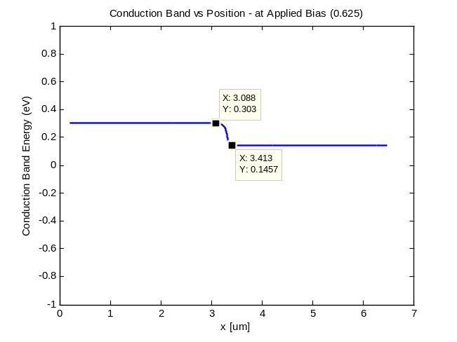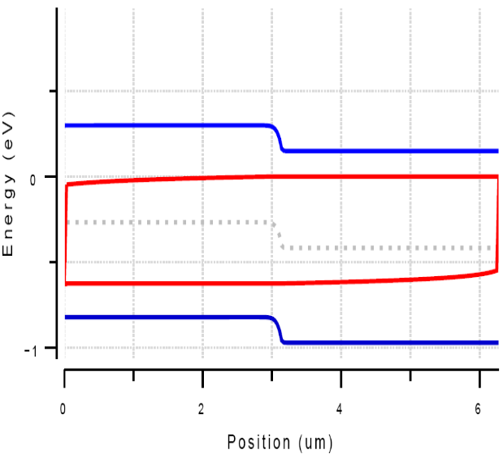

MatLab (Equilibrium) Nano Hub (Equilibrium)

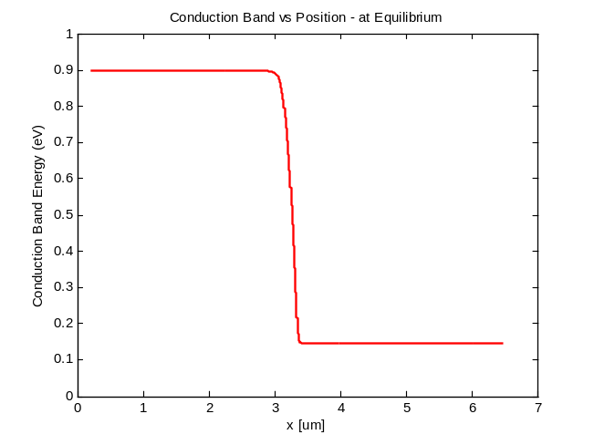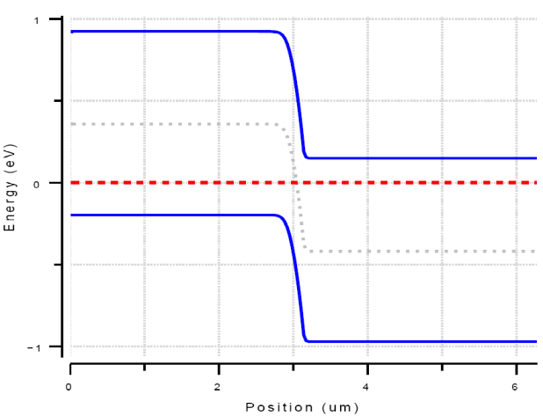

Electron and Hole Densities vs Device Length

MatLab (Equilibrium) Nano Hub (Equilibrium)

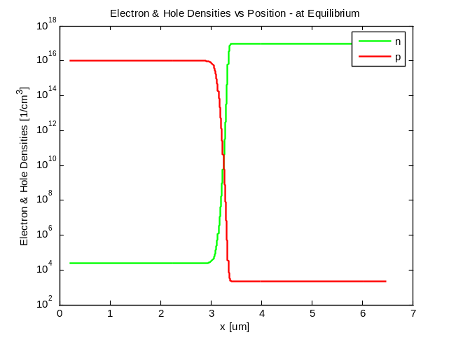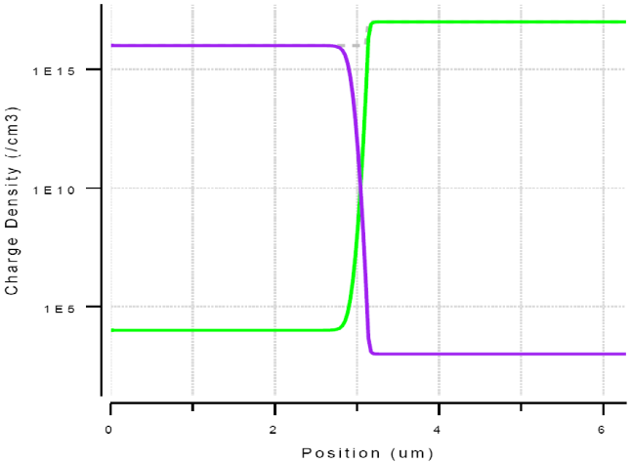

MatLab (Va = 0.625V) Nano Hub (Va = 0.625V)

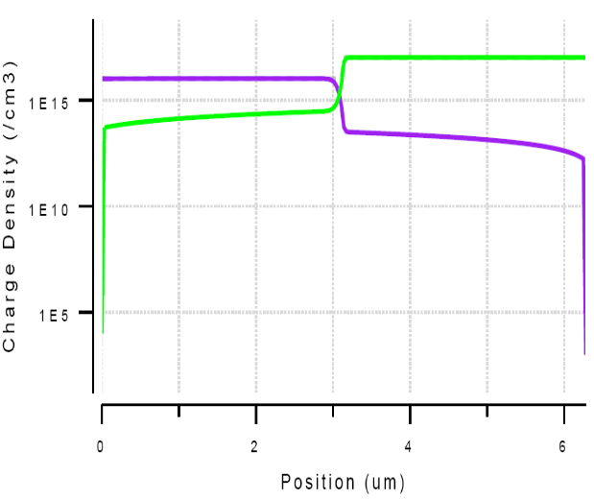
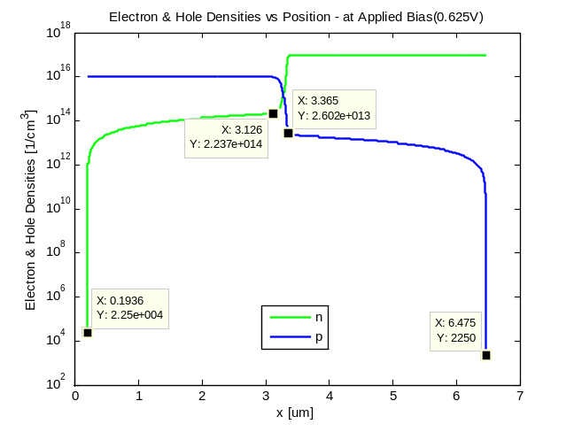

The electron and hole densities calculated at 0.625V in Matlab matches with Nanohub values.

IV Characteristics

Total Current - MatLab (Va = 0.625) Total Current - Nano Hub (Va = 0.625V)

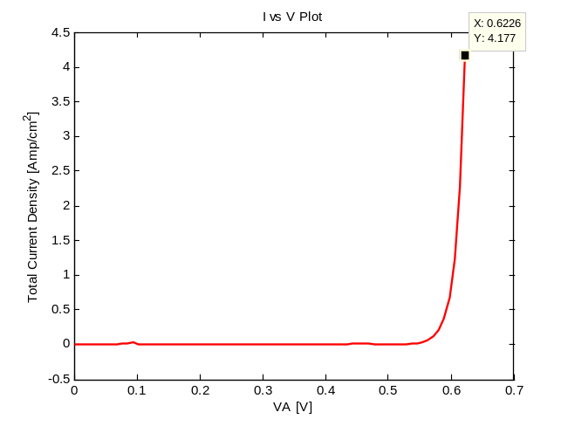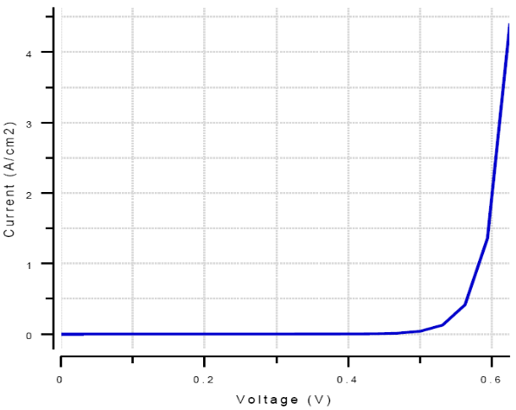
The final current at Va=0.6226 is 4.177 A/cm² . The Matlab and Nanohub values match.

IV Plot for Electron, Hole and Total Current Current Continuity

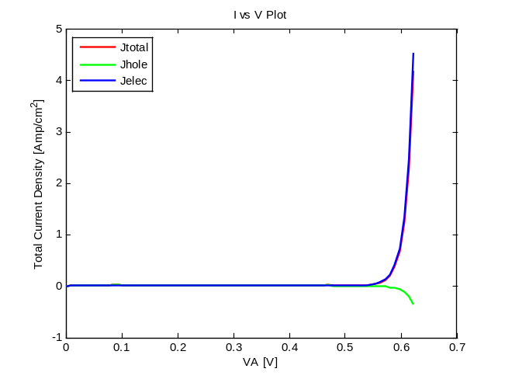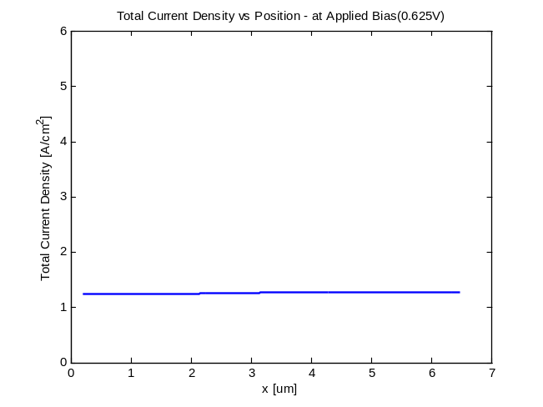
Total Current (Electron + Hole) going
from Cathode to Anode is Constant.

Total Current (sum of electron and Hole currents) for 0.625 V is found to be 4.177 A/cm² which matches with NanoHub Total current for the same bias voltage. The total current is constant through the entire device from cathode to anode as shown in the plot. This proves current continuity.

Electron and Hole Quasi Fermi Levels

MatLab (Va = 0.625V) Nano Hub (Va = 0.625V)

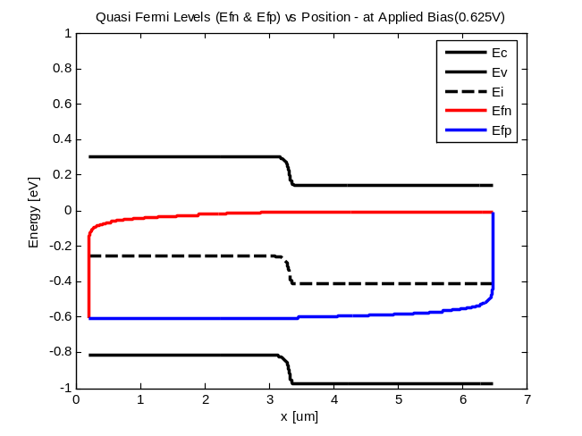

The quasi Fermi levels are calculated as given below
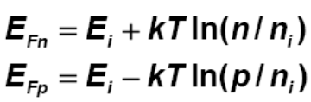

Net Charge Density

MatLab (Va = 0.625V) Nano Hub (Va = 0.625V)

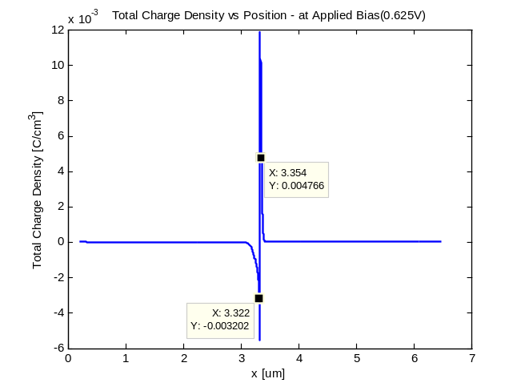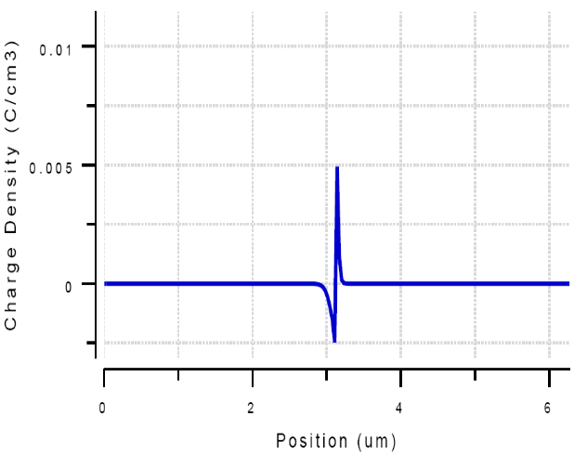

Electric Field

MatLab (Va = 0.625V) Nano Hub (Va = 0.625V)
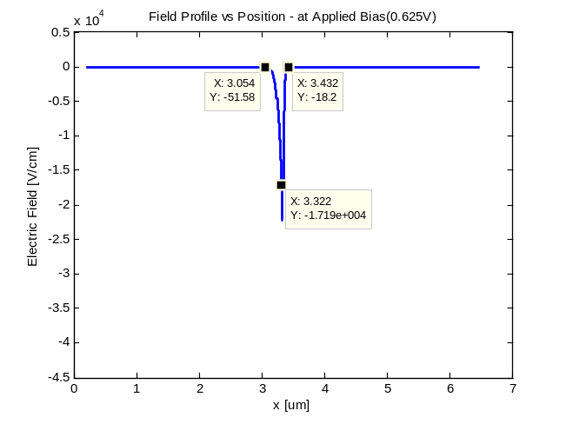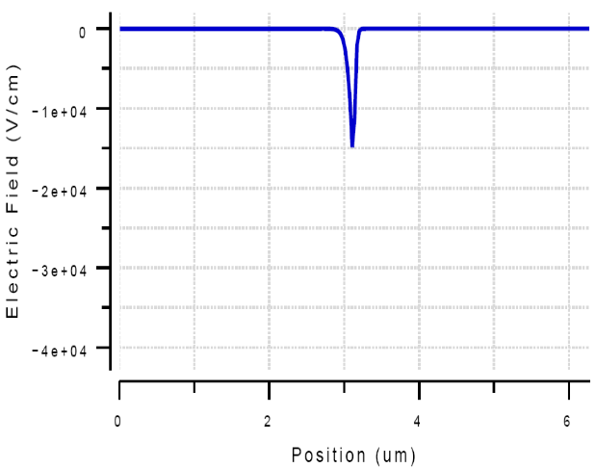

Equilibrium Condition
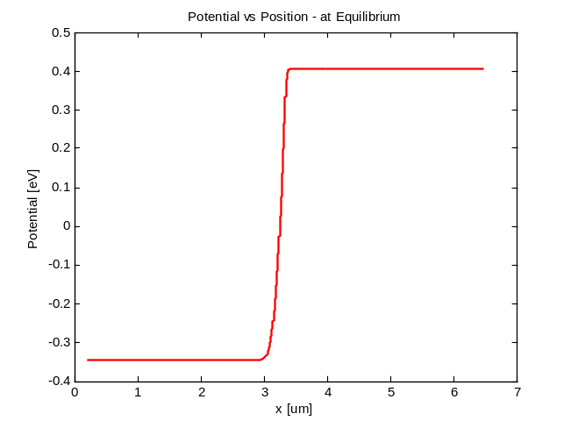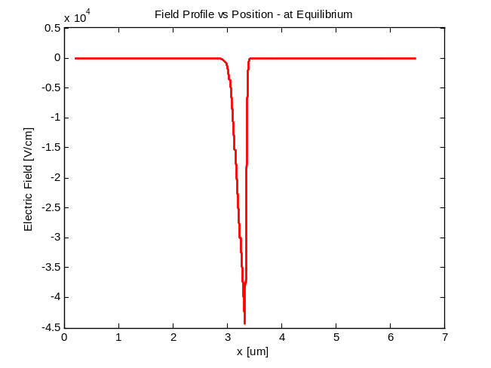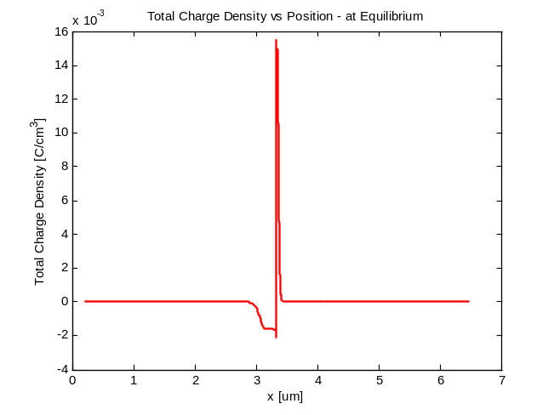
From this project I conclude that I learnt more by designing the simulator myself compared to generating the plots on Nanohub. Nanohub is a wonderful tool to explore device properties and verify results. But designing one’s own simulator gives greater insight into the actual working of the commercial simulator and Nanohub. I can better understand how the equations are solved, how it is better to take smaller biases and finer mesh sizes to solve an equilibrium condition.

APPENDIX A

Results from Larger Bias steps = V_{T}.

The output plots do not match with the actual NanoHub results when larger Bias steps are used for Anode voltage increment. Hence finer bias steps give better results.

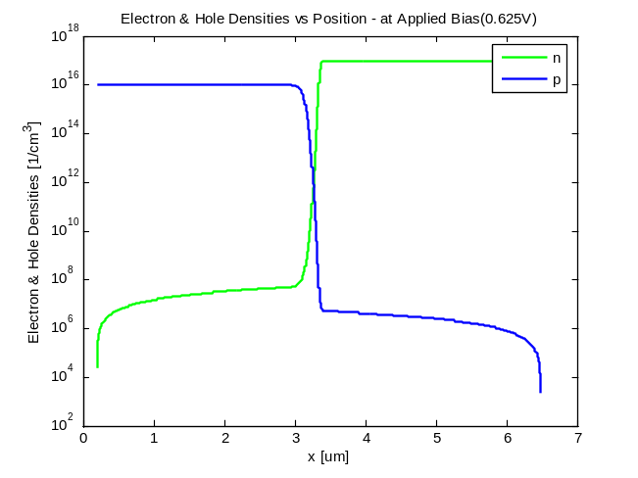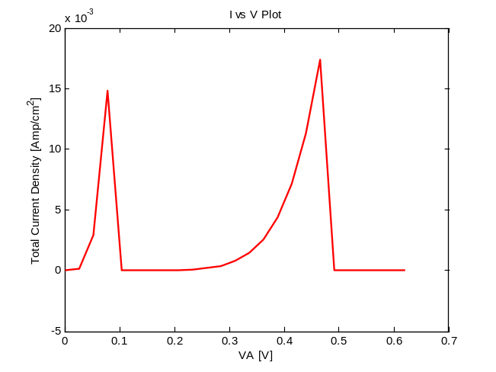
The charge density values are lower than actual The total current plot is distorted and lesser.

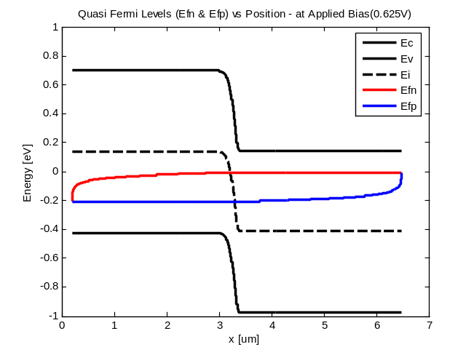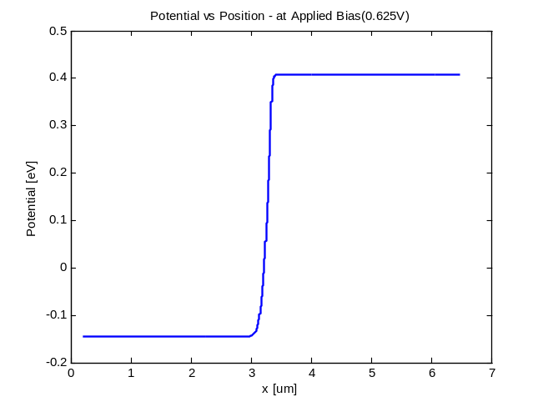
Quasi Fermi levels are lesser than actual Potential values for 0 to 3um is less than actual

APPENDIX B

Matlab Code for 1D drift Diffusion simulator for modeling pn-junction (diodes)

%%%%%%%%%%%%%%%%%%%%%%%%%%%%%%%%%%%%%%%%%%%%%%%%%%%%%%%
%% %%
%% 1D Drift Diffusion Model for pn Diodes %%
%% Equilibrium and Non Equilibrium Solver %%
%% %%
%%%%%%%%%%%%%%%%%%%%%%%%%%%%%%%%%%%%%%%%%%%%%%%%%%%%%%%

clear all;
close all;

% Defining the Fundamental and Material Constants %

q = 1.602E-19; % C or [J/eV]
kb = 1.38E-23; % [J/K]
eps = 1.05E-12; % This includes the eps = 11.7 for Si [F/cm]
T = 300; % [K]
ni = 1.5E10; % Intrinsic carrier concentration [1/cm^3]
Vt = kb*T/q; % [eV]
RNc = 2.8E19; % This is 2.8e20 in the FORTRAN file
TAUN0 = 0.1E-6; % Electron SRH life time
TAUP0 = 0.1E-6; % Hole SRH life time
mun0 = 1500; % Electron Mobility in cm2/V-s
mup0 = 1000; % Hole Mobility in cm2/V-s

dEc = Vt*log(RNc/ni);

% Define Doping Values %

Na = 1E16; % [1/cm^3]
Nd = 1E17; % [1/cm^3]

% Calculate relevant parameters for the simulation %

Vbi = Vt*log(Na*Nd/(ni*ni));
W = sqrt(2*eps*(Na+Nd)*Vbi/(q*Na*Nd)) % [cm]
Wn = W*sqrt(Na/(Na+Nd)) % [cm]
Wp = W*sqrt(Nd/(Na+Nd)) % [cm]
Wone = sqrt(2*eps*Vbi/(q*Na)) % [cm]
E_p = q*Nd*Wn/eps % [V/cm]
Ldn = sqrt(eps*Vt/(q*Nd));
Ldp = sqrt(eps*Vt/(q*Na));
Ldi = sqrt(eps*Vt/(q*ni))

% Calculate relevant parameters in an input file %

% Write to a file
save input_params.txt Na Nd Vbi W Wn Wp E_p Ldn Ldp

%Material_Constants %Define some material constants

% Setting the size of the simulation domain based
% on the analytical results for the width of the depletion regions
% for a simple pn-diode %

x_max = 0;
if(x_max < Wn)
x_max = Wn;
end
if(x_max < Wp)
x_max = Wp;
end
x_max = 20*x_max

% Setting the grid size based on the extrinsic Debye lengths %

dx = Ldn;
if(dx > Ldp)
dx=Ldp;
end
dx = dx/20;

% Calculate the required number of grid points and renormalize dx %

n_max = x_max/dx
n_max = round(n_max);

dx = dx/Ldi; % Renormalize lengths with Ldi

% Set up the doping C(x)=Nd(x)-Na(x) that is normalized with ni %

for i = 1:n_max
if(i <= n_max/2)
dop(i) = - Na/ni;
elseif(i > n_max/2)
dop(i) = Nd/ni;
end
end

% Initialize the potential based on the requirement of charge
% neutrality throughout the whole structure

for i = 1: n_max
zz = 0.5*dop(i);
if(zz > 0)
xx = zz*(1 + sqrt(1+1/(zz*zz)));
elseif(zz < 0)
xx = zz*(1 - sqrt(1+1/(zz*zz)));
end
fi(i) = log(xx);
n(i) = xx;
p(i) = 1/xx;
end

delta_acc = 1E-5; % Preset the Tolerance

%%%%%%%%%%%%%%%%%%%%%%%%%%%%%%%%%%%%%%%%%%%%%%%%%%%%%%%%%%%%%%%%%%%%%%%%%%
%% %%
%% EQUILIBRIUM SOLUTION PART BEGINS %%
%% %%
%%%%%%%%%%%%%%%%%%%%%%%%%%%%%%%%%%%%%%%%%%%%%%%%%%%%%%%%%%%%%%%%%%%%%%%%%%

%(A) Define the elements of the coefficient matrix for the internal nodes and
% initialize the forcing function

dx2 = dx*dx;
for i = 1: n_max
a(i) = 1/dx2;
c(i) = 1/dx2;
b(i) = -(2/dx2+exp(fi(i))+exp(-fi(i)));
f(i) = exp(fi(i)) - exp(-fi(i)) - dop(i) - fi(i)*(exp(fi(i))+exp(-fi(i)));
end

%(B) Define the elements of the coefficient matrix and initialize the forcing
% function at the ohmic contacts

a(1) = 0;
c(1) = 0;
b(1) = 1;
f(1) = fi(1);
a(n_max) = 0;
c(n_max) = 0;
b(n_max) = 1;
f(n_max) = fi(n_max);

%(C) Start the iterative procedure for the solution of the linearized Poisson
% equation using LU decomposition method:

flag_conv = 0; % convergence of the Poisson loop
k_iter= 0;
while(~flag_conv)
k_iter = k_iter + 1;

alpha(1) = b(1);
for i=2:n_max
beta(i)=a(i)/alpha(i-1);
alpha(i)=b(i)-beta(i)*c(i-1);
end

% Solution of Lv = f %

v(1) = f(1);
for i = 2:n_max
v(i) = f(i) - beta(i)*v(i-1);
end

% Solution of U*fi = v %

temp = v(n_max)/alpha(n_max);
delta(n_max) = temp - fi(n_max);
fi(n_max)=temp;
for i = (n_max-1):-1:1 %delta%
temp = (v(i)-c(i)*fi(i+1))/alpha(i);
delta(i) = temp - fi(i);
fi(i) = temp;
end

delta_max = 0;

for i = 1: n_max
xx = abs(delta(i));
if(xx > delta_max)
delta_max=xx;
end
%sprintf('delta_max = %d',delta_max) %'k_iter = %d',k_iter,'

end

%delta_max=max(abs(delta));

% Test convergence and recalculate forcing function and
% central coefficient b if necessary

if(delta_max < delta_acc)
flag_conv = 1;
else
for i = 2: n_max-1
b(i) = -(2/dx2 + exp(fi(i)) + exp(-fi(i)));
f(i) = exp(fi(i)) - exp(-fi(i)) - dop(i) - fi(i)*(exp(fi(i)) + exp(-fi(i)));
end
end
end

xx1(1) = dx*1e4;
for i = 2:n_max-1
Ec(i) = dEc - Vt*fi(i); %Values from the second Node%
ro(i) = -ni*(exp(fi(i)) - exp(-fi(i)) - dop(i));
el_field1(i) = -(fi(i+1) - fi(i))*Vt/(dx*Ldi);
el_field2(i) = -(fi(i+1) - fi(i-1))*Vt/(2*dx*Ldi);
n(i) = exp(fi(i));
p(i) = exp(-fi(i));
xx1(i) = xx1(i-1) + dx*Ldi*1e4;
end

Ec(1) = Ec(2);
Ec(n_max) = Ec(n_max-1);
xx1(n_max) = xx1(n_max-1) + dx*Ldi*1e4;
el_field1(1) = el_field1(2);
el_field2(1) = el_field2(2);
el_field1(n_max) = el_field1(n_max-1);
el_field2(n_max) = el_field2(n_max-1);
nf = n*ni;
pf = p*ni;
ro(1) = ro(2);
ro(n_max) = ro(n_max-1);

figure(1)
plot(xx1, Vt*fi,'r','LineWidth',2)
xlabel('x [um]');
ylabel('Potential [eV]');
title('Potential vs Position - at Equilibrium');

figure(2)
plot(xx1, el_field1,'r','LineWidth',2)
hold on;
plot(xx1, el_field2,'r','LineWidth',2)
xlabel('x [um]');
ylabel('Electric Field [V/cm]');
title('Field Profile vs Position - at Equilibrium');

figure(3)
%plot(xx1, nf,'g','LineWidth',2)
semilogy(xx1, nf,'g','LineWidth',2)
hold on;
%plot(xx1, pf,'r','LineWidth',2)
semilogy(xx1, pf,'r','LineWidth',2)
xlabel('x [um]');
ylabel('Electron & Hole Densities [1/cm^3]');
title('Electron & Hole Densities vs Position - at Equilibrium');
legend('n','p');
%axis([0 6.75 0 10.2e17])

figure(4)
%plot(xx1, ro,'r','LineWidth',2)
plot(xx1, q*ro,'r','LineWidth',2)
xlabel('x [um]');
%ylabel('Total Charge Density [1/cm^3]');
ylabel('Total Charge Density [C/cm^3]');
title('Total Charge Density vs Position - at Equilibrium');
%axis([0.5 5 -3e17 8e17])

figure(5)
plot(xx1, Ec,'r','LineWidth',2)
xlabel('x [um]');
%ylabel('Total Charge Density [1/cm^3]');
ylabel('Conduction Band Energy (eV)');
title('Conduction Band vs Position - at Equilibrium');

%%%%%%%%%%%%%%%%%%%%%%%%%%%%%%%%%%%%%%%%%%%%%%%%%%%%%%%%%%%%%%%%%%%%%%%%%%
%% END OF EQUILIBRIUM SOLUTION PART %%
%%%%%%%%%%%%%%%%%%%%%%%%%%%%%%%%%%%%%%%%%%%%%%%%%%%%%%%%%%%%%%%%%%%%%%%%%%

%%%%%%%%%%%%%%%%%%%%%%%%%%%%%%%%%%%%%%%%%%%%%%%%%%%%%%%%%%%%%%%%%%%%%%%%%%
%% %%
%% NON-EQUILIBRIUM SOLUTION PART BEGINS %%
%% %%
%%%%%%%%%%%%%%%%%%%%%%%%%%%%%%%%%%%%%%%%%%%%%%%%%%%%%%%%%%%%%%%%%%%%%%%%%%

%%%%%%%%%%%%%%%%%%%%%%%%%%%%%%%%%%%%%%%%%%%%%%%%%%%%%%%%%%%%%%%%%%%%%%%%%%
%% 1. Calculate Low filed mobility %%
%%%%%%%%%%%%%%%%%%%%%%%%%%%%%%%%%%%%%%%%%%%%%%%%%%%%%%%%%%%%%%%%%%%%%%%%%%

%% Prameters for Low field mobility calculation %%

TL = 300; % Temp in Kelvin
N = Na + Nd; % Local (total) impurity concentration

MU1N.CAUG = 55.24; % cm2/(V.s)
MU2N.CAUG = 1429.23; % cm2/(V.s)
ALPHAN.CAUG = 0.0; % unitless
BETAN.CAUG = -2.3; % unitless
GAMMAN.CAUG = -3.8; % unitless
DELTAN.CAUG = 0.73; % unitless
NCRITN.CAUG = 1.072*10^17; % cm-3

MU1P.CAUG = 49.7; % cm2/(V.s)
MU2P.CAUG = 479.37; % cm2/(V.s)
ALPHAP.CAUG = 0.0; % unitless
BETAP.CAUG = -2.2; % unitless
GAMMAP.CAUG = 13.7; % unitless
DELTAP.CAUG = 0.70; % unitless
NCRITP.CAUG = 1.606*10^17; % cm-3
BETAN = 2.0;
BETAP = 1.0;

% % mun0 = ( MU1N.CAUG*((TL/300)^ALPHAN.CAUG) ) ...
% % + (( (MU2N.CAUG*((TL/300)^BETAN.CAUG)) - (MU1N.CAUG*((TL/300)^ALPHAN.CAUG)) ) ...
% % / ( 1 + ((TL/300)^GAMMAN.CAUG) * ((N/NCRITN.CAUG)^DELTAN.CAUG) ))
% %
% %
% % mup0 = ( MU1P.CAUG*((TL/300)^ALPHAP.CAUG) ) ...
% % + (( (MU2P.CAUG*((TL/300)^BETAP.CAUG)) - (MU1P.CAUG*((TL/300)^ALPHAP.CAUG)) ) ...
% % / ( 1 + ((TL/300)^GAMMAP.CAUG) * ((N/NCRITP.CAUG)^DELTAP.CAUG) ))

VSATN = (2.4*10^7) / (1 + 0.8*exp(TL/600)); % Saturation Velocity of Electrons
VSATP = VSATN; % Saturation Velocity of Holes

%%%%%%%%%%%%%%%%%%% END of Low Field Mobility Calculation %%%%%%%%%%%%%%%%

%%%%%%%%%%%%%%%%%%%%%%%%%%%%%%%%%%%%%%%%%%%%%%%%%%%%%%%%%%%%%%%%%%%%%%%%%%
%% 2. Start the main Loop to increment the Anode voltage by Vt=KbT/q %%
%% till it reaches 0.625V. %%
%%%%%%%%%%%%%%%%%%%%%%%%%%%%%%%%%%%%%%%%%%%%%%%%%%%%%%%%%%%%%%%%%%%%%%%%%%

vindex=0;

for VA = 0:0.33*Vt:0.625 % Start VA increment loop
VA

Each_Step = 0.33*Vt
Total_Steps = 0.625/(0.33*Vt)
vindex = vindex +1
Vplot(vindex) = VA;

fi(1) = fi(1) + VA; % Apply potential to Anode (1st node)
%fi(1)

flag_conv2 = 0; % Convergence of the Poisson loop
k_itern= 0;

%% Initialize the First and Last Node for Poisson's eqn
a(1) = 0;
c(1) = 0;
b(1) = 1;
f(1) = fi(1);
a(n_max) = 0;
c(n_max) = 0;
b(n_max) = 1;
f(n_max) = fi(n_max);

%%%%%%%%%%%%%%%%%%%%%%%%%%%%%%%%%%%%%%%%%%%%%%%%%%%%%%%%%%%%%%%%%%%%%%%
%% 3. Start the Poisson equation solver loop to calculate the %%
%% potential for each Anode voltage increase %%
%%%%%%%%%%%%%%%%%%%%%%%%%%%%%%%%%%%%%%%%%%%%%%%%%%%%%%%%%%%%%%%%%%%%%%%

while(~flag_conv2) % Start Poisson's eqn

k_itern = k_itern + 1

%%%%%%%%%%%%%%%%%%%%%%%%%%%%%%%%%%%%%%%%%%%%%%%%%%%%%%%%%%%%%%%%%%%%%%%
%% 3.1 . Calculate Field Dependant Mobility for each value of 'fi' %%
%% at each node point of the PN diode. %%
%%%%%%%%%%%%%%%%%%%%%%%%%%%%%%%%%%%%%%%%%%%%%%%%%%%%%%%%%%%%%%%%%%%%%%%

%%% To test with Constant Mobility without field dependancy.
% % for i = 1:n_max % Start Loop for Field Dep Mobility
% % mup(i) = mup0;
% % mun(i) = mun0;
% % end

%% Calculate the Electric Field at each Node
for i = 2:n_max-1
Ef(i) = abs(fi(i) - fi(i+1))*Vt/(dx*Ldi);
end

Ef(1) = Ef(2);
Ef(n_max) = Ef(n_max-1);

%% Calculate the Field Dependant Mobility at each Node
for i = 1:n_max

pdeno = (mup0 * Ef(i) / VSATP) ^ BETAP;
mup(i) = mup0 * ( (1/(1 + pdeno)) ^(1/BETAP));

ndeno = (mun0 * Ef(i) / VSATN) ^ BETAN;
mun(i) = mun0 * ( (1/(1 + ndeno)) ^(1/BETAN));

end

mup(1) = mup(2);
mup(n_max) = mup(n_max-1);

mun(1) = mun(2);
mun(n_max) = mun(n_max-1);

%%%%%%%%%%% END of FIELD Dependant Mobility Calculation %%%%%%%%%%%

%%%%%%%%%%%%%%%%%%%%%%%%%%%%%%%%%%%%%%%%%%%%%%%%%%%%%%%%%%%%%%%%%%%%%%%%%%%%%%%%%
%% 3.2 Solve Continuity Equation for Electron and Holes using LU Decomposition %%
%%%%%%%%%%%%%%%%%%%%%%%%%%%%%%%%%%%%%%%%%%%%%%%%%%%%%%%%%%%%%%%%%%%%%%%%%%%%%%%%%

%(A) Define the elements of the coefficient matrix and initialize the forcing
% function at the ohmic contacts for ELECTRON and HOLE Continuity Eqns

an(1) = 0; %Co-ef for electron at Anode
bn(1) = 1; %Co-ef for electron at Anode
cn(1) = 0; %Co-ef for electron at Anode
ap(1) = 0; %Co-ef for hole at Anode
bp(1) = 1; %Co-ef for hole at Anode
cp(1) = 0; %Co-ef for hole at Anode
%fnp(1) = (Ldi*Ldi*dx2/Vt) * ( p(1)*n(1) - 1 ) / ( TAUP0*(n(1) + 1 ) + TAUN0*(p(1) + 1 ) );
fn(1) = n(1);
fp(1) = p(1);

an(n_max) = 0; %Co-ef for electron at Cathode
bn(n_max) = 1; %Co-ef for electron at Cathode
cn(n_max) = 0; %Co-ef for electron at Cathode
ap(n_max) = 0; %Co-ef for hole at Cathode
bp(n_max) = 1; %Co-ef for hole at Cathode
cp(n_max) = 0; %Co-ef for hole at Cathode
%fnp(n_max) = (Ldi*Ldi*dx2/Vt) * ( p(n_max)*n(n_max) - 1 ) / ( TAUP0*(n(n_max) + 1) + TAUN0*(p(n_max) + 1) );
fn(n_max) = n(n_max);
fp(n_max) = p(n_max);

%(B) Define the elements of the coefficient matrix for the internal nodes and
% initialize the forcing function

for i = 2: n_max-1
munim1by2 = (mun(i-1)+mun(i))/2;
munip1by2 = (mun(i)+mun(i+1))/2;
mupim1by2 = (mup(i-1)+mup(i))/2;
mupip1by2 = (mup(i)+mup(i+1))/2;

%% Co-efficients for HOLE Continuity eqn
cp(i) = mupip1by2 * BER(fi(i) - fi(i+1));
ap(i) = mupim1by2 * BER(fi(i) - fi(i-1));
bp(i) = -( mupim1by2 * BER(fi(i-1) - fi(i)) + mupip1by2 * BER(fi(i+1) - fi(i)));
%% Co-efficients for ELECTRON Continuity eqn
cn(i) = munip1by2 * BER(fi(i+1) - fi(i));
an(i) = munim1by2 * BER(fi(i-1) - fi(i));
n(i) = -( munim1by2 * BER(fi(i) - fi(i-1)) + munip1by2 * BER(fi(i) - fi(i+1)));

%% Forcing Function for ELECTRON and HOLE Continuity eqns
fn(i) = (Ldi*Ldi*dx2/Vt) * ( p(i)*n(i) - 1 ) / ( TAUP0*(n(i) + 1) + TAUN0*(p(i)+1));
fp(i) = (Ldi*Ldi*dx2/Vt) * ( p(i)*n(i) - 1 ) / ( TAUP0*(n(i) + 1) + TAUN0*(p(i)+1));
end

%(C) Start the iterative procedure for the solution of the linearized Continuity
% equation for "ELECTRONS" using LU decomposition method:

alphan(1) = bn(1);
for i=2:n_max
betan(i)=an(i)/alphan(i-1);
alphan(i)=bn(i)-betan(i)*cn(i-1);
end

% Solution of Lv = f %

vn(1) = fn(1);
for i = 2:n_max
vn(i) = fn(i) - betan(i)*vn(i-1);
end

% Solution of U*fi = v %

tempn = vn(n_max)/alphan(n_max);
%deltan(n_max) = tempn - n(n_max);
n(n_max)=tempn;
for i = (n_max-1):-1:1 %delta%
tempn = (vn(i)-cn(i)*n(i+1))/alphan(i);
% deltan(i) = tempn - n(i);
n(i) = tempn;
end

%%%%%%%%%%%%%%%%%%%%%%% END of ELECTRON Continuty Solver %%%%%%%%%%%

%(D) Start the iterative procedure for the solution of the linearized Continuity
% equation for "HOLES" using LU decomposition method:

alphap(1) = bp(1);
for i=2:n_max
betap(i)=ap(i)/alphap(i-1);
alphap(i)=bp(i)-betap(i)*cp(i-1);
end

% Solution of Lv = f %

vp(1) = fp(1);
for i = 2:n_max
vp(i) = fp(i) - betap(i)*vp(i-1);
end

% Solution of U*fi = v %

tempp = vp(n_max)/alphap(n_max);
%deltap(n_max) = tempp - p(n_max);
p(n_max)=tempp;
for i = (n_max-1):-1:1 %delta%
tempp = (vp(i)-cp(i)*p(i+1))/alphap(i);
% deltap(i) = tempp - p(i);
p(i) = tempp;
end

%%%%%%%%%%%%%%%%%%%%%%% END of HOLE Continuty Solver %%%%%%%%%%%

%%%%%%%%%%%%%%%%%%%%%%%%%%%%%%%%%%%%%%%%%%%%%%%%%%%%%%%%%%%%%%%%%%%%
%% 3.3 Calculate potential fi again with new values of "n" and "p"%%
%% and check for convergence %%
%%%%%%%%%%%%%%%%%%%%%%%%%%%%%%%%%%%%%%%%%%%%%%%%%%%%%%%%%%%%%%%%%%%%

% Recalculate forcing function and central coefficient b for fi

for i = 2: n_max-1
b(i) = -(2/dx2 + n(i) + p(i));
f(i) = n(i) - p(i) - dop(i) - (fi(i)*(n(i) + p(i)));
%% here values of n(i) and p(i) are used in place of exp(fi(i))
end

% Solve for Updated potential given the new value of Forcing
% Function using LU decomposition

alpha(1) = b(1);
for i=2:n_max
beta(i)=a(i)/alpha(i-1);
alpha(i)=b(i)-beta(i)*c(i-1);
end

% Solution of Lv = f %

v(1) = f(1);
for i = 2:n_max
v(i) = f(i) - beta(i)*v(i-1);
end

% Solution of U*fi = v %

temp = v(n_max)/alpha(n_max);
delta(n_max) = temp - fi(n_max);
fi(n_max)=temp;
for i = (n_max-1):-1:1 %delta%
temp = (v(i)-c(i)*fi(i+1))/alpha(i);
delta(i) = temp - fi(i);
fi(i) = temp;
end

delta_max = 0;

for i = 1: n_max
xx = abs(delta(i));
if(xx > delta_max)
delta_max=xx; %% Calculate the max error
end
end

%delta_max=max(abs(delta));

% Test convergence and start the loop if necessary else increase
% the applied potential
%% delta_max
if(delta_max < delta_acc)
flag_conv2 = 1;
end

end % End of WHILE Loop for Poisson's eqn solver

%%%%%%%%%%%%%%%%%%%%%%%%%%%%%%%%%%%%%%%%%%%%%%%%%%%%%%%%%%%%%%%%%%%%%%%%%%
%% CALCULATE CURRENT %%
%%%%%%%%%%%%%%%%%%%%%%%%%%%%%%%%%%%%%%%%%%%%%%%%%%%%%%%%%%%%%%%%%%%%%%%%%%

% Electron Current
for i=2:n_max-1
Jnim1by2(vindex,i) = (q*mun(i)*Vt/(dx*Ldi)) * ni*( n(i)*BER(fi(i)-fi(i-1)) \
- n(i-1)*BER(fi(i-1)-fi(i)) );
Jnip1by2(vindex,i) = (q*mun(i)*Vt/(dx*Ldi)) * ni*( n(i+1)*BER(fi(i+1)-fi(i)) \
- n(i)*BER(fi(i)-fi(i+1)) );
Jelec(vindex,i) = (Jnip1by2(vindex,i) + Jnim1by2(vindex,i))/2;

% % % Electron Current with only one node
% % Jnim1by2 = (q*mun(2)*Vt/dx*Ldi) * ( (n(2)*ni)*BER((fi(2)-fi(2-1)))
- (n(2-1)*ni)*BER((fi(2-1)-fi(2))) );
% % Jnip1by2 = (q*mun(2)*Vt/dx*Ldi) * ( (n(2+1)*ni)*BER((fi(2+1)-fi(2)))
- (n(2)*ni)*BER((fi(2)-fi(2+1))) );
% % Jelec(vindex) = (Jnip1by2 + Jnim1by2)/2;

% Hole Current
% % Jpim1by2 = (q*mup(2)*Vt/dx*Ldi) * ( (p(2)*ni)*BER((fi(2-1)-fi(2)))
- (p(2-1)*ni)*BER((fi(2)-fi(2-1))) );
% % Jpip1by2 = (q*mup(2)*Vt/dx*Ldi) * ( (p(2+1)*ni)*BER((fi(2)-fi(2+1)))
- (p(2)*ni)*BER((fi(2+1)-fi(2))) );
% % Jhole(vindex) = (Jpip1by2 + Jpim1by2)/2;

Jpim1by2(vindex,i) = (q*mup(i)*Vt/(dx*Ldi)) * ni*( p(i)*BER((fi(i-1)-fi(i))) \
- p(i-1)*BER((fi(i)-fi(i-1))) );
Jpip1by2(vindex,i) = (q*mup(i)*Vt/(dx*Ldi)) * ni*( p(i+1)*BER((fi(i)-fi(i+1))) \
- p(i)*BER((fi(i+1)-fi(i))) );
Jhole(vindex,i) = (Jpip1by2(vindex,i) + Jpim1by2(vindex,i))/2;

end

Jtotal = Jelec + Jhole;
%% Jtotal(vindex) = Jelec;

end % End of main FOR loop for VA increment.

%%%%%%%%%%%%%%%%%%%%%%%%%%%%%%%%%%%%%%%%%%%%%%%%%%%%%%%%%%%%%%%%%%%%%%%%%%
%% END OF NON-EQUILIBRIUM SOLUTION PART %%
%%%%%%%%%%%%%%%%%%%%%%%%%%%%%%%%%%%%%%%%%%%%%%%%%%%%%%%%%%%%%%%%%%%%%%%%%%

% Write the results of the simulation in files %

xx1(1) = dx*1e4;
for i = 2:n_max-1
Ec(i) = dEc - Vt*fi(i); %Values from the second Node%
ro(i) = -ni*(n(i) - p(i) - dop(i));
el_field1(i) = -(fi(i+1) - fi(i))*Vt/(dx*Ldi);
el_field2(i) = -(fi(i+1) - fi(i-1))*Vt/(2*dx*Ldi);
xx1(i) = xx1(i-1) + dx*Ldi*1e4;
end

Jtotal(:,1) = Jtotal(:,2);
Jelec(:,1) = Jelec(:,2);
Jhole(:,1) = Jhole(:,2);
Jtotal(:,n_max) = Jtotal(:,(n_max-1));
Jelec(:,n_max) = Jelec(:,(n_max-1));
Jhole(:,n_max) = Jhole(:,(n_max-1));

Ec(1) = Ec(2);
Ec(n_max) = Ec(n_max-1);
xx1(n_max) = xx1(n_max-1) + dx*Ldi*1e4;
el_field1(1) = el_field1(2);
el_field2(1) = el_field2(2);
el_field1(n_max) = el_field1(n_max-1);
el_field2(n_max) = el_field2(n_max-1);
nf = n*ni;
pf = p*ni;
ro(1) = ro(2);
ro(n_max) = ro(n_max-1);

%% Calculate Quasi Fermi Level - Efn Efp
for i = 1:n_max
Ei(i) = Ec(i) - 0.56;
Efn(i) = Ei(i) + Vt*log(nf(i)/ni);
Efp(i) = Ei(i) - Vt*log(pf(i)/ni);
end
Ev = Ec - 1.12;

figure(14)
plot(xx1, Ec,'black','LineWidth',2.5);
hold on;
plot(xx1, Ev,'black','LineWidth',2.5);
hold on;
plot(xx1, Ei,'--black','LineWidth',2.5);
hold on;
plot(xx1, Efn,'r','LineWidth',2.5);
hold on;
plot(xx1, Efp,'b','LineWidth',2.5);
xlabel('x [um]');
ylabel('Energy [eV]');
title('Quasi Fermi Levels (Efn & Efp) vs Position - at Applied Bias(0.625V)');
legend('Ec','Ev','Ei','Efn','Efp');
axis([0 7 -1 1]);

figure(6)
plot(xx1, Ec,'b','LineWidth',2)
xlabel('x [um]');
ylabel('Conduction Band Energy (eV)');
title('Conduction Band vs Position - at Applied Bias (0.625)');

figure(7)
plot(xx1, Vt*fi,'b','LineWidth',2)
xlabel('x [um]');
ylabel('Potential [eV]');
title('Potential vs Position - at Applied Bias(0.625V)');

figure(8)
plot(xx1, el_field1,'b','LineWidth',2)
hold on;
plot(xx1, el_field2,'b','LineWidth',2)
xlabel('x [um]');
ylabel('Electric Field [V/cm]');
title('Field Profile vs Position - at Applied Bias(0.625V)');

figure(9)
%plot(xx1, nf,'g','LineWidth',2)
semilogy(xx1, nf,'g','LineWidth',2)
hold on;
%plot(xx1, pf,'b','LineWidth',2)
semilogy(xx1, pf,'b','LineWidth',2)
xlabel('x [um]');
ylabel('Electron & Hole Densities [1/cm^3]');
title('Electron & Hole Densities vs Position - at Applied Bias(0.625V)');
legend('n','p');
%axis([0 6.75 0 10.2e17])

figure(10)
%plot(xx1, ro,'b','LineWidth',2)
plot(xx1, q*ro,'b','LineWidth',2)
xlabel('x [um]');
%ylabel('Total Charge Density [1/cm^3]');
ylabel('Total Charge Density [C/cm^3]');
title('Total Charge Density vs Position - at Applied Bias(0.625V)');
%axis([0.5 5 -3e17 8e17])

figure(11)
plot(Vplot, Jtotal(:,2),'r','LineWidth',2)
hold on
plot(Vplot, Jhole(:,2),'g','LineWidth',2)
hold on
plot(Vplot, Jelec(:,2),'b','LineWidth',2)
xlabel('VA [V]');
ylabel('Total Current Density [Amp/cm^2]');
title('I vs V Plot');
legend('Jtotal','Jhole','Jelec','2');

figure(12)
plot(Vplot, Jtotal(:,2),'r','LineWidth',2)
xlabel('VA [V]');
ylabel('Total Current Density [Amp/cm^2]');
title('I vs V Plot');
%legend('Jtotal','Jhole','Jelec','2');

figure(13)
plot(xx1,Jtotal((round((Total_Steps)-1)),:),'b','LineWidth',2)
xlabel('x [um]');
ylabel('Total Current Density [A/cm^2]');
title('Total Current Density vs Position - at Applied Bias(0.625V)');
axis([0 7 0 6]);

%figure(5)
%plot(xx1, n)
%hold all
%plot(xx1, p)

save cond_band xx1 Ec;
save tot_charge xx1 ro;
save el_field xx1 el_field1 el_field2;
save np_data xx1 nf pf;
save pot_1 fi;

