**Open GeniE and creating a workspace**

GenieRules.Compatibility.version = "V8.4-06";

GenieRules.Tolerances.useTolerantModelling = true;

GenieRules.Tolerances.angleTolerance = 2 deg;

GenieRules.Meshing.autoSimplifyTopology = true;

GenieRules.Meshing.eliminateInternalEdges = true;

GenieRules.BeamCreation.DefaultCurveOffset = ReparameterizedBeamCurveOffset();

GenieRules.Transformation.DefaultConnectedCopy = false;

GenieRules.Units.setOutputUnits("m", "kN", "delC");

GenieRules.Units.setInputUnit(Length, "m");

GenieRules.Units.setInputUnit(Force, "kN");

GenieRules.Units.setInputUnit(TempDiff, "delC");

**Creating guiding points**

// This is input from user – not to be changed by GaFra for now.

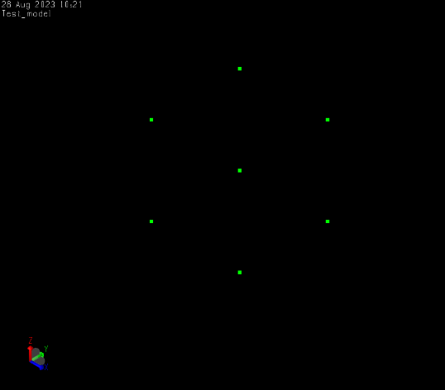

Point1 = Point(0, 0, 0);

Point2 = Point(0, 0, 5);

Point3 = Point1.copyTranslate(Vector3d(0, 5, 0));

Point4 = Point2.copyTranslate(Vector3d(0, 5, 0));

Point5 = Point1.copyTranslate(Vector3d(5, 0, 0));

Point6 = Point2.copyTranslate(Vector3d(5, 0, 0));

Point7 = Point3.copyTranslate(Vector3d(5, 0, 0));

Point8 = Point4.copyTranslate(Vector3d(5, 0, 0));

**Importing section sizes from library**

// The input of members and section sizes here can be huge. GeniE has its own library of sections based on standard sizes  
// User can also create their own sections

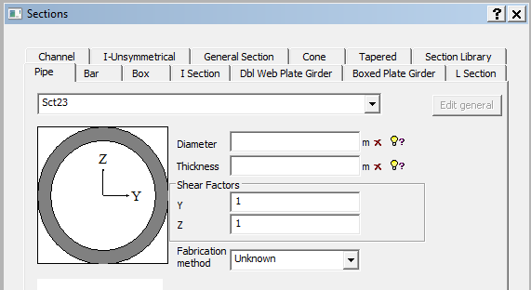

// This library shall be used from GaFra to select appropriate section sizes for the code checks – Parameter 1

UB_127x76x13 = ISection(0.127 m, 0.076 m, 0.004 m, 0.0076 m, 0.0076 m);

UB_127x76x13.description = "BS4 Part1 1993 lib: UB 127x76x13";

UB_127x76x13.libraryGeneralSection = GeneralSection(0.00165 m^2, 2.85e-08 m^4, 4.73e-06 m^4, 5.57e-07 m^4, 0 m^4, 4.212430596e-06 m^3, 7.46e-05 m^3, 1.47e-05 m^3, 0.00075648734 m^2, 0.0004500664202 m^2, 0 m, 0 m, 4.207594209e-05 m^3, 1.1198e-05 m^3, 8.42e-05 m^3, 2.26e-05 m^3);

UB_152x89x16 = ISection(0.1524 m, 0.0887 m, 0.0045 m, 0.0077 m, 0.0076 m);

UB_152x89x16.description = "BS4 Part1 1993 lib: UB 152x89x16";

UB_152x89x16.libraryGeneralSection = GeneralSection(0.00203 m^2, 3.56e-08 m^4, 8.34e-06 m^4, 8.98e-07 m^4, 0 m^4, 5.260389739e-06 m^3, 0.000109 m^3, 2.02e-05 m^3, 0.0008920729847 m^2, 0.0006091595876 m^2, 0 m, 0 m, 6.162785522e-05 m^3, 1.54920845e-05 m^3, 0.000123 m^3, 3.12e-05 m^3);

UB_178x102x19 = ISection(0.1778 m, 0.1012 m, 0.0048 m, 0.0079 m, 0.0076 m);

UB_178x102x19.description = "BS4 Part1 1993 lib: UB 178x102x19";

UB_178x102x19.libraryGeneralSection = GeneralSection(0.00243 m^2, 4.41e-08 m^4, 1.356e-05 m^4, 1.37e-06 m^4, 0 m^4, 6.456501978e-06 m^3, 0.000153 m^3, 2.7e-05 m^3, 0.001043716625 m^2, 0.0007601021143 m^2, 0 m, 0 m, 8.562807727e-05 m^3, 2.0693404e-05 m^3, 0.000171 m^3, 4.16e-05 m^3);

UB_203x102x23 = ISection(0.2032 m, 0.1018 m, 0.0054 m, 0.0093 m, 0.0076 m);

UB_203x102x23.description = "BS4 Part1 1993 lib: UB 203x102x23";

UB_203x102x23.libraryGeneralSection = GeneralSection(0.00294 m^2, 7.02e-08 m^4, 2.105e-05 m^4, 1.64e-06 m^4, 0 m^4, 8.985140555e-06 m^3, 0.000207 m^3, 3.22e-05 m^3, 0.001230566781 m^2, 0.000971196143 m^2, 0 m, 0 m, 0.0001170345134 m^3, 2.47674e-05 m^3, 0.000234 m^3, 4.98e-05 m^3);

UC_152x152x23 = ISection(0.1524 m, 0.1522 m, 0.0058 m, 0.0068 m, 0.0076 m);

UC_152x152x23.description = "BS4 Part1 1993 lib: UC 152x152x23";

UC_152x152x23.libraryGeneralSection = GeneralSection(0.00292 m^2, 4.63e-08 m^4, 1.25e-05 m^4, 4e-06 m^4, 0 m^4, 7.825149035e-06 m^3, 0.000164 m^3, 5.26e-05 m^3, 0.001360918593 m^2, 0.0007966502758 m^2, 0 m, 0 m, 9.099080994e-05 m^3, 3.9963882e-05 m^3, 0.000182 m^3, 8.02e-05 m^3);

UC_152x152x30 = ISection(0.1576 m, 0.1529 m, 0.0065 m, 0.0094 m, 0.0076 m);

UC_152x152x30.description = "BS4 Part1 1993 lib: UC 152x152x30";

UC_152x152x30.libraryGeneralSection = GeneralSection(0.00383 m^2, 1.05e-07 m^4, 1.748e-05 m^4, 5.6e-06 m^4, 0 m^4, 1.346608859e-05 m^3, 0.000222 m^3, 7.33e-05 m^3, 0.00189259744 m^2, 0.0009175450618 m^2, 0 m, 0 m, 0.0001238324139 m^3, 5.5672301e-05 m^3, 0.000248 m^3, 0.000112 m^3);

UC_152x152x37 = ISection(0.1618 m, 0.1544 m, 0.008 m, 0.0115 m, 0.0076 m);

UC_152x152x37.description = "BS4 Part1 1993 lib: UC 152x152x37";

UC_152x152x37.libraryGeneralSection = GeneralSection(0.00471 m^2, 1.92e-07 m^4, 2.21e-05 m^4, 7.06e-06 m^4, 0 m^4, 2.037464754e-05 m^3, 0.000273 m^3, 9.15e-05 m^3, 0.002332210462 m^2, 0.001145461171 m^2, 0 m, 0 m, 0.0001543800579 m^3, 6.964856e-05 m^3, 0.000309 m^3, 0.00014 m^3);

UC_203x203x46 = ISection(0.2032 m, 0.2036 m, 0.0072 m, 0.011 m, 0.0102 m);

UC_203x203x46.description = "BS4 Part1 1993 lib: UC 203x203x46";

UC_203x203x46.libraryGeneralSection = GeneralSection(0.00587 m^2, 2.22e-07 m^4, 4.568e-05 m^4, 1.548e-05 m^4, 0 m^4, 2.401516542e-05 m^3, 0.00045 m^3, 0.000152 m^3, 0.002957356604 m^2, 0.001322292661 m^2, 0 m, 0 m, 0.0002487193139 m^3, 0.000115169816 m^3, 0.000497 m^3, 0.000231 m^3);

UC_203x203x52 = ISection(0.2062 m, 0.2043 m, 0.0079 m, 0.0125 m, 0.0102 m);

UC_203x203x52.description = "BS4 Part1 1993 lib: UC 203x203x52";

UC_203x203x52.libraryGeneralSection = GeneralSection(0.00663 m^2, 3.18e-07 m^4, 5.259e-05 m^4, 1.778e-05 m^4, 0 m^4, 3.076269878e-05 m^3, 0.00051 m^3, 0.000174 m^3, 0.003370563344 m^2, 0.001464388136 m^2, 0 m, 0 m, 0.0002836973674 m^3, 0.0001318463678 m^3, 0.000567 m^3, 0.000264 m^3);

UC_203x203x60 = ISection(0.2096 m, 0.2058 m, 0.0094 m, 0.0142 m, 0.0102 m);

UC_203x203x60.description = "BS4 Part1 1993 lib: UC 203x203x60";

UC_203x203x60.libraryGeneralSection = GeneralSection(0.00764 m^2, 4.72e-07 m^4, 6.125e-05 m^4, 2.065e-05 m^4, 0 m^4, 4.055728897e-05 m^3, 0.000584 m^3, 0.000201 m^3, 0.003848446 m^2, 0.001754982899 m^2, 0 m, 0 m, 0.0003280375219 m^3, 0.000152356776 m^3, 0.000656 m^3, 0.000305 m^3);

UB_203x133x25 = ISection(0.2032 m, 0.1332 m, 0.0057 m, 0.0078 m, 0.0076 m);

UB_203x133x25.description = "BS4 Part1 1993 lib: UB 203x133x25";

UB_203x133x25.libraryGeneralSection = GeneralSection(0.0032 m^2, 5.96e-08 m^4, 2.34e-05 m^4, 3.08e-06 m^4, 0 m^4, 8.9534922e-06 m^3, 0.00023 m^3, 4.62e-05 m^3, 0.001357161846 m^2, 0.001035104249 m^2, 0 m, 0 m, 0.0001288651196 m^3, 3.53592585e-05 m^3, 0.000258 m^3, 7.09e-05 m^3);

**Include material**

// This can be another parameter for GaFra but fro simplicity lets keep S355 steel for now

S355 = MaterialLinear(355000, 7.85 tonne/m^3, 210000000 kPa, 0.3, 1.2e-05 delC^-1, 3e-05 kN*s/m);

S355.damping = 3e-05 kN*s/m;

S275 = MaterialLinear(275000, 7.85 tonne/m^3, 210000000 kPa, 0.3, 1.2e-05 delC^-1, 3e-05 kN*s/m);

S275.damping = 3e-05 kN*s/m;

**Create loads and loadcombinations**

// create a gravity case, a load case and a combination

// GaFra shall only use this as input

Gravity = LoadCase();

Gravity.setAcceleration(Vector3d(0 m/s^2, 0 m/s^2, -9.80665 m/s^2));

Gravity.includeSelfWeight();

Gravity.includeStructureMassWithRotationField();

Load = LoadCase();

LC1 = LoadCombination();

LC1.addCase(Gravity, 1);

LC1.addCase(Load, 1.3);

LC1.convertLoadToMass = false;

LC1.EquipmentRep = EquipmentAsLineLoads;

**Create simple structure**

// GaFra shall only use this as input

// 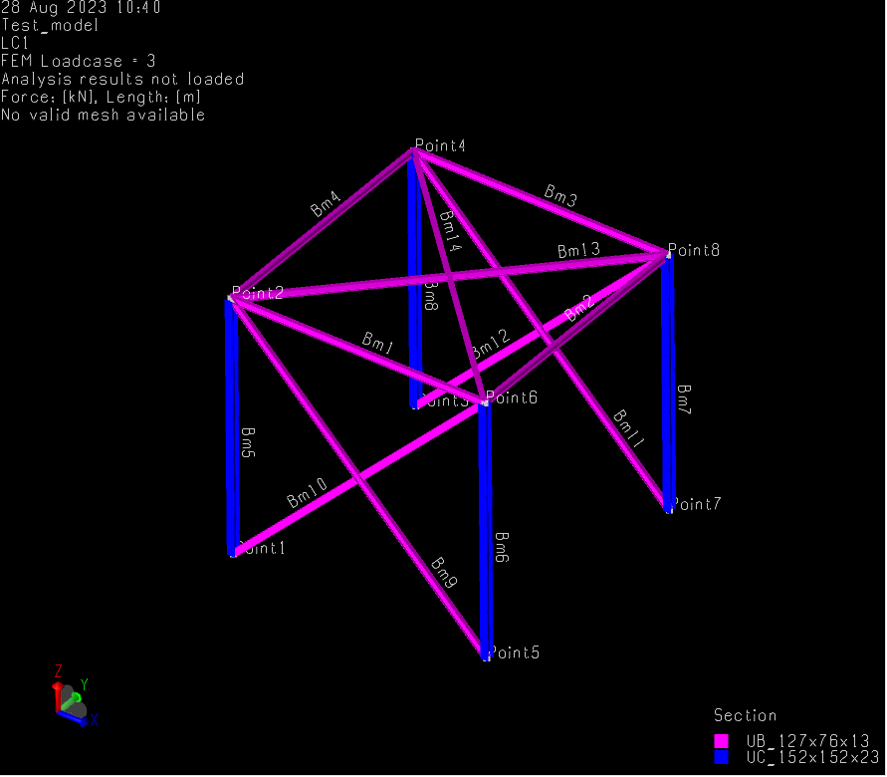

UB_127x76x13.setDefault();

S355.setDefault();

Bm1 = StraightBeam(Point(0 m,0 m,5 m), Point(5 m,0 m,5 m));

Bm2 = StraightBeam(Point(5 m,0 m,5 m), Point(5 m,5 m,5 m));

Bm3 = StraightBeam(Point(5 m,5 m,5 m), Point(0 m,5 m,5 m));

Bm4 = StraightBeam(Point(0 m,5 m,5 m), Point(0 m,0 m,5 m));

UC_152x152x23.setDefault();

Bm5 = StraightBeam(Point(0 m,0 m,5 m), Point(0 m,0 m,0 m));

Bm6 = StraightBeam(Point(5 m,0 m,5 m), Point(5 m,0 m,0 m));

Bm7 = StraightBeam(Point(5 m,5 m,5 m), Point(5 m,5 m,0 m));

Bm8 = StraightBeam(Point(0 m,5 m,5 m), Point(0 m,5 m,0 m));

UB_152x89x16.setDefault();

UB_127x76x13.setDefault();

Bm9 = StraightBeam(Point(0 m,0 m,5 m), Point(5 m,0 m,0 m));

Bm10 = StraightBeam(Point(5 m,0 m,5 m), Point(0 m,0 m,0 m));

Bm11 = StraightBeam(Point(0 m,5 m,5 m), Point(5 m,5 m,0 m));

Bm12 = StraightBeam(Point(5 m,5 m,5 m), Point(0 m,5 m,0 m));

Bm13 = StraightBeam(Point(0 m,0 m,5 m), Point(5 m,5 m,5 m));

Bm14 = StraightBeam(Point(5 m,0 m,5 m), Point(0 m,5 m,5 m));

**Create fixed support points at base**

Sp1 = SupportPoint(Point(5 m,0 m,0 m));

Sp2 = SupportPoint(Point(0 m,0 m,0 m));

Sp3 = SupportPoint(Point(5 m,5 m,0 m));

Sp4 = SupportPoint(Point(0 m,5 m,0 m));

**Include load at loadcase ‘Load’**

// 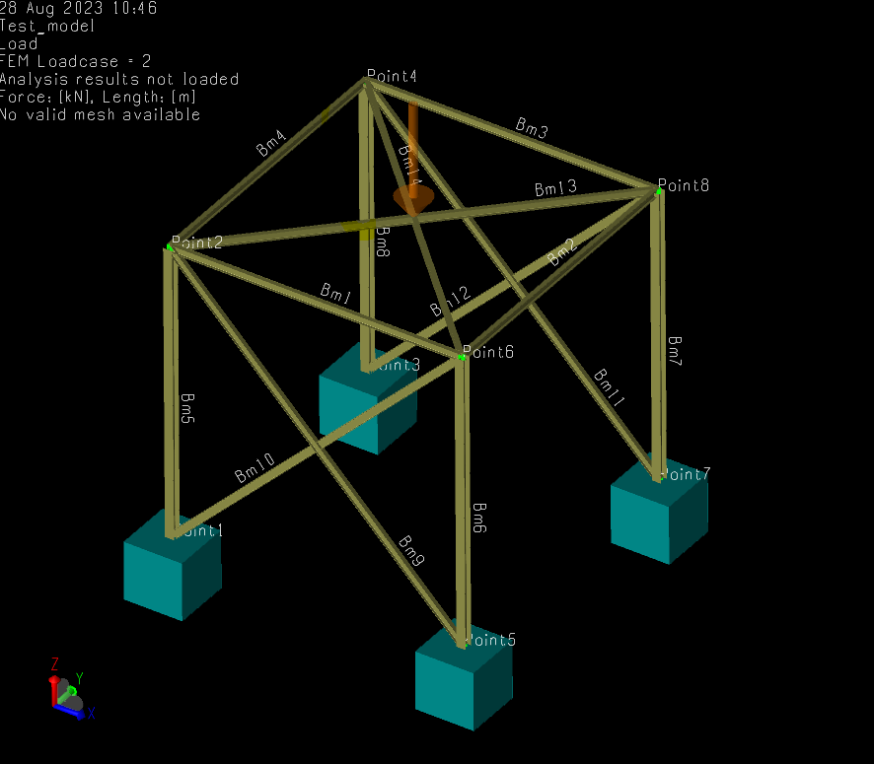

Load.setActive();

PLoad1 = PointLoad(Load, FootprintPoint(Point(2.5 m,2.5 m,5 m)), PointForceMoment(Vector3d(0 kN, 0 kN, -10 kN), Vector3d(0 kN*m, 0 kN*m, 0 kN*m)));

**Create and run analysis**

Analysis1 = Analysis(true);

Analysis1.add(MeshActivity());

Analysis1.add(LinearAnalysis());

Analysis1.step(2).useSestra10(true);

Analysis1.add(LoadResultsActivity());

Analysis1.setActive();

Analysis1.step(1).step(1).execute();

Analysis1.step(1).step(2).execute();

SimplifyTopology();

Analysis1.step(1).step(4).execute();

Analysis1.step(2).execute();

Analysis1.step(3).execute();

**Create member check as per AISC**

AISC_Member_check = CapacityManager(Analysis1);

AISC_Member_check.defaultRunType = "AISC ASD 9th edition";

MemberCreationOpts = MemberCreationOption();

MemberCreationOpts.splitAtJoint = false;

MemberCreationOpts.splitAtIncomingBeam = true;

MemberCreationOpts.splitAtBeamEnd = true;

MemberCreationOpts.considerBeamOffset = true;

AISC_Member_check.createMembers(MemberCreationOpts);

AISC_Member_check.useFromStructureMemberOptions = false;

AISC_Member_check.AddRun(AiscAsd9thRun());

AISC_Member_check.run(1).generateListingFile = false;

AISC_Member_check.run(1).addLoadCase(LC1);

AISC_Member_check.run(1).generalOptions.computeLoadsAsNeeded = true;

**Run code checks**

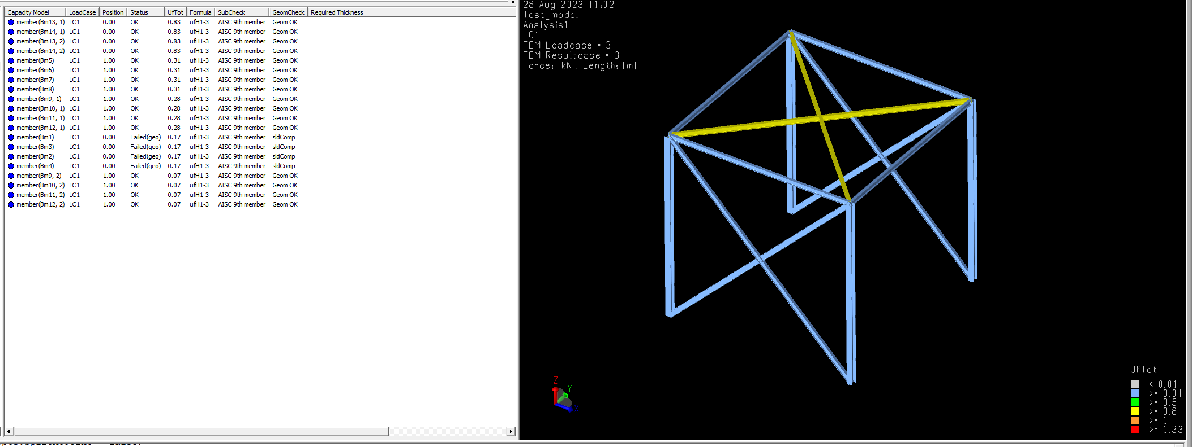

AISC_Member_check.updateStructureFromMembers();

Analysis1.step(2).execute();

Analysis1.step(3).execute();

AISC_Member_check.executeCodeChecks();

Analysis1.setActive();

LC1.setActive();

**GaFra optimization**

// Now the fun part

// Highest UC are the two top beams. Let’s say we want highest UC to be 0.6 in all members. Gafra needs to select from the library (or members included in the previous step) and generate and execute the code checks

// Original code checks need to be deleted and re-assigned

// Note some commands are repeated; this is a problem with GeniE. You need to run the analysis twice to be sure it took the new sizes into account (assigned them properly)

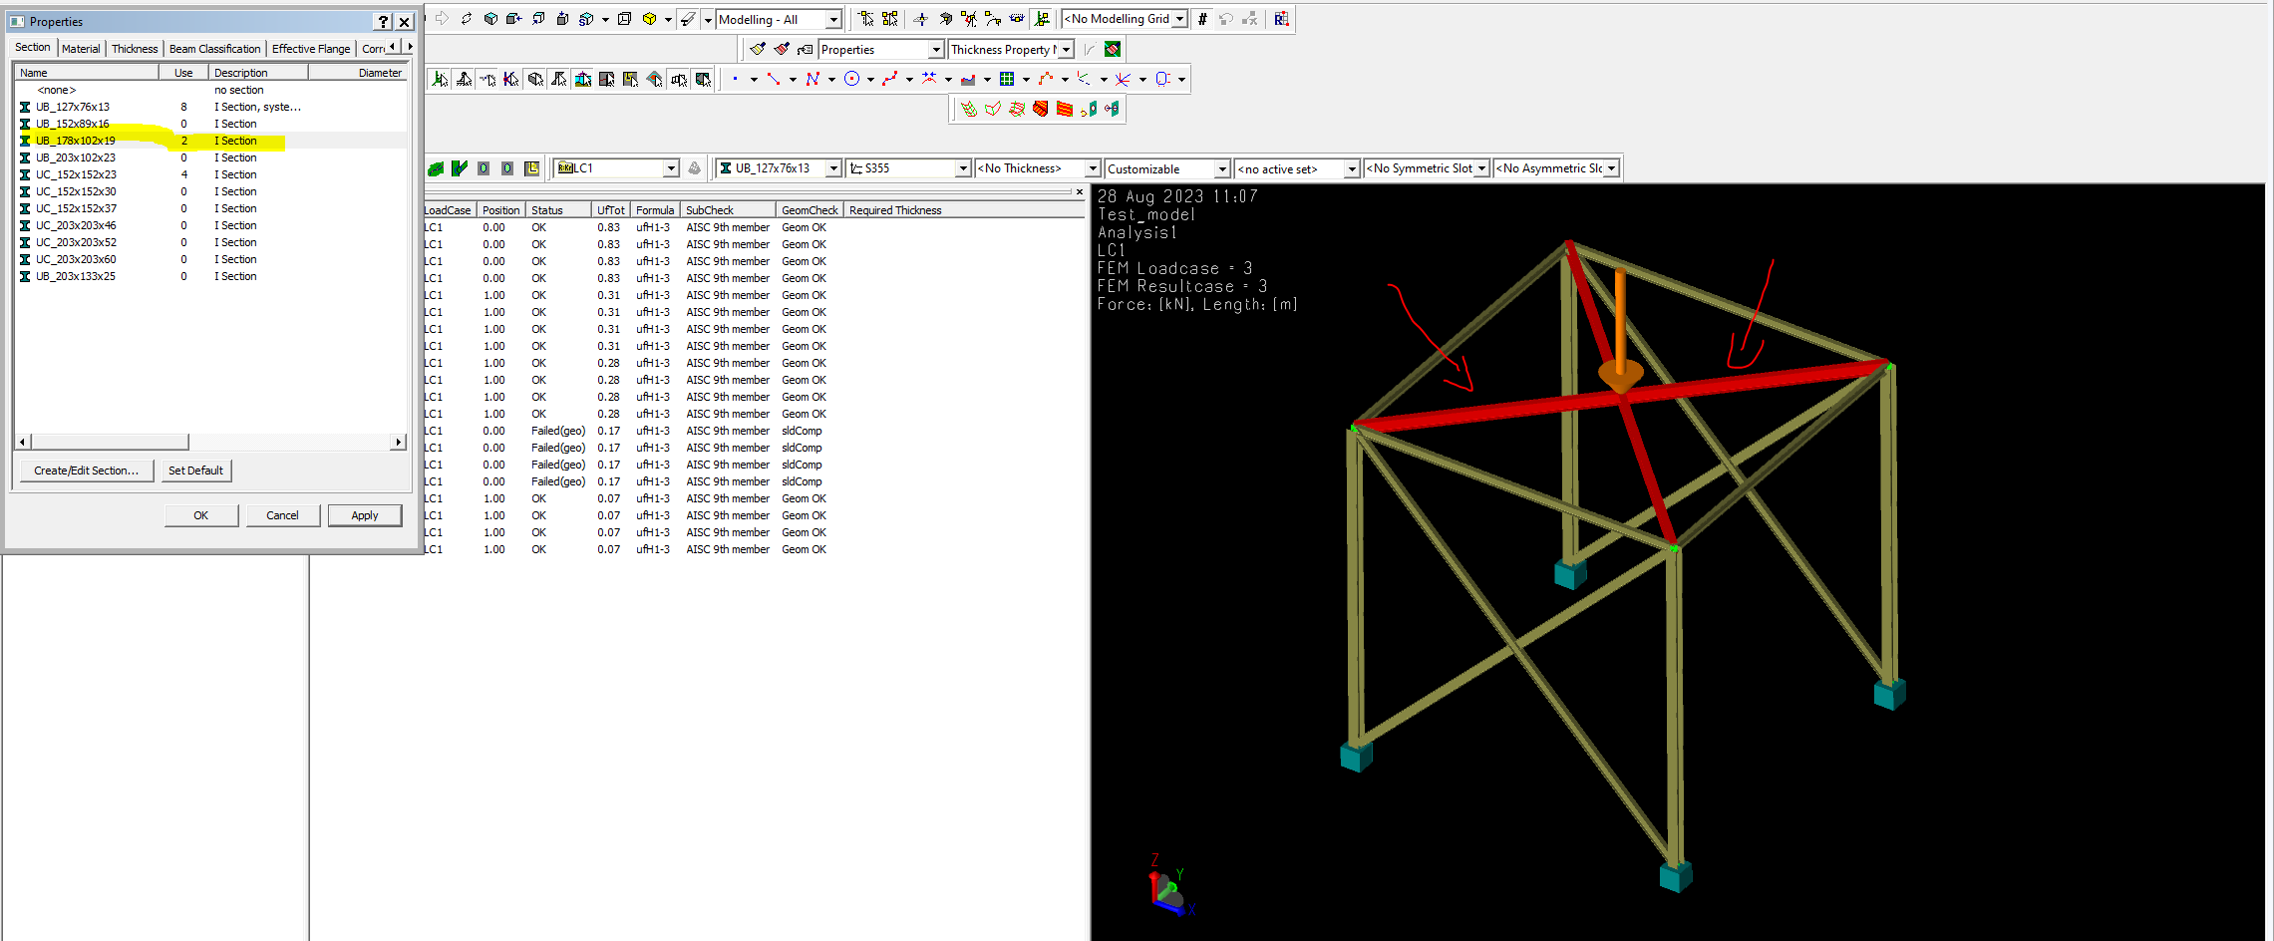

// this is the optimization process from Gafra

Bm13.section = UB_178x102x19;

Bm14.section = UB_178x102x19;

//

Delete(AISC_Member_check);

SimplifyTopology();

Analysis1.step(1).step(4).execute();

Analysis1.step(2).execute();

Analysis1.step(3).execute();

Analysis1.step(2).execute();

Analysis1.step(3).execute();

AISC_Member_check = CapacityManager(Analysis1);

AISC_Member_check.defaultRunType = "AISC ASD 9th edition";

MemberCreationOpts = MemberCreationOption();

MemberCreationOpts.splitAtJoint = false;

MemberCreationOpts.splitAtIncomingBeam = true;

MemberCreationOpts.splitAtBeamEnd = true;

MemberCreationOpts.considerBeamOffset = true;

AISC_Member_check.createMembers(MemberCreationOpts);

AISC_Member_check.useFromStructureMemberOptions = false;

AISC_Member_check.AddRun(AiscAsd9thRun());

AISC_Member_check.run(1).generateListingFile = false;

AISC_Member_check.run(1).addLoadCase(LC1);

AISC_Member_check.run(1).generalOptions.computeLoadsAsNeeded = true;

AISC_Member_check.updateStructureFromMembers();

Analysis1.step(2).execute();

Analysis1.step(3).execute();

AISC_Member_check.executeCodeChecks();

Analysis1.setActive();

**Check new results**

//

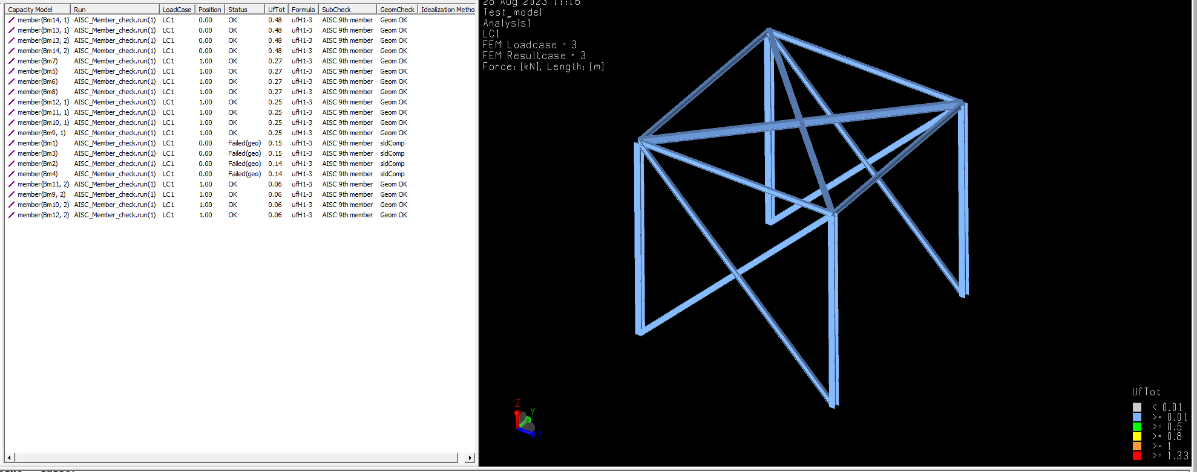

// All members below 0.6

// Success!!!!