**Emergency preparedness in ports: Orientation and navigation training in VR.**

**Panos Kostakos1, Paula Alavesa1, Mario Monteiro Marques2, Filipe Duarte3, Victor Lobo2**

1University of Oulu, Finland

2CINAV, Portugal

3Optimal Defence, Portugal

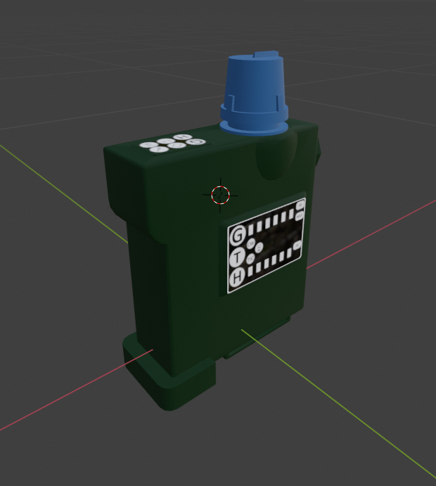

**Figure 1.** Participants’ view of the underground parking scene in VR along with associated game objects. The virtual environment and game objects are created based on requirements produced by the end-users of the PRINCE project.

Chemical, Biological, Radiological, Nuclear, and high-yield Explosive (CBRNE) events can destabilize governments, enable conditions that aggravate violence, or promote terrorism. Furthermore, these events can quickly wear down the civil protection infrastructure and capability of the responders leading to loss of trust to public institutions [1-2]. Ports are a critical part of transportation infrastructure, which makes them also critical when planning and designing CBRNE training scenarios [2]. Ships themselves are also vulnerable to CBRNE attacks, and in this case it is particularly important that their crews and first responders at sea that are usually navy crews, are trained to deal with this threat, even though that is not their primary job. The PRINCE project aims to support front-line emergency medical responders, law enforcement/security services, and also ship crews, by providing them with Virtual Reality Simulations (VRS) known to drastically increase the immersion of training scenarios, with realistic physiological and emotional responses [4-5]. As the market for commercial Virtual Reality (VR) technology is expected to generate 98.4 million sales and reaching a worldwide population penetration of 2% by 2023, many security services across the globe have already adapted VR technology for training responders on dangerous situations that cannot be illustrated accurately using traditional media. VR training can commence in realistic environments, such as a seaport, without disturbing the logistic flow [6]. In addition,

This paper presents preliminary results from a pilot experiment that explores the decision-making processes of users when navigating confined environments while controlling for variables associated to visual impairment. Our experimental set-up consists of a commercially available Head-mounted Display (HMD) which is used to display various incidents in a custom-designed 3D underground parking space (Figure 1). This site was chosen mainly because it allows the use of a safe and easily accessible and controllable environment, yet it is realistic (ports usually have similar parking and storage spaces), and similar enough to spaces such as ferry cargo bays or ship holds. Later tests are to be conducted at the Portuguese Navy Damage Control School facilities, that include a pier, a small village, and other buildings. photoplethysmography (PPG) sensors for monitng hear rate per minute.

In situ experiments in the parking space are conducted with participants drawn from aconvenient subset of local parking customers. Following the consent form and a quick tutorial, the simulation begins by asking participants to follow various directional wayfinding signage embedded in the 3D underground parking model. During the gameplay, different optical distortions are introduced to simulate the effects that chemical agents and smoke might have on first responders’ vision. The simulation is developed in Unity engine (C#) for Oculus HMD. The study explores the decision-making process of users under the following two experimental conditions: i) Normal visibility with no optical distortions, and ii) medium/low visibility simulated with smoke/fog particle system effects. A series of disability glares, blurs and colour distortions are introduced which are extremely common in similar experiment designs also using immersive 3D models for sensory stimulation. Visual manipulations were performed mainly using Cg/HLSL and GLSL fragment shaders, and by applying various custom shaders, lighting, and volumetric fog into the graphic pipeline of the scenes**.**

The objective of the study is to compare the performance of participants who are immersed into the CBRNE scenarios while controlling for experimental conditions in low visibility. The evaluation is enabled by the collection and analysis of quantitative data related to users’ performance in the simulated environment. Prior studies exploring wayfinding systems in VR [7] have widely acknowledged the significance of at least five key measures: i) Distance travelled by the users in order to compete the objective/mission of the game; ii) Time required to complete the objective/mission; iii) Pauses during the simulation that are calculated as user inactivity for over 3 seconds; iv) Speed of the user measured as the total distance by time spent; and v) total area covered by the users during the simulation. Distances were measured using a combination of Artificial Intelligence (AI) distance detection and distance-to-checkpoint scripts. The remaining user statistics are calculated and scripted in the code as game variables that can be readily exported in a structured format for further analysis of statistical significance.

Based on our results, we can suggest optimal setup for training emergency respondents for working in low visibility in confined indoor spaces such as storage facilities in the docks areas or aboard ships, and cruise vessels and ferries in particular. Our main goal is to use what we learn through this experiment to expand the selection of available VR training modules for multiple logistically and ecologically critical urban sites, including maritime ports.

Photoplethysmography (PPG) is a simple and low-cost, non-invasive, optical measurement technology. The principle behind it is to measure the light propagation in tissue during the cardiac cycle by detecting the volume of blood in the microvascular bed tissue, which changes with the blood flow (Challoner & Ramsay 1974; Allen 2007). PPG technology is based on a light beam illuminating the tissue. Some of the light is absorbed in the tissue, while some of it is reflected or trans-illuminated to the optical sensors (Lemay et al. 2014). PPG has complicated relationships to several biomechanical, optical and physiological covariates (Allen 2007; Reisner et al. 2008) but can provide useful information about cardiovascular and ANS activity (Kamal et al. 1989).

**Participants**

<https://www.nature.com/articles/srep37212>

Raw PPG data and Unity game engine analytics were analysed from 10 users who played a Virtual Reality simulation that didn’t not contain any sinags and 7 control users who played the same simulation with signage. All users were at least 18 years old with low experience in VR as confirmed by post expoerent questioner. All participants were selected randomly from a public location in Tellus Arena located at the LInama Campus of the Univesrity of Oulu and fulfilled  fulfilled DSM-IV diagnosis of a schizophrenia spectrum disorder (*n* = 34; 72.7% males; schizophrenia *n* = 17; schizoaffective *n* = 4; schizophreniform disorder *n* = 1; other psychosis = 12) or a bipolar disorder spectrum disorder (*n* = 21; 39.1% males; bipolar disorder I *n* = 13; bipolar disorder II *n* = 7; or bipolar disorder NOS *n* = 1).

**Collection of physiology and game engine data**

Pre-survey: A short self-evaluation survey was commissioned before the user mounted the HUD that gauged user demographic data experience in VR gaming as well as self-evaluation on memory and distance.

Game statistics were collected for all users using the popular Unity Engine.

* **Completion time:** The time elapsed since the beginning of the scene. Uses Time.time command.
* **Distance travelled:** Uses Vector3.Distance to get player movement each frame. These are combined to get total distance. Vector3 stores player position vector (x,y,z).
* **Average speed:** Calculated after the scene is completed simply by: “Distance travelled divided by completion time”.
* **Total stops:** Checked using player position. If the previous frame position is the same as current frame position it is calculated as a stop.
* **Number of rotations:** Same principle as in total stops. The player orientation is checked each frame and compared to the previous orientation. If the frames have different orientation values it is calculated as one 45 degree rotation. The player rotation control stick turns the player 45 degrees each time it is pressed.  Rotation is converted from player object using “transform.eulerAngles”.
* **Total rotation:** Simple calculation to convert number of rotation to degrees. 1 rotation = 45 deg
* **Ambulance Found:** Just a flag that is triggered when player reaches the ambulance
* **Ambulance Time:** Time the ambulance is found. Using Time.time when player reaches the ambulance trigger.

**Photoplythismography measurement**

Hear rate data was collected from all subjects using a standadred Polar A327 wrist band **PPG (photoplethysmography) sensors**. PPG sensors use a light-based technology to sense the rate of blood flow as controlled by the heart’s pumping action. Pulse Rate Variation correlates

The electronic signal derived from the fitbit devses shows the agreegated systolil and diastoli heart activity and has been used to evaluate the health agiing diseseas related to the vascular system contorling for key demographic varialbes like age and gender.

We know that PPG signals reveal the aggregated systolic and diastolic activities of the heart[35](https://www.nature.com/articles/sdata201876" \l "ref-CR35" \o "), the state of the vascular system (e.g., health, aging, disease,

etc.)[36](https://www.nature.com/articles/sdata201876" \l "ref-CR36" \o "),[37](https://www.nature.com/articles/sdata201876" \l "ref-CR37" \o "), the differences between the microcirculation systems of different populations, gender[38](https://www.nature.com/articles/sdata201876" \l "ref-CR38" \o "), gravity (i.e., the vertical distance from the heart to the PPG sensor)[39](https://www.nature.com/articles/sdata201876" \l "ref-CR39" \o "), muscle jitter, movement, white noise, and other measurements.

# **METHODS**

Using the above srouces of multimodal data, we use hypothesis testing methods (time series decomposition, anova, correlation and chi-square testing ) to help us understand patterns in our data. We formed two groups of hypothesis to help us guide through this process: Physiological, VR game analytics, perception.

To gague the phisiologiucal impact of the VR conditions we are testing in the game we hypothesed that

The control condition will reduce the sein on the heart and will therefore reduce the overall heart rate of the users playing this simulation. This hypothesis will be tested by looking at the HR trend across the groups monitoring for possitive or negative trends and also by measuring the energy consumption of the users. We posit that users in the control condition will burn on avenge more calories that users playing the neutral condition. Past research has shown that simulation with signage tent to facialite the game place and reduce the mental processing of the users that in trun translates in less energy consumption.

**Results**

To analyse the Figure 1 illustrates a box plot of the raw PPG SSQI for G1, G2, and G3, which indicates different levels of signal quality between each group

**Endnotes**

[1] F. Su and I. Anthony, “Reassessing CBRN Threats in a Changing Global Environment”. Solna, Sweden: Stockholm International Peace Research Institute, 2019.

[2] S. van Buuren and D. J. Wijnmalen, “Measuring Psychosocial Impact of CBRN Incidents by the Rasch Model,” *Journal of applied measurement*, vol. 16, p. 3, 2015.

[3] K. Christopher, *Port security management*, 2nd ed. CRC Press, Taylor Francis, 2014.

[4] J. E. Driskell and J. H. Johnston, “Stress exposure training,” Making decisions under stress: Implications for individual and team training, pp. 191–217, 1998.

[5] PRINCE, EU ISF-P CBRN-E Project, <https://www.isfp-prince.eu/>

[6] S. Rogers, “2019: The Year Virtual Reality Gets Real,” Forbes. [Online]. Available: https://www.forbes.com/sites/solrogers/2019/06/21/2019-the-year-virtual-reality-gets-real/.

[7] C.-H. Tang, W.-T. Wu, and C.-Y. Lin, “Using virtual reality to determine how emergency signs facilitate way-finding,” *Applied ergonomics*, vol. 40, no. 4, pp. 722–730, 2009.