UNIVERSITY OF ARCHITECTURE, CIVIL ENGINEERING AND GEODESY
Department of Reinforced Concrete Structures

COURSE PROJECT IN REINFORCED CONCRETE
Explanatory note with static analysis and design calculations
Reinforced concrete structure of the slab above the first floor of an administrative building

Student | Dionisios Papadimitriou
Faculty number | 17945
Date | 07.10.2026

Table 1. Input data (assignment)
Input data | Value
a [cm] | 630
b [cm] | 580
c [cm] | 350
d [cm] | 170
h_s [cm] | 310
h_b [cm] | 290
q_k1 [kN/m²] | 5.6
q_k2 [kN/m²] | 3.3
R_0 [kN/m²] | 230

Contents
Right-click here and choose "Update field" to build the table of contents.

General data
Codes: EN 1990, EN 1991-1-1, EN 1992-1-1 (Eurocode 2) with the recommended values. Units: kN, m (statics); N, mm (design of sections).
Materials: concrete C25/30, reinforcing steel B500. Partial factors: γ_G = 1.35, γ_Q = 1.5, γ_c = 1.5, γ_s = 1.15.
Table 2. Structural grid (from the formwork plan)
Axis | x [cm] |  | Axis | y [cm]
1 | 0 |  | A (А) | 0
2 | 630 |  | B (Б) | 580
3 | 1260 |  | C (В) | 755
4 | 1645 |  | D (Г) | 930
5' | 2070 |  | E (Д) | 1510
5 | 2275
6 | 2905
7 | 3535

Exhibition hall: 6 one-way slabs per bay, secondary beams every 251.7 cm (l/l = 2.503 ≥ 2). Meeting room: 6 one-way slabs, secondary beams every 244.2 cm (l/l = 2.375 ≥ 2).
Storey heights: first storey h_b = 290 cm, upper storeys h_s = 310 cm (4 storeys). Level of the designed slab: +2.9 m.

I. Design of reinforced concrete single-span simply supported slab
Slab 17 - corridor between axes B and D (Б-Г) and axes 4-7. The slab is supported on the beams on axes B and D and spans in the short direction.

1. Static scheme
Clear span in the long direction
$$l_{m​ax,cl}=1865 cm$$
Clear span in the short direction
$$l_{m​in,cl}=325 cm$$
Ratio of the spans
$$λ=\frac{l_{m​ax,cl}}{l_{m​in,cl}}=\frac{1865}{325}=5.738$$
$$λ=5.738 > 2$$
✔ Slab spanning in one direction (simply supported strip)
Thickness of the slab
$$h_{f}=14 cm$$
EC2 5.3.2.2(1): a_i = min(h/2; t/2)
$$a_{1}=min\left(\frac{h_{f}}{2} ; \frac{t}{2}\right)=min\left(\frac{14}{2} ; \frac{25}{2}\right)=7 cm$$
Effective span l_eff = l_n + a_1 + a_2
$$l_{eff}=l_{m​in,cl}+2·a_{1}=325+2·7=339 cm$$

2. Actions
Characteristic values - permanent actions:
Self-weight of the slab (γ = 25 kN/m³)
$$g_{k,1}=h_{f}·25=0.14·25=3.5 kN/m²$$
Floor finishes, 5 cm (γ = 22 kN/m³)
$$g_{k,2}=0.05·22=1.1 kN/m²$$
Ceiling plaster, 2 cm (γ = 18 kN/m³)
$$g_{k,3}=0.02·18=0.36 kN/m²$$
Total permanent action
$${Σg}_{k}=g_{k,1}+g_{k,2}+g_{k,3}=3.5+1.1+0.36=4.96 kN/m²$$
Characteristic value - variable action:
Imposed load - corridor (category B/C)
$$q_{k}=3.5 kN/m²$$
Design values (EN 1990, 6.10):
Permanent action, γ_G = 1.35
$$g_{d}=1.35·{Σg}_{k}=1.35·4.96=6.696 kN/m²$$
Variable action, γ_Q = 1.5
$$q_{d}=1.5·q_{k}=1.5·3.5=5.25 kN/m²$$
Total design load
$$p_{d}=g_{d}+q_{d}=6.696+5.25=11.95 kN/m²$$
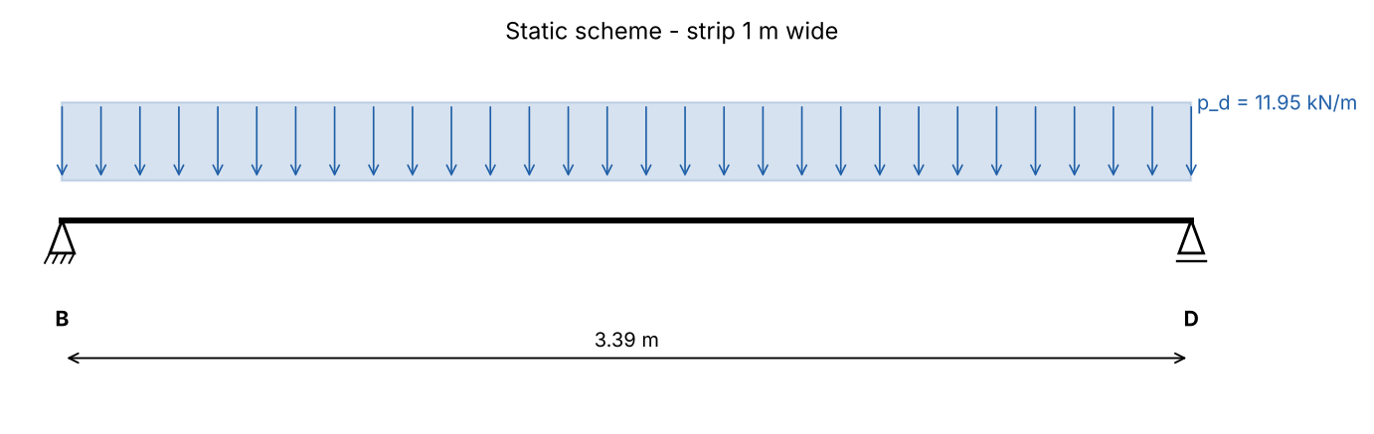
Figure 1. Static scheme of the simply supported slab

3. Static analysis
Maximum bending moment (mid-span)
$$M_{Ed}=\frac{p_{d}·{l_{eff}}^{2}}{8}=\frac{11.95·{3.39}^{2}}{8}=17.16 kNm/m$$
Maximum shear force (supports)
$$V_{Ed}=\frac{p_{d}·l_{eff}}{2}=\frac{11.95·3.39}{2}=20.25 kN/m$$
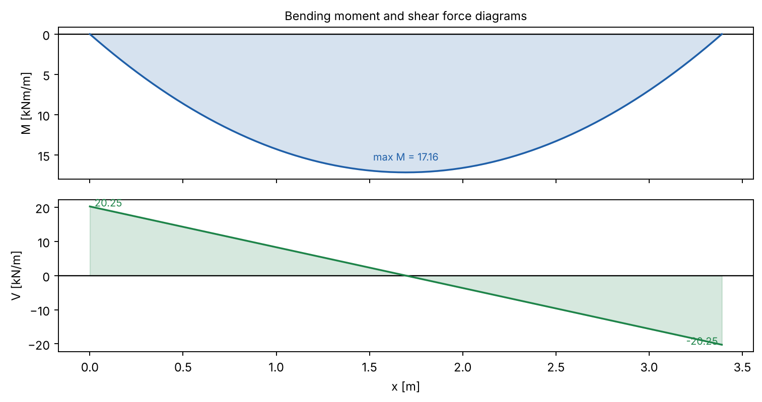
Figure 2. Internal forces in the simply supported slab

4. Design of the bending reinforcement
Design characteristics of the materials (EN 1992-1-1):
Concrete C25/30, reinforcing steel B500.
Characteristic cylinder strength of concrete
$$f_{ck}=25 N/mm²$$
Design compressive strength
$$f_{cd}=\frac{α_{cc}·f_{ck}}{γ_{c}}=\frac{1·25}{1.5}=16.67 N/mm²$$
Mean tensile strength
$$f_{ctm}=2.56 N/mm²$$
Characteristic yield strength of steel
$$f_{yk}=500 N/mm²$$
Design yield strength of steel
$$f_{yd}=\frac{f_{yk}}{γ_{s}}=\frac{500}{1.15}=434.8 N/mm²$$
Effective depth of the cross-section:
c_nom = 25 mm (XC1, 50 years), assumed bar Φ10
$$d=h_{f}−c_{nom}−\frac{φ}{2}=140−25−\frac{10}{2}=110 mm$$
Mid-span section (b = 1000 mm, per metre)
Relative design moment
$$μ_{Ed}=\frac{\left|M_{Ed}\right|·10⁶}{b·d^{2}·f_{cd}}=\frac{\left|17.16\right|·10⁶}{1000·{110}^{2}·16.67}=0.0851$$
$$μ_{Ed}=0.0851 ≤ μ_{l​im}=0.295$$
✔ Single reinforcement is sufficient
Lever arm ratio z/d
$$ζ=0.5·\left(1+\sqrt{1−2·μ_{Ed}}\right)=0.5·\left(1+\sqrt{1−2·0.0851}\right)=0.9555$$
Required reinforcement
$$A_{s,req}=\frac{\left|M_{Ed}\right|·10⁶}{ζ·d·f_{yd}}=\frac{\left|17.16\right|·10⁶}{0.9555·110·434.8}=375.5 mm²/m$$
Minimum reinforcement (EC2 9.2.1.1)
$$A_{s,m​in}=max\left(\frac{0.26·f_{ctm}}{f_{yk}}·b·d ; 0.0013·b·d\right)$$
$$=max\left(\frac{0.26·2.56}{500}·1000·110 ; 0.0013·1000·110\right)=146.7 mm²/m$$
Provided reinforcement: 5Φ10/20 cm → A_s,prov = 392.7 mm²/m
Required reinforcement ratio
$$ρ=\frac{A_{s}}{b·d}=\frac{375.5}{1000·110}=0.00341$$
Provided reinforcement ratio
$$ρ_{prov}=\frac{A_{s,prov}}{b·d}=\frac{392.7}{1000·110}=0.00357$$

5. Design for shear
Size factor
$$k=min\left(1+\sqrt{\frac{200}{d}} ; 2\right)=min\left(1+\sqrt{\frac{200}{110}} ; 2\right)=2$$
$$v_{m​in}=0.035·k^{\frac{3}{2}}·\sqrt{f_{ck}}=0.035·2^{\frac{3}{2}}·\sqrt{25}=0.495 N/mm²$$
Shear resistance without shear reinforcement (EC2 6.2.2)
$$V_{Rd,c}=\frac{C_{Rd,c}·k·\sqrt[3]{100·ρ_{l}·f_{ck}}·b·d}{10³}=\frac{0.12·2·\sqrt[3]{100·0.00357·25}·1000·110}{10³}=54.76 kN/m$$
$$V_{Rd,c,m​in}=\frac{v_{m​in}·b·d}{10³}=\frac{0.495·1000·110}{10³}=54.45 kN/m$$
V_Rd,c = max(V_Rd,c ; V_Rd,c,min) = 54.76 kN/m
$$V_{Ed}=20.25 kN/m ≤ V_{Rd,c}=54.76 kN/m$$
✔ No shear reinforcement is required

6. Control of deflection (EC2 7.4.2)
Simply supported slab: K = 1.0
$$ρ_{0}=\sqrt{f_{ck}}·10⁻³=\sqrt{25}·10⁻³=0.005$$
Basic span/depth ratio, ρ ≤ ρ_0 (EC2 7.16a)
$${(l/d)}_{basic}=K·\left(11+\frac{1.5·\sqrt{f_{ck}}·ρ_{0}}{ρ}+3.2·\sqrt{f_{ck}}·{\left(\frac{ρ_{0}}{ρ}−1\right)}^{\frac{3}{2}}\right)$$
$$=1·\left(11+\frac{1.5·\sqrt{25}·0.005}{0.00341}+3.2·\sqrt{25}·{\left(\frac{0.005}{0.00341}−1\right)}^{\frac{3}{2}}\right)=27.05$$
Steel stress under the quasi-permanent load
$$σ_{s}=\frac{\frac{f_{yd}·\left(g_{k}+0.3·q_{k}\right)}{g_{d}+q_{d}}·A_{s,req}}{A_{s,prov}}=\frac{\frac{434.8·\left(4.96+0.3·3.5\right)}{6.696+5.25}·375.5}{392.7}=209.2 N/mm²$$
Correction factor 310/σ_s (≤ 1.5)
$$k_{σ}=min\left(\frac{310}{σ_{s}} ; 1.5\right)=min\left(\frac{310}{209.2} ; 1.5\right)=1.482$$
$${(l/d)}_{l​im}={(l/d)}_{basic}·k_{σ}=27.05·1.482=40.09$$
$$l/d=\frac{l_{eff}}{d}=\frac{3390}{110}=30.82$$
$$l/d=30.82 ≤ {(l/d)}_{l​im}=40.09$$
✔ Deflection need not be calculated (l/d check satisfied)

7. Detailing
Detailing of the reinforcement (EC2 9.3.1):
- Distribution (secondary) reinforcement: A_s,dist ≥ max(0.20·A_s; 3Φ8/m) = 150.8 mm²/m → Φ6/17.5 cm
- Spacing of main bars ≤ min(2·h_f; 250 mm) = 250 mm (adopted 200 mm); distribution bars ≤ min(3·h_f; 400 mm).
- Top reinforcement at end supports (monolithic connection): A_s3 ≥ max(0.25·A_s,span; A_s,min; 5Φ8/m), length 0.2·l_min from the face of the support + l_bd.
- Bottom bars are anchored at end supports with l_bd and lapped over interior supports; top bars over interior supports extend 0.3·l_min beyond the face of the support.

II. Design of reinforced concrete continuous slab spanning in one direction - elastic analysis
Slabs 1-6 - exhibition hall, axes 1-3 / A-E. The slab is continuous over the secondary beams B5... (5 interior supports at a spacing of 251.7 cm) and spans from axis A to axis E (Д) in 6 spans.

1. Static scheme
Clear span in the long direction (wall 25 cm on axis 1, beam 30 cm on axis 2)
$$l_{m​ax,cl}=602.5 cm$$
Clear span between the secondary beams (b_w = 25 cm)
$$l_{m​in,cl}=226.7 cm$$
$$λ=\frac{l_{m​ax,cl}}{l_{m​in,cl}}=\frac{602.5}{226.7}=2.658$$
$$λ=2.658 > 2$$
✔ Slab spanning in one direction - continuous strip 1 m wide
Thickness of the slab
$$h_{f}=12 cm$$
End span: l_eff,1 = l_n + min(h_f/2; t/2) + t/2
$$l_{eff,1}=l_{m​in,cl}+min\left(\frac{h_{f}}{2} ; \frac{t}{2}\right)+\frac{t}{2}=226.7+min\left(\frac{12}{2} ; \frac{25}{2}\right)+\frac{25}{2}=245.2 cm$$
Interior spans: l_eff,2 = l_n + t
$$l_{eff,2}=l_{m​in,cl}+t=226.7+25=251.7 cm$$

2. Actions
Characteristic values - permanent actions:
Self-weight of the slab (γ = 25 kN/m³)
$$g_{k,1}=h_{f}·25=0.12·25=3 kN/m²$$
Floor finishes, 5 cm (γ = 22 kN/m³)
$$g_{k,2}=0.05·22=1.1 kN/m²$$
Ceiling plaster, 2 cm (γ = 18 kN/m³)
$$g_{k,3}=0.02·18=0.36 kN/m²$$
Total permanent action
$${Σg}_{k}=g_{k,1}+g_{k,2}+g_{k,3}=3+1.1+0.36=4.46 kN/m²$$
Characteristic value - variable action:
Imposed load - exhibition hall q_k1 (assignment)
$$q_{k}=5.6 kN/m²$$
Design values (EN 1990, 6.10):
Permanent action, γ_G = 1.35
$$g_{d}=1.35·{Σg}_{k}=1.35·4.46=6.021 kN/m²$$
Variable action, γ_Q = 1.5
$$q_{d}=1.5·q_{k}=1.5·5.6=8.4 kN/m²$$
Total design load
$$p_{d}=g_{d}+q_{d}=6.021+8.4=14.42 kN/m²$$

3. Static analysis - bending moments and shear forces
The strip is analysed as a continuous beam with 6 spans (stiffness method). The permanent load acts on all spans; the variable load is placed span by span in the most unfavourable arrangement for every section (pattern loading). The envelope is obtained by superposition, the results are written in the familiar coefficient form M = (α_g·g_d + α_q·q_d)·l².
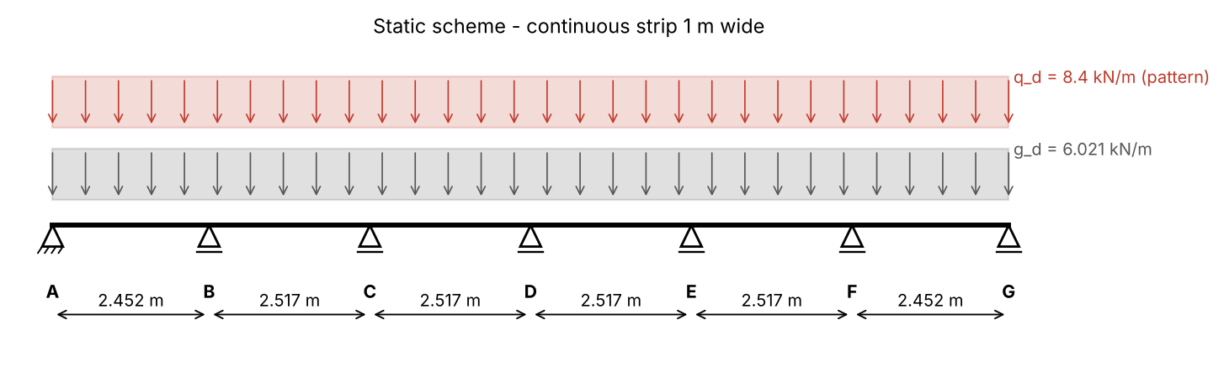
Figure 3. Static scheme of the continuous slab
Span 1 (x = 1.042 m)
$${maxM}_{Ed,1}=\left(α_{g}·g_{d}+α_{q}·q_{d}\right)·{l_{eff,1}}^{2}=\left(0.0765·6.021+0.1005·8.4\right)·{2.452}^{2}=7.84 kNm/m$$
Span 2 (x = 3.757 m)
$${maxM}_{Ed,2}=\left(α_{g}·g_{d}+α_{q}·q_{d}\right)·{l_{eff,2}}^{2}=\left(0.0352·6.021+0.0791·8.4\right)·{2.517}^{2}=5.554 kNm/m$$
Span 3 (x = 6.211 m)
$${maxM}_{Ed,3}=\left(α_{g}·g_{d}+α_{q}·q_{d}\right)·{l_{eff,2}}^{2}=\left(0.043·6.021+0.0837·8.4\right)·{2.517}^{2}=6.094 kNm/m$$
Support B
$${minM}_{B}=−\left(α_{g}·g_{d}+α_{q}·q_{d}\right)·{l_{eff}}^{2}=−\left(0.1021·6.021+0.1164·8.4\right)·{2.517}^{2}=-10.09 kNm/m$$
Support C
$${minM}_{C}=−\left(α_{g}·g_{d}+α_{q}·q_{d}\right)·{l_{eff}}^{2}=−\left(0.078·6.021+0.1101·8.4\right)·{2.517}^{2}=-8.832 kNm/m$$
Support D
$${minM}_{D}=−\left(α_{g}·g_{d}+α_{q}·q_{d}\right)·{l_{eff}}^{2}=−\left(0.086·6.021+0.1148·8.4\right)·{2.517}^{2}=-9.386 kNm/m$$
Maximum shear force (left of support B)
$${maxV}_{Ed}=\left(β_{g}·g_{d}+β_{q}·q_{d}\right)·l_{eff,1}=\left(0.6076·6.021+0.6227·8.4\right)·2.452=21.79 kN/m$$
Table 3. Coefficients and design values from the elastic analysis
Section | α_g (β_g) | α_q (β_q) | Design value [kNm/m, kN/m]
Span 1 | 0.0765 | 0.1005 | 7.84
Span 2 | 0.0352 | 0.0791 | 5.554
Span 3 | 0.043 | 0.0837 | 6.094
Support B | -0.1021 | -0.1164 | -10.09
Support C | -0.078 | -0.1101 | -8.832
Support D | -0.086 | -0.1148 | -9.386
Shear at B (left) | 0.6076 | 0.6227 | 21.79

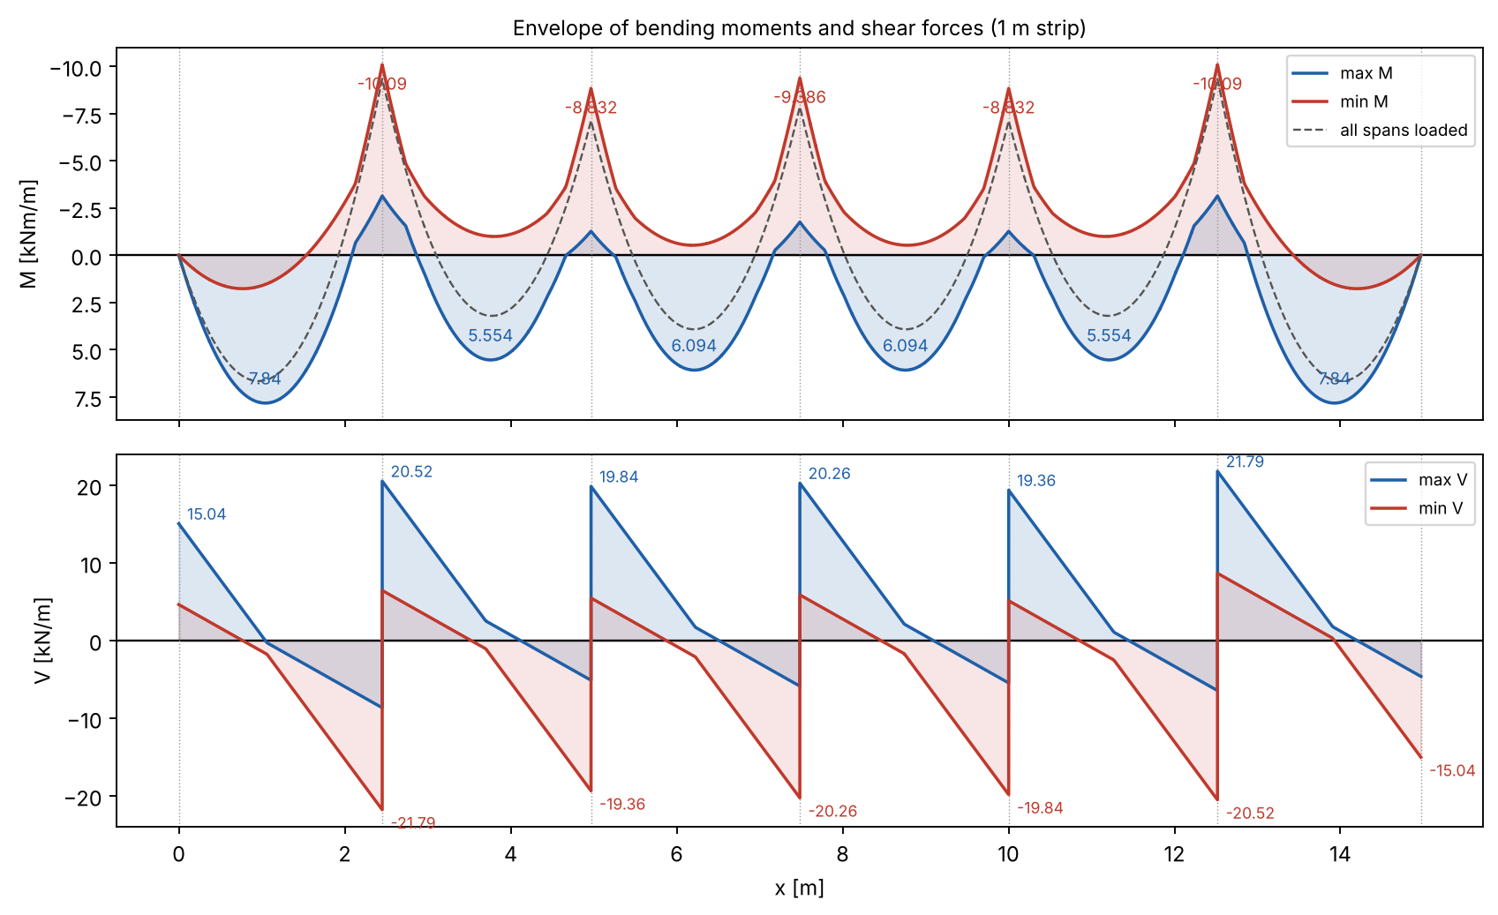
Figure 4. Envelopes of M and V for the continuous slab (pattern loading)

4. Design of the bending reinforcement
Design characteristics of the materials (EN 1992-1-1):
Concrete C25/30, reinforcing steel B500.
Characteristic cylinder strength of concrete
$$f_{ck}=25 N/mm²$$
Design compressive strength
$$f_{cd}=\frac{α_{cc}·f_{ck}}{γ_{c}}=\frac{1·25}{1.5}=16.67 N/mm²$$
Mean tensile strength
$$f_{ctm}=2.56 N/mm²$$
Characteristic yield strength of steel
$$f_{yk}=500 N/mm²$$
Design yield strength of steel
$$f_{yd}=\frac{f_{yk}}{γ_{s}}=\frac{500}{1.15}=434.8 N/mm²$$
Effective depth of the cross-section:
c_nom = 25 mm (XC1, 50 years), assumed bar Φ10
$$d=h_{f}−c_{nom}−\frac{φ}{2}=120−25−\frac{10}{2}=90 mm$$
Span 1 (bottom reinforcement)
Relative design moment
$$μ_{Ed,1}=\frac{\left|{maxM}_{Ed,1}\right|·10⁶}{b·d^{2}·f_{cd}}=\frac{\left|7.84\right|·10⁶}{1000·{90}^{2}·16.67}=0.0581$$
$$μ_{Ed,1}=0.0581 ≤ μ_{l​im}=0.295$$
✔ Single reinforcement is sufficient
Lever arm ratio z/d
$$ζ_{1}=0.5·\left(1+\sqrt{1−2·μ_{Ed,1}}\right)=0.5·\left(1+\sqrt{1−2·0.0581}\right)=0.9701$$
Required reinforcement
$$A_{s,req,1}=\frac{\left|{maxM}_{Ed,1}\right|·10⁶}{ζ_{1}·d·f_{yd}}=\frac{\left|7.84\right|·10⁶}{0.9701·90·434.8}=206.5 mm²/m$$
Minimum reinforcement (EC2 9.2.1.1)
$$A_{s,m​in,1}=max\left(\frac{0.26·f_{ctm}}{f_{yk}}·b·d ; 0.0013·b·d\right)=max\left(\frac{0.26·2.56}{500}·1000·90 ; 0.0013·1000·90\right)=120 mm²/m$$
Provided reinforcement: 5Φ8/20 cm → A_s,prov = 251.3 mm²/m
Required reinforcement ratio
$$ρ_{1}=\frac{A_{s}}{b·d}=\frac{206.5}{1000·90}=0.00229$$
Provided reinforcement ratio
$$ρ_{prov,1}=\frac{A_{s,prov}}{b·d}=\frac{251.3}{1000·90}=0.00279$$
Span 2 (bottom reinforcement)
Relative design moment
$$μ_{Ed,2}=\frac{\left|{maxM}_{Ed,2}\right|·10⁶}{b·d^{2}·f_{cd}}=\frac{\left|5.554\right|·10⁶}{1000·{90}^{2}·16.67}=0.0411$$
$$μ_{Ed,2}=0.0411 ≤ μ_{l​im}=0.295$$
✔ Single reinforcement is sufficient
Lever arm ratio z/d
$$ζ_{2}=0.5·\left(1+\sqrt{1−2·μ_{Ed,2}}\right)=0.5·\left(1+\sqrt{1−2·0.0411}\right)=0.979$$
Required reinforcement
$$A_{s,req,2}=\frac{\left|{maxM}_{Ed,2}\right|·10⁶}{ζ_{2}·d·f_{yd}}=\frac{\left|5.554\right|·10⁶}{0.979·90·434.8}=145 mm²/m$$
Minimum reinforcement (EC2 9.2.1.1)
$$A_{s,m​in,2}=max\left(\frac{0.26·f_{ctm}}{f_{yk}}·b·d ; 0.0013·b·d\right)=max\left(\frac{0.26·2.56}{500}·1000·90 ; 0.0013·1000·90\right)=120 mm²/m$$
Provided reinforcement: 5Φ8/20 cm → A_s,prov = 251.3 mm²/m
Required reinforcement ratio
$$ρ_{2}=\frac{A_{s}}{b·d}=\frac{145}{1000·90}=0.00161$$
Provided reinforcement ratio
$$ρ_{prov,2}=\frac{A_{s,prov}}{b·d}=\frac{251.3}{1000·90}=0.00279$$
Span 3 (bottom reinforcement)
Relative design moment
$$μ_{Ed,3}=\frac{\left|{maxM}_{Ed,3}\right|·10⁶}{b·d^{2}·f_{cd}}=\frac{\left|6.094\right|·10⁶}{1000·{90}^{2}·16.67}=0.0451$$
$$μ_{Ed,3}=0.0451 ≤ μ_{l​im}=0.295$$
✔ Single reinforcement is sufficient
Lever arm ratio z/d
$$ζ_{3}=0.5·\left(1+\sqrt{1−2·μ_{Ed,3}}\right)=0.5·\left(1+\sqrt{1−2·0.0451}\right)=0.9769$$
Required reinforcement
$$A_{s,req,3}=\frac{\left|{maxM}_{Ed,3}\right|·10⁶}{ζ_{3}·d·f_{yd}}=\frac{\left|6.094\right|·10⁶}{0.9769·90·434.8}=159.4 mm²/m$$
Minimum reinforcement (EC2 9.2.1.1)
$$A_{s,m​in,3}=max\left(\frac{0.26·f_{ctm}}{f_{yk}}·b·d ; 0.0013·b·d\right)=max\left(\frac{0.26·2.56}{500}·1000·90 ; 0.0013·1000·90\right)=120 mm²/m$$
Provided reinforcement: 5Φ8/20 cm → A_s,prov = 251.3 mm²/m
Required reinforcement ratio
$$ρ_{3}=\frac{A_{s}}{b·d}=\frac{159.4}{1000·90}=0.00177$$
Provided reinforcement ratio
$$ρ_{prov,3}=\frac{A_{s,prov}}{b·d}=\frac{251.3}{1000·90}=0.00279$$
Support B (top reinforcement) - moment at the face of the support:
ΔM = V_Ed·t/2
$${ΔM}_{Ed}=\frac{V_{Ed,B}·t}{2}=\frac{21.79·0.25}{2}=2.724 kNm/m$$
Not less than 65 % of the fixed-end moment (EC2 5.3.2.2(4))
$$M_{Ed,B}=max\left(\left|{minM}_{B}\right|−{ΔM}_{Ed} ; 0.65·p·l²/12\right)=max\left(\left|-10.09\right|−2.724 ; 4.947\right)=7.363 kNm/m$$
Relative design moment
$$μ_{Ed,B}=\frac{\left|M_{Ed,B}\right|·10⁶}{b·d^{2}·f_{cd}}=\frac{\left|7.363\right|·10⁶}{1000·{90}^{2}·16.67}=0.0545$$
$$μ_{Ed,B}=0.0545 ≤ μ_{l​im}=0.295$$
✔ Single reinforcement is sufficient
Lever arm ratio z/d
$$ζ_{B}=0.5·\left(1+\sqrt{1−2·μ_{Ed,B}}\right)=0.5·\left(1+\sqrt{1−2·0.0545}\right)=0.9719$$
Required reinforcement
$$A_{s,req,B}=\frac{\left|M_{Ed,B}\right|·10⁶}{ζ_{B}·d·f_{yd}}=\frac{\left|7.363\right|·10⁶}{0.9719·90·434.8}=193.6 mm²/m$$
Minimum reinforcement (EC2 9.2.1.1)
$$A_{s,m​in,B}=max\left(\frac{0.26·f_{ctm}}{f_{yk}}·b·d ; 0.0013·b·d\right)=max\left(\frac{0.26·2.56}{500}·1000·90 ; 0.0013·1000·90\right)=120 mm²/m$$
Provided reinforcement: 5Φ8/20 cm → A_s,prov = 251.3 mm²/m
Required reinforcement ratio
$$ρ_{B}=\frac{A_{s}}{b·d}=\frac{193.6}{1000·90}=0.00215$$
Provided reinforcement ratio
$$ρ_{prov,B}=\frac{A_{s,prov}}{b·d}=\frac{251.3}{1000·90}=0.00279$$
Support C (top reinforcement) - moment at the face of the support:
ΔM = V_Ed·t/2
$${ΔM}_{Ed}=\frac{V_{Ed,C}·t}{2}=\frac{19.84·0.25}{2}=2.48 kNm/m$$
Not less than 65 % of the fixed-end moment (EC2 5.3.2.2(4))
$$M_{Ed,C}=max\left(\left|{minM}_{C}\right|−{ΔM}_{Ed} ; 0.65·p·l²/12\right)=max\left(\left|-8.832\right|−2.48 ; 4.947\right)=6.351 kNm/m$$
Relative design moment
$$μ_{Ed,C}=\frac{\left|M_{Ed,C}\right|·10⁶}{b·d^{2}·f_{cd}}=\frac{\left|6.351\right|·10⁶}{1000·{90}^{2}·16.67}=0.047$$
$$μ_{Ed,C}=0.047 ≤ μ_{l​im}=0.295$$
✔ Single reinforcement is sufficient
Lever arm ratio z/d
$$ζ_{C}=0.5·\left(1+\sqrt{1−2·μ_{Ed,C}}\right)=0.5·\left(1+\sqrt{1−2·0.047}\right)=0.9759$$
Required reinforcement
$$A_{s,req,C}=\frac{\left|M_{Ed,C}\right|·10⁶}{ζ_{C}·d·f_{yd}}=\frac{\left|6.351\right|·10⁶}{0.9759·90·434.8}=166.3 mm²/m$$
Minimum reinforcement (EC2 9.2.1.1)
$$A_{s,m​in,C}=max\left(\frac{0.26·f_{ctm}}{f_{yk}}·b·d ; 0.0013·b·d\right)=max\left(\frac{0.26·2.56}{500}·1000·90 ; 0.0013·1000·90\right)=120 mm²/m$$
Provided reinforcement: 5Φ8/20 cm → A_s,prov = 251.3 mm²/m
Required reinforcement ratio
$$ρ_{C}=\frac{A_{s}}{b·d}=\frac{166.3}{1000·90}=0.00185$$
Provided reinforcement ratio
$$ρ_{prov,C}=\frac{A_{s,prov}}{b·d}=\frac{251.3}{1000·90}=0.00279$$
Support D (top reinforcement) - moment at the face of the support:
ΔM = V_Ed·t/2
$${ΔM}_{Ed}=\frac{V_{Ed,D}·t}{2}=\frac{20.26·0.25}{2}=2.533 kNm/m$$
Not less than 65 % of the fixed-end moment (EC2 5.3.2.2(4))
$$M_{Ed,D}=max\left(\left|{minM}_{D}\right|−{ΔM}_{Ed} ; 0.65·p·l²/12\right)=max\left(\left|-9.386\right|−2.533 ; 4.947\right)=6.853 kNm/m$$
Relative design moment
$$μ_{Ed,D}=\frac{\left|M_{Ed,D}\right|·10⁶}{b·d^{2}·f_{cd}}=\frac{\left|6.853\right|·10⁶}{1000·{90}^{2}·16.67}=0.0508$$
$$μ_{Ed,D}=0.0508 ≤ μ_{l​im}=0.295$$
✔ Single reinforcement is sufficient
Lever arm ratio z/d
$$ζ_{D}=0.5·\left(1+\sqrt{1−2·μ_{Ed,D}}\right)=0.5·\left(1+\sqrt{1−2·0.0508}\right)=0.9739$$
Required reinforcement
$$A_{s,req,D}=\frac{\left|M_{Ed,D}\right|·10⁶}{ζ_{D}·d·f_{yd}}=\frac{\left|6.853\right|·10⁶}{0.9739·90·434.8}=179.8 mm²/m$$
Minimum reinforcement (EC2 9.2.1.1)
$$A_{s,m​in,D}=max\left(\frac{0.26·f_{ctm}}{f_{yk}}·b·d ; 0.0013·b·d\right)=max\left(\frac{0.26·2.56}{500}·1000·90 ; 0.0013·1000·90\right)=120 mm²/m$$
Provided reinforcement: 5Φ8/20 cm → A_s,prov = 251.3 mm²/m
Required reinforcement ratio
$$ρ_{D}=\frac{A_{s}}{b·d}=\frac{179.8}{1000·90}=0.002$$
Provided reinforcement ratio
$$ρ_{prov,D}=\frac{A_{s,prov}}{b·d}=\frac{251.3}{1000·90}=0.00279$$

5. Design for shear
Size factor
$$k=min\left(1+\sqrt{\frac{200}{d}} ; 2\right)=min\left(1+\sqrt{\frac{200}{90}} ; 2\right)=2$$
$$v_{m​in}=0.035·k^{\frac{3}{2}}·\sqrt{f_{ck}}=0.035·2^{\frac{3}{2}}·\sqrt{25}=0.495 N/mm²$$
Shear resistance without shear reinforcement (EC2 6.2.2)
$$V_{Rd,c}=\frac{C_{Rd,c}·k·\sqrt[3]{100·ρ_{l}·f_{ck}}·b·d}{10³}=\frac{0.12·2·\sqrt[3]{100·0.00279·25}·1000·90}{10³}=41.28 kN/m$$
$$V_{Rd,c,m​in}=\frac{v_{m​in}·b·d}{10³}=\frac{0.495·1000·90}{10³}=44.55 kN/m$$
V_Rd,c = max(V_Rd,c ; V_Rd,c,min) = 44.55 kN/m
$${maxV}_{Ed}=21.79 kN/m ≤ V_{Rd,c}=44.55 kN/m$$
✔ No shear reinforcement is required

6. Control of deflection (EC2 7.4.2)
End span of a continuous slab: K = 1.3
$$ρ_{0}=\sqrt{f_{ck}}·10⁻³=\sqrt{25}·10⁻³=0.005$$
Basic span/depth ratio, ρ ≤ ρ_0 (EC2 7.16a)
$${(l/d)}_{basic}=K·\left(11+\frac{1.5·\sqrt{f_{ck}}·ρ_{0}}{ρ}+3.2·\sqrt{f_{ck}}·{\left(\frac{ρ_{0}}{ρ}−1\right)}^{\frac{3}{2}}\right)$$
$$=1.3·\left(11+\frac{1.5·\sqrt{25}·0.005}{0.00229}+3.2·\sqrt{25}·{\left(\frac{0.005}{0.00229}−1\right)}^{\frac{3}{2}}\right)=62.17$$
Steel stress under the quasi-permanent load
$$σ_{s}=\frac{\frac{f_{yd}·\left(g_{k}+0.3·q_{k}\right)}{g_{d}+q_{d}}·A_{s,req}}{A_{s,prov}}=\frac{\frac{434.8·\left(4.46+0.3·5.6\right)}{6.021+8.4}·206.5}{251.3}=152.1 N/mm²$$
Correction factor 310/σ_s (≤ 1.5)
$$k_{σ}=min\left(\frac{310}{σ_{s}} ; 1.5\right)=min\left(\frac{310}{152.1} ; 1.5\right)=1.5$$
$${(l/d)}_{l​im}={(l/d)}_{basic}·k_{σ}=62.17·1.5=93.25$$
$$l/d=\frac{l_{eff}}{d}=\frac{2452}{90}=27.24$$
$$l/d=27.24 ≤ {(l/d)}_{l​im}=93.25$$
✔ Deflection need not be calculated (l/d check satisfied)

7. Detailing
Detailing of the reinforcement (EC2 9.3.1):
- Distribution (secondary) reinforcement: A_s,dist ≥ max(0.20·A_s; 3Φ8/m) = 150.8 mm²/m → Φ6/17.5 cm
- Spacing of main bars ≤ min(2·h_f; 250 mm) = 240 mm (adopted 200 mm); distribution bars ≤ min(3·h_f; 400 mm).
- Top reinforcement at end supports (monolithic connection): A_s3 ≥ max(0.25·A_s,span; A_s,min; 5Φ8/m), length 0.2·l_min from the face of the support + l_bd.
- Bottom bars are anchored at end supports with l_bd and lapped over interior supports; top bars over interior supports extend 0.3·l_min beyond the face of the support.
Table 4. Reinforcement of the continuous slab
Section | M_Ed [kNm/m] | A_s,req [mm²/m] | Adopted reinforcement | A_s,prov [mm²/m]
Span 1 | 7.84 | 206.5 | 5Φ8/20 cm | 251.3
Span 2 | 5.554 | 145 | 5Φ8/20 cm | 251.3
Span 3 | 6.094 | 159.4 | 5Φ8/20 cm | 251.3
Support B | 10.09 | 193.6 | 5Φ8/20 cm | 251.3
Support C | 8.832 | 166.3 | 5Φ8/20 cm | 251.3
Support D | 9.386 | 179.8 | 5Φ8/20 cm | 251.3

8. Reinforcement with welded wire meshes
The slabs are reinforced with welded wire meshes of type R (main bars in the long direction of the sheet, standard sheet 5 × 2.15 m), main bars parallel to the span. Bottom meshes are placed in every panel and run into the beams up to the far face minus the cover; top meshes are strips over the beams (0.3·l beyond the face of the beam) and at the edges. Laps of the transverse bars ≥ 150 mm.
Table 5. Welded wire meshes (R-type)
Mesh | Main bars | Transverse bars | A_s [mm²/m] | A_s,tr [mm²/m]
R131 | Φ5/15 cm | Φ4.2/25 cm | 130.9 | 55.42
R188 | Φ6/15 cm | Φ4.2/25 cm | 188.5 | 55.42
R221 | Φ6.5/15 cm | Φ4.5/25 cm | 221.2 | 63.62
R257 | Φ7/15 cm | Φ4.5/25 cm | 256.6 | 63.62
R335 | Φ8/15 cm | Φ5/25 cm | 335.1 | 78.54
R424 | Φ9/15 cm | Φ5.5/25 cm | 424.1 | 95.03
R524 | Φ10/15 cm | Φ6/25 cm | 523.6 | 113.1

Table 6. Welded wire meshes of the continuous slab
Section | A_s,req [mm²/m] | Adopted mesh | A_s,prov [mm²/m]
Span 1 (bottom) | 206.5 | R221 | 221.2
Span 2 (bottom) | 145 | R188 | 188.5
Span 3 (bottom) | 159.4 | R188 | 188.5
Support B (top) | 193.6 | R221 | 221.2
Support C (top) | 166.3 | R188 | 188.5
Support D (top) | 179.8 | R188 | 188.5
End supports A, E (top): max(0.25·A_s; A_s,min; 5Φ8/m) | 251.3 | R257 | 256.6
Edges on axes 1, 2, 3 (top, constructive 5Φ8/m) | 251.3 | R257 | 256.6

Control of deflection with the mesh of the end span (R221):
$$ρ_{0}=\sqrt{f_{ck}}·10⁻³=\sqrt{25}·10⁻³=0.005$$
Basic span/depth ratio, ρ ≤ ρ_0 (EC2 7.16a)
$${(l/d)}_{basic}=K·\left(11+\frac{1.5·\sqrt{f_{ck}}·ρ_{0}}{ρ}+3.2·\sqrt{f_{ck}}·{\left(\frac{ρ_{0}}{ρ}−1\right)}^{\frac{3}{2}}\right)$$
$$=1.3·\left(11+\frac{1.5·\sqrt{25}·0.005}{0.00229}+3.2·\sqrt{25}·{\left(\frac{0.005}{0.00229}−1\right)}^{\frac{3}{2}}\right)=62.17$$
Steel stress under the quasi-permanent load
$$σ_{s}=\frac{\frac{f_{yd}·\left(g_{k}+0.3·q_{k}\right)}{g_{d}+q_{d}}·A_{s,req}}{A_{s,prov}}=\frac{\frac{434.8·\left(4.46+0.3·5.6\right)}{6.021+8.4}·206.5}{221.2}=172.8 N/mm²$$
Correction factor 310/σ_s (≤ 1.5)
$$k_{σ}=min\left(\frac{310}{σ_{s}} ; 1.5\right)=min\left(\frac{310}{172.8} ; 1.5\right)=1.5$$
$${(l/d)}_{l​im}={(l/d)}_{basic}·k_{σ}=62.17·1.5=93.25$$
$$l/d=\frac{l_{eff}}{d}=\frac{2452}{90}=27.24$$
$$l/d=27.24 ≤ {(l/d)}_{l​im}=93.25$$
✔ Deflection need not be calculated (l/d check satisfied)
Spacing of the main bars of the meshes 150 mm ≤ min(2·h_f; 250 mm) = 240 mm.

III. Design of reinforced concrete continuous slab spanning in one direction - plastic analysis
Slabs 11, 12, 13, 14, 15, 16 - meeting room, axes 5'-7 / D-E. The slab is continuous over 5 secondary beams (spacing 244.2 cm) between the walls on axes 5' and 7.

1. Static scheme
Clear span in the long direction (axes D-E)
$$l_{m​ax,cl}=555 cm$$
Clear span between the secondary beams
$$l_{m​in,cl}=219.2 cm$$
$$λ=\frac{l_{m​ax,cl}}{l_{m​in,cl}}=\frac{555}{219.2}=2.532$$
$$λ=2.532 > 2$$
✔ Slab spanning in one direction
Thickness of the slab
$$h_{f}=12 cm$$
End spans
$$l_{eff,1}=l_{m​in,cl}+min\left(\frac{h_{f}}{2} ; \frac{t}{2}\right)+\frac{t}{2}=219.2+min\left(\frac{12}{2} ; \frac{25}{2}\right)+\frac{25}{2}=237.7 cm$$
Interior spans
$$l_{eff,2}=l_{m​in,cl}+t=219.2+25=244.2 cm$$

2. Actions
Characteristic values - permanent actions:
Self-weight of the slab (γ = 25 kN/m³)
$$g_{k,1}=h_{f}·25=0.12·25=3 kN/m²$$
Floor finishes, 5 cm (γ = 22 kN/m³)
$$g_{k,2}=0.05·22=1.1 kN/m²$$
Ceiling plaster, 2 cm (γ = 18 kN/m³)
$$g_{k,3}=0.02·18=0.36 kN/m²$$
Total permanent action
$${Σg}_{k}=g_{k,1}+g_{k,2}+g_{k,3}=3+1.1+0.36=4.46 kN/m²$$
Characteristic value - variable action:
Imposed load - meeting room q_k2 (assignment)
$$q_{k}=3.3 kN/m²$$
Design values (EN 1990, 6.10):
Permanent action, γ_G = 1.35
$$g_{d}=1.35·{Σg}_{k}=1.35·4.46=6.021 kN/m²$$
Variable action, γ_Q = 1.5
$$q_{d}=1.5·q_{k}=1.5·3.3=4.95 kN/m²$$
Total design load
$$p_{d}=g_{d}+q_{d}=6.021+4.95=10.97 kN/m²$$

3. Static analysis - plastic analysis (moment redistribution)
For slabs with approximately equal spans (difference ≤ 20 %) and q_k ≤ 1.25 g_k... the design effects may be taken with the coefficients of the plastic analysis (course table):
Table 7. Coefficients of the plastic analysis
Section | Moment | Shear
End span | p·l²/11 | 0.40·p·l (outer support)
First interior support | −p·l²/11 | 0.60·p·l
Interior spans and supports | ± p·l²/16 | 0.50·p·l

End span
$$M_{Ed,1}=\frac{p_{d}·{l_{eff,1}}^{2}}{11}=\frac{10.97·{2.377}^{2}}{11}=5.634 kNm/m$$
First interior support (absolute value)
$$M_{Ed,B}=\frac{p_{d}·{max\left(l_{eff,1} ; l_{eff,2}\right)}^{2}}{11}=\frac{10.97·{max\left(2.377 ; 2.442\right)}^{2}}{11}=5.946 kNm/m$$
Interior spans and interior supports
$$M_{Ed,2}=\frac{p_{d}·{l_{eff,2}}^{2}}{16}=\frac{10.97·{2.442}^{2}}{16}=4.088 kNm/m$$
Outer support
$$V_{Ed,1}=0.4·p_{d}·l_{eff,1}=0.4·10.97·2.377=10.43 kN/m$$
First interior support
$$V_{Ed,2}=0.6·p_{d}·l_{eff,1}=0.6·10.97·2.377=15.64 kN/m$$
Interior supports
$$V_{Ed,3}=0.5·p_{d}·l_{eff,2}=0.5·10.97·2.442=13.39 kN/m$$
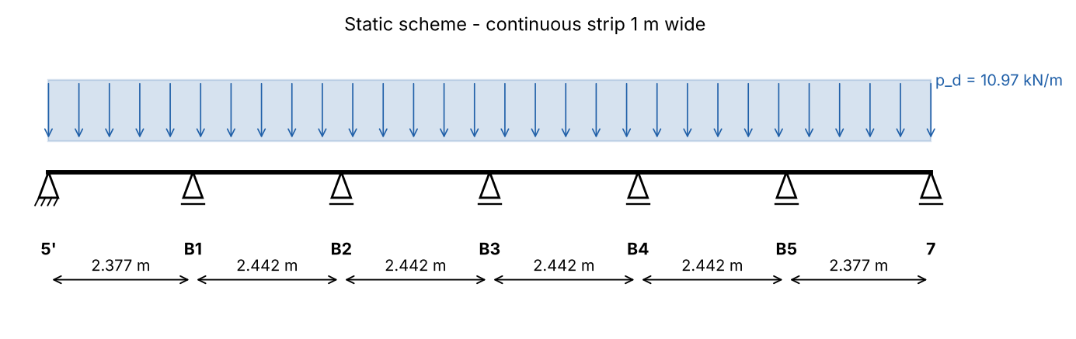
Figure 5. Static scheme of the slabs in the meeting room
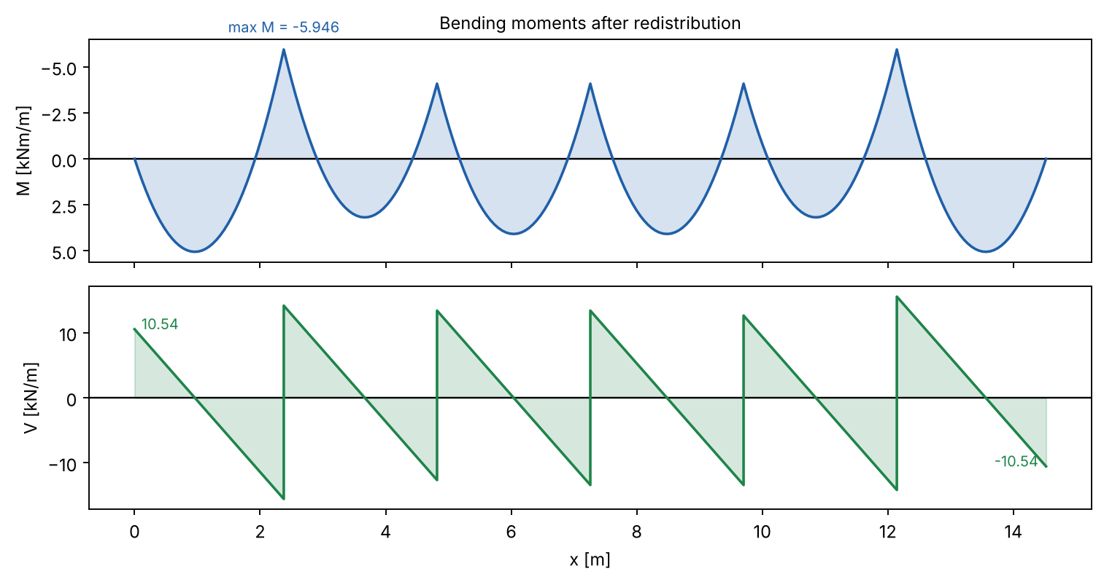
Figure 6. Bending moments and shear forces - plastic analysis

4. Design of the bending reinforcement
Design characteristics of the materials (EN 1992-1-1):
Concrete C25/30, reinforcing steel B500.
Characteristic cylinder strength of concrete
$$f_{ck}=25 N/mm²$$
Design compressive strength
$$f_{cd}=\frac{α_{cc}·f_{ck}}{γ_{c}}=\frac{1·25}{1.5}=16.67 N/mm²$$
Mean tensile strength
$$f_{ctm}=2.56 N/mm²$$
Characteristic yield strength of steel
$$f_{yk}=500 N/mm²$$
Design yield strength of steel
$$f_{yd}=\frac{f_{yk}}{γ_{s}}=\frac{500}{1.15}=434.8 N/mm²$$
Effective depth of the cross-section:
c_nom = 25 mm (XC1, 50 years), assumed bar Φ10
$$d=h_{f}−c_{nom}−\frac{φ}{2}=120−25−\frac{10}{2}=90 mm$$
End span (bottom)
Relative design moment
$$μ_{Ed,1}=\frac{\left|M_{Ed,1}\right|·10⁶}{b·d^{2}·f_{cd}}=\frac{\left|5.634\right|·10⁶}{1000·{90}^{2}·16.67}=0.0417$$
$$μ_{Ed,1}=0.0417 ≤ μ_{l​im}=0.295$$
✔ Single reinforcement is sufficient
Lever arm ratio z/d
$$ζ_{1}=0.5·\left(1+\sqrt{1−2·μ_{Ed,1}}\right)=0.5·\left(1+\sqrt{1−2·0.0417}\right)=0.9787$$
Required reinforcement
$$A_{s,req,1}=\frac{\left|M_{Ed,1}\right|·10⁶}{ζ_{1}·d·f_{yd}}=\frac{\left|5.634\right|·10⁶}{0.9787·90·434.8}=147.1 mm²/m$$
Minimum reinforcement (EC2 9.2.1.1)
$$A_{s,m​in,1}=max\left(\frac{0.26·f_{ctm}}{f_{yk}}·b·d ; 0.0013·b·d\right)=max\left(\frac{0.26·2.56}{500}·1000·90 ; 0.0013·1000·90\right)=120 mm²/m$$
Provided reinforcement: 5Φ8/20 cm → A_s,prov = 251.3 mm²/m
Required reinforcement ratio
$$ρ_{1}=\frac{A_{s}}{b·d}=\frac{147.1}{1000·90}=0.00163$$
Provided reinforcement ratio
$$ρ_{prov,1}=\frac{A_{s,prov}}{b·d}=\frac{251.3}{1000·90}=0.00279$$
First interior support (top)
Relative design moment
$$μ_{Ed,B}=\frac{\left|M_{Ed,B}\right|·10⁶}{b·d^{2}·f_{cd}}=\frac{\left|5.946\right|·10⁶}{1000·{90}^{2}·16.67}=0.044$$
$$μ_{Ed,B}=0.044 ≤ μ_{l​im}=0.295$$
✔ Single reinforcement is sufficient
Lever arm ratio z/d
$$ζ_{B}=0.5·\left(1+\sqrt{1−2·μ_{Ed,B}}\right)=0.5·\left(1+\sqrt{1−2·0.044}\right)=0.9775$$
Required reinforcement
$$A_{s,req,B}=\frac{\left|M_{Ed,B}\right|·10⁶}{ζ_{B}·d·f_{yd}}=\frac{\left|5.946\right|·10⁶}{0.9775·90·434.8}=155.5 mm²/m$$
Minimum reinforcement (EC2 9.2.1.1)
$$A_{s,m​in,B}=max\left(\frac{0.26·f_{ctm}}{f_{yk}}·b·d ; 0.0013·b·d\right)=max\left(\frac{0.26·2.56}{500}·1000·90 ; 0.0013·1000·90\right)=120 mm²/m$$
Provided reinforcement: 5Φ8/20 cm → A_s,prov = 251.3 mm²/m
Required reinforcement ratio
$$ρ_{B}=\frac{A_{s}}{b·d}=\frac{155.5}{1000·90}=0.00173$$
Provided reinforcement ratio
$$ρ_{prov,B}=\frac{A_{s,prov}}{b·d}=\frac{251.3}{1000·90}=0.00279$$
Interior spans (bottom) and interior supports (top)
Relative design moment
$$μ_{Ed,2}=\frac{\left|M_{Ed,2}\right|·10⁶}{b·d^{2}·f_{cd}}=\frac{\left|4.088\right|·10⁶}{1000·{90}^{2}·16.67}=0.0303$$
$$μ_{Ed,2}=0.0303 ≤ μ_{l​im}=0.295$$
✔ Single reinforcement is sufficient
Lever arm ratio z/d
$$ζ_{2}=0.5·\left(1+\sqrt{1−2·μ_{Ed,2}}\right)=0.5·\left(1+\sqrt{1−2·0.0303}\right)=0.9846$$
Required reinforcement
$$A_{s,req,2}=\frac{\left|M_{Ed,2}\right|·10⁶}{ζ_{2}·d·f_{yd}}=\frac{\left|4.088\right|·10⁶}{0.9846·90·434.8}=106.1 mm²/m$$
Minimum reinforcement (EC2 9.2.1.1)
$$A_{s,m​in,2}=max\left(\frac{0.26·f_{ctm}}{f_{yk}}·b·d ; 0.0013·b·d\right)=max\left(\frac{0.26·2.56}{500}·1000·90 ; 0.0013·1000·90\right)=120 mm²/m$$
Provided reinforcement: 5Φ8/20 cm → A_s,prov = 251.3 mm²/m
Required reinforcement ratio
$$ρ_{2}=\frac{A_{s}}{b·d}=\frac{120}{1000·90}=0.00133$$
Provided reinforcement ratio
$$ρ_{prov,2}=\frac{A_{s,prov}}{b·d}=\frac{251.3}{1000·90}=0.00279$$
Ductility requirement for plastic analysis (EC2 5.6.2(2)): x_u/d ≤ 0.25 (C ≤ 50/60)
$$x_{u/d,1}=\frac{1−ζ}{0.4}=\frac{1−0.9787}{0.4}=0.0533$$
$$x_{u/d,1}=0.0533 ≤ 0.25$$
✔ Rotation capacity is sufficient
$$x_{u/d,B}=\frac{1−ζ}{0.4}=\frac{1−0.9775}{0.4}=0.0563$$
$$x_{u/d,B}=0.0563 ≤ 0.25$$
✔ Rotation capacity is sufficient
$$x_{u/d,2}=\frac{1−ζ}{0.4}=\frac{1−0.9846}{0.4}=0.0384$$
$$x_{u/d,2}=0.0384 ≤ 0.25$$
✔ Rotation capacity is sufficient

5. Design for shear
V_Ed,max = max(V_Ed,1; V_Ed,2; V_Ed,3) = 15.64 kN/m
Size factor
$$k=min\left(1+\sqrt{\frac{200}{d}} ; 2\right)=min\left(1+\sqrt{\frac{200}{90}} ; 2\right)=2$$
$$v_{m​in}=0.035·k^{\frac{3}{2}}·\sqrt{f_{ck}}=0.035·2^{\frac{3}{2}}·\sqrt{25}=0.495 N/mm²$$
Shear resistance without shear reinforcement (EC2 6.2.2)
$$V_{Rd,c}=\frac{C_{Rd,c}·k·\sqrt[3]{100·ρ_{l}·f_{ck}}·b·d}{10³}=\frac{0.12·2·\sqrt[3]{100·0.00279·25}·1000·90}{10³}=41.28 kN/m$$
$$V_{Rd,c,m​in}=\frac{v_{m​in}·b·d}{10³}=\frac{0.495·1000·90}{10³}=44.55 kN/m$$
V_Rd,c = max(V_Rd,c ; V_Rd,c,min) = 44.55 kN/m
$$V_{Ed,m​ax}=15.64 kN/m ≤ V_{Rd,c}=44.55 kN/m$$
✔ No shear reinforcement is required

6. Control of deflection (EC2 7.4.2)
End span of a continuous slab: K = 1.3
$$ρ_{0}=\sqrt{f_{ck}}·10⁻³=\sqrt{25}·10⁻³=0.005$$
Basic span/depth ratio, ρ ≤ ρ_0 (EC2 7.16a)
$${(l/d)}_{basic}=K·\left(11+\frac{1.5·\sqrt{f_{ck}}·ρ_{0}}{ρ}+3.2·\sqrt{f_{ck}}·{\left(\frac{ρ_{0}}{ρ}−1\right)}^{\frac{3}{2}}\right)$$
$$=1.3·\left(11+\frac{1.5·\sqrt{25}·0.005}{0.00163}+3.2·\sqrt{25}·{\left(\frac{0.005}{0.00163}−1\right)}^{\frac{3}{2}}\right)=105.6$$
Steel stress under the quasi-permanent load
$$σ_{s}=\frac{\frac{f_{yd}·\left(g_{k}+0.3·q_{k}\right)}{g_{d}+q_{d}}·A_{s,req}}{A_{s,prov}}=\frac{\frac{434.8·\left(4.46+0.3·3.3\right)}{6.021+4.95}·147.1}{251.3}=126.4 N/mm²$$
Correction factor 310/σ_s (≤ 1.5)
$$k_{σ}=min\left(\frac{310}{σ_{s}} ; 1.5\right)=min\left(\frac{310}{126.4} ; 1.5\right)=1.5$$
$${(l/d)}_{l​im}={(l/d)}_{basic}·k_{σ}=105.6·1.5=158.4$$
$$l/d=\frac{l_{eff}}{d}=\frac{2377}{90}=26.41$$
$$l/d=26.41 ≤ {(l/d)}_{l​im}=158.4$$
✔ Deflection need not be calculated (l/d check satisfied)

7. Detailing
Detailing of the reinforcement (EC2 9.3.1):
- Distribution (secondary) reinforcement: A_s,dist ≥ max(0.20·A_s; 3Φ8/m) = 150.8 mm²/m → Φ6/17.5 cm
- Spacing of main bars ≤ min(2·h_f; 250 mm) = 240 mm (adopted 200 mm); distribution bars ≤ min(3·h_f; 400 mm).
- Top reinforcement at end supports (monolithic connection): A_s3 ≥ max(0.25·A_s,span; A_s,min; 5Φ8/m), length 0.2·l_min from the face of the support + l_bd.
- Bottom bars are anchored at end supports with l_bd and lapped over interior supports; top bars over interior supports extend 0.3·l_min beyond the face of the support.
Table 8. Reinforcement of the slabs in the meeting room
Section | M_Ed [kNm/m] | A_s,req [mm²/m] | Adopted | A_s,prov [mm²/m]
End span | 5.634 | 147.1 | 5Φ8/20 cm | 251.3
First interior support | 5.946 | 155.5 | 5Φ8/20 cm | 251.3
Interior span/support | 4.088 | 120 | 5Φ8/20 cm | 251.3

IV. Design of reinforced concrete slabs spanning in two directions
Slabs 19, 20, 21 - offices, axes 4-7 / A-B. In direction x (along axis A) the slabs are continuous over the beams on axes 5 and 6; in direction y they are supported on the beams on axes A and B. Slabs 22 and 23 are the balconies (cantilevers, l = d) in front of slabs 19 and 21.

1. Static scheme
Clear span in direction x (axes 4-5, 5-6, 6-7)
$$l_{x,cl}=605 cm$$
Clear span in direction y (axes A-B)
$$l_{y,cl}=555 cm$$
Thickness of the slabs
$$h_{f}=15 cm$$
Support at a wall / edge beam: min(h/2; t/2)
$$a_{s}=min\left(\frac{h_{f}}{2} ; \frac{t}{2}\right)=min\left(\frac{15}{2} ; \frac{25}{2}\right)=7.5 cm$$
Slabs 19 and 21 (one continuous edge)
$$l_{eff,x1}=l_{x,cl}+a_{s}+\frac{t}{2}=605+7.5+\frac{25}{2}=625 cm$$
Slab 20 (both edges continuous)
$$l_{eff,x2}=l_{x,cl}+t=605+25=630 cm$$
Direction y
$$l_{eff,y}=l_{y,cl}+2·a_{s}=555+2·7.5=570 cm$$
$$λ_{1}=\frac{l_{eff,y}}{l_{eff,x1}}=\frac{570}{625}=0.912$$
$$λ_{1}=0.912 ≥ 0.5$$
✔ l_max/l_min ≤ 2 - slabs spanning in two directions
Clear length of the balconies (= d)
$$l_{c,cl}=170 cm$$
Effective length of the cantilever
$$l_{c}=l_{c,cl}+\frac{t}{2}=170+\frac{25}{2}=182.5 cm$$
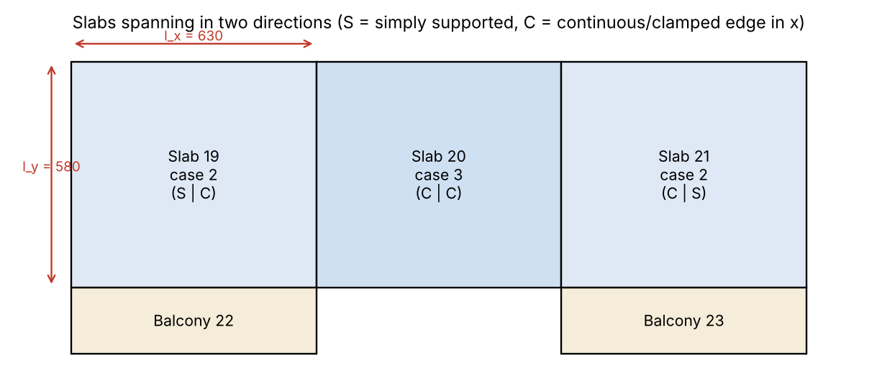
Figure 7. Slabs in two directions and boundary conditions

2. Actions
Characteristic values - permanent actions:
Self-weight of the slab (γ = 25 kN/m³)
$$g_{k,1}=h_{f}·25=0.15·25=3.75 kN/m²$$
Floor finishes, 5 cm (γ = 22 kN/m³)
$$g_{k,2}=0.05·22=1.1 kN/m²$$
Ceiling plaster, 2 cm (γ = 18 kN/m³)
$$g_{k,3}=0.02·18=0.36 kN/m²$$
Total permanent action
$${Σg}_{k}=g_{k,1}+g_{k,2}+g_{k,3}=3.75+1.1+0.36=5.21 kN/m²$$
Characteristic value - variable action:
Imposed load - offices
$$q_{k}=3.5 kN/m²$$
Design values (EN 1990, 6.10):
Permanent action, γ_G = 1.35
$$g_{d}=1.35·{Σg}_{k}=1.35·5.21=7.034 kN/m²$$
Variable action, γ_Q = 1.5
$$q_{d}=1.5·q_{k}=1.5·3.5=5.25 kN/m²$$
Total design load
$$p_{d}=g_{d}+q_{d}=7.034+5.25=12.28 kN/m²$$
Balconies - characteristic permanent actions:
Self-weight, variable thickness h_f → 12 cm (mean)
$$g_{k,c1}=\frac{h_{f}+h_{tip}}{200}·25=\frac{15+12}{200}·25=3.375 kN/m²$$
Perlite concrete 10 cm, screed 4 cm, mosaic 2 cm, plaster 2 cm
$$g_{k,c2}=0.1·6+0.04·22+0.02·22+0.02·18=2.28 kN/m²$$
$${Σg}_{k,c}=g_{k,c1}+g_{k,c2}=3.375+2.28=5.655 kN/m²$$
Imposed load on the balcony
$$q_{k,c}=3 kN/m²$$
$$g_{d,c}=1.35·{Σg}_{k,c}=1.35·5.655=7.634 kN/m²$$
$$q_{d,c}=1.5·q_{k,c}=1.5·3=4.5 kN/m²$$
Parapet (RC base 15/30 cm and metal railing):
$$G_{k,par}=0.15·0.3·25+\left(0.3+0.4+0.15\right)·0.02·18+0.8=2.231 kN/m$$
Horizontal load on the railing (h = 1.1 m)
$$H_{k}=0.5 kN/m$$
$$G_{d,par}=1.35·G_{k,par}=1.35·2.231=3.012 kN/m$$
$$H_{d}=1.5·H_{k}=1.5·0.5=0.75 kN/m$$

3. Static analysis

3.1 Cantilever slabs (balconies)
Bending moment at the root of the cantilever
$$M_{Ed,c}=\frac{g_{d,c}·{l_{c}}^{2}}{2}+\frac{q_{d,c}·{\left(l_{c}−b_{par}\right)}^{2}}{2}+G_{d,par}·\left(l_{c}−b_{par}\right)+H_{d}·1.1$$
$$=\frac{7.634·{1.825}^{2}}{2}+\frac{4.5·{\left(1.825−0.075\right)}^{2}}{2}+3.012·\left(1.825−0.075\right)+0.75·1.1=25.7 kNm/m$$
$$V_{Ed,c}=g_{d,c}·l_{c}+q_{d,c}·\left(l_{c}−b_{par}\right)+G_{d,par}=7.634·1.825+4.5·\left(1.825−0.075\right)+3.012=24.82 kN/m$$
Characteristic moment from permanent actions (restraint of the slab edge)
$$M_{k,cg}=\frac{{Σg}_{k,c}·{l_{c}}^{2}}{2}+G_{k,par}·\left(l_{c}−b_{par}\right)=\frac{5.655·{1.825}^{2}}{2}+2.231·\left(1.825−0.075\right)=13.32 kNm/m$$

3.2 Verification of the boundary condition between slabs and balconies
First approximation: the edge on axis A is restrained by the cantilever. Load carried in direction y (Marcus distribution, edge y fixed - other edge simply supported):
k = 2 for fixed-simple, k = 5 for simple-simple, k = 1 for fixed-fixed strips
$$χ_{y}=\frac{k_{x}·{l_{x}}^{4}}{k_{x}·{l_{x}}^{4}+k_{y}·{l_{y}}^{4}}=\frac{2·{6.25}^{4}}{2·{6.25}^{4}+2·{5.7}^{4}}=0.5911$$
Restraining moment required for a fixed edge (p·l²/8 of the propped strip)
$$M_{A,restr}=\frac{χ_{y}·p_{d}·{l_{y}}^{2}}{8}=\frac{0.5911·12.28·{5.7}^{2}}{8}=29.49 kNm/m$$
✔ M_A,restr > M_k,cg - the assumption of a fixed edge is NOT confirmed; the edge on axis A is treated as simply supported (case 2 / case 3 tables).

3.3 Bending moments in the spans - elastic analysis (plate theory)
The coefficients m are obtained from the theory of elastic plates (Lévy series, ν = 0) - the same basis as the tables of Marcus/Czerny used in the course. M = p·l²/m. For the maximum span moments the load is split into p' = g_d + q_d/2 acting on the slab with its real boundary conditions and p'' = q_d/2 acting on all slabs as simply supported (chequerboard loading).
Table 9. Moment coefficients (plate theory, ν = 0)
Case | Edges x | l_x [m] | l_y [m] | m_x | m_y | m_x,sup
1 | S - S | 6.25 | 5.7 | 33.45 | 22.5 | -
2 | S - C | 6.25 | 5.7 | 34.61 | 31.29 | 13.13
1 (l_x2) | S - S | 6.3 | 5.7 | 34.09 | 22.16 | -
3 | C - C | 6.3 | 5.7 | 40.03 | 45.33 | 15.42

$$p'=g_{d}+\frac{q_{d}}{2}=7.034+\frac{5.25}{2}=9.659 kN/m²$$
$$p''=\frac{q_{d}}{2}=\frac{5.25}{2}=2.625 kN/m²$$
Slabs 19 and 21 (case 2):
$$M_{Ed,x}=\left(\frac{p'}{m_{x2}}+\frac{p''}{m_{x1}}\right)·{l_{eff,x1}}^{2}=\left(\frac{9.659}{34.61}+\frac{2.625}{33.45}\right)·{6.25}^{2}=13.97 kNm/m$$
$$M_{Ed,y}=\left(\frac{p'}{m_{y2}}+\frac{p''}{m_{y1}}\right)·{l_{eff,y}}^{2}=\left(\frac{9.659}{31.29}+\frac{2.625}{22.5}\right)·{5.7}^{2}=13.82 kNm/m$$
Slab 20 (case 3):
$$M_{Ed,x,2}=\left(\frac{p'}{m_{x3}}+\frac{p''}{m_{x1}}\right)·{l_{eff,x2}}^{2}=\left(\frac{9.659}{40.03}+\frac{2.625}{34.09}\right)·{6.3}^{2}=12.63 kNm/m$$
$$M_{Ed,y,2}=\left(\frac{p'}{m_{y3}}+\frac{p''}{m_{y1}}\right)·{l_{eff,y}}^{2}=\left(\frac{9.659}{45.33}+\frac{2.625}{22.16}\right)·{5.7}^{2}=10.77 kNm/m$$

3.4 Bending moments over the supports (axes 5 and 6)
Clamped edge of slab 19
$$M_{19}=\frac{p_{d}·{l_{eff,x1}}^{2}}{m_{x2,s​up}}=\frac{12.28·{6.25}^{2}}{13.13}=36.53 kNm/m$$
Clamped edge of slab 20
$$M_{20}=\frac{p_{d}·{l_{eff,x2}}^{2}}{m_{x3,s​up}}=\frac{12.28·{6.3}^{2}}{15.42}=31.61 kNm/m$$
Ratio ≥ 0.8 → mean value of the two moments
$$M_{19-20}=\frac{M_{19}+M_{20}}{2}=\frac{36.53+31.61}{2}=34.07 kNm/m$$
Share of the load carried in direction x (Marcus)
$$χ_{x}=\frac{k_{y}·{l_{eff,y}}^{4}}{k_{x}·{l_{eff,x1}}^{4}+k_{y}·{l_{eff,y}}^{4}}=\frac{5·{5.7}^{4}}{2·{6.25}^{4}+5·{5.7}^{4}}=0.6336$$
Reduction to the face of the beam
$$ΔM=\frac{\frac{χ_{x}·p_{d}·l_{eff,x1}}{2}·t}{2}=\frac{\frac{0.6336·12.28·6.25}{2}·0.25}{2}=3.04 kNm/m$$
Design moment over the supports (absolute value)
$$M_{Ed,56}=M_{19-20}−ΔM=34.07−3.04=31.03 kNm/m$$

3.5 Shear forces
At the continuous edge (5/8 of the strip load)
$$V_{Ed,x}=0.625·χ_{x}·p_{d}·l_{eff,x1}=0.625·0.6336·12.28·6.25=30.4 kN/m$$
$$V_{Ed,y}=0.5·\left(1−χ_{x}\right)·p_{d}·l_{eff,y}=0.5·\left(1−0.6336\right)·12.28·5.7=12.83 kN/m$$

4. Design of the bending reinforcement
Design characteristics of the materials (EN 1992-1-1):
Concrete C25/30, reinforcing steel B500.
Characteristic cylinder strength of concrete
$$f_{ck}=25 N/mm²$$
Design compressive strength
$$f_{cd}=\frac{α_{cc}·f_{ck}}{γ_{c}}=\frac{1·25}{1.5}=16.67 N/mm²$$
Mean tensile strength
$$f_{ctm}=2.56 N/mm²$$
Characteristic yield strength of steel
$$f_{yk}=500 N/mm²$$
Design yield strength of steel
$$f_{yd}=\frac{f_{yk}}{γ_{s}}=\frac{500}{1.15}=434.8 N/mm²$$
Effective depth of the cross-section:
c_nom = 25 mm (XC1, 50 years), assumed bar Φ10
$$d_{x}=h_{f}−c_{nom}−\frac{φ}{2}=150−25−\frac{10}{2}=120 mm$$
Bars in direction y are placed above the bars in x
$$d_{y}=d_{x}−φ=120−10=110 mm$$
Slabs 19, 21 - direction x (bottom)
Relative design moment
$$μ_{Ed,x}=\frac{\left|M_{Ed,x}\right|·10⁶}{b·{d_{x}}^{2}·f_{cd}}=\frac{\left|13.97\right|·10⁶}{1000·{120}^{2}·16.67}=0.0582$$
$$μ_{Ed,x}=0.0582 ≤ μ_{l​im}=0.295$$
✔ Single reinforcement is sufficient
Lever arm ratio z/d
$$ζ_{x}=0.5·\left(1+\sqrt{1−2·μ_{Ed,x}}\right)=0.5·\left(1+\sqrt{1−2·0.0582}\right)=0.97$$
Required reinforcement
$$A_{s,req,x}=\frac{\left|M_{Ed,x}\right|·10⁶}{ζ_{x}·d_{x}·f_{yd}}=\frac{\left|13.97\right|·10⁶}{0.97·120·434.8}=276 mm²/m$$
Minimum reinforcement (EC2 9.2.1.1)
$$A_{s,m​in,x}=max\left(\frac{0.26·f_{ctm}}{f_{yk}}·b·d_{x} ; 0.0013·b·d_{x}\right)$$
$$=max\left(\frac{0.26·2.56}{500}·1000·120 ; 0.0013·1000·120\right)=160.1 mm²/m$$
Provided reinforcement: Φ8/17.5 cm → A_s,prov = 287.2 mm²/m
Required reinforcement ratio
$$ρ_{x}=\frac{A_{s}}{b·d_{x}}=\frac{276}{1000·120}=0.0023$$
Provided reinforcement ratio
$$ρ_{prov,x}=\frac{A_{s,prov}}{b·d_{x}}=\frac{287.2}{1000·120}=0.00239$$
Slabs 19, 21 - direction y (bottom)
Relative design moment
$$μ_{Ed,y}=\frac{\left|M_{Ed,y}\right|·10⁶}{b·{d_{y}}^{2}·f_{cd}}=\frac{\left|13.82\right|·10⁶}{1000·{110}^{2}·16.67}=0.0685$$
$$μ_{Ed,y}=0.0685 ≤ μ_{l​im}=0.295$$
✔ Single reinforcement is sufficient
Lever arm ratio z/d
$$ζ_{y}=0.5·\left(1+\sqrt{1−2·μ_{Ed,y}}\right)=0.5·\left(1+\sqrt{1−2·0.0685}\right)=0.9645$$
Required reinforcement
$$A_{s,req,y}=\frac{\left|M_{Ed,y}\right|·10⁶}{ζ_{y}·d_{y}·f_{yd}}=\frac{\left|13.82\right|·10⁶}{0.9645·110·434.8}=299.6 mm²/m$$
Minimum reinforcement (EC2 9.2.1.1)
$$A_{s,m​in,y}=max\left(\frac{0.26·f_{ctm}}{f_{yk}}·b·d_{y} ; 0.0013·b·d_{y}\right)$$
$$=max\left(\frac{0.26·2.56}{500}·1000·110 ; 0.0013·1000·110\right)=146.7 mm²/m$$
Provided reinforcement: Φ8/16 cm → A_s,prov = 314.2 mm²/m
Required reinforcement ratio
$$ρ_{y}=\frac{A_{s}}{b·d_{y}}=\frac{299.6}{1000·110}=0.00272$$
Provided reinforcement ratio
$$ρ_{prov,y}=\frac{A_{s,prov}}{b·d_{y}}=\frac{314.2}{1000·110}=0.00286$$
Slab 20 - direction x (bottom)
Relative design moment
$$μ_{Ed,x2}=\frac{\left|M_{Ed,x,2}\right|·10⁶}{b·{d_{x}}^{2}·f_{cd}}=\frac{\left|12.63\right|·10⁶}{1000·{120}^{2}·16.67}=0.0526$$
$$μ_{Ed,x2}=0.0526 ≤ μ_{l​im}=0.295$$
✔ Single reinforcement is sufficient
Lever arm ratio z/d
$$ζ_{x2}=0.5·\left(1+\sqrt{1−2·μ_{Ed,x2}}\right)=0.5·\left(1+\sqrt{1−2·0.0526}\right)=0.973$$
Required reinforcement
$$A_{s,req,x2}=\frac{\left|M_{Ed,x,2}\right|·10⁶}{ζ_{x2}·d_{x}·f_{yd}}=\frac{\left|12.63\right|·10⁶}{0.973·120·434.8}=248.8 mm²/m$$
Minimum reinforcement (EC2 9.2.1.1)
$$A_{s,m​in,x2}=max\left(\frac{0.26·f_{ctm}}{f_{yk}}·b·d_{x} ; 0.0013·b·d_{x}\right)$$
$$=max\left(\frac{0.26·2.56}{500}·1000·120 ; 0.0013·1000·120\right)=160.1 mm²/m$$
Provided reinforcement: 5Φ8/20 cm → A_s,prov = 251.3 mm²/m
Required reinforcement ratio
$$ρ_{x2}=\frac{A_{s}}{b·d_{x}}=\frac{248.8}{1000·120}=0.00207$$
Provided reinforcement ratio
$$ρ_{prov,x2}=\frac{A_{s,prov}}{b·d_{x}}=\frac{251.3}{1000·120}=0.00209$$
Slab 20 - direction y (bottom)
Relative design moment
$$μ_{Ed,y2}=\frac{\left|M_{Ed,y,2}\right|·10⁶}{b·{d_{y}}^{2}·f_{cd}}=\frac{\left|10.77\right|·10⁶}{1000·{110}^{2}·16.67}=0.0534$$
$$μ_{Ed,y2}=0.0534 ≤ μ_{l​im}=0.295$$
✔ Single reinforcement is sufficient
Lever arm ratio z/d
$$ζ_{y2}=0.5·\left(1+\sqrt{1−2·μ_{Ed,y2}}\right)=0.5·\left(1+\sqrt{1−2·0.0534}\right)=0.9725$$
Required reinforcement
$$A_{s,req,y2}=\frac{\left|M_{Ed,y,2}\right|·10⁶}{ζ_{y2}·d_{y}·f_{yd}}=\frac{\left|10.77\right|·10⁶}{0.9725·110·434.8}=231.6 mm²/m$$
Minimum reinforcement (EC2 9.2.1.1)
$$A_{s,m​in,y2}=max\left(\frac{0.26·f_{ctm}}{f_{yk}}·b·d_{y} ; 0.0013·b·d_{y}\right)$$
$$=max\left(\frac{0.26·2.56}{500}·1000·110 ; 0.0013·1000·110\right)=146.7 mm²/m$$
Provided reinforcement: 5Φ8/20 cm → A_s,prov = 251.3 mm²/m
Required reinforcement ratio
$$ρ_{y2}=\frac{A_{s}}{b·d_{y}}=\frac{231.6}{1000·110}=0.00211$$
Provided reinforcement ratio
$$ρ_{prov,y2}=\frac{A_{s,prov}}{b·d_{y}}=\frac{251.3}{1000·110}=0.00228$$
Over the supports on axes 5 and 6 (top)
Relative design moment
$$μ_{Ed,56}=\frac{\left|M_{Ed,56}\right|·10⁶}{b·{d_{x}}^{2}·f_{cd}}=\frac{\left|31.03\right|·10⁶}{1000·{120}^{2}·16.67}=0.1293$$
$$μ_{Ed,56}=0.1293 ≤ μ_{l​im}=0.295$$
✔ Single reinforcement is sufficient
Lever arm ratio z/d
$$ζ_{56}=0.5·\left(1+\sqrt{1−2·μ_{Ed,56}}\right)=0.5·\left(1+\sqrt{1−2·0.1293}\right)=0.9305$$
Required reinforcement
$$A_{s,req,56}=\frac{\left|M_{Ed,56}\right|·10⁶}{ζ_{56}·d_{x}·f_{yd}}=\frac{\left|31.03\right|·10⁶}{0.9305·120·434.8}=639.2 mm²/m$$
Minimum reinforcement (EC2 9.2.1.1)
$$A_{s,m​in,56}=max\left(\frac{0.26·f_{ctm}}{f_{yk}}·b·d_{x} ; 0.0013·b·d_{x}\right)$$
$$=max\left(\frac{0.26·2.56}{500}·1000·120 ; 0.0013·1000·120\right)=160.1 mm²/m$$
Provided reinforcement: Φ12/17.5 cm → A_s,prov = 646.3 mm²/m
Required reinforcement ratio
$$ρ_{56}=\frac{A_{s}}{b·d_{x}}=\frac{639.2}{1000·120}=0.00533$$
Provided reinforcement ratio
$$ρ_{prov,56}=\frac{A_{s,prov}}{b·d_{x}}=\frac{646.3}{1000·120}=0.00539$$
Balconies - top reinforcement at the root of the cantilever:
Relative design moment
$$μ_{Ed,c}=\frac{\left|M_{Ed,c}\right|·10⁶}{b·{d_{x}}^{2}·f_{cd}}=\frac{\left|25.7\right|·10⁶}{1000·{120}^{2}·16.67}=0.1071$$
$$μ_{Ed,c}=0.1071 ≤ μ_{l​im}=0.295$$
✔ Single reinforcement is sufficient
Lever arm ratio z/d
$$ζ_{c}=0.5·\left(1+\sqrt{1−2·μ_{Ed,c}}\right)=0.5·\left(1+\sqrt{1−2·0.1071}\right)=0.9432$$
Required reinforcement
$$A_{s,req,c}=\frac{\left|M_{Ed,c}\right|·10⁶}{ζ_{c}·d_{x}·f_{yd}}=\frac{\left|25.7\right|·10⁶}{0.9432·120·434.8}=522.2 mm²/m$$
Minimum reinforcement (EC2 9.2.1.1)
$$A_{s,m​in,c}=max\left(\frac{0.26·f_{ctm}}{f_{yk}}·b·d_{x} ; 0.0013·b·d_{x}\right)$$
$$=max\left(\frac{0.26·2.56}{500}·1000·120 ; 0.0013·1000·120\right)=160.1 mm²/m$$
Provided reinforcement: Φ10/15 cm → A_s,prov = 523.6 mm²/m
Required reinforcement ratio
$$ρ_{c}=\frac{A_{s}}{b·d_{x}}=\frac{522.2}{1000·120}=0.00435$$
Provided reinforcement ratio
$$ρ_{prov,c}=\frac{A_{s,prov}}{b·d_{x}}=\frac{523.6}{1000·120}=0.00436$$

5. Design for shear
V_Ed,max = max(V_Ed,x; V_Ed,y; V_Ed,c) = 30.4 kN/m
Size factor
$$k=min\left(1+\sqrt{\frac{200}{d_{x}}} ; 2\right)=min\left(1+\sqrt{\frac{200}{120}} ; 2\right)=2$$
$$v_{m​in}=0.035·k^{\frac{3}{2}}·\sqrt{f_{ck}}=0.035·2^{\frac{3}{2}}·\sqrt{25}=0.495 N/mm²$$
Shear resistance without shear reinforcement (EC2 6.2.2)
$$V_{Rd,c}=\frac{C_{Rd,c}·k·\sqrt[3]{100·ρ_{l}·f_{ck}}·b·d_{x}}{10³}=\frac{0.12·2·\sqrt[3]{100·0.00436·25}·1000·120}{10³}=63.87 kN/m$$
$$V_{Rd,c,m​in}=\frac{v_{m​in}·b·d_{x}}{10³}=\frac{0.495·1000·120}{10³}=59.4 kN/m$$
V_Rd,c = max(V_Rd,c ; V_Rd,c,min) = 63.87 kN/m
$$V_{Ed,m​ax}=30.4 kN/m ≤ V_{Rd,c}=63.87 kN/m$$
✔ No shear reinforcement is required

6. Control of deflection (EC2 7.4.2)
Two-way slab - the shorter span is checked; one edge continuous: K = 1.3
$$ρ_{0}=\sqrt{f_{ck}}·10⁻³=\sqrt{25}·10⁻³=0.005$$
Basic span/depth ratio, ρ ≤ ρ_0 (EC2 7.16a)
$${(l/d)}_{basic}=K·\left(11+\frac{1.5·\sqrt{f_{ck}}·ρ_{0}}{ρ}+3.2·\sqrt{f_{ck}}·{\left(\frac{ρ_{0}}{ρ}−1\right)}^{\frac{3}{2}}\right)$$
$$=1.3·\left(11+\frac{1.5·\sqrt{25}·0.005}{0.00272}+3.2·\sqrt{25}·{\left(\frac{0.005}{0.00272}−1\right)}^{\frac{3}{2}}\right)=48.1$$
Steel stress under the quasi-permanent load
$$σ_{s}=\frac{\frac{f_{yd}·\left(g_{k}+0.3·q_{k}\right)}{g_{d}+q_{d}}·A_{s,req}}{A_{s,prov}}=\frac{\frac{434.8·\left(5.21+0.3·3.5\right)}{7.034+5.25}·299.6}{314.2}=211.3 N/mm²$$
Correction factor 310/σ_s (≤ 1.5)
$$k_{σ}=min\left(\frac{310}{σ_{s}} ; 1.5\right)=min\left(\frac{310}{211.3} ; 1.5\right)=1.467$$
$${(l/d)}_{l​im}={(l/d)}_{basic}·k_{σ}=48.1·1.467=70.57$$
$$l/d=\frac{l_{eff}}{d_{y}}=\frac{5700}{110}=51.82$$
$$l/d=51.82 ≤ {(l/d)}_{l​im}=70.57$$
✔ Deflection need not be calculated (l/d check satisfied)
Balcony (cantilever): K = 0.4
$$ρ_{0}=\sqrt{f_{ck}}·10⁻³=\sqrt{25}·10⁻³=0.005$$
Basic span/depth ratio, ρ ≤ ρ_0 (EC2 7.16a)
$${(l/d)}_{basic}=K·\left(11+\frac{1.5·\sqrt{f_{ck}}·ρ_{0}}{ρ}+3.2·\sqrt{f_{ck}}·{\left(\frac{ρ_{0}}{ρ}−1\right)}^{\frac{3}{2}}\right)$$
$$=0.4·\left(11+\frac{1.5·\sqrt{25}·0.005}{0.00435}+3.2·\sqrt{25}·{\left(\frac{0.005}{0.00435}−1\right)}^{\frac{3}{2}}\right)=8.215$$
Steel stress under the quasi-permanent load
$$σ_{s}=\frac{\frac{f_{yd}·\left(g_{k}+0.3·q_{k}\right)}{g_{d}+q_{d}}·A_{s,req}}{A_{s,prov}}=\frac{\frac{434.8·\left(5.655+0.3·3\right)}{7.634+4.5}·522.2}{523.6}=234.3 N/mm²$$
Correction factor 310/σ_s (≤ 1.5)
$$k_{σ}=min\left(\frac{310}{σ_{s}} ; 1.5\right)=min\left(\frac{310}{234.3} ; 1.5\right)=1.323$$
$${(l/d)}_{l​im}={(l/d)}_{basic}·k_{σ}=8.215·1.323=10.87$$
$$l/d=\frac{l_{eff}}{d_{x}}=\frac{1825}{120}=15.21$$
$$l/d=15.21 > {(l/d)}_{l​im}=10.87$$
✘ l/d too large - increase the depth

7. Reinforcement summary
Table 10. Reinforcement of the slabs in two directions
Location | M_Ed [kNm/m] | A_s,req [mm²/m] | Adopted | A_s,prov [mm²/m]
19/21 x | 13.97 | 276 | Φ8/17.5 cm | 287.2
19/21 y | 13.82 | 299.6 | Φ8/16 cm | 314.2
20 x | 12.63 | 248.8 | 5Φ8/20 cm | 251.3
20 y | 10.77 | 231.6 | 5Φ8/20 cm | 251.3
supports 5, 6 | 31.03 | 639.2 | Φ12/17.5 cm | 646.3
balcony root | 25.7 | 522.2 | Φ10/15 cm | 523.6

Note: the simplified l/d check of the cantilever is not satisfied. The balconies are made with a root thickness h_f and a tip thickness of 12 cm; increase the root thickness or verify the deflection by calculation (EC2 7.4.3).

V. Design of reinforced concrete stairs
Two-flight staircase between axes 3 and 4. Storey height H = h_b = 290 cm, intermediate landing at H/2. Width of a flight d = 170 cm.

1. Geometry and static scheme
Height of the storey served by the stair
$$H=290 cm$$
Height of one flight
$$H_{fl}=\frac{H}{2}=\frac{290}{2}=145 cm$$
Number of risers in a flight (riser ≤ 17.5 cm)
$$n=9$$
Height of a riser
$$h_{st}=\frac{H_{fl}}{n}=\frac{145}{9}=16.11 cm$$
Width of a tread (2·h_st + b_st ≈ 62-64 cm)
$$b_{st}=30 cm$$
$${2h}_{st+b_st}=2·h_{st}+b_{st}=2·16.11+30=62.22 cm$$
Horizontal projection of the flight
$$l_{fl}=\left(n−1\right)·b_{st}=\left(9−1\right)·30=240 cm$$
Depth of the landing (= d)
$$l_{la}=170 cm$$
Inclination of the flight
$$α=arctan\left(\frac{h_{st}}{b_{st}}\right)=arctan\left(\frac{16.11}{30}\right)=28.24 °$$
Thickness of the waist slab
$$h=17 cm$$
Span of the simply supported model (flight + landing)
$$l_{eff}=l_{fl}+l_{la}=240+170=410 cm$$
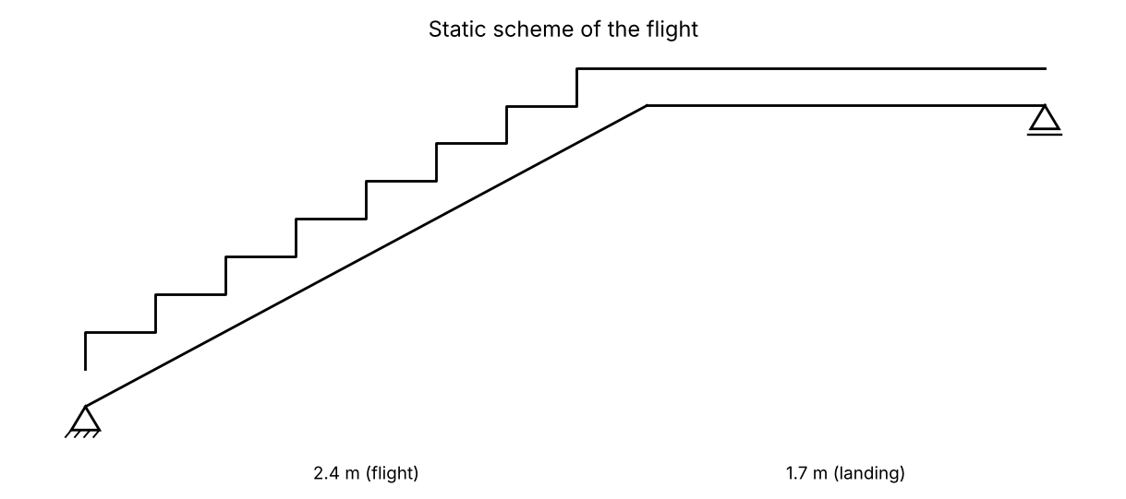
Figure 8. Flight and landing - simply supported inclined slab

2. Actions (per 1 m width)
Flight (per m² of plan):
Waist slab (h/cos α) and steps (h_st/2)
$$g_{k,1}=\frac{h}{cos α}·25+\frac{h_{st}}{2}·25=\frac{0.17}{0.881}·25+\frac{0.1611}{2}·25=6.838 kN/m²$$
Plaster
$$g_{k,2}=\frac{0.02}{cos α}·18=\frac{0.02}{0.881}·18=0.4086 kN/m²$$
Finishing of the steps
$$g_{k,3}=1 kN/m²$$
$$g_{k,fl}=g_{k,1}+g_{k,2}+g_{k,3}=6.838+0.4086+1=8.247 kN/m²$$
Landing:
$$g_{k,la}=h·25+0.02·18+1=0.17·25+0.02·18+1=5.61 kN/m²$$
Imposed load on stairs
$$q_{k}=3 kN/m²$$
Design load on the flight
$$p_{fl}=1.35·g_{k,fl}+1.5·q_{k}=1.35·8.247+1.5·3=15.63 kN/m$$
Design load on the landing
$$p_{la}=1.35·g_{k,la}+1.5·q_{k}=1.35·5.61+1.5·3=12.07 kN/m$$

3. Static analysis
Reaction at the lower support
$$R_{A}=\frac{p_{fl}·l_{fl}·\left(l_{eff}−\frac{l_{fl}}{2}\right)+\frac{p_{la}·{l_{la}}^{2}}{2}}{l_{eff}}=\frac{15.63·2.4·\left(4.1−\frac{2.4}{2}\right)+\frac{12.07·{1.7}^{2}}{2}}{4.1}=30.79 kN/m$$
$$R_{B}=p_{fl}·l_{fl}+p_{la}·l_{la}−R_{A}=15.63·2.4+12.07·1.7−30.79=27.25 kN/m$$
Section with V = 0 (on the flight)
$$x_{0}=\frac{R_{A}}{p_{fl}}=\frac{30.79}{15.63}=1.97 m$$
$${maxM}_{Ed}=\frac{{R_{A}}^{2}}{2·p_{fl}}=\frac{{30.79}^{2}}{2·15.63}=30.33 kNm/m$$
$${maxV}_{Ed}=max\left(R_{A} ; R_{B}\right)=max\left(30.79 ; 27.25\right)=30.79 kN/m$$
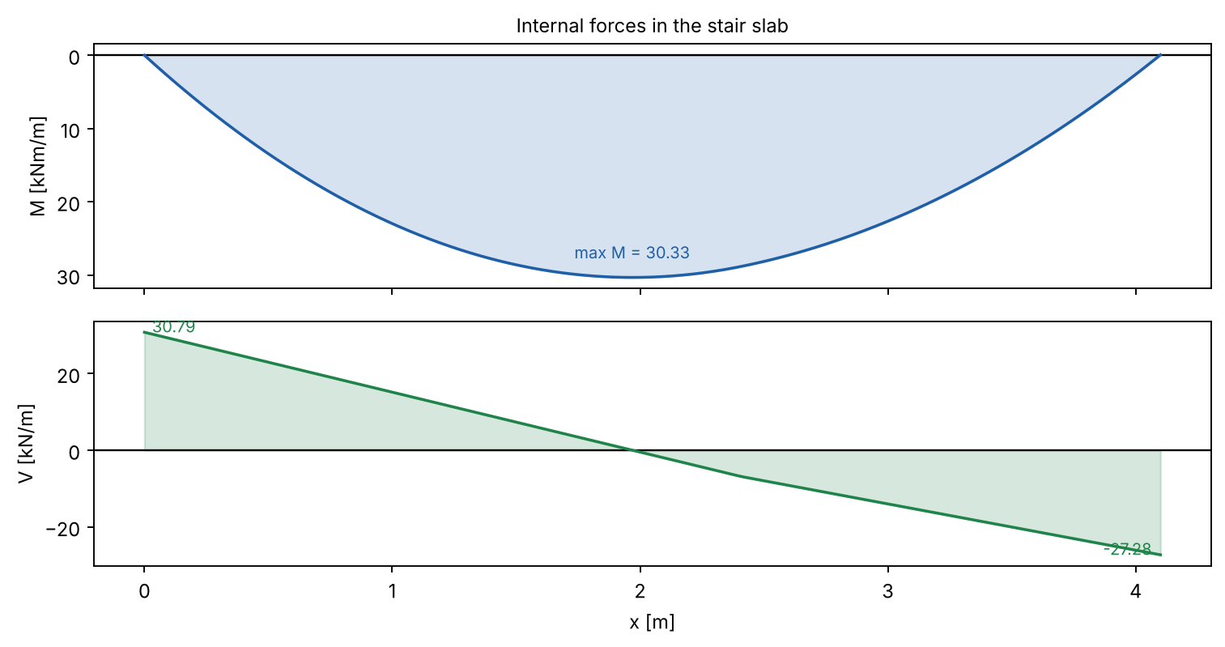
Figure 9. Bending moment and shear force in the stair

4. Design of the section
Design characteristics of the materials (EN 1992-1-1):
Concrete C25/30, reinforcing steel B500.
Characteristic cylinder strength of concrete
$$f_{ck}=25 N/mm²$$
Design compressive strength
$$f_{cd}=\frac{α_{cc}·f_{ck}}{γ_{c}}=\frac{1·25}{1.5}=16.67 N/mm²$$
Mean tensile strength
$$f_{ctm}=2.56 N/mm²$$
Characteristic yield strength of steel
$$f_{yk}=500 N/mm²$$
Design yield strength of steel
$$f_{yd}=\frac{f_{yk}}{γ_{s}}=\frac{500}{1.15}=434.8 N/mm²$$
$$d=h−c_{nom}−\frac{φ}{2}=170−25−\frac{12}{2}=139 mm$$
Bottom reinforcement of the flight
Relative design moment
$$μ_{Ed}=\frac{\left|{maxM}_{Ed}\right|·10⁶}{b·d^{2}·f_{cd}}=\frac{\left|30.33\right|·10⁶}{1000·{139}^{2}·16.67}=0.0942$$
$$μ_{Ed}=0.0942 ≤ μ_{l​im}=0.295$$
✔ Single reinforcement is sufficient
Lever arm ratio z/d
$$ζ=0.5·\left(1+\sqrt{1−2·μ_{Ed}}\right)=0.5·\left(1+\sqrt{1−2·0.0942}\right)=0.9505$$
Required reinforcement
$$A_{s,req}=\frac{\left|{maxM}_{Ed}\right|·10⁶}{ζ·d·f_{yd}}=\frac{\left|30.33\right|·10⁶}{0.9505·139·434.8}=528 mm²/m$$
Minimum reinforcement (EC2 9.2.1.1)
$$A_{s,m​in}=max\left(\frac{0.26·f_{ctm}}{f_{yk}}·b·d ; 0.0013·b·d\right)$$
$$=max\left(\frac{0.26·2.56}{500}·1000·139 ; 0.0013·1000·139\right)=185.4 mm²/m$$
Provided reinforcement: Φ10/14 cm → A_s,prov = 561 mm²/m
Required reinforcement ratio
$$ρ=\frac{A_{s}}{b·d}=\frac{528}{1000·139}=0.0038$$
Provided reinforcement ratio
$$ρ_{prov}=\frac{A_{s,prov}}{b·d}=\frac{561}{1000·139}=0.00404$$

5. Shear
Size factor
$$k=min\left(1+\sqrt{\frac{200}{d}} ; 2\right)=min\left(1+\sqrt{\frac{200}{139}} ; 2\right)=2$$
$$v_{m​in}=0.035·k^{\frac{3}{2}}·\sqrt{f_{ck}}=0.035·2^{\frac{3}{2}}·\sqrt{25}=0.495 N/mm²$$
Shear resistance without shear reinforcement (EC2 6.2.2)
$$V_{Rd,c}=\frac{C_{Rd,c}·k·\sqrt[3]{100·ρ_{l}·f_{ck}}·b·d}{10³}=\frac{0.12·2·\sqrt[3]{100·0.00404·25}·1000·139}{10³}=72.09 kN/m$$
$$V_{Rd,c,m​in}=\frac{v_{m​in}·b·d}{10³}=\frac{0.495·1000·139}{10³}=68.8 kN/m$$
V_Rd,c = max(V_Rd,c ; V_Rd,c,min) = 72.09 kN/m
$${maxV}_{Ed}=30.79 kN/m ≤ V_{Rd,c}=72.09 kN/m$$
✔ No shear reinforcement is required

6. Control of deflection
$$ρ_{0}=\sqrt{f_{ck}}·10⁻³=\sqrt{25}·10⁻³=0.005$$
Basic span/depth ratio, ρ ≤ ρ_0 (EC2 7.16a)
$${(l/d)}_{basic}=K·\left(11+\frac{1.5·\sqrt{f_{ck}}·ρ_{0}}{ρ}+3.2·\sqrt{f_{ck}}·{\left(\frac{ρ_{0}}{ρ}−1\right)}^{\frac{3}{2}}\right)$$
$$=1·\left(11+\frac{1.5·\sqrt{25}·0.005}{0.0038}+3.2·\sqrt{25}·{\left(\frac{0.005}{0.0038}−1\right)}^{\frac{3}{2}}\right)=23.72$$
Steel stress under the quasi-permanent load
$$σ_{s}=\frac{\frac{f_{yd}·\left(g_{k}+0.3·q_{k}\right)}{g_{d}+q_{d}}·A_{s,req}}{A_{s,prov}}=\frac{\frac{434.8·\left(8.247+0.3·3\right)}{11.13+4.5}·528}{561}=239.4 N/mm²$$
Correction factor 310/σ_s (≤ 1.5)
$$k_{σ}=min\left(\frac{310}{σ_{s}} ; 1.5\right)=min\left(\frac{310}{239.4} ; 1.5\right)=1.295$$
$${(l/d)}_{l​im}={(l/d)}_{basic}·k_{σ}=23.72·1.295=30.71$$
$$l/d=\frac{l_{eff}}{d}=\frac{4100}{139}=29.5$$
$$l/d=29.5 ≤ {(l/d)}_{l​im}=30.71$$
✔ Deflection need not be calculated (l/d check satisfied)

7. Detailing
- Distribution bars Φ8/20 cm in every step and along the waist; top bars Φ8/20 cm at both ends (0.2·l), bottom bars bent at the kink between flight and landing are replaced by two crossing bars anchored with l_bd.

VI. Design of reinforced concrete simply supported beam
Beam B21 on axis 5 between axes A and B (offices). It carries the slabs 19 and 20 (two-way, h_f = 15 cm), its self-weight and a brick partition wall.

1. Static scheme and geometry
$$b_{w}=25 cm$$
$$h=60 cm$$
$$h_{f}=15 cm$$
Clear span (columns 25 cm on axes A and B)
$$l_{cl}=555 cm$$
a_i = min(h/2; t/2)
$$l_{eff}=l_{cl}+2·min\left(\frac{h}{2} ; \frac{t}{2}\right)=555+2·min\left(\frac{60}{2} ; \frac{25}{2}\right)=580 cm$$
The beam is on the short side of the slabs → triangular load (lines at 45°).

2. Actions
Characteristic permanent actions directly on the beam:
Self-weight of the beam
$$g_{k,1}=b_{w}·h·25=0.25·0.6·25=3.75 kN/m$$
Brick wall on the beam
$$g_{k,2}=t_{w}·\left(h_{s}−h\right)·γ_{w}=0.25·\left(3.1−0.6\right)·17=10.62 kN/m$$
Plaster of the wall
$$g_{k,3}=2·0.02·\left(h_{s}−h_{f}\right)·18=2·0.02·\left(3.1−0.15\right)·18=2.124 kN/m$$
$${ΣG}_{k}=g_{k,1}+g_{k,2}+g_{k,3}=3.75+10.62+2.124=16.5 kN/m$$
From the slabs 19 and 20 (peak value of the triangle):
$$g_{fk}=\frac{g_{k,slab}·l_{load}}{2}=\frac{5.21·5.8}{2}=15.11 kN/m$$
$$q_{fk}=\frac{q_{k,slab}·l_{load}}{2}=\frac{3.5·5.8}{2}=10.15 kN/m$$
Design values:
$$g_{d}=1.35·{ΣG}_{k}=1.35·16.5=22.27 kN/m$$
$$g_{fd}=1.35·g_{fk}=1.35·15.11=20.4 kN/m$$
$$q_{fd}=1.5·q_{fk}=1.5·10.15=15.23 kN/m$$

3. Static analysis
UDL: g·l²/8 ; triangle (both sides): 2·w_0·l²/12
$${maxM}_{Ed}=\frac{g_{d}·{l_{eff}}^{2}}{8}+\frac{2·\left(g_{fd}+q_{fd}\right)·{l_{eff}}^{2}}{12}=\frac{22.27·{5.8}^{2}}{8}+\frac{2·\left(20.4+15.23\right)·{5.8}^{2}}{12}=293.4 kNm$$
$${maxV}_{Ed}=\frac{g_{d}·l_{eff}}{2}+\frac{2·\left(g_{fd}+q_{fd}\right)·l_{eff}}{4}=\frac{22.27·5.8}{2}+\frac{2·\left(20.4+15.23\right)·5.8}{4}=167.9 kN$$
Quasi-permanent combination (ψ_2 = 0.3)
$$M_{qp}=\frac{{ΣG}_{k}·{l_{eff}}^{2}}{8}+\frac{2·\left(g_{fk}+0.3·q_{fk}\right)·{l_{eff}}^{2}}{12}=\frac{16.5·{5.8}^{2}}{8}+\frac{2·\left(15.11+0.3·10.15\right)·{5.8}^{2}}{12}=171.2 kNm$$
Bending moment at x = l/4 (from the analysis)
$$M_{Δx}=M(l/4)=207.6 kNm$$
Reaction from permanent actions (design) - for the columns
$$R_{g}=\frac{g_{d}·l_{eff}}{2}+\frac{2·g_{fd}·l_{eff}}{4}=\frac{22.27·5.8}{2}+\frac{2·20.4·5.8}{4}=123.7 kN$$
Reaction from variable actions (design)
$$R_{q}=\frac{2·q_{fd}·l_{eff}}{4}=\frac{2·15.23·5.8}{4}=44.15 kN$$
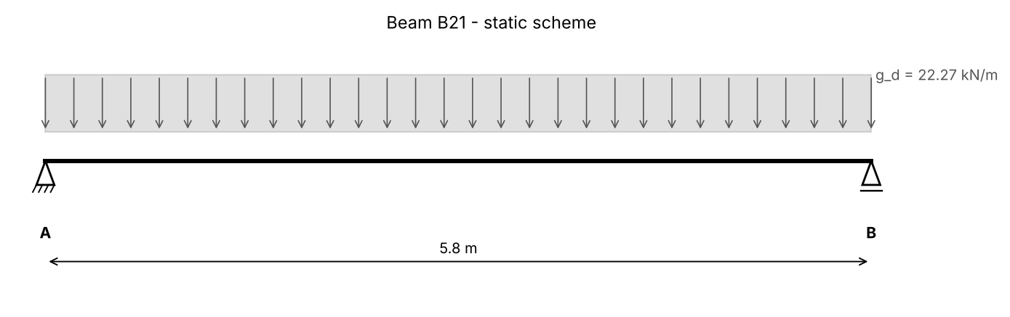
Figure 10. Static scheme of beam B21 (plus the triangular/trapezoidal load from the slabs)
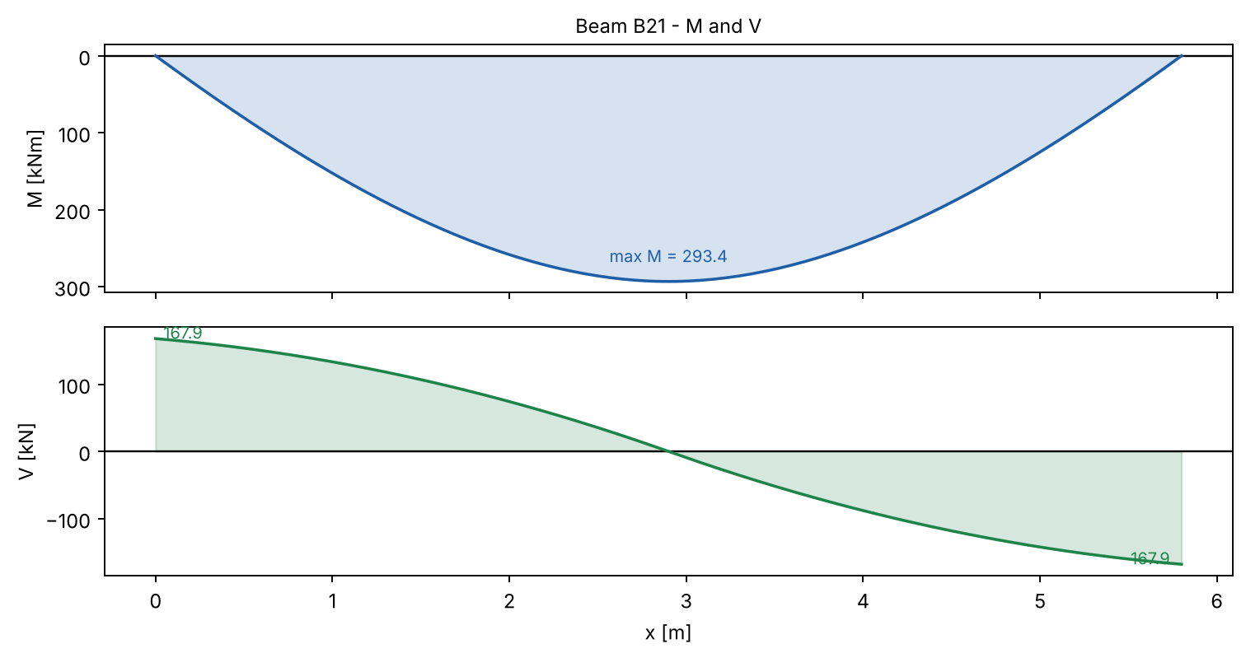
Figure 11. Bending moment and shear force diagrams of beam B21

4. Design of the bending reinforcement
Design characteristics of the materials (EN 1992-1-1):
Concrete C25/30, reinforcing steel B500.
Characteristic cylinder strength of concrete
$$f_{ck}=25 N/mm²$$
Design compressive strength
$$f_{cd}=\frac{α_{cc}·f_{ck}}{γ_{c}}=\frac{1·25}{1.5}=16.67 N/mm²$$
Mean tensile strength
$$f_{ctm}=2.56 N/mm²$$
Characteristic yield strength of steel
$$f_{yk}=500 N/mm²$$
Design yield strength of steel
$$f_{yd}=\frac{f_{yk}}{γ_{s}}=\frac{500}{1.15}=434.8 N/mm²$$
Effective depth (c_nom = 25 mm, links Φ8, main bars Φ20)
$$d=h−c_{nom}−φ_{w}−\frac{φ}{2}=600−25−8−\frac{20}{2}=557 mm$$
Effective width of the flange (T-section, EC2 5.3.2.1):
b_eff,i = 0.2·b_i + 0.1·l_0 ≤ 0.2·l_0 ; ≤ b_i
$$b_{eff,1}=min\left(0.2·b_{1}+0.1·l_{0} ; 0.2·l_{0} ; b_{1}\right)=min\left(0.2·3.025+0.1·5.8 ; 0.2·5.8 ; 3.025\right)=1.16 m$$
b_eff,i = 0.2·b_i + 0.1·l_0 ≤ 0.2·l_0 ; ≤ b_i
$$b_{eff,2}=min\left(0.2·b_{2}+0.1·l_{0} ; 0.2·l_{0} ; b_{2}\right)=min\left(0.2·3.025+0.1·5.8 ; 0.2·5.8 ; 3.025\right)=1.16 m$$
Effective width of the flange
$$b_{eff}=b_{w}+b_{eff,1}+b_{eff,2}=0.25+1.16+1.16=2.57 m$$
Compression force of the whole flange (0.8x = h_f)
$$F_{cd}=\frac{b_{eff}·h_{f}·f_{cd}}{10³}=\frac{2570·150·16.67}{10³}=6425 kN$$
Moment resisted by the flange
$$M_{f}=\frac{F_{cd}·\left(d−\frac{h_{f}}{2}\right)}{10³}=\frac{6425·\left(557−\frac{150}{2}\right)}{10³}=3097 kNm$$
$${maxM}_{Ed}=293.4 kNm ≤ M_{f}=3097 kNm$$
✔ The neutral axis is in the flange - rectangular section b = b_eff
Mid-span section
Relative design moment
$$μ_{Ed}=\frac{\left|{maxM}_{Ed}\right|·10⁶}{b_{eff}·d^{2}·f_{cd}}=\frac{\left|293.4\right|·10⁶}{2570·{557}^{2}·16.67}=0.0221$$
$$μ_{Ed}=0.0221 ≤ μ_{l​im}=0.295$$
✔ Single reinforcement is sufficient
Lever arm ratio z/d
$$ζ=0.5·\left(1+\sqrt{1−2·μ_{Ed}}\right)=0.5·\left(1+\sqrt{1−2·0.0221}\right)=0.9888$$
Required reinforcement
$$A_{s,req}=\frac{\left|{maxM}_{Ed}\right|·10⁶}{ζ·d·f_{yd}}=\frac{\left|293.4\right|·10⁶}{0.9888·557·434.8}=1225 mm²$$
Minimum reinforcement (EC2 9.2.1.1)
$$A_{s,m​in}=max\left(\frac{0.26·f_{ctm}}{f_{yk}}·b_{w}·d ; 0.0013·b_{w}·d\right)=max\left(\frac{0.26·2.56}{500}·250·557 ; 0.0013·250·557\right)=185.7 mm²$$
Provided reinforcement: 4Φ20 → A_s,prov = 1257 mm²
Required reinforcement ratio
$$ρ=\frac{A_{s}}{b_{w}·d}=\frac{1225}{250·557}=0.0088$$
Provided reinforcement ratio
$$ρ_{prov}=\frac{A_{s,prov}}{b_{w}·d}=\frac{1257}{250·557}=0.00902$$

5. Design for shear
Strut inclination θ: cot θ = 2.5 (θ = 21.8°)
Internal lever arm
$$z=0.9·d=0.9·557=501.3 mm$$
$$ν_{1}=0.6·\left(1−\frac{f_{ck}}{250}\right)=0.6·\left(1−\frac{25}{250}\right)=0.54$$
Resistance of the compression struts (EC2 6.9)
$$V_{Rd,m​ax}=\frac{\frac{b_{w}·z·ν_{1}·f_{cd}}{cot θ+\frac{1}{cot θ}}}{10³}=\frac{\frac{250·501.3·0.54·16.67}{2.5+\frac{1}{2.5}}}{10³}=388.9 kN$$
$${maxV}_{Ed}=167.9 kN ≤ V_{Rd,m​ax}=388.9 kN$$
✔ The concrete struts are not crushed
Size factor
$$k=min\left(1+\sqrt{\frac{200}{d}} ; 2\right)=min\left(1+\sqrt{\frac{200}{557}} ; 2\right)=1.599$$
$$v_{m​in}=0.035·k^{\frac{3}{2}}·\sqrt{f_{ck}}=0.035·{1.599}^{\frac{3}{2}}·\sqrt{25}=0.3539 N/mm²$$
Shear resistance without shear reinforcement (EC2 6.2.2)
$$V_{Rd,c}=\frac{C_{Rd,c}·k·\sqrt[3]{100·ρ_{l}·f_{ck}}·b_{w}·d}{10³}=\frac{0.12·1.599·\sqrt[3]{100·0.02·25}·250·557}{10³}=98.45 kN$$
$$V_{Rd,c,m​in}=\frac{v_{m​in}·b_{w}·d}{10³}=\frac{0.3539·250·557}{10³}=49.28 kN$$
V_Rd,c = max(V_Rd,c ; V_Rd,c,min) = 98.45 kN
$${maxV}_{Ed}=167.9 kN > V_{Rd,c}=98.45 kN$$
➜ Shear reinforcement is required - designed below
Required shear reinforcement (EC2 6.8)
$$A_{sw/s}=\frac{{maxV}_{Ed}·10³}{z·f_{yd}·cot θ}=\frac{167.9·10³}{501.3·434.8·2.5}=0.3081 mm²/mm$$
$$ρ_{w,m​in}=\frac{0.08·\sqrt{f_{ck}}}{f_{yk}}=\frac{0.08·\sqrt{25}}{500}=0.0008$$
$${(A}_{sw/s)_m​in}=ρ_{w,m​in}·b_{w}=0.0008·250=0.2 mm²/mm$$
Spacing of 2-leg links Φ8 (A_sw = 2·50.27 mm²)
$$s=\frac{A_{sw}}{{(A}_{sw/s)}}=\frac{100.5}{0.3081}=326.3 mm$$
Maximum longitudinal spacing of links (EC2 9.2.2)
$$s_{l,m​ax}=0.75·d=0.75·557=417.8 mm$$
Adopted links: Φ8/30 cm (2-leg) in the support zones
Additional tensile force in the longitudinal reinforcement (EC2 6.2.3(7))
$${ΔF}_{td}=0.5·{maxV}_{Ed}·cot θ=0.5·167.9·2.5=209.9 kN$$
Shear between the web and the flange (EC2 6.2.4):
Change of the longitudinal force in one flange outstand over Δx
$${ΔF}_{d}=\frac{\frac{M_{Δx}·10⁶}{d−\frac{h_{f}}{2}}·\frac{0.5·\left(b_{eff}−b_{w}\right)}{b_{eff}}}{10³}=\frac{\frac{207.6·10⁶}{557−\frac{150}{2}}·\frac{0.5·\left(2570−250\right)}{2570}}{10³}=194.4 kN$$
Longitudinal shear stress
$$v_{Ed}=\frac{{ΔF}_{d}·10³}{h_{f}·Δx}=\frac{194.4·10³}{150·1450}=0.8936 N/mm²$$
$$v_{Ed}=0.8936 N/mm² > {0.4·f}_{ctd}=0.4788$$
➜ Transverse reinforcement for the flange shear is needed - designed below
$$v_{Ed}=0.8936 N/mm² ≤ {ν·f}_{cd·sinθ·cosθ}=3.6$$
✔ The compression struts in the flange are adequate
Required transverse reinforcement in the flange
$$A_{sf/s_f}=\frac{v_{Ed}·h_{f}}{f_{yd}·{cot θ}_{f}}·1000=\frac{0.8936·150}{434.8·2}·1000=154.1 mm²/m$$

6. Deflection of the beam (EC2 7.4.3)
$$E_{cm}=31.48 GPa$$
Effective modulus (creep)
$$E_{c,eff}=\frac{E_{cm}}{1+φ(∞,t0)}=\frac{31.48}{1+2}=10.49 GPa$$
$$α_{e}=\frac{E_{s}}{E_{c,eff}}=\frac{200}{10.49}=19.06$$
Uncracked section (state I):
$$A_{I}=521954 mm²$$
$$x_{I}=161.8 mm$$
$$I_{I}=14380563347 mm⁴$$
Cracking moment
$$M_{cr}=\frac{\frac{f_{ctm}·I_{I}}{h−x_{I}}}{10⁶}=\frac{\frac{2.56·14380563347}{600−161.8}}{10⁶}=84.17 kNm$$
Cracked section (state II):
$$x_{II}=93 mm$$
$$I_{II}=5846339912 mm⁴$$
Distribution coefficient (EC2 7.19)
$$ζ=1−β·{\left(\frac{M_{cr}}{M_{qp}}\right)}^{2}=1−0.5·{\left(\frac{84.17}{171.2}\right)}^{2}=0.8791$$
Curvature from the quasi-permanent moment
$${1/r}_{m}=\frac{M_{qp}·10⁶}{E_{c,eff}·1000}·\left(\frac{ζ}{I_{II}}+\frac{1−ζ}{I_{I}}\right)$$
$$=\frac{171.2·10⁶}{10.49·1000}·\left(\frac{0.8791}{5846339912}+\frac{1−0.8791}{14380563347}\right)=0.00000259 1/mm$$
$$ε_{cd}=k_{h}·ε_{cd,0}=0.903·0.00045=0.000406$$
$$ε_{ca}=2.5·\left(f_{ck}−10\right)·10⁻⁶=2.5·\left(25−10\right)·10⁻⁶=0.000037$$
Total shrinkage strain
$$ε_{cs}=ε_{cd}+ε_{ca}=0.000406+0.000037=0.000444$$
Curvature from shrinkage (EC2 7.21)
$${1/r}_{cs}=ε_{cs}·α_{e}·\left(\frac{ζ·S_{II}}{I_{II}}+\frac{\left(1−ζ\right)·S_{I}}{I_{I}}\right)$$
$$=0.000444·19.06·\left(\frac{0.8791·583076}{5846339912}+\frac{\left(1−0.8791\right)·496646}{14380563347}\right)=0.000000777 1/mm$$
Deflection (k = 5/48)
$$f=5/48·\left({1/r}_{m}+{1/r}_{cs}\right)·{l_{eff}}^{2}=5/48·\left(0.00000259+0.000000777\right)·{5800}^{2}=11.8 mm$$
$$f_{l​im}=\frac{l_{eff}}{250}=\frac{5800}{250}=23.2 mm$$
$$f=11.8 mm ≤ f_{l​im}=23.2 mm$$
✔ The deflection is acceptable

VII. Design of reinforced concrete beam for torsion
Beam on axis E (Д) between axes 3 and 4 carrying the cantilever canopy slab 7 (length 1.25·d = 212.5 cm). Bending: simply supported beam. Torsion: both ends fixed against rotation (walls on axes 3 and 4).

1. Static scheme
$$b=25 cm$$
$$h=50 cm$$
Clear span between the walls (2d + 45 − 25)
$$l_{cl}=360 cm$$
Effective span for bending
$$l_{eff}=l_{cl}+2·min\left(\frac{h}{2} ; \frac{t}{2}\right)=360+2·min\left(\frac{50}{2} ; \frac{25}{2}\right)=385 cm$$
Effective span for torsion: l_T = l_cl = 360 cm
Length of the cantilever measured to the axis of the beam
$$l_{c}=1.25·d+b=2.125+0.125=2.25 m$$

2. Actions
Canopy slab 7 - characteristic permanent actions:
slab + plaster + screed 4 cm + insulation
$${Σg}_{k7}=h_{f7}·25+0.02·18+0.04·20+0.2=0.15·25+0.02·18+0.04·20+0.2=5.11 kN/m²$$
Snow
$$s_{k}=1 kN/m²$$
Torsional moment per metre (permanent)
$$M_{cg}=\frac{{Σg}_{k7}·{l_{c}}^{2}}{2}=\frac{5.11·{2.25}^{2}}{2}=12.93 kNm/m$$
$$R_{cg}={Σg}_{k7}·l_{c}=5.11·2.25=11.5 kN/m$$
$$M_{sk}=\frac{s_{k}·{l_{c}}^{2}}{2}=\frac{1·{2.25}^{2}}{2}=2.531 kNm/m$$
$$R_{sk}=s_{k}·l_{c}=1·2.25=2.25 kN/m$$
Self-weight and plaster of the beam
$$g_{k,b}=b·h·25+0.02·18·\left(2·h+b\right)=0.25·0.5·25+0.02·18·\left(2·0.5+0.25\right)=3.575 kN/m$$
$$g_{d}=1.35·\left(R_{cg}+g_{k,b}\right)=1.35·\left(11.5+3.575\right)=20.35 kN/m$$
$$q_{d}=1.5·R_{sk}=1.5·2.25=3.375 kN/m$$
$$p_{d}=g_{d}+q_{d}=20.35+3.375=23.72 kN/m$$
Distributed torsional moment
$$t_{d}=1.35·M_{cg}+1.5·M_{sk}=1.35·12.93+1.5·2.531=21.26 kNm/m$$

3. Static analysis
$$M_{Ed}=\frac{p_{d}·{l_{eff}}^{2}}{8}=\frac{23.72·{3.85}^{2}}{8}=43.95 kNm$$
$$V_{Ed}=\frac{p_{d}·l_{eff}}{2}=\frac{23.72·3.85}{2}=45.67 kN$$
Torsion - beam fixed at both ends
$$T_{Ed}=\frac{t_{d}·l_{T}}{2}=\frac{21.26·3.6}{2}=38.27 kNm$$
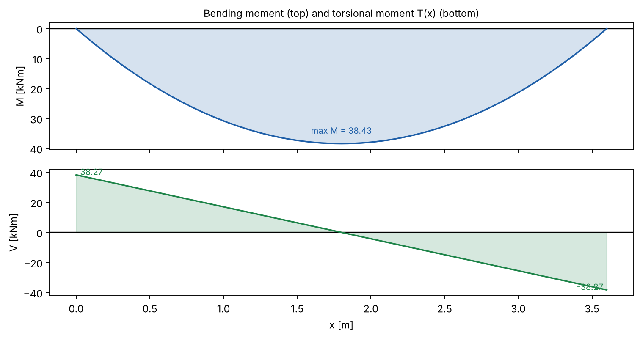
Figure 12. Internal forces of the beam subjected to torsion

4. Design of the cross-section for torsion (EC2 6.3)
Design characteristics of the materials (EN 1992-1-1):
Concrete C25/30, reinforcing steel B500.
Characteristic cylinder strength of concrete
$$f_{ck}=25 N/mm²$$
Design compressive strength
$$f_{cd}=\frac{α_{cc}·f_{ck}}{γ_{c}}=\frac{1·25}{1.5}=16.67 N/mm²$$
Mean tensile strength
$$f_{ctm}=2.56 N/mm²$$
Characteristic yield strength of steel
$$f_{yk}=500 N/mm²$$
Design yield strength of steel
$$f_{yd}=\frac{f_{yk}}{γ_{s}}=\frac{500}{1.15}=434.8 N/mm²$$
$$A=b·h=250·500=125000 mm²$$
$$u=2·\left(b+h\right)=2·\left(250+500\right)=1500 mm$$
Effective wall thickness
$$t_{ef}=\frac{A}{u}=\frac{125000}{1500}=83.33 mm$$
$$A_{k}=\left(b−t_{ef}\right)·\left(h−t_{ef}\right)=\left(250−83.33\right)·\left(500−83.33\right)=69444 mm²$$
$$u_{k}=2·\left(b−t_{ef}+h−t_{ef}\right)=2·\left(250−83.33+500−83.33\right)=1167 mm$$
Effective depth (c_nom = 25 mm, links Φ8, main bars Φ16)
$$d=h−c_{nom}−φ_{w}−\frac{φ}{2}=500−25−8−\frac{16}{2}=459 mm$$
$$ν=0.6·\left(1−\frac{f_{ck}}{250}\right)=0.6·\left(1−\frac{25}{250}\right)=0.54$$
Angle of the compression struts θ = 45° (cot θ = 1).
T_Rd,max = 2·ν·α_cw·f_cd·A_k·t_ef·sinθ·cosθ
$$T_{Rd,m​ax}=\frac{2·ν·f_{cd}·A_{k}·t_{ef}·0.5}{10⁶}=\frac{2·0.54·16.67·69444·83.33·0.5}{10⁶}=52.08 kNm$$
V_Rd,max = α_cw·b·z·ν·f_cd/(cotθ + tanθ)
$$V_{Rd,m​ax}=\frac{\frac{b·0.9·d·ν·f_{cd}}{2}}{10³}=\frac{\frac{250·0.9·459·0.54·16.67}{2}}{10³}=464.7 kN$$
Interaction torsion + shear (EC2 6.29)
$$η=\frac{T_{Ed}}{T_{Rd,m​ax}}+\frac{V_{Ed}}{V_{Rd,m​ax}}=\frac{38.27}{52.08}+\frac{45.67}{464.7}=0.833$$
$$η=0.833 ≤ 1$$
✔ The concrete section is adequate

5. Reinforcement
Links for shear (both legs)
$$A_{sw/s,V}=\frac{V_{Ed}·1000}{z·f_{yd}·1}=\frac{45.67·1000}{413.1·434.8·1}=0.2543 mm²/mm$$
Links for torsion (one leg)
$$A_{sw/s,T}=\frac{T_{Ed}·10⁶}{2·A_{k}·f_{yd}·1}=\frac{38.27·10⁶}{2·69444·434.8·1}=0.6337 mm²/mm$$
Total, one leg
$$A_{sw1/s}=\frac{A_{sw/s,V}}{2}+A_{sw/s,T}=\frac{0.2543}{2}+0.6337=0.7608 mm²/mm$$
Maximum spacing of torsion links
$$s_{m​ax}=min\left(\frac{u_{k}}{8} ; 0.75·d ; b\right)=min\left(\frac{1167}{8} ; 0.75·459 ; 250\right)=145.8 mm$$
Adopted closed links: Φ10/10 cm
Longitudinal reinforcement for torsion (cot θ = 1)
$${ΣA}_{sl}=\frac{T_{Ed}·10⁶·u_{k}}{2·A_{k}·f_{yd}}=\frac{38.27·10⁶·1167}{2·69444·434.8}=739.3 mm²$$
Bending reinforcement (rectangular section):
Relative design moment
$$μ_{Ed}=\frac{\left|M_{Ed}\right|·10⁶}{b·d^{2}·f_{cd}}=\frac{\left|43.95\right|·10⁶}{250·{459}^{2}·16.67}=0.0501$$
$$μ_{Ed}=0.0501 ≤ μ_{l​im}=0.295$$
✔ Single reinforcement is sufficient
Lever arm ratio z/d
$$ζ=0.5·\left(1+\sqrt{1−2·μ_{Ed}}\right)=0.5·\left(1+\sqrt{1−2·0.0501}\right)=0.9743$$
Required reinforcement
$$A_{s,req}=\frac{\left|M_{Ed}\right|·10⁶}{ζ·d·f_{yd}}=\frac{\left|43.95\right|·10⁶}{0.9743·459·434.8}=226.1 mm²$$
Minimum reinforcement (EC2 9.2.1.1)
$$A_{s,m​in}=max\left(\frac{0.26·f_{ctm}}{f_{yk}}·b·d ; 0.0013·b·d\right)=max\left(\frac{0.26·2.56}{500}·250·459 ; 0.0013·250·459\right)=153.1 mm²$$
Provided reinforcement: 2Φ12 → A_s,prov = 226.2 mm²
Required reinforcement ratio
$$ρ=\frac{A_{s}}{b·d}=\frac{226.1}{250·459}=0.00197$$
Provided reinforcement ratio
$$ρ_{prov}=\frac{A_{s,prov}}{b·d}=\frac{226.2}{250·459}=0.00197$$
Bottom face: bending + torsion share
$$A_{s,bot}=A_{s}+\frac{{ΣA}_{sl}·b_{k}}{u_{k}}=226.1+\frac{739.3·166.7}{1167}=331.7 mm²$$
Top face
$$A_{s,top}=\frac{{ΣA}_{sl}·b_{k}}{u_{k}}=\frac{739.3·166.7}{1167}=105.6 mm²$$
Each side face
$$A_{s,side}=\frac{{ΣA}_{sl}·h_{k}}{u_{k}}=\frac{739.3·416.7}{1167}=264 mm²$$
Adopted: bottom 3Φ12 (339.3 mm²), top 2Φ12 (226.2 mm²), side bars 3Φ12 on each face.

6. Canopy slab 7 - top reinforcement at the root of the cantilever
Design moment at the root (per metre)
$$M_{Ed,7}=1.35·M_{cg}+1.5·M_{sk}=1.35·12.93+1.5·2.531=21.26 kNm/m$$
$$d_{7}=h−c_{nom}−\frac{φ}{2}=150−25−\frac{10}{2}=120 mm$$
Relative design moment
$$μ_{Ed,7}=\frac{\left|M_{Ed,7}\right|·10⁶}{b·{d_{7}}^{2}·f_{cd}}=\frac{\left|21.26\right|·10⁶}{1000·{120}^{2}·16.67}=0.0886$$
$$μ_{Ed,7}=0.0886 ≤ μ_{l​im}=0.295$$
✔ Single reinforcement is sufficient
Lever arm ratio z/d
$$ζ_{7}=0.5·\left(1+\sqrt{1−2·μ_{Ed,7}}\right)=0.5·\left(1+\sqrt{1−2·0.0886}\right)=0.9536$$
Required reinforcement
$$A_{s,req,7}=\frac{\left|M_{Ed,7}\right|·10⁶}{ζ_{7}·d_{7}·f_{yd}}=\frac{\left|21.26\right|·10⁶}{0.9536·120·434.8}=427.3 mm²/m$$
Minimum reinforcement (EC2 9.2.1.1)
$$A_{s,m​in,7}=max\left(\frac{0.26·f_{ctm}}{f_{yk}}·b·d_{7} ; 0.0013·b·d_{7}\right)$$
$$=max\left(\frac{0.26·2.56}{500}·1000·120 ; 0.0013·1000·120\right)=160.1 mm²/m$$
Provided reinforcement: Φ10/17.5 cm → A_s,prov = 448.8 mm²/m
Required reinforcement ratio
$$ρ_{7}=\frac{A_{s}}{b·d_{7}}=\frac{427.3}{1000·120}=0.00356$$
Provided reinforcement ratio
$$ρ_{prov,7}=\frac{A_{s,prov}}{b·d_{7}}=\frac{448.8}{1000·120}=0.00374$$

VIII. Design of reinforced concrete continuous beams
Secondary beam B5 (and B6-B9) of the exhibition hall: continuous beam over two spans (axes 1-2-3), supported on the walls on axes 1 and 3 and on the frame beam B15 (axis 2). Load width = spacing of the beams = 251.7 cm.

1. Static scheme
$$b_{w}=25 cm$$
$$h=45 cm$$
Clear span
$$l_{cl}=602.5 cm$$
$$l_{eff}=l_{cl}+min\left(\frac{h}{2} ; \frac{t_{1}}{2}\right)+\frac{t_{2}}{2}=602.5+min\left(\frac{45}{2} ; \frac{25}{2}\right)+\frac{30}{2}=630 cm$$

2. Actions
Web of the beam
$$g_{k,1}=b_{w}·\left(h−h_{f}\right)·25=0.25·\left(0.45−0.12\right)·25=2.062 kN/m$$
Plaster
$$g_{k,2}=0.02·18·\left(2·\left(h−h_{f}\right)+b_{w}\right)=0.02·18·\left(2·\left(0.45−0.12\right)+0.25\right)=0.3276 kN/m$$
From the slab (load width s)
$$g_{k,3}=g_{k,slab}·s=4.46·2.517=11.22 kN/m$$
$${Σg}_{k}=g_{k,1}+g_{k,2}+g_{k,3}=2.062+0.3276+11.22=13.61 kN/m$$
Variable action from the slab
$$q_{k}=q_{k1}·s=5.6·2.517=14.09 kN/m$$
$$g_{d}=1.35·{Σg}_{k}=1.35·13.61=18.38 kN/m$$
$$q_{d}=1.5·q_{k}=1.5·14.09=21.14 kN/m$$

3. Static analysis
Continuous beam with two equal spans; permanent load on both spans, variable load in the most unfavourable arrangement (stiffness method, envelopes).
Span moment (q on one span)
$${maxM}_{Ed,1}=\left(α_{g}·g_{d}+α_{q}·q_{d}\right)·{l_{eff}}^{2}=\left(0.0698·18.38+0.0952·21.14\right)·{6.3}^{2}=130.8 kNm$$
Moment at the middle support (q on both spans)
$${minM}_{B}=−\left(α_{g}·g_{d}+α_{q}·q_{d}\right)·{l_{eff}}^{2}=−\left(0.125·18.38+0.125·21.14\right)·{6.3}^{2}=-196.1 kNm$$
Shear at the middle support (5/8·p·l)
$${maxV}_{Ed}=0.625·\left(g_{d}+q_{d}\right)·l_{eff}=0.625·\left(18.38+21.14\right)·6.3=155.6 kN$$
Maximum reaction at the end support
$$V_{Ed,A}=R_{A,m​ax}=101.7 kN$$
Reaction on the frame beam B15 (10/8·p·l)
$${maxR}_{B}=1.25·\left(g_{d}+q_{d}\right)·l_{eff}=1.25·\left(18.38+21.14\right)·6.3=311.2 kN$$
Characteristic reaction - permanent
$$R_{B,gk}=1.25·{Σg}_{k}·l_{eff}=1.25·13.61·6.3=107.2 kN$$
Characteristic reaction - variable
$$R_{B,qk}=1.25·q_{k}·l_{eff}=1.25·14.09·6.3=111 kN$$
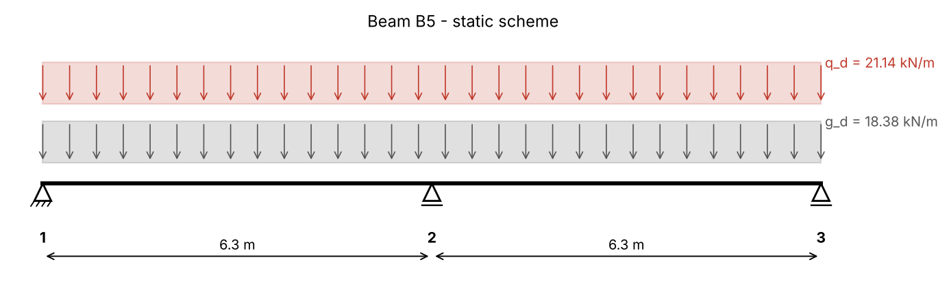
Figure 13. Static scheme of the continuous beam B5
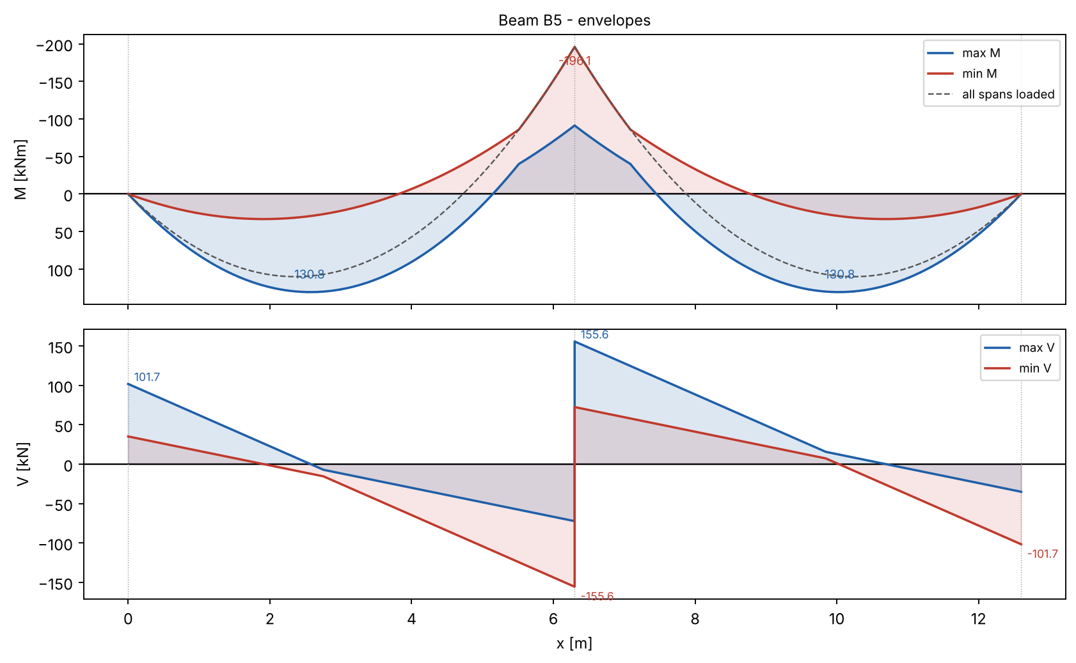
Figure 14. Envelopes of M and V of beam B5

4. Design of the bending reinforcement
Design characteristics of the materials (EN 1992-1-1):
Concrete C25/30, reinforcing steel B500.
Characteristic cylinder strength of concrete
$$f_{ck}=25 N/mm²$$
Design compressive strength
$$f_{cd}=\frac{α_{cc}·f_{ck}}{γ_{c}}=\frac{1·25}{1.5}=16.67 N/mm²$$
Mean tensile strength
$$f_{ctm}=2.56 N/mm²$$
Characteristic yield strength of steel
$$f_{yk}=500 N/mm²$$
Design yield strength of steel
$$f_{yd}=\frac{f_{yk}}{γ_{s}}=\frac{500}{1.15}=434.8 N/mm²$$
Effective depth (c_nom = 25 mm, links Φ8, main bars Φ20)
$$d=h−c_{nom}−φ_{w}−\frac{φ}{2}=450−25−8−\frac{20}{2}=407 mm$$
Spans - T-section, effective width (l_0 = 0.85·l_eff):
b_eff,i = 0.2·b_i + 0.1·l_0 ≤ 0.2·l_0 ; ≤ b_i
$$b_{eff,1}=min\left(0.2·b_{1}+0.1·l_{0} ; 0.2·l_{0} ; b_{1}\right)=min\left(0.2·1.133+0.1·5.355 ; 0.2·5.355 ; 1.133\right)=0.7622 m$$
b_eff,i = 0.2·b_i + 0.1·l_0 ≤ 0.2·l_0 ; ≤ b_i
$$b_{eff,2}=min\left(0.2·b_{2}+0.1·l_{0} ; 0.2·l_{0} ; b_{2}\right)=min\left(0.2·1.133+0.1·5.355 ; 0.2·5.355 ; 1.133\right)=0.7622 m$$
Effective width of the flange
$$b_{eff}=b_{w}+b_{eff,1}+b_{eff,2}=0.25+0.7622+0.7622=1.774 m$$
Compression force of the whole flange (0.8x = h_f)
$$F_{cd}=\frac{b_{eff}·h_{f}·f_{cd}}{10³}=\frac{1774·120·16.67}{10³}=3549 kN$$
Moment resisted by the flange
$$M_{f}=\frac{F_{cd}·\left(d−\frac{h_{f}}{2}\right)}{10³}=\frac{3549·\left(407−\frac{120}{2}\right)}{10³}=1231 kNm$$
$${maxM}_{Ed,1}=130.8 kNm ≤ M_{f}=1231 kNm$$
✔ The neutral axis is in the flange - rectangular section b = b_eff
Span 1-2 and 2-3 (bottom)
Relative design moment
$$μ_{Ed,1}=\frac{\left|{maxM}_{Ed,1}\right|·10⁶}{b_{eff}·d^{2}·f_{cd}}=\frac{\left|130.8\right|·10⁶}{1774·{407}^{2}·16.67}=0.0267$$
$$μ_{Ed,1}=0.0267 ≤ μ_{l​im}=0.295$$
✔ Single reinforcement is sufficient
Lever arm ratio z/d
$$ζ_{1}=0.5·\left(1+\sqrt{1−2·μ_{Ed,1}}\right)=0.5·\left(1+\sqrt{1−2·0.0267}\right)=0.9865$$
Required reinforcement
$$A_{s,req,1}=\frac{\left|{maxM}_{Ed,1}\right|·10⁶}{ζ_{1}·d·f_{yd}}=\frac{\left|130.8\right|·10⁶}{0.9865·407·434.8}=749.5 mm²$$
Minimum reinforcement (EC2 9.2.1.1)
$$A_{s,m​in,1}=max\left(\frac{0.26·f_{ctm}}{f_{yk}}·b_{w}·d ; 0.0013·b_{w}·d\right)$$
$$=max\left(\frac{0.26·2.56}{500}·250·407 ; 0.0013·250·407\right)=135.7 mm²$$
Provided reinforcement: 2Φ22 → A_s,prov = 760.3 mm²
Required reinforcement ratio
$$ρ_{1}=\frac{A_{s}}{b_{w}·d}=\frac{749.5}{250·407}=0.00737$$
Provided reinforcement ratio
$$ρ_{prov,1}=\frac{A_{s,prov}}{b_{w}·d}=\frac{760.3}{250·407}=0.00747$$
Middle support - rectangular section b_w (flange in tension), moment at the face:
ΔM = V_Ed·t_2/2
$$ΔM=\frac{V_{Ed}·t_{2}}{200}=\frac{155.6·30}{200}=23.34 kNm$$
$$M_{Ed,B}=\left|{minM}_{B}\right|−ΔM=\left|-196.1\right|−23.34=172.7 kNm$$
Relative design moment
$$μ_{Ed,B}=\frac{\left|M_{Ed,B}\right|·10⁶}{b_{w}·d^{2}·f_{cd}}=\frac{\left|172.7\right|·10⁶}{250·{407}^{2}·16.67}=0.2503$$
$$μ_{Ed,B}=0.2503 ≤ μ_{l​im}=0.295$$
✔ Single reinforcement is sufficient
Lever arm ratio z/d
$$ζ_{B}=0.5·\left(1+\sqrt{1−2·μ_{Ed,B}}\right)=0.5·\left(1+\sqrt{1−2·0.2503}\right)=0.8534$$
Required reinforcement
$$A_{s,req,B}=\frac{\left|M_{Ed,B}\right|·10⁶}{ζ_{B}·d·f_{yd}}=\frac{\left|172.7\right|·10⁶}{0.8534·407·434.8}=1144 mm²$$
Minimum reinforcement (EC2 9.2.1.1)
$$A_{s,m​in,B}=max\left(\frac{0.26·f_{ctm}}{f_{yk}}·b_{w}·d ; 0.0013·b_{w}·d\right)$$
$$=max\left(\frac{0.26·2.56}{500}·250·407 ; 0.0013·250·407\right)=135.7 mm²$$
Provided reinforcement: 4Φ20 → A_s,prov = 1257 mm²
Required reinforcement ratio
$$ρ_{B}=\frac{A_{s}}{b_{w}·d}=\frac{1144}{250·407}=0.0112$$
Provided reinforcement ratio
$$ρ_{prov,B}=\frac{A_{s,prov}}{b_{w}·d}=\frac{1257}{250·407}=0.0124$$
End supports: A_s3 ≥ 0.25·A_s,span = 190.1 mm² → 2Φ14; assembly bars in the span 2Φ10.

5. Design for shear
Strut inclination θ: cot θ = 2.5 (θ = 21.8°)
Internal lever arm
$$z=0.9·d=0.9·407=366.3 mm$$
$$ν_{1}=0.6·\left(1−\frac{f_{ck}}{250}\right)=0.6·\left(1−\frac{25}{250}\right)=0.54$$
Resistance of the compression struts (EC2 6.9)
$$V_{Rd,m​ax}=\frac{\frac{b_{w}·z·ν_{1}·f_{cd}}{cot θ+\frac{1}{cot θ}}}{10³}=\frac{\frac{250·366.3·0.54·16.67}{2.5+\frac{1}{2.5}}}{10³}=284.2 kN$$
$${maxV}_{Ed}=155.6 kN ≤ V_{Rd,m​ax}=284.2 kN$$
✔ The concrete struts are not crushed
Size factor
$$k=min\left(1+\sqrt{\frac{200}{d}} ; 2\right)=min\left(1+\sqrt{\frac{200}{407}} ; 2\right)=1.701$$
$$v_{m​in}=0.035·k^{\frac{3}{2}}·\sqrt{f_{ck}}=0.035·{1.701}^{\frac{3}{2}}·\sqrt{25}=0.3882 N/mm²$$
Shear resistance without shear reinforcement (EC2 6.2.2)
$$V_{Rd,c}=\frac{C_{Rd,c}·k·\sqrt[3]{100·ρ_{l}·f_{ck}}·b_{w}·d}{10³}=\frac{0.12·1.701·\sqrt[3]{100·0.01235·25}·250·407}{10³}=65.16 kN$$
$$V_{Rd,c,m​in}=\frac{v_{m​in}·b_{w}·d}{10³}=\frac{0.3882·250·407}{10³}=39.5 kN$$
V_Rd,c = max(V_Rd,c ; V_Rd,c,min) = 65.16 kN
$${maxV}_{Ed}=155.6 kN > V_{Rd,c}=65.16 kN$$
➜ Shear reinforcement is required - designed below
Required shear reinforcement (EC2 6.8)
$$A_{sw/s}=\frac{{maxV}_{Ed}·10³}{z·f_{yd}·cot θ}=\frac{155.6·10³}{366.3·434.8·2.5}=0.3908 mm²/mm$$
$$ρ_{w,m​in}=\frac{0.08·\sqrt{f_{ck}}}{f_{yk}}=\frac{0.08·\sqrt{25}}{500}=0.0008$$
$${(A}_{sw/s)_m​in}=ρ_{w,m​in}·b_{w}=0.0008·250=0.2 mm²/mm$$
Spacing of 2-leg links Φ8 (A_sw = 2·50.27 mm²)
$$s=\frac{A_{sw}}{{(A}_{sw/s)}}=\frac{100.5}{0.3908}=257.2 mm$$
Maximum longitudinal spacing of links (EC2 9.2.2)
$$s_{l,m​ax}=0.75·d=0.75·407=305.2 mm$$
Adopted links: Φ8/25 cm (2-leg) in the support zones
Additional tensile force in the longitudinal reinforcement (EC2 6.2.3(7))
$${ΔF}_{td}=0.5·{maxV}_{Ed}·cot θ=0.5·155.6·2.5=194.5 kN$$
Supporting (hanger) reinforcement in the intersection with the frame beam B15:
The whole reaction is hung up by links
$$A_{sw,hang}=\frac{{maxR}_{B}·1000}{f_{yd}}=\frac{311.2·1000}{434.8}=715.8 mm²$$
Required 8 additional two-leg links Φ8 in the intersection zone (each side of B5).
Shear between the web and the flange:
Change of the longitudinal force in one flange outstand over Δx
$${ΔF}_{d}=\frac{\frac{M_{Δx}·10⁶}{d−\frac{h_{f}}{2}}·\frac{0.5·\left(b_{eff}−b_{w}\right)}{b_{eff}}}{10³}=\frac{\frac{111.1·10⁶}{407−\frac{120}{2}}·\frac{0.5·\left(1774−250\right)}{1774}}{10³}=137.6 kN$$
Longitudinal shear stress
$$v_{Ed}=\frac{{ΔF}_{d}·10³}{h_{f}·Δx}=\frac{137.6·10³}{120·1575}=0.728 N/mm²$$
$$v_{Ed}=0.728 N/mm² > {0.4·f}_{ctd}=0.4788$$
➜ Transverse reinforcement for the flange shear is needed - designed below
$$v_{Ed}=0.728 N/mm² ≤ {ν·f}_{cd·sinθ·cosθ}=3.6$$
✔ The compression struts in the flange are adequate
Required transverse reinforcement in the flange
$$A_{sf/s_f}=\frac{v_{Ed}·h_{f}}{f_{yd}·{cot θ}_{f}}·1000=\frac{0.728·120}{434.8·2}·1000=100.5 mm²/m$$

6. Control of deflection
End span of a continuous beam: K = 1.3 (flanged section b_eff/b_w > 3 → × 0.8)
$$ρ_{0}=\sqrt{f_{ck}}·10⁻³=\sqrt{25}·10⁻³=0.005$$
Basic span/depth ratio, ρ > ρ_0 (EC2 7.16b, ρ' = 0)
$${(l/d)}_{basic}=K·\left(11+\frac{1.5·\sqrt{f_{ck}}·ρ_{0}}{ρ}\right)=1.04·\left(11+\frac{1.5·\sqrt{25}·0.005}{0.00737}\right)=16.73$$
Steel stress under the quasi-permanent load
$$σ_{s}=\frac{\frac{f_{yd}·\left(g_{k}+0.3·q_{k}\right)}{g_{d}+q_{d}}·A_{s,req}}{A_{s,prov}}$$
$$=\frac{\frac{434.8·\left(13.61+0.3·14.09\right)}{18.38+21.14}·749.5}{760.3}=193.5 N/mm²$$
Correction factor 310/σ_s (≤ 1.5)
$$k_{σ}=min\left(\frac{310}{σ_{s}} ; 1.5\right)=min\left(\frac{310}{193.5} ; 1.5\right)=1.5$$
$${(l/d)}_{l​im}={(l/d)}_{basic}·k_{σ}=16.73·1.5=25.1$$
$$l/d=\frac{l_{eff}}{d}=\frac{6300}{407}=15.48$$
$$l/d=15.48 ≤ {(l/d)}_{l​im}=25.1$$
✔ Deflection need not be calculated (l/d check satisfied)

IX. Design of reinforced concrete columns
Column C10 at the intersection of axes 5 and B (offices). It carries beam B21 (axis 5) and the continuous beam B12 (axis B, axes 4-7) on every floor, and the roof.

1. Static scheme
Cross-section 25/60 cm. Storeys: first h_b = 290 cm, then 4 × h_s = 310 cm. The column is part of a braced structure (walls) - effective length l_0 = 0.7·l.

2. Actions

2.1 From beam B21 (section VI)
Design reaction - permanent
$$R_{gd,B21}=123.7 kN$$
Design reaction - variable
$$R_{qd,B21}=44.15 kN$$

2.2 From the continuous beam B12 (axis B)
Self-weight of B12 + brick wall + plaster
$$g_{k,1}=b·h·25+t_{w}·\left(h_{s}−h\right)·γ_{w}+2·0.02·\left(h_{s}−h_{f}\right)·18$$
$$=0.25·0.6·25+0.25·\left(3.1−0.6\right)·17+2·0.02·\left(3.1−0.15\right)·18=16.5 kN/m$$
From the corridor slab 17 (one-way, span c)
$$g_{k,2}=g_{k,corr}·c=4.96·1.75=8.68 kN/m$$
$$q_{k,2}=q_{k}·c=3.5·1.75=6.125 kN/m$$
Peak value from the office slabs (trapezoid)
$$g_{k,3}=\frac{g_{k,off}·l_{s}}{2}=\frac{5.21·5.8}{2}=15.11 kN/m$$
$$q_{k,3}=\frac{q_{k}·l_{s}}{2}=\frac{3.5·5.8}{2}=10.15 kN/m$$
Design reaction on axis 5 - permanent (stiffness method)
$$R_{gd,B12}=313.5 kN$$
Design reaction on axis 5 - variable, pattern loading for max R
$$R_{qd,B12}=134.1 kN$$

2.3 From the roof
Characteristic permanent actions on the roof (offices / corridor):
Table 11. Permanent actions - roof (offices / corridor)
Layer | g_k [kN/m²]
waterproofing | 0.04
protective layer | 0.66
thermal insulation | 0.2
vapour barrier | 0.03
levelling cement screed | 0.44
lightweight concrete for slope | 1.76
RC slab h_f = 15 cm | 3.75
ceiling plaster | 0.36

Total permanent action of the roof
$${Σg}_{k,roof}=7.24 kN/m²$$
Variable action on the roof (snow / maintenance)
$$s_{k}=1 kN/m²$$
Roof beams B12 + B21 - permanent
$$R_{gd,r}=361.9 kN$$
Roof - snow
$$R_{qd,r}=50.93 kN$$

2.4 Self-weight of the column (one storey)
$$G_{d,c}=1.35·\left(b·h·h_{s}·25+2·0.02·\left(b+h\right)·h_{s}·18\right)$$
$$=1.35·\left(0.25·0.6·3.1·25+2·0.02·\left(0.25+0.6\right)·3.1·18\right)=18.25 kN$$

3. Static analysis - normal forces
Permanent - one floor
$$N_{g1}=R_{gd,B21}+R_{gd,B12}+G_{d,c}=123.7+313.5+18.25=455.5 kN$$
Variable - one floor
$$N_{q1}=R_{qd,B21}+R_{qd,B12}=44.15+134.1=178.3 kN$$
Permanent - roof
$$N_{gr}=R_{gd,r}+G_{d,c}=361.9+18.25=380.1 kN$$
Variable - roof
$$N_{sr}=R_{qd,r}=50.93 kN$$
The variable action of n floors is reduced by α_n = (2 + (n − 2)·ψ_0)/n, ψ_0 = 0.7 (EN 1991-1-1, 6.3.1.2(11)).
Table 12. Normal forces in column C10
Section | Floors above | α_n | N_g [kN] | N_q [kN] | N_Ed [kN]
4-4 | 0 | 1 | 380.1 | 50.93 | 431.1
3-3 | 1 | 1 | 835.6 | 229.2 | 1065
2-2 | 2 | 1 | 1291 | 407.4 | 1699
1-1 | 3 | 0.9 | 1747 | 532.2 | 2279
0-0 | 4 | 0.85 | 2202 | 657 | 2859

4. Design of the column
Design characteristics of the materials (EN 1992-1-1):
Concrete C25/30, reinforcing steel B500.
Characteristic cylinder strength of concrete
$$f_{ck}=25 N/mm²$$
Design compressive strength
$$f_{cd}=\frac{α_{cc}·f_{ck}}{γ_{c}}=\frac{1·25}{1.5}=16.67 N/mm²$$
Mean tensile strength
$$f_{ctm}=2.56 N/mm²$$
Characteristic yield strength of steel
$$f_{yk}=500 N/mm²$$
Design yield strength of steel
$$f_{yd}=\frac{f_{yk}}{γ_{s}}=\frac{500}{1.15}=434.8 N/mm²$$

4.1 Section 0-0 (N_Ed = 2859 kN)
Preliminary design for the axial force (ρ = 1 %):
$$A_{c,req}=\frac{N_{Ed}·1000}{f_{cd}+0.01·f_{yd}}=\frac{2859·1000}{14.17+0.01·434.8}=154431 mm²$$
EC2 9.5.2(2)
$$A_{s,m​in}=max\left(\frac{0.1·N_{Ed}·1000}{f_{yd}} ; 0.002·A_{c}\right)=max\left(\frac{0.1·2859·1000}{434.8} ; 0.002·150000\right)=657.6 mm²$$
Weak axis - bending about the weak axis: b = 600 mm, h = 250 mm
Effective length
$$l_{0}=2.38 m$$
Radius of gyration
$$i=\frac{h}{\sqrt{12}}=\frac{250}{\sqrt{12}}=72.17 mm$$
Slenderness
$$λ=\frac{l_{0}·1000}{i}=\frac{2.38·1000}{72.17}=32.98$$
Relative normal force (f_cd with α_cc = 0.85)
$$n=\frac{N_{Ed}·1000}{A_{c}·f_{cd}}=\frac{2859·1000}{150000·14.17}=1.346$$
EC2 5.8.3.1: A = 0.7, B = √(1+2ω), C = 1.7 − r_m
$$λ_{l​im}=\frac{20·A·B·C}{\sqrt{n}}=\frac{20·0.7·1.569·0.7}{\sqrt{1.346}}=13.25$$
Eccentricity from imperfections (EC2 6.1(4), 5.2(7))
$$e_{i}=max\left(\frac{l_{0}·1000}{400} ; \frac{h}{30} ; 20\right)=max\left(\frac{2.38·1000}{400} ; \frac{250}{30} ; 20\right)=20 mm$$
➜ λ > λ_lim - second order effects are taken into account (nominal curvature method, EC2 5.8.8)
K_r = (n_u − n)/(n_u − n_bal) ≤ 1
$$K_{r}=0.2895$$
K_φ = 1 + β·φ_ef, φ_ef = 2
$$K_{φ}=1.51$$
$${1/r}_{0}=\frac{f_{yd}}{E_{s}·0.45·d}=\frac{434.8}{200000·0.45·205}=0.0000236 1/mm$$
$$1/r=K_{r}·K_{φ}·{1/r}_{0}=0.2895·1.51·0.0000236=0.0000103 1/mm$$
Second order eccentricity
$$e_{2}=\frac{1/r·{\left(l_{0}·1000\right)}^{2}}{10}=\frac{0.0000103·{\left(2.38·1000\right)}^{2}}{10}=5.836 mm$$
M_Ed = max(M_0e; M_02) + N_Ed·e_i + N_Ed·e_2
$$M_{Ed}=max\left(M_{0e}+\frac{N_{Ed}·e_{i}}{1000} ; M_{02}+\frac{N_{Ed}·e_{i}}{1000}\right)+\frac{N_{Ed}·e_{2}}{1000}$$
$$=max\left(0+\frac{2859·20}{1000} ; 0+\frac{2859·20}{1000}\right)+\frac{2859·5.836}{1000}=73.87 kNm$$
Relative moment
$$μ_{Ed}=\frac{M_{Ed}·10⁶}{b·h^{2}·f_{cd}}=\frac{73.87·10⁶}{600·{250}^{2}·14.17}=0.139$$
Required reinforcement from the N-M interaction diagram of the section (symmetric reinforcement, d_1 = 45 mm, rectangular stress block, ε_cu = 3.5 ‰):
(ω used for λ_lim and K_r: ω = 0.7307 - iterated until it agrees with the result)
Mechanical reinforcement ratio (from the diagram)
$$ω_{tot}=0.731$$
$$A_{s,tot}=\frac{ω_{tot}·b·h·f_{cd}}{f_{yd}}=\frac{0.731·600·250·14.17}{434.8}=3572 mm²$$
A_s,tot = max(A_s,tot; A_s,min) = 3572 mm² → adopted 6Φ28 (3695 mm²), ρ = 2.463 % (0.2 % ≤ ρ ≤ 4 %)

4.2 Section 1-1 (N_Ed = 2279 kN)
Preliminary design for the axial force (ρ = 1 %):
$$A_{c,req}=\frac{N_{Ed}·1000}{f_{cd}+0.01·f_{yd}}=\frac{2279·1000}{14.17+0.01·434.8}=123088 mm²$$
EC2 9.5.2(2)
$$A_{s,m​in}=max\left(\frac{0.1·N_{Ed}·1000}{f_{yd}} ; 0.002·A_{c}\right)=max\left(\frac{0.1·2279·1000}{434.8} ; 0.002·150000\right)=524.2 mm²$$
Weak axis - bending about the weak axis: b = 600 mm, h = 250 mm
Effective length
$$l_{0}=2.17 m$$
Radius of gyration
$$i=\frac{h}{\sqrt{12}}=\frac{250}{\sqrt{12}}=72.17 mm$$
Slenderness
$$λ=\frac{l_{0}·1000}{i}=\frac{2.17·1000}{72.17}=30.07$$
Relative normal force (f_cd with α_cc = 0.85)
$$n=\frac{N_{Ed}·1000}{A_{c}·f_{cd}}=\frac{2279·1000}{150000·14.17}=1.072$$
EC2 5.8.3.1: A = 0.7, B = √(1+2ω), C = 1.7 − r_m
$$λ_{l​im}=\frac{20·A·B·C}{\sqrt{n}}=\frac{20·0.7·1.311·0.7}{\sqrt{1.072}}=12.4$$
Eccentricity from imperfections (EC2 6.1(4), 5.2(7))
$$e_{i}=max\left(\frac{l_{0}·1000}{400} ; \frac{h}{30} ; 20\right)=max\left(\frac{2.17·1000}{400} ; \frac{250}{30} ; 20\right)=20 mm$$
➜ λ > λ_lim - second order effects are taken into account (nominal curvature method, EC2 5.8.8)
K_r = (n_u − n)/(n_u − n_bal) ≤ 1
$$K_{r}=0.2989$$
K_φ = 1 + β·φ_ef, φ_ef = 2
$$K_{φ}=1.549$$
$${1/r}_{0}=\frac{f_{yd}}{E_{s}·0.45·d}=\frac{434.8}{200000·0.45·205}=0.0000236 1/mm$$
$$1/r=K_{r}·K_{φ}·{1/r}_{0}=0.2989·1.549·0.0000236=0.0000109 1/mm$$
Second order eccentricity
$$e_{2}=\frac{1/r·{\left(l_{0}·1000\right)}^{2}}{10}=\frac{0.0000109·{\left(2.17·1000\right)}^{2}}{10}=5.139 mm$$
M_Ed = max(M_0e; M_02) + N_Ed·e_i + N_Ed·e_2
$$M_{Ed}=max\left(M_{0e}+\frac{N_{Ed}·e_{i}}{1000} ; M_{02}+\frac{N_{Ed}·e_{i}}{1000}\right)+\frac{N_{Ed}·e_{2}}{1000}$$
$$=max\left(0+\frac{2279·20}{1000} ; 0+\frac{2279·20}{1000}\right)+\frac{2279·5.139}{1000}=57.29 kNm$$
Relative moment
$$μ_{Ed}=\frac{M_{Ed}·10⁶}{b·h^{2}·f_{cd}}=\frac{57.29·10⁶}{600·{250}^{2}·14.17}=0.1078$$
Required reinforcement from the N-M interaction diagram of the section (symmetric reinforcement, d_1 = 45 mm, rectangular stress block, ε_cu = 3.5 ‰):
(ω used for λ_lim and K_r: ω = 0.3591 - iterated until it agrees with the result)
Mechanical reinforcement ratio (from the diagram)
$$ω_{tot}=0.359$$
$$A_{s,tot}=\frac{ω_{tot}·b·h·f_{cd}}{f_{yd}}=\frac{0.359·600·250·14.17}{434.8}=1756 mm²$$
A_s,tot = max(A_s,tot; A_s,min) = 1756 mm² → adopted 6Φ20 (1885 mm²), ρ = 1.257 % (0.2 % ≤ ρ ≤ 4 %)
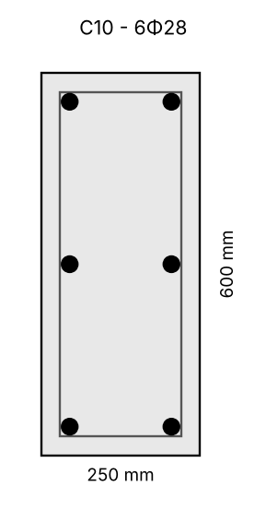
Figure 15. Cross-section of column C10 (section 0-0)
Links: Φ8, spacing s ≤ min(20·Φ_long; b; 400 mm) = 250 mm, reduced by 0.6 within h above/below beams and at laps (EC2 9.5.3).

X. Design of reinforced concrete frame
Frame on axis 2: beams B15 between axes A - C - E (two spans of 755 cm), columns C1 (A), C7 (C) and C12 (E). 5 storeys: h_b = 290 cm and 4 × h_s = 310 cm; fixed at the top of the footings.

1. Static scheme and stiffness
Beam B15: b_w/h = 30/65 cm, flange h_f = 12 cm, b_eff = 278.4 cm. Columns C1, C12: 40/60 cm; C7: 40/80 cm (h in the plane of the frame).
Moment of inertia of the T-section of the beam
$$I_{b}=1550090 cm⁴$$
Columns C1, C12
$$I_{c,1}=720000 cm⁴$$
Column C7
$$I_{c,7}=1706667 cm⁴$$

2. Actions (characteristic values)

2.1 Point loads from the secondary beams B5-B9 (section VIII)
Reaction R_B of B5 - permanent
$$G_{k,1}=107.2 kN$$
Reaction R_B of B5 - variable
$$Q_{k,1}=111 kN$$

2.2 Facade beams on axes A and E (B1, B10) - reaction on axis 2
Beam 30/60 + facade wall + plaster + slab (s/2)
$$g_{k,f}=b·h·25+b·\left(h_{s}−h\right)·18+2·0.02·\left(h_{s}−h_{f}\right)·18+g_{k,slab}·s$$
$$=0.3·0.6·25+0.3·\left(3.1−0.6\right)·18+2·0.02·\left(3.1−0.12\right)·18+4.46·1.258=25.76 kN/m$$
$$q_{k,f}=q_{k1}·s=5.6·1.258=7.047 kN/m$$
Middle reaction of a two-span beam (10/8·w·l)
$$G_{k,2}=1.25·g_{k,f}·a=1.25·25.76·6.3=202.8 kN$$
$$Q_{k,2}=1.25·q_{k,f}·a=1.25·7.047·6.3=55.49 kN$$

2.3 Roof
Characteristic permanent actions on the roof above the hall:
Table 13. Permanent actions - roof above the hall
Layer | g_k [kN/m²]
waterproofing | 0.04
protective layer | 0.66
thermal insulation | 0.2
vapour barrier | 0.03
levelling cement screed | 0.44
lightweight concrete for slope | 1.76
RC slab h_f = 12 cm | 3
ceiling plaster | 0.36

Total permanent action of the roof
$${Σg}_{k,roof}=6.49 kN/m²$$
Variable action on the roof (snow / maintenance)
$$s_{k}=1 kN/m²$$
Roof beams B5-B9
$$g_{k,r5}=b_{w}·\left(h−h_{f}\right)·25+{Σg}_{k,roof}·s=0.25·\left(0.45−0.12\right)·25+6.49·2.517=18.4 kN/m$$
$$G_{kr,1}=1.25·g_{k,r5}·a=1.25·18.4·6.3=144.9 kN$$
$$Q_{kr,1}=1.25·s_{k}·s·a=1.25·1·2.517·6.3=19.82 kN$$
Roof facade beam + parapet 1.0 kN/m
$$G_{kr,2}=1.25·\left(b·h·25+{Σg}_{k,roof}·s+1\right)·a=1.25·\left(0.3·0.6·25+6.49·1.258+1\right)·6.3=107.6 kN$$
$$Q_{kr,2}=1.25·s_{k}·s·a=1.25·1·1.258·6.3=9.909 kN$$

2.4 Frame beam B15 and columns
Web of B15 + plaster
$$g_{k,B15}=b_{w}·\left(h−h_{f}\right)·25+0.02·18·\left(2·\left(h−h_{f}\right)+b_{w}\right)=0.3·\left(0.65−0.12\right)·25+0.02·18·\left(2·\left(0.65−0.12\right)+0.3\right)=4.465 kN/m$$
Self-weight of the columns: C1/C12: 6 kN/m, C7: 8 kN/m (applied at the top of every storey).
Load cases (design values 1.35·G + 1.5·Q):
- LC1 - variable load on all spans of all floors (maximum normal forces and support moments)
- LC2 - chequerboard: variable load in bay A-C on storeys 1, 3, 5 and in bay C-E on storeys 2, 4
- LC3 - the opposite chequerboard (maximum span moments / column moments)
The frame is analysed by the stiffness method (Euler-Bernoulli elements, E_cm, gross sections, T-section for the beams).
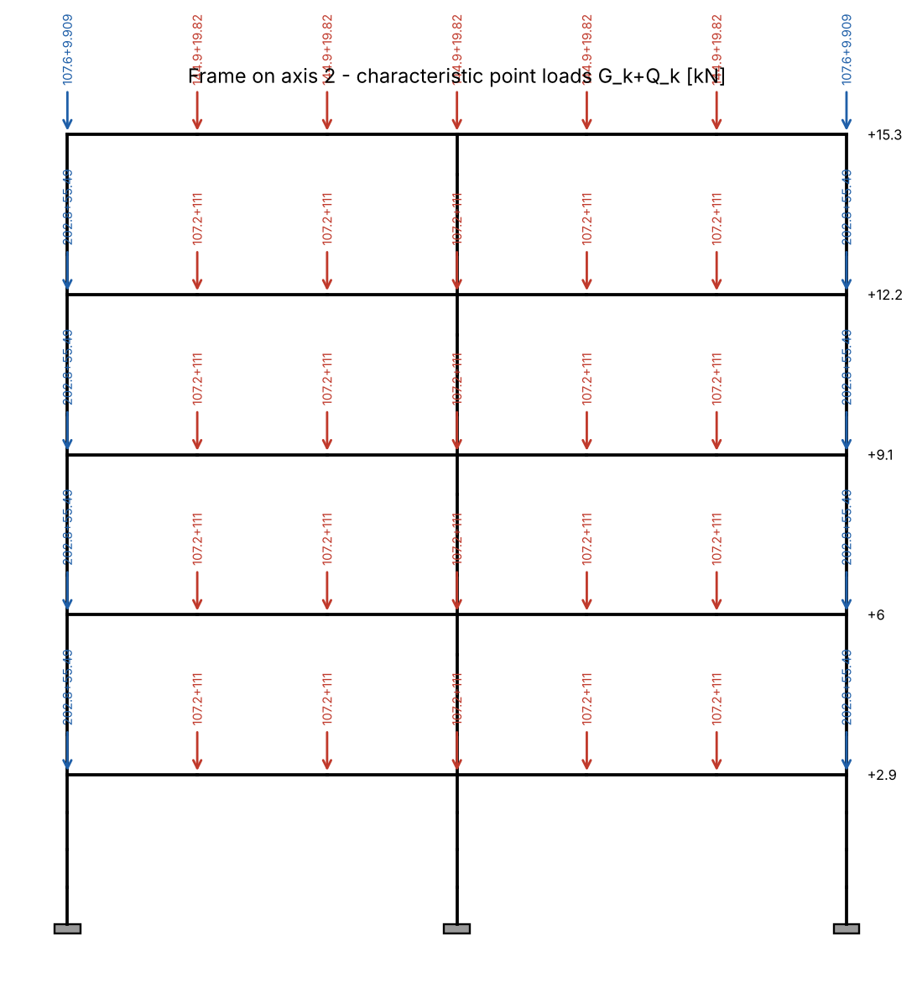
Figure 16. Static scheme of the frame and characteristic loads from the secondary beams
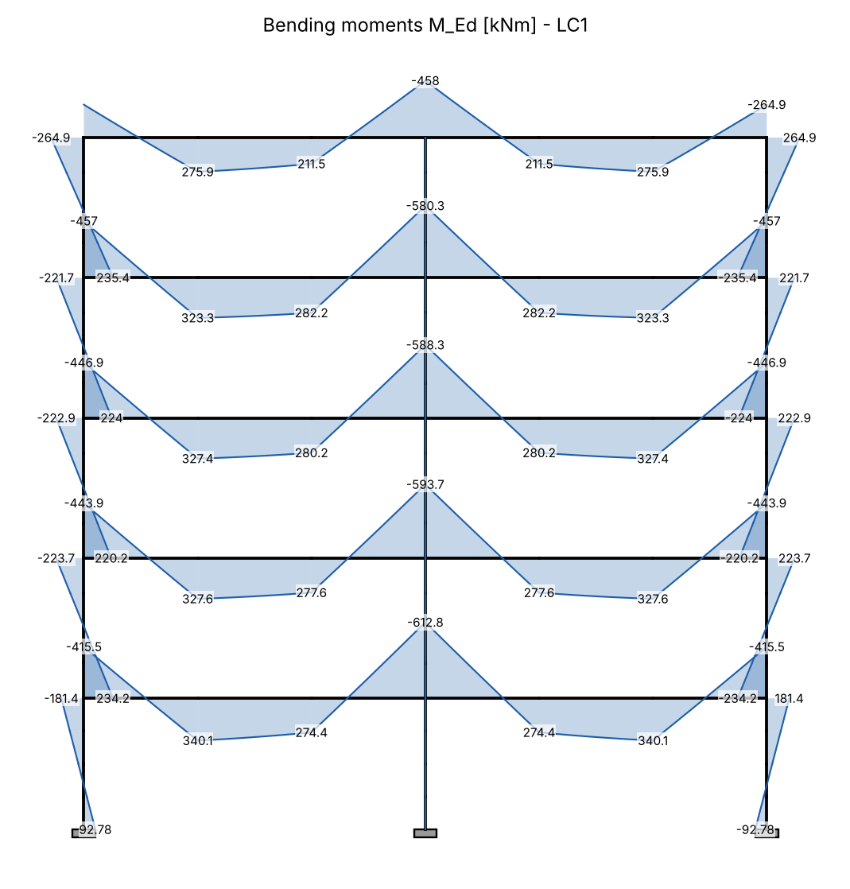
Figure 17. Bending moment diagram - LC1
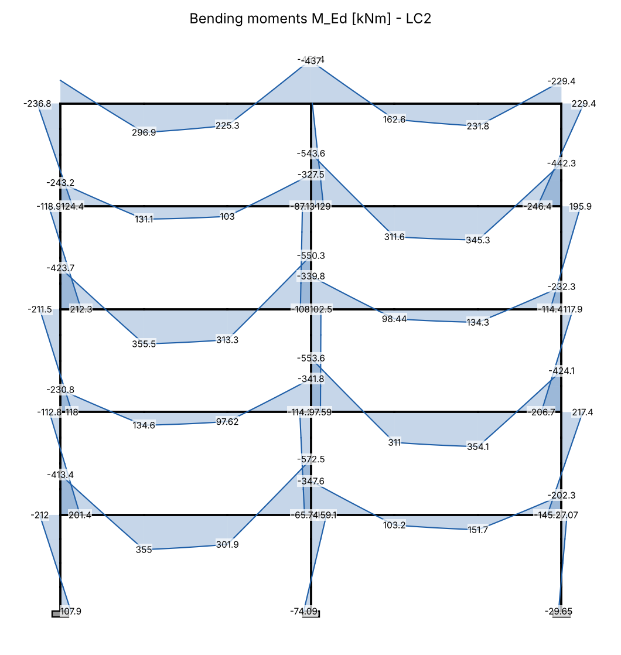
Figure 18. Bending moment diagram - LC2
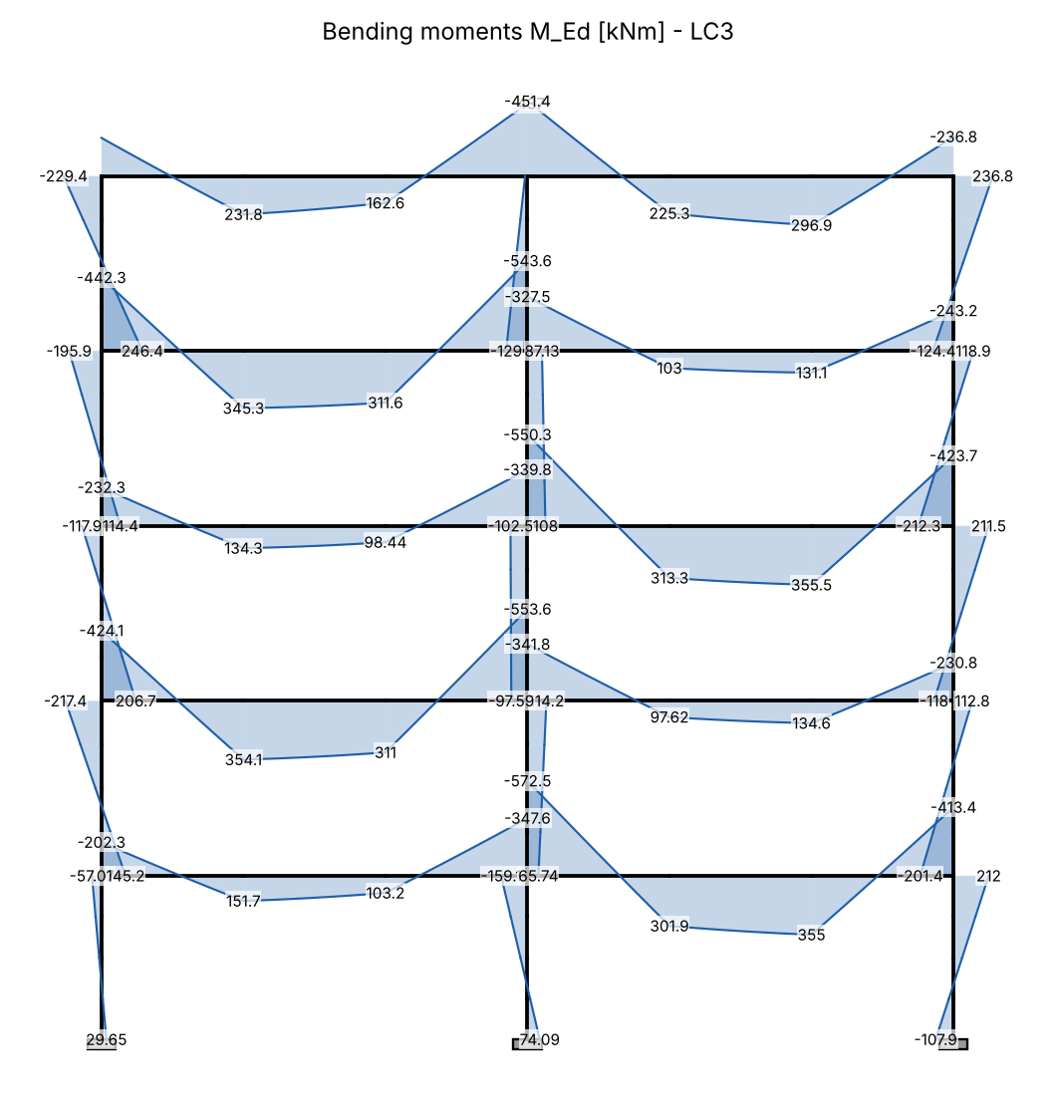
Figure 19. Bending moment diagram - LC3
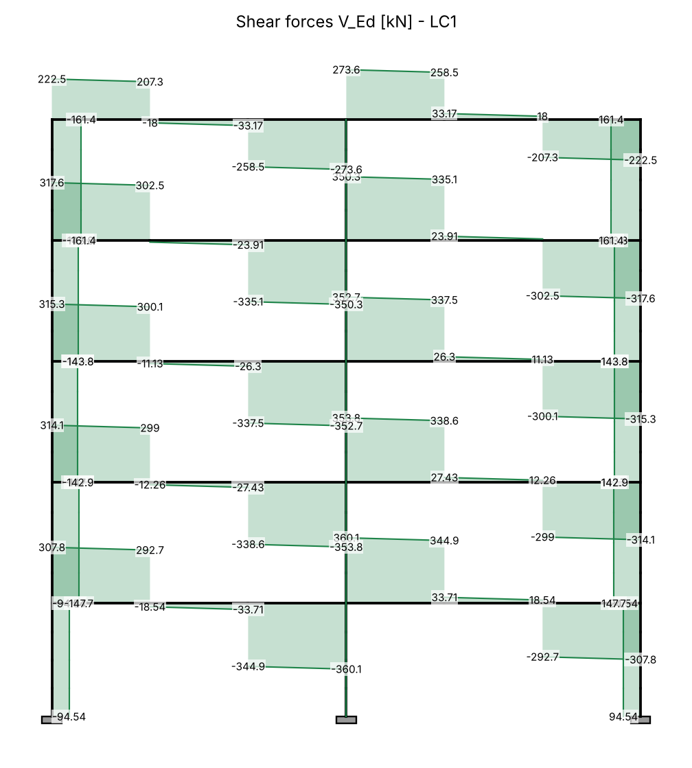
Figure 20. Shear force diagram - LC1
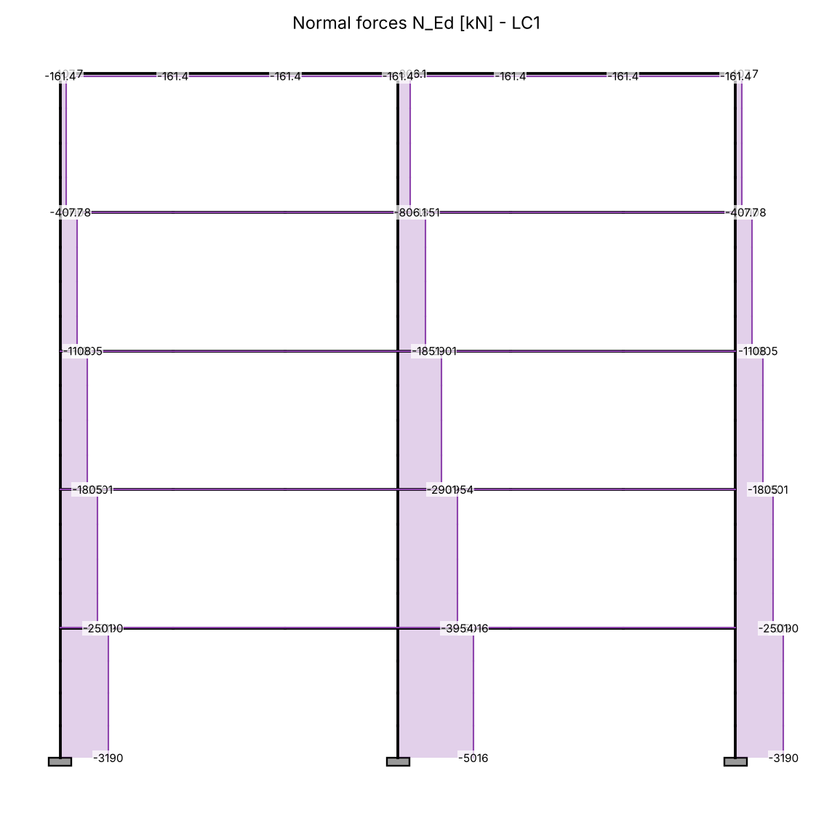
Figure 21. Normal force diagram - LC1
Table 14. Frame beam B15 - design values [kNm, kN]
LC | Floor | max M_span | M at C7 | M at C1 | max |V|
LC1 | 1 | 340.1 | -612.8 | -415.5 | 360.1
LC1 | 2 | 327.6 | -593.7 | -443.9 | 353.8
LC1 | 3 | 327.4 | -588.3 | -446.9 | 352.7
LC1 | 4 | 323.3 | -580.3 | -457 | 350.3
LC1 | 5 | 275.9 | -458 | -264.9 | 273.6
LC2 | 1 | 355 | -572.5 | -413.4 | 355
LC2 | 2 | 354.1 | -553.6 | -230.8 | 351.1
LC2 | 3 | 355.5 | -550.3 | -423.7 | 350.7
LC2 | 4 | 345.3 | -543.6 | -243.2 | 347.4
LC2 | 5 | 296.9 | -451.4 | -236.8 | 276.5
LC3 | 1 | 355 | -572.5 | -202.3 | 355
LC3 | 2 | 354.1 | -553.6 | -424.1 | 351.1
LC3 | 3 | 355.5 | -550.3 | -232.3 | 350.7
LC3 | 4 | 345.3 | -543.6 | -442.3 | 347.4
LC3 | 5 | 296.9 | -451.4 | -229.4 | 276.5

Table 15. Columns - design forces
LC | Column | Storey | N_Ed [kN] | M_bottom [kNm] | M_top [kNm]
LC1 | C1 | 1 | 3190 | 92.78 | -181.4
LC1 | C1 | 2 | 2501 | 234.2 | -223.7
LC1 | C7 | 1 | 5016 | -0.0000000000102 | 0.00000000000364
LC1 | C7 | 2 | 3954 | -0.00000000000837 | 0.00000000000632
LC2 | C1 | 1 | 2705 | 107.9 | -212
LC2 | C1 | 2 | 2011 | 201.4 | -112.8
LC2 | C7 | 1 | 3943 | -74.09 | 159.1
LC2 | C7 | 2 | 3142 | -65.74 | -114.2
LC3 | C1 | 1 | 2661 | 29.65 | -57.07
LC3 | C1 | 2 | 2215 | 145.2 | -217.4
LC3 | C7 | 1 | 3943 | 74.09 | -159.1
LC3 | C7 | 2 | 3142 | 65.74 | 114.2

3. Design of the frame beam B15
Design characteristics of the materials (EN 1992-1-1):
Concrete C25/30, reinforcing steel B500.
Characteristic cylinder strength of concrete
$$f_{ck}=25 N/mm²$$
Design compressive strength
$$f_{cd}=\frac{α_{cc}·f_{ck}}{γ_{c}}=\frac{1·25}{1.5}=16.67 N/mm²$$
Mean tensile strength
$$f_{ctm}=2.56 N/mm²$$
Characteristic yield strength of steel
$$f_{yk}=500 N/mm²$$
Design yield strength of steel
$$f_{yd}=\frac{f_{yk}}{γ_{s}}=\frac{500}{1.15}=434.8 N/mm²$$
Effective depth (c_nom = 25 mm, links Φ8, main bars Φ20)
$$d=h−c_{nom}−φ_{w}−\frac{φ}{2}=650−25−8−\frac{20}{2}=607 mm$$
Maximum span moment: LC2, floor 3.
Compression force of the whole flange (0.8x = h_f)
$$F_{cd}=\frac{b_{eff}·h_{f}·f_{cd}}{10³}=\frac{2784·120·16.67}{10³}=5567 kN$$
Moment resisted by the flange
$$M_{f}=\frac{F_{cd}·\left(d−\frac{h_{f}}{2}\right)}{10³}=\frac{5567·\left(607−\frac{120}{2}\right)}{10³}=3045 kNm$$
$${maxM}_{Ed,span}=355.5 kNm ≤ M_{f}=3045 kNm$$
✔ The neutral axis is in the flange - rectangular section b = b_eff
Span section (bottom)
Relative design moment
$$μ_{Ed,span}=\frac{\left|{maxM}_{Ed,span}\right|·10⁶}{b_{eff}·d^{2}·f_{cd}}=\frac{\left|355.5\right|·10⁶}{2784·{607}^{2}·16.67}=0.0208$$
$$μ_{Ed,span}=0.0208 ≤ μ_{l​im}=0.295$$
✔ Single reinforcement is sufficient
Lever arm ratio z/d
$$ζ_{span}=0.5·\left(1+\sqrt{1−2·μ_{Ed,span}}\right)=0.5·\left(1+\sqrt{1−2·0.0208}\right)=0.9895$$
Required reinforcement
$$A_{s,req,span}=\frac{\left|{maxM}_{Ed,span}\right|·10⁶}{ζ_{span}·d·f_{yd}}=\frac{\left|355.5\right|·10⁶}{0.9895·607·434.8}=1361 mm²$$
Minimum reinforcement (EC2 9.2.1.1)
$$A_{s,m​in,span}=max\left(\frac{0.26·f_{ctm}}{f_{yk}}·b_{w}·d ; 0.0013·b_{w}·d\right)$$
$$=max\left(\frac{0.26·2.56}{500}·300·607 ; 0.0013·300·607\right)=242.9 mm²$$
Provided reinforcement: 3Φ25 → A_s,prov = 1473 mm²
Required reinforcement ratio
$$ρ_{span}=\frac{A_{s}}{b_{w}·d}=\frac{1361}{300·607}=0.00748$$
Provided reinforcement ratio
$$ρ_{prov,span}=\frac{A_{s,prov}}{b_{w}·d}=\frac{1473}{300·607}=0.00809$$
Support at column C7 (top) - LC1, floor 1; moment at the face:
ΔM = V_Ed·h_c/2
$$ΔM=V_{Ed}·h_{c7}=360.1·0.4=144 kNm$$
$$M_{Ed,C7}=M_{C7}−ΔM=612.8−144=468.7 kNm$$
Relative design moment
$$μ_{Ed,C7}=\frac{\left|M_{Ed,C7}\right|·10⁶}{b_{w}·d^{2}·f_{cd}}=\frac{\left|468.7\right|·10⁶}{300·{607}^{2}·16.67}=0.2544$$
$$μ_{Ed,C7}=0.2544 ≤ μ_{l​im}=0.295$$
✔ Single reinforcement is sufficient
Lever arm ratio z/d
$$ζ_{C7}=0.5·\left(1+\sqrt{1−2·μ_{Ed,C7}}\right)=0.5·\left(1+\sqrt{1−2·0.2544}\right)=0.8504$$
Required reinforcement
$$A_{s,req,C7}=\frac{\left|M_{Ed,C7}\right|·10⁶}{ζ_{C7}·d·f_{yd}}=\frac{\left|468.7\right|·10⁶}{0.8504·607·434.8}=2088 mm²$$
Minimum reinforcement (EC2 9.2.1.1)
$$A_{s,m​in,C7}=max\left(\frac{0.26·f_{ctm}}{f_{yk}}·b_{w}·d ; 0.0013·b_{w}·d\right)$$
$$=max\left(\frac{0.26·2.56}{500}·300·607 ; 0.0013·300·607\right)=242.9 mm²$$
Provided reinforcement: 5Φ25 → A_s,prov = 2454 mm²
Required reinforcement ratio
$$ρ_{C7}=\frac{A_{s}}{b_{w}·d}=\frac{2088}{300·607}=0.0115$$
Provided reinforcement ratio
$$ρ_{prov,C7}=\frac{A_{s,prov}}{b_{w}·d}=\frac{2454}{300·607}=0.0135$$
End support at column C1 (top):
Relative design moment
$$μ_{Ed,C1}=\frac{\left|M_{C1}\right|·10⁶}{b_{w}·d^{2}·f_{cd}}=\frac{\left|457\right|·10⁶}{300·{607}^{2}·16.67}=0.2481$$
$$μ_{Ed,C1}=0.2481 ≤ μ_{l​im}=0.295$$
✔ Single reinforcement is sufficient
Lever arm ratio z/d
$$ζ_{C1}=0.5·\left(1+\sqrt{1−2·μ_{Ed,C1}}\right)=0.5·\left(1+\sqrt{1−2·0.2481}\right)=0.8549$$
Required reinforcement
$$A_{s,req,C1}=\frac{\left|M_{C1}\right|·10⁶}{ζ_{C1}·d·f_{yd}}=\frac{\left|457\right|·10⁶}{0.8549·607·434.8}=2026 mm²$$
Minimum reinforcement (EC2 9.2.1.1)
$$A_{s,m​in,C1}=max\left(\frac{0.26·f_{ctm}}{f_{yk}}·b_{w}·d ; 0.0013·b_{w}·d\right)$$
$$=max\left(\frac{0.26·2.56}{500}·300·607 ; 0.0013·300·607\right)=242.9 mm²$$
Provided reinforcement: 5Φ25 → A_s,prov = 2454 mm²
Required reinforcement ratio
$$ρ_{C1}=\frac{A_{s}}{b_{w}·d}=\frac{2026}{300·607}=0.0111$$
Provided reinforcement ratio
$$ρ_{prov,C1}=\frac{A_{s,prov}}{b_{w}·d}=\frac{2454}{300·607}=0.0135$$

Shear
Strut inclination θ: cot θ = 2.5 (θ = 21.8°)
Internal lever arm
$$z=0.9·d=0.9·607=546.3 mm$$
$$ν_{1}=0.6·\left(1−\frac{f_{ck}}{250}\right)=0.6·\left(1−\frac{25}{250}\right)=0.54$$
Resistance of the compression struts (EC2 6.9)
$$V_{Rd,m​ax}=\frac{\frac{b_{w}·z·ν_{1}·f_{cd}}{cot θ+\frac{1}{cot θ}}}{10³}=\frac{\frac{300·546.3·0.54·16.67}{2.5+\frac{1}{2.5}}}{10³}=508.6 kN$$
$$V_{Ed}=360.1 kN ≤ V_{Rd,m​ax}=508.6 kN$$
✔ The concrete struts are not crushed
Size factor
$$k=min\left(1+\sqrt{\frac{200}{d}} ; 2\right)=min\left(1+\sqrt{\frac{200}{607}} ; 2\right)=1.574$$
$$v_{m​in}=0.035·k^{\frac{3}{2}}·\sqrt{f_{ck}}=0.035·{1.574}^{\frac{3}{2}}·\sqrt{25}=0.3456 N/mm²$$
Shear resistance without shear reinforcement (EC2 6.2.2)
$$V_{Rd,c}=\frac{C_{Rd,c}·k·\sqrt[3]{100·ρ_{l}·f_{ck}}·b_{w}·d}{10³}=\frac{0.12·1.574·\sqrt[3]{100·0.01348·25}·300·607}{10³}=111.1 kN$$
$$V_{Rd,c,m​in}=\frac{v_{m​in}·b_{w}·d}{10³}=\frac{0.3456·300·607}{10³}=62.93 kN$$
V_Rd,c = max(V_Rd,c ; V_Rd,c,min) = 111.1 kN
$$V_{Ed}=360.1 kN > V_{Rd,c}=111.1 kN$$
➜ Shear reinforcement is required - designed below
Required shear reinforcement (EC2 6.8)
$$A_{sw/s}=\frac{V_{Ed}·10³}{z·f_{yd}·cot θ}=\frac{360.1·10³}{546.3·434.8·2.5}=0.6064 mm²/mm$$
$$ρ_{w,m​in}=\frac{0.08·\sqrt{f_{ck}}}{f_{yk}}=\frac{0.08·\sqrt{25}}{500}=0.0008$$
$${(A}_{sw/s)_m​in}=ρ_{w,m​in}·b_{w}=0.0008·300=0.24 mm²/mm$$
Spacing of 2-leg links Φ10 (A_sw = 2·78.54 mm²)
$$s=\frac{A_{sw}}{{(A}_{sw/s)}}=\frac{157.1}{0.6064}=259 mm$$
Maximum longitudinal spacing of links (EC2 9.2.2)
$$s_{l,m​ax}=0.75·d=0.75·607=455.2 mm$$
Adopted links: Φ10/25 cm (2-leg) in the support zones
Additional tensile force in the longitudinal reinforcement (EC2 6.2.3(7))
$${ΔF}_{td}=0.5·V_{Ed}·cot θ=0.5·360.1·2.5=450.1 kN$$
Hanger reinforcement for the reactions of B5-B9 (R = 1.35·G_k,1 + 1.5·Q_k,1):
$$R_{B5}=1.35·G_{k,1}+1.5·Q_{k,1}=1.35·107.2+1.5·111=311.2 kN$$
$$A_{s,hang}=\frac{R_{B5}·1000}{f_{yd}}=\frac{311.2·1000}{434.8}=715.8 mm²$$
→ 5 additional two-leg links Φ10 at each secondary beam (or bent-up bars 2Φ16 at 45°).

4. Design of the columns

Column C7 - first storey (40/80 cm)
Flexibility of the restraint at the top (course formula)
$$k_{1}=\frac{\frac{I_{c}}{l}}{\frac{8·I_{b}}{l_{b}}}=\frac{\frac{1706667}{290}}{\frac{8·1550090}{755}}=0.3583$$
Footing (minimum recommended value)
$$k_{2}=0.1$$
Effective length in the plane of the frame (braced, EC2 5.15)
$$l_{0}=0.5·l·\sqrt{\left(1+\frac{k_{1}}{0.45+k_{1}}\right)·\left(1+\frac{k_{2}}{0.45+k_{2}}\right)}=0.5·2.9·\sqrt{\left(1+\frac{0.3583}{0.45+0.3583}\right)·\left(1+\frac{0.1}{0.45+0.1}\right)}=1.894 m$$
Out of the plane of the frame
$$l_{0,out}=0.7·l=0.7·2.9=2.03 m$$
Table 16. Design forces of column C7 (first storey)
LC | N_Ed [kN] | M_01 [kNm] | M_02 [kNm]
LC1 | 5016 | 0.00000000000364 | -0.0000000000102
LC2 | 3943 | -74.09 | 159.1
LC3 | 3943 | 74.09 | -159.1

LC1:
C7 - bending in the plane of the frame: b = 400 mm, h = 800 mm
Effective length
$$l_{0}=1.894 m$$
Radius of gyration
$$i=\frac{h}{\sqrt{12}}=\frac{800}{\sqrt{12}}=230.9 mm$$
Slenderness
$$λ=\frac{l_{0}·1000}{i}=\frac{1.894·1000}{230.9}=8.2$$
Relative normal force (f_cd with α_cc = 0.85)
$$n=\frac{N_{Ed}·1000}{A_{c}·f_{cd}}=\frac{5016·1000}{320000·14.17}=1.107$$
EC2 5.8.3.1: A = 0.7, B = √(1+2ω), C = 1.7 − r_m
$$λ_{l​im}=\frac{20·A·B·C}{\sqrt{n}}=\frac{20·0.7·1.173·0.7}{\sqrt{1.107}}=10.93$$
Eccentricity from imperfections (EC2 6.1(4), 5.2(7))
$$e_{i}=max\left(\frac{l_{0}·1000}{400} ; \frac{h}{30} ; 20\right)=max\left(\frac{1.894·1000}{400} ; \frac{800}{30} ; 20\right)=26.67 mm$$
✔ λ ≤ λ_lim - second order effects may be ignored
M_Ed = M_02 + N_Ed·e_i
$$M_{Ed}=M_{02}+\frac{N_{Ed}·e_{i}}{1000}=0.0000000000102+\frac{5016·26.67}{1000}=133.8 kNm$$
Relative moment
$$μ_{Ed}=\frac{M_{Ed}·10⁶}{b·h^{2}·f_{cd}}=\frac{133.8·10⁶}{400·{800}^{2}·14.17}=0.0369$$
Required reinforcement from the N-M interaction diagram of the section (symmetric reinforcement, d_1 = 45 mm, rectangular stress block, ε_cu = 3.5 ‰):
(ω used for λ_lim and K_r: ω = 0.1877 - iterated until it agrees with the result)
Mechanical reinforcement ratio (from the diagram)
$$ω_{tot}=0.188$$
$$A_{s,tot}=\frac{ω_{tot}·b·h·f_{cd}}{f_{yd}}=\frac{0.188·400·800·14.17}{434.8}=1957 mm²$$
LC2:
C7 - bending in the plane of the frame: b = 400 mm, h = 800 mm
Effective length
$$l_{0}=1.894 m$$
Radius of gyration
$$i=\frac{h}{\sqrt{12}}=\frac{800}{\sqrt{12}}=230.9 mm$$
Slenderness
$$λ=\frac{l_{0}·1000}{i}=\frac{1.894·1000}{230.9}=8.2$$
Relative normal force (f_cd with α_cc = 0.85)
$$n=\frac{N_{Ed}·1000}{A_{c}·f_{cd}}=\frac{3943·1000}{320000·14.17}=0.8699$$
EC2 5.8.3.1: A = 0.7, B = √(1+2ω), C = 1.7 − r_m
$$λ_{l​im}=\frac{20·A·B·C}{\sqrt{n}}=\frac{20·0.7·1.06·2.166}{\sqrt{0.8699}}=34.44$$
Eccentricity from imperfections (EC2 6.1(4), 5.2(7))
$$e_{i}=max\left(\frac{l_{0}·1000}{400} ; \frac{h}{30} ; 20\right)=max\left(\frac{1.894·1000}{400} ; \frac{800}{30} ; 20\right)=26.67 mm$$
✔ λ ≤ λ_lim - second order effects may be ignored
M_Ed = M_02 + N_Ed·e_i
$$M_{Ed}=M_{02}+\frac{N_{Ed}·e_{i}}{1000}=159.1+\frac{3943·26.67}{1000}=264.3 kNm$$
Relative moment
$$μ_{Ed}=\frac{M_{Ed}·10⁶}{b·h^{2}·f_{cd}}=\frac{264.3·10⁶}{400·{800}^{2}·14.17}=0.0729$$
Required reinforcement from the N-M interaction diagram of the section (symmetric reinforcement, d_1 = 45 mm, rectangular stress block, ε_cu = 3.5 ‰):
(ω used for λ_lim and K_r: ω = 0.0614 - iterated until it agrees with the result)
Mechanical reinforcement ratio (from the diagram)
$$ω_{tot}=0.042$$
$$A_{s,tot}=\frac{ω_{tot}·b·h·f_{cd}}{f_{yd}}=\frac{0.042·400·800·14.17}{434.8}=433.6 mm²$$
C7 - bending out of the plane of the frame (N_max): b = 800 mm, h = 400 mm
Effective length
$$l_{0}=2.03 m$$
Radius of gyration
$$i=\frac{h}{\sqrt{12}}=\frac{400}{\sqrt{12}}=115.5 mm$$
Slenderness
$$λ=\frac{l_{0}·1000}{i}=\frac{2.03·1000}{115.5}=17.58$$
Relative normal force (f_cd with α_cc = 0.85)
$$n=\frac{N_{Ed}·1000}{A_{c}·f_{cd}}=\frac{5016·1000}{320000·14.17}=1.107$$
EC2 5.8.3.1: A = 0.7, B = √(1+2ω), C = 1.7 − r_m
$$λ_{l​im}=\frac{20·A·B·C}{\sqrt{n}}=\frac{20·0.7·1.223·0.7}{\sqrt{1.107}}=11.39$$
Eccentricity from imperfections (EC2 6.1(4), 5.2(7))
$$e_{i}=max\left(\frac{l_{0}·1000}{400} ; \frac{h}{30} ; 20\right)=max\left(\frac{2.03·1000}{400} ; \frac{400}{30} ; 20\right)=20 mm$$
➜ λ > λ_lim - second order effects are taken into account (nominal curvature method, EC2 5.8.8)
K_r = (n_u − n)/(n_u − n_bal) ≤ 1
$$K_{r}=0.1662$$
K_φ = 1 + β·φ_ef, φ_ef = 2
$$K_{φ}=1.716$$
$${1/r}_{0}=\frac{f_{yd}}{E_{s}·0.45·d}=\frac{434.8}{200000·0.45·355}=0.0000136 1/mm$$
$$1/r=K_{r}·K_{φ}·{1/r}_{0}=0.1662·1.716·0.0000136=0.0000039 1/mm$$
Second order eccentricity
$$e_{2}=\frac{1/r·{\left(l_{0}·1000\right)}^{2}}{10}=\frac{0.0000039·{\left(2.03·1000\right)}^{2}}{10}=1.599 mm$$
M_Ed = max(M_0e; M_02) + N_Ed·e_i + N_Ed·e_2
$$M_{Ed}=max\left(M_{0e}+\frac{N_{Ed}·e_{i}}{1000} ; M_{02}+\frac{N_{Ed}·e_{i}}{1000}\right)+\frac{N_{Ed}·e_{2}}{1000}$$
$$=max\left(0+\frac{5016·20}{1000} ; 0+\frac{5016·20}{1000}\right)+\frac{5016·1.599}{1000}=108.3 kNm$$
Relative moment
$$μ_{Ed}=\frac{M_{Ed}·10⁶}{b·h^{2}·f_{cd}}=\frac{108.3·10⁶}{800·{400}^{2}·14.17}=0.0598$$
Required reinforcement from the N-M interaction diagram of the section (symmetric reinforcement, d_1 = 45 mm, rectangular stress block, ε_cu = 3.5 ‰):
(ω used for λ_lim and K_r: ω = 0.2474 - iterated until it agrees with the result)
Mechanical reinforcement ratio (from the diagram)
$$ω_{tot}=0.247$$
$$A_{s,tot}=\frac{ω_{tot}·b·h·f_{cd}}{f_{yd}}=\frac{0.247·800·400·14.17}{434.8}=2579 mm²$$
Required A_s,tot = 2579 mm² (A_s,min = 1154 mm²) → adopted 14Φ16 (2815 mm², ρ = 0.8796 %)
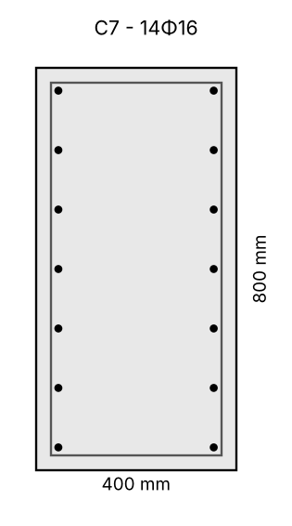
Figure 22. Cross-section of column C7
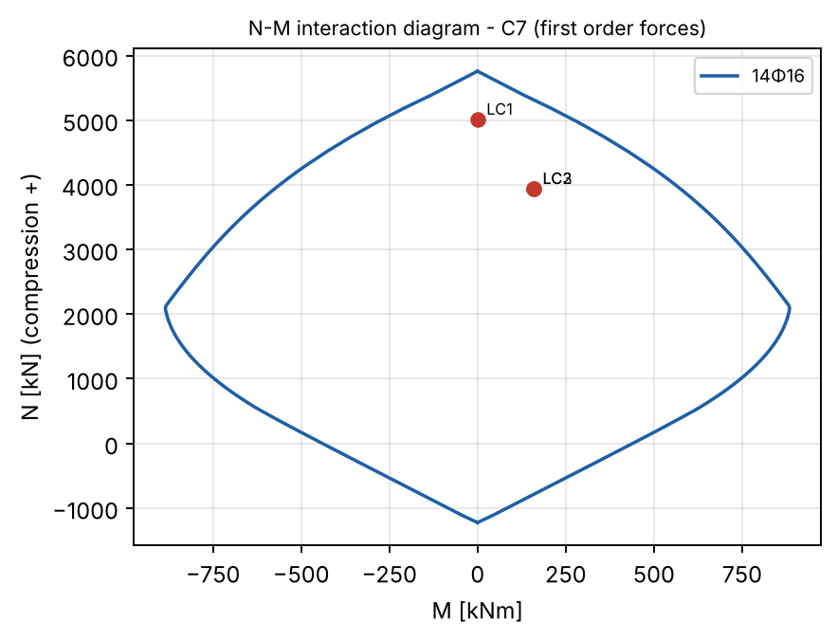
Figure 23. Interaction diagram of column C7 with the design forces

Column C1 - first storey (40/60 cm)
Flexibility of the restraint at the top (course formula)
$$k_{1}=\frac{\frac{I_{c}}{l}}{\frac{4·I_{b}}{l_{b}}}=\frac{\frac{720000}{290}}{\frac{4·1550090}{755}}=0.3023$$
Footing (minimum recommended value)
$$k_{2}=0.1$$
Effective length in the plane of the frame (braced, EC2 5.15)
$$l_{0}=0.5·l·\sqrt{\left(1+\frac{k_{1}}{0.45+k_{1}}\right)·\left(1+\frac{k_{2}}{0.45+k_{2}}\right)}=0.5·2.9·\sqrt{\left(1+\frac{0.3023}{0.45+0.3023}\right)·\left(1+\frac{0.1}{0.45+0.1}\right)}=1.866 m$$
Out of the plane of the frame
$$l_{0,out}=0.7·l=0.7·2.9=2.03 m$$
Table 17. Design forces of column C1 (first storey)
LC | N_Ed [kN] | M_01 [kNm] | M_02 [kNm]
LC1 | 3190 | 92.78 | -181.4
LC2 | 2705 | 107.9 | -212
LC3 | 2661 | 29.65 | -57.07

LC1:
C1 - bending in the plane of the frame: b = 400 mm, h = 600 mm
Effective length
$$l_{0}=1.866 m$$
Radius of gyration
$$i=\frac{h}{\sqrt{12}}=\frac{600}{\sqrt{12}}=173.2 mm$$
Slenderness
$$λ=\frac{l_{0}·1000}{i}=\frac{1.866·1000}{173.2}=10.78$$
Relative normal force (f_cd with α_cc = 0.85)
$$n=\frac{N_{Ed}·1000}{A_{c}·f_{cd}}=\frac{3190·1000}{240000·14.17}=0.9382$$
EC2 5.8.3.1: A = 0.7, B = √(1+2ω), C = 1.7 − r_m
$$λ_{l​im}=\frac{20·A·B·C}{\sqrt{n}}=\frac{20·0.7·1.209·2.212}{\sqrt{0.9382}}=38.64$$
Eccentricity from imperfections (EC2 6.1(4), 5.2(7))
$$e_{i}=max\left(\frac{l_{0}·1000}{400} ; \frac{h}{30} ; 20\right)=max\left(\frac{1.866·1000}{400} ; \frac{600}{30} ; 20\right)=20 mm$$
✔ λ ≤ λ_lim - second order effects may be ignored
M_Ed = M_02 + N_Ed·e_i
$$M_{Ed}=M_{02}+\frac{N_{Ed}·e_{i}}{1000}=181.4+\frac{3190·20}{1000}=245.2 kNm$$
Relative moment
$$μ_{Ed}=\frac{M_{Ed}·10⁶}{b·h^{2}·f_{cd}}=\frac{245.2·10⁶}{400·{600}^{2}·14.17}=0.1202$$
Required reinforcement from the N-M interaction diagram of the section (symmetric reinforcement, d_1 = 45 mm, rectangular stress block, ε_cu = 3.5 ‰):
(ω used for λ_lim and K_r: ω = 0.2308 - iterated until it agrees with the result)
Mechanical reinforcement ratio (from the diagram)
$$ω_{tot}=0.231$$
$$A_{s,tot}=\frac{ω_{tot}·b·h·f_{cd}}{f_{yd}}=\frac{0.231·400·600·14.17}{434.8}=1805 mm²$$
LC2:
C1 - bending in the plane of the frame: b = 400 mm, h = 600 mm
Effective length
$$l_{0}=1.866 m$$
Radius of gyration
$$i=\frac{h}{\sqrt{12}}=\frac{600}{\sqrt{12}}=173.2 mm$$
Slenderness
$$λ=\frac{l_{0}·1000}{i}=\frac{1.866·1000}{173.2}=10.78$$
Relative normal force (f_cd with α_cc = 0.85)
$$n=\frac{N_{Ed}·1000}{A_{c}·f_{cd}}=\frac{2705·1000}{240000·14.17}=0.7955$$
EC2 5.8.3.1: A = 0.7, B = √(1+2ω), C = 1.7 − r_m
$$λ_{l​im}=\frac{20·A·B·C}{\sqrt{n}}=\frac{20·0.7·1.133·2.209}{\sqrt{0.7955}}=39.3$$
Eccentricity from imperfections (EC2 6.1(4), 5.2(7))
$$e_{i}=max\left(\frac{l_{0}·1000}{400} ; \frac{h}{30} ; 20\right)=max\left(\frac{1.866·1000}{400} ; \frac{600}{30} ; 20\right)=20 mm$$
✔ λ ≤ λ_lim - second order effects may be ignored
M_Ed = M_02 + N_Ed·e_i
$$M_{Ed}=M_{02}+\frac{N_{Ed}·e_{i}}{1000}=212+\frac{2705·20}{1000}=266.1 kNm$$
Relative moment
$$μ_{Ed}=\frac{M_{Ed}·10⁶}{b·h^{2}·f_{cd}}=\frac{266.1·10⁶}{400·{600}^{2}·14.17}=0.1304$$
Required reinforcement from the N-M interaction diagram of the section (symmetric reinforcement, d_1 = 45 mm, rectangular stress block, ε_cu = 3.5 ‰):
(ω used for λ_lim and K_r: ω = 0.1421 - iterated until it agrees with the result)
Mechanical reinforcement ratio (from the diagram)
$$ω_{tot}=0.142$$
$$A_{s,tot}=\frac{ω_{tot}·b·h·f_{cd}}{f_{yd}}=\frac{0.142·400·600·14.17}{434.8}=1111 mm²$$
C1 - bending out of the plane of the frame (N_max): b = 600 mm, h = 400 mm
Effective length
$$l_{0}=2.03 m$$
Radius of gyration
$$i=\frac{h}{\sqrt{12}}=\frac{400}{\sqrt{12}}=115.5 mm$$
Slenderness
$$λ=\frac{l_{0}·1000}{i}=\frac{2.03·1000}{115.5}=17.58$$
Relative normal force (f_cd with α_cc = 0.85)
$$n=\frac{N_{Ed}·1000}{A_{c}·f_{cd}}=\frac{3190·1000}{240000·14.17}=0.9382$$
EC2 5.8.3.1: A = 0.7, B = √(1+2ω), C = 1.7 − r_m
$$λ_{l​im}=\frac{20·A·B·C}{\sqrt{n}}=\frac{20·0.7·1.06·0.7}{\sqrt{0.9382}}=10.72$$
Eccentricity from imperfections (EC2 6.1(4), 5.2(7))
$$e_{i}=max\left(\frac{l_{0}·1000}{400} ; \frac{h}{30} ; 20\right)=max\left(\frac{2.03·1000}{400} ; \frac{400}{30} ; 20\right)=20 mm$$
➜ λ > λ_lim - second order effects are taken into account (nominal curvature method, EC2 5.8.8)
K_r = (n_u − n)/(n_u − n_bal) ≤ 1
$$K_{r}=0.1863$$
K_φ = 1 + β·φ_ef, φ_ef = 2
$$K_{φ}=1.716$$
$${1/r}_{0}=\frac{f_{yd}}{E_{s}·0.45·d}=\frac{434.8}{200000·0.45·355}=0.0000136 1/mm$$
$$1/r=K_{r}·K_{φ}·{1/r}_{0}=0.1863·1.716·0.0000136=0.0000043 1/mm$$
Second order eccentricity
$$e_{2}=\frac{1/r·{\left(l_{0}·1000\right)}^{2}}{10}=\frac{0.0000043·{\left(2.03·1000\right)}^{2}}{10}=1.793 mm$$
M_Ed = max(M_0e; M_02) + N_Ed·e_i + N_Ed·e_2
$$M_{Ed}=max\left(M_{0e}+\frac{N_{Ed}·e_{i}}{1000} ; M_{02}+\frac{N_{Ed}·e_{i}}{1000}\right)+\frac{N_{Ed}·e_{2}}{1000}$$
$$=max\left(0+\frac{3190·20}{1000} ; 0+\frac{3190·20}{1000}\right)+\frac{3190·1.793}{1000}=69.51 kNm$$
Relative moment
$$μ_{Ed}=\frac{M_{Ed}·10⁶}{b·h^{2}·f_{cd}}=\frac{69.51·10⁶}{600·{400}^{2}·14.17}=0.0511$$
Required reinforcement from the N-M interaction diagram of the section (symmetric reinforcement, d_1 = 45 mm, rectangular stress block, ε_cu = 3.5 ‰):
(ω used for λ_lim and K_r: ω = 0.0614 - iterated until it agrees with the result)
Mechanical reinforcement ratio (from the diagram)
$$ω_{tot}=0.054$$
$$A_{s,tot}=\frac{ω_{tot}·b·h·f_{cd}}{f_{yd}}=\frac{0.054·600·400·14.17}{434.8}=423.4 mm²$$
Required A_s,tot = 1805 mm² (A_s,min = 733.6 mm²) → adopted 6Φ20 (1885 mm², ρ = 0.7854 %)
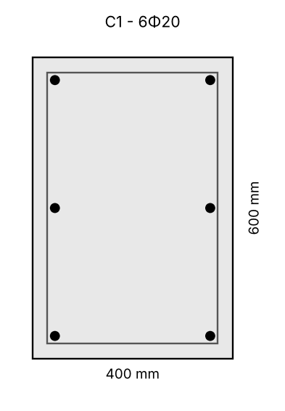
Figure 24. Cross-section of column C1
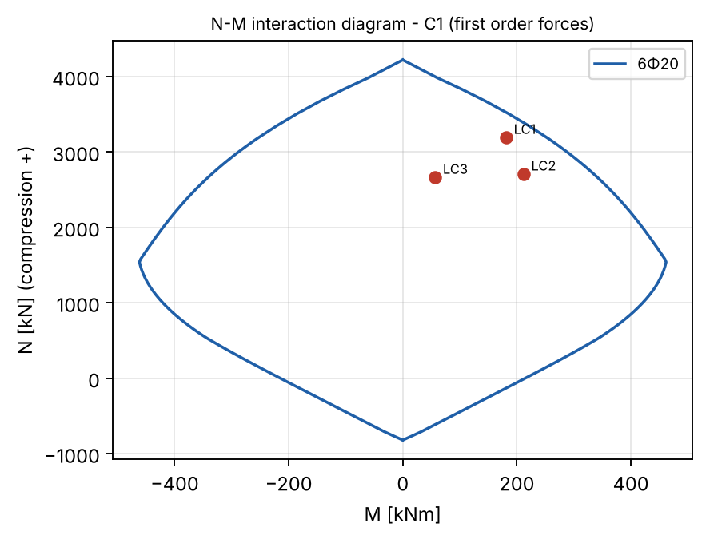
Figure 25. Interaction diagram of column C1 with the design forces
Links in the columns: Φ8 (Φ10 for Φ25 bars), s ≤ min(20·Φ; b; 400 mm), 0.6·s in the critical regions at the beams and at laps.

XI. Design of reinforced concrete pad footing for single columns
Pad footing under column C7 (40/80 cm), frame on axis 2.

1. Actions
Design normal force at the base (LC1, frame X)
$$N_{Ed}=5016 kN$$
Corresponding bending moment
$$M_{Ed}=0.0000000000102 kNm$$
Characteristic normal force (G_k + Q_k) - SLS
$$N_{k}=3557 kN$$
$$M_{k}=0.00000000000728 kNm$$
Weight of the footing and the backfill (≈ 15 %)
$$G_{f,k}=0.15·N_{k}=0.15·3557=533.5 kN$$
$$N_{f,k}=N_{k}+G_{f,k}=3557+533.5=4090 kN$$

2. Plan size of the footing (SLS)
Characteristic soil pressure (assignment)
$$R_{0}=230 kN/m²$$
$$A_{f,req}=\frac{N_{f,k}}{R_{0}}=\frac{4090}{230}=17.78 m²$$
Equal overhangs on all sides
$$l_{c,req}=0.5·\left(\sqrt{A_{f,req}}−\frac{h_{c}+b_{c}}{2}\right)=0.5·\left(\sqrt{17.78}−\frac{0.8+0.4}{2}\right)=1.809 m$$
Adopted overhang (rounded up to 5 cm)
$$l_{c}=1.85 m$$
$$L_{f}=2·l_{c}+h_{c}=2·1.85+0.8=4.5 m$$
$$B_{f}=2·l_{c}+b_{c}=2·1.85+0.4=4.1 m$$
$$A_{f}=L_{f}·B_{f}=4.5·4.1=18.45 m²$$
$$σ_{k}=\frac{N_{f,k}}{A_{f}}=\frac{4090}{18.45}=221.7 kN/m²$$
$$σ_{k}=221.7 kN/m² ≤ R_{0}=230 kN/m²$$
✔ The soil pressure is acceptable
Eccentricity of the load (in the plane of the frame)
$$e=\frac{M_{k}}{N_{f,k}}=\frac{0.00000000000728}{4090}=0 m$$
$$σ_{k,m​ax}=\frac{N_{f,k}}{A_{f}}·\left(1+\frac{6·e}{L_{f}}\right)=\frac{4090}{18.45}·\left(1+\frac{6·0}{4.5}\right)=221.7 kN/m²$$
$$σ_{k,m​ax}=221.7 kN/m² ≤ {1.2·R}_{0}=276 kN/m²$$
✔ Edge pressure acceptable
Shape (≤ 1.5 recommended)
$$L_{f/B_f}=\frac{L_{f}}{B_{f}}=\frac{4.5}{4.1}=1.098$$

3. Thickness and reinforcement
Design characteristics of the materials (EN 1992-1-1):
Concrete C25/30, reinforcing steel B500.
Characteristic cylinder strength of concrete
$$f_{ck}=25 N/mm²$$
Design compressive strength
$$f_{cd}=\frac{α_{cc}·f_{ck}}{γ_{c}}=\frac{1·25}{1.5}=16.67 N/mm²$$
Mean tensile strength
$$f_{ctm}=2.56 N/mm²$$
Characteristic yield strength of steel
$$f_{yk}=500 N/mm²$$
Design yield strength of steel
$$f_{yd}=\frac{f_{yk}}{γ_{s}}=\frac{500}{1.15}=434.8 N/mm²$$
Design soil pressure (self-weight not included)
$$σ_{gr}=\frac{N_{Ed}}{A_{f}}=\frac{5016}{18.45}=271.9 kN/m²$$
Perimeter of the column
$$u_{0}=2·\left(h_{c}+b_{c}\right)=2·\left(800+400\right)=2400 mm$$
$$V_{Ed,red}=N_{Ed}−σ_{gr}·h_{c}·b_{c}=5016−271.9·0.8·0.4=4929 kN$$
$$ν=0.6·\left(1−\frac{f_{ck}}{250}\right)=0.6·\left(1−\frac{25}{250}\right)=0.54$$
From v_Ed ≤ v_Rd,max = 0.4·ν·f_cd at the column face (EC2 6.4.5(3))
$$d_{req}=\frac{V_{Ed,red}·1000}{u_{0}·0.4·ν·f_{cd}}=\frac{4929·1000}{2400·0.4·0.54·16.67}=570.5 mm$$
Adopted height (≥ d_req + c_nom + Φ, ≥ l_c/2.5 for a rigid footing; increased if needed for punching)
$$H_{f}=900 mm$$
$$d=H_{f}−c_{nom}−φ=900−50−15=835 mm$$

3.1 Bending reinforcement
Moment at the face of the column (cantilever l_c)
$$M_{Ed,f}=\frac{σ_{gr}·{l_{c}}^{2}}{2}=\frac{271.9·{1.85}^{2}}{2}=465.3 kNm/m$$
Both directions (per metre)
Relative design moment
$$μ_{Ed}=\frac{\left|M_{Ed,f}\right|·10⁶}{b·d^{2}·f_{cd}}=\frac{\left|465.3\right|·10⁶}{1000·{835}^{2}·16.67}=0.04$$
$$μ_{Ed}=0.04 ≤ μ_{l​im}=0.295$$
✔ Single reinforcement is sufficient
Lever arm ratio z/d
$$ζ=0.5·\left(1+\sqrt{1−2·μ_{Ed}}\right)=0.5·\left(1+\sqrt{1−2·0.04}\right)=0.9796$$
Required reinforcement
$$A_{s,req}=\frac{\left|M_{Ed,f}\right|·10⁶}{ζ·d·f_{yd}}=\frac{\left|465.3\right|·10⁶}{0.9796·835·434.8}=1308 mm²/m$$
Minimum reinforcement (EC2 9.2.1.1)
$$A_{s,m​in}=max\left(\frac{0.26·f_{ctm}}{f_{yk}}·b·d ; 0.0013·b·d\right)=max\left(\frac{0.26·2.56}{500}·1000·835 ; 0.0013·1000·835\right)=1114 mm²/m$$
Provided reinforcement: Φ16/15 cm → A_s,prov = 1340 mm²/m
Required reinforcement ratio
$$ρ=\frac{A_{s}}{b·d}=\frac{1308}{1000·835}=0.00157$$
Provided reinforcement ratio
$$ρ_{prov}=\frac{A_{s,prov}}{b·d}=\frac{1340}{1000·835}=0.00161$$

3.2 Punching shear (EC2 6.4.4(2))
The control perimeter is searched between a = 0.2·d and a = 2·d; the soil pressure inside the perimeter reduces the punching force.
Critical control perimeter (largest v_Ed/v_Rd)
$$a_{crit}=709.8 mm$$
$$u=2·\left(h_{c}+b_{c}\right)+2·π·a_{crit}=2·\left(800+400\right)+2·3.142·709.8=6859 mm$$
$$A_{in}=\frac{h_{c}·b_{c}+2·a_{crit}·\left(h_{c}+b_{c}\right)+π·{a_{crit}}^{2}}{10⁶}=\frac{800·400+2·709.8·\left(800+400\right)+3.142·{709.8}^{2}}{10⁶}=3.606 m²$$
$$V_{Ed,red}=N_{Ed}−σ_{gr}·A_{in}=5016−271.9·3.606=4036 kN$$
$$v_{Ed}=\frac{V_{Ed,red}·1000}{u·d}=\frac{4036·1000}{6859·835}=0.7046 N/mm²$$
$$k=min\left(1+\sqrt{\frac{200}{d}} ; 2\right)=min\left(1+\sqrt{\frac{200}{835}} ; 2\right)=1.489$$
v_Rd = C_Rd,c·k·(100·ρ·f_ck)^(1/3)·2d/a ≥ v_min·2d/a
$$v_{Rd}=\frac{max\left(C_{Rd,c}·k·{\left(100·ρ_{l}·f_{ck}\right)}^{\frac{1}{3}} ; 0.035·k^{\frac{3}{2}}·\sqrt{f_{ck}}\right)·2·d}{a_{crit}}$$
$$=\frac{max\left(0.12·1.489·{\left(100·0.00161·25\right)}^{\frac{1}{3}} ; 0.035·{1.489}^{\frac{3}{2}}·\sqrt{25}\right)·2·835}{709.8}=0.7485 N/mm²$$
$$v_{Ed}=0.7046 N/mm² ≤ v_{Rd}=0.7485 N/mm²$$
✔ No punching shear reinforcement is required
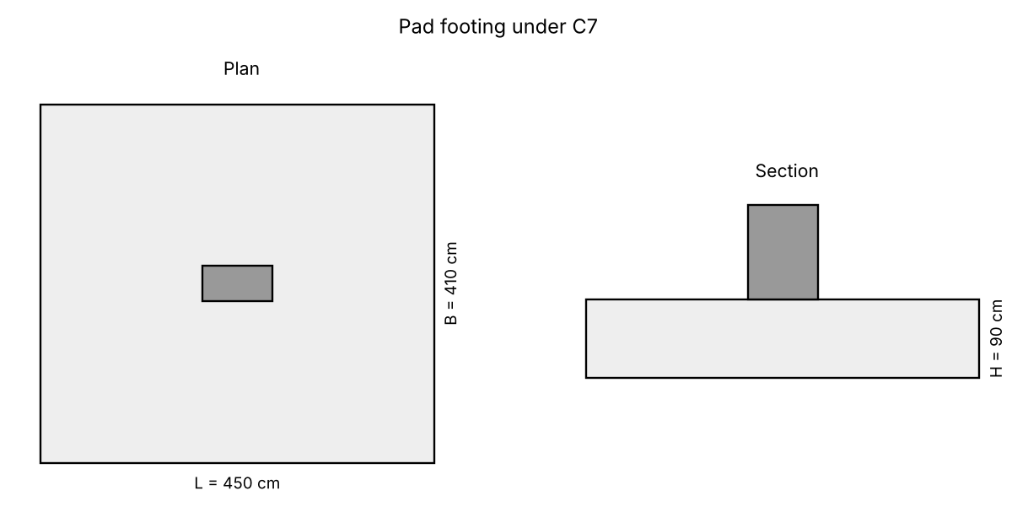
Figure 26. Pad footing - plan and section

XII. Drawings and bar schedules
The following drawings were produced from the results of the calculations (DXF, scale 1:50, drawing unit = 1 cm):
- Formwork_Dionisios_Papadimitriou.dxf
- Slab_reinforcement_Dionisios_Papadimitriou.dxf
The slabs of the hall are reinforced with the welded wire meshes adopted in section II (part 8); the bar diameters and spacings of the other slabs are the ones adopted in sections I, III, IV and VII. Distribution bars, top bars at the end supports and along the edges parallel to the span and the assembly bars follow the detailing rules given there (EC2 9.3).
Slabs 1-6: welded wire meshes (R-type, main bars along the span, laps of the transverse bars 150 mm). Top meshes on spacers.
Slabs 10 and 18 are reinforced like slabs 19-21 (two-way slabs, smaller spans).
Table 18. Bar schedule of the slabs (BR/DR bottom, TR/AR top)
Pos. | Mark | Φ | Shape [cm] | s [cm] | n | Total [m] | Location
N1 | BR | Φ8 | 264 | 20 | 168 | 443.5 | slabs 11-16, end span; slabs 11-16, interior span
N2 | DR | Φ6 | 600 | 17.5 | 72 | 432 | slabs 11-16, distribution
N3 | BR | Φ10 | 370 | 20 | 94 | 347.8 | slab 17
N4 | DR | Φ6 | 655 | 17.5 | 38 | 248.9 | slab 17, distribution
N5 | DR | Φ6 | 660 | 17.5 | 19 | 125.4 | slab 17, distribution
N6 | BR | Φ8 | 650 | 17.5 | 64 | 416 | slab 19, direction x; slab 21, direction x
N7 | BR | Φ8 | 600 | 16 | 101 | 606 | slab 19, direction y; slab 21, direction y; slab 10, direction y
N8 | BR | Φ8 | 650 | 20 | 28 | 182 | slab 20, direction x
N9 | BR | Φ8 | 600 | 20 | 30 | 180 | slab 20, direction y
N10 | BR | Φ8 | 445 | 17.5 | 32 | 142.4 | slab 10, direction x
N11 | BR | Φ8 | 405 | 17.5 | 37 | 149.8 | slab 18, direction x
N12 | BR | Φ8 | 691 | 16 | 22 | 152 | slab 18, direction y
N13 | TR | Φ8 | 7+165+7 | 20 | 140 | 250.6 | slabs 11-16, over the beams
N14 | AR | Φ6 | 600 | 25 | 89 | 534 | slabs 11-16, under TR; slabs 19-21, under TR; slab 10, under TR
N15 | TR | Φ8 | 15+67+7 | 20 | 188 | 167.3 | slabs 11-16, edges 5' / 7; slabs 11-16, edges on axes D, E
N16 | AR | Φ6 | 264 | 25 | 36 | 95.04 | slabs 11-16, edges on axes D, E
N17 | TR | Φ8 | 15+87+9 | 20 | 220 | 244.2 | slab 17, edges B / D; slab 17, edges 4 / 7
N18 | AR | Φ6 | 655 | 25 | 16 | 104.8 | slab 17, under TR
N19 | AR | Φ6 | 660 | 25 | 8 | 52.8 | slab 17, under TR
N20 | AR | Φ6 | 370 | 25 | 8 | 29.6 | slab 17, under TR
N21 | TR | Φ12 | 10+335+10 | 17.5 | 64 | 227.2 | slabs 19-21, over axes 5, 6
N22 | TR | Φ8 | 15+147+10 | 20 | 56 | 96.32 | slabs 19, 21, edges 4 / 7
N23 | TR | Φ8 | 15+137+10 | 20 | 160 | 259.2 | slabs 19-21, edge B; slab 20, edge A; slab 10, edges
N24 | AR | Φ6 | 650 | 25 | 24 | 156 | slabs 19-21, under TR
N25 | TR | Φ8 | 15+102+10 | 20 | 56 | 71.12 | slab 10, edges
N26 | AR | Φ6 | 445 | 25 | 12 | 53.4 | slab 10, under TR
N27 | TR | Φ8 | 15+97+10 | 20 | 64 | 78.08 | slab 18, edges
N28 | AR | Φ6 | 691 | 25 | 8 | 55.28 | slab 18, under TR
N29 | TR | Φ8 | 15+152+10 | 20 | 36 | 63.72 | slab 18, edges
N30 | AR | Φ6 | 405 | 25 | 12 | 48.6 | slab 18, under TR
N31 | TR | Φ10 | 7+362+10 | 15 | 80 | 303.2 | balconies 22, 23
N32 | DR | Φ6 | 600 | 17.5 | 20 | 120 | balconies 22, 23
N33 | TR | Φ10 | 10+232+40 | 17.5 | 13 | 36.66 | canopy slab 7
N34 | DR | Φ6 | 227 | 17.5 | 12 | 27.24 | canopy slab 7

Reinforcement drawings of the elements
The reinforcement file contains also the detail drawings of the elements designed in the note (elevations, cross-sections, bars drawn separately, bar schedules): Beam B21 - simply supported beam (axis 5, A-B); Beam on axis E (3-4) - bending and torsion; Beam B5 - continuous beam over the frame beam B15; Frame on axis 2 - beam B15, columns C1, C7, C12 (first storey); Column C10 - first and second storey; Pad footing under column C7; Stairs - flight and landing (axes 3-4).
Table 19. Bar schedule of the elements
Element | Pos. | Φ | Shape [cm] | n | Total [m] | Mass [kg]
Beam B21 | 1 | Φ20 | 25+600+25 | 4 | 26 | 64.12
Beam B21 | 2 | Φ12 | 15+600+15 | 2 | 12.6 | 11.19
Beam B21 | 3 | Φ8 | 20+55+20+55+8+8 | 19 | 31.54 | 12.45
Beam on axis E (3-4) | 1 | Φ12 | 15+405+15 | 5 | 21.75 | 19.31
Beam on axis E (3-4) | 2 | Φ12 | 405 | 6 | 24.3 | 21.57
Beam on axis E (3-4) | 3 | Φ10 | 20+45+20+45+10+10 | 36 | 54 | 33.29
Beam B5 | 1 | Φ22 | 30+652 | 4 | 27.28 | 81.4
Beam B5 | 2 | Φ20 | 400 | 4 | 16 | 39.46
Beam B5 | 3 | Φ10 | 15+660 | 4 | 27 | 16.65
Beam B5 | 4 | Φ12 | 15+148 | 4 | 6.52 | 5.789
Beam B5 | 5 | Φ8 | 20+40+20+40+8+8 | 44 | 59.84 | 23.61
Frame on axis 2 | 1 | Φ25 | 30+820 | 6 | 51 | 196.5
Frame on axis 2 | 2 | Φ25 | 500 | 5 | 25 | 96.33
Frame on axis 2 | 3 | Φ25 | 55+268 | 10 | 32.3 | 124.5
Frame on axis 2 | 4 | Φ12 | 15+808 | 4 | 32.92 | 29.23
Frame on axis 2 | 5 | Φ10 | 25+60+25+60+10+10 | 72 | 136.8 | 84.34
Frame on axis 2 | 6 | Φ16 | 30+452 | 14 | 67.48 | 106.5
Frame on axis 2 | 7 | Φ8 | 75+35+75+35+8+8 | 17 | 40.12 | 15.83
Frame on axis 2 | 8 | Φ20 | 30+472 | 12 | 60.24 | 148.6
Frame on axis 2 | 9 | Φ8 | 55+35+55+35+8+8 | 32 | 62.72 | 24.75
Column C10 | 1 | Φ28 | 440 | 6 | 26.4 | 127.6
Column C10 | 2 | Φ20 | 410 | 6 | 24.6 | 60.67
Column C10 | 3 | Φ10 | 55+20+55+20+10+10 | 42 | 71.4 | 44.02
Column C10 | 4 | Φ10 | 20+10+10 | 42 | 16.8 | 10.36
Pad footing under column C7 | 1 | Φ16 | 20+440+20 | 27 | 129.6 | 204.6
Pad footing under column C7 | 2 | Φ16 | 20+400+20 | 30 | 132 | 208.3
Pad footing under column C7 | 3 | Φ16 | 30+162 | 14 | 26.88 | 42.43
Pad footing under column C7 | 4 | Φ8 | 75+35+75+35+8+8 | 3 | 7.08 | 2.794
Stairs | 1 | Φ10 | 330 | 12 | 39.6 | 24.41
Stairs | 2 | Φ10 | 198 | 12 | 23.76 | 14.65
Stairs | 3 | Φ8 | 50+119 | 9 | 15.21 | 6.002
Stairs | 4 | Φ8 | 15+128 | 9 | 12.87 | 5.078
Stairs | 5 | Φ8 | 165 | 25 | 41.25 | 16.28

Table 20. Mass of the reinforcement of the elements
Element | Mass [kg]
Beam B21 | 87.75
Beam on axis E (3-4) | 74.18
Beam B5 | 166.9
Frame on axis 2 | 826.5
Column C10 | 242.7
Pad footing under column C7 | 458.1
Stairs | 66.42
Total | 1923

Slabs
Table 21. Mesh schedule of the slabs (welded wire meshes, R-type)
Pos. | Mesh | L × B [m] | n | Area [m²] | kg/pc | Total [kg] | Location
M1 | R221 | 2.72 × 2.11 | 12 | 68.87 | 13.53 | 162.3 | slabs 1-6, bottom, span 1
M2 | R188 | 2.72 × 2.11 | 24 | 137.7 | 11.58 | 277.9 | slabs 1-6, bottom, span 2; slabs 1-6, bottom, span 3
M3 | R221 | 1.65 × 2.11 | 12 | 41.78 | 8.291 | 99.49 | slabs 1-6, over support B
M4 | R188 | 1.65 × 2.11 | 18 | 62.67 | 7.1 | 127.8 | slabs 1-6, over support C; slabs 1-6, over support D
M5 | R257 | 0.72 × 2.11 | 12 | 18.23 | 4.053 | 48.64 | slabs 1-6, edges A / E
M6 | R257 | 0.72 × 1.21 | 24 | 20.91 | 2.411 | 57.86 | slabs 1-6, edges on axes 1, 2, 3
M7 | R257 | 1.30 × 1.21 | 12 | 18.88 | 4.441 | 53.29 | slabs 1-6, edges on axes 1, 2, 3

Table 22. Mass of the reinforcement of the slabs
Steel | Length [m] | kg/m | Mass [kg]
Φ6 | 2083 | 0.222 | 462.3
Φ8 | 3502 | 0.3946 | 1382
Φ10 | 687.7 | 0.6165 | 424
Φ12 | 227.2 | 0.8878 | 201.7
Meshes |  |  | 827.3
Total |  |  | 3297

Summary of the results
Sizes chosen automatically by the program: h_f slab I: 14; h_f slab II: 12; h_f slab III: 12; h_f slab IV: 15; h stair: 17; B21: 25/60 cm; B5: 25/45 cm; footing height: 90 cm
Table 23. Main results
Element | Result
Slab 17 (corridor, simply supported) | h_f = 14 cm, 5Φ10/20 cm
Slabs 1-6 (hall, continuous) | h_f = 12 cm, welded meshes: span 1 R221, support B R221
Slabs 11, 12, 13, 14, 15, 16 (meeting room, plastic) | h_f = 12 cm, end span 5Φ8/20 cm, support B 5Φ8/20 cm
Slabs 19, 20, 21 (offices, two-way) | h_f = 15 cm, x: Φ8/17.5 cm, y: Φ8/16 cm, supports: Φ12/17.5 cm
Balconies 22, 23 | top Φ10/15 cm
Stairs | h = 17 cm, 9 risers 16.11/30 cm, Φ10/14 cm
Beam B21 | 25/60 cm, 4Φ20, links Φ8/30 cm
Torsion beam (axis E, 3-4) | 25/50 cm, bottom 3Φ12, top 2Φ12, links Φ10/10
Beam B5-B9 | 25/45 cm, span 2Φ22, support 4Φ20, links Φ8/25 cm
Column C10 | 25/60 cm, 0-0: 6Φ28; 1-1: 6Φ20
Frame beam B15 | 30/65 cm: span 3Φ25, over C7 5Φ25, over C1 5Φ25, links Φ10/25 cm
Column C7 (1st storey) | 40/80 cm, 14Φ16
Columns C1/C12 (1st storey) | 40/60 cm, 6Φ20
Footing under C7 | 450 × 410 × 90 cm, Φ16/15 cm both ways

