WORKING DRAFT - REWRITE THE PROSE IN YOUR OWN WORDS

The Technological and Economic Constraints of Asteroid Mining
Independent Research Project
Author: ______________________________
Date: ______________________________
Research question: Under what conditions could asteroid-resource extraction become commercially viable, and which variables have the greatest effect on the required break-even resource price?
Project type: Independent literature review and computational scenario analysis

Abstract
Asteroid mining is often described as a future source of water, metals, and other materials, but the presence of useful resources does not by itself make a mining mission commercially viable. A complete system must locate and characterize a suitable asteroid, reach it, operate in very low gravity, extract and process resources, transport the resulting product, and sell it into a market. This project combines a review of NASA and peer-reviewed literature with a transparent Python scenario model to examine how selected technical and economic variables influence the price required for a hypothetical asteroid-resource mission to break even. The model calculates recovered resource mass from feedstock throughput, resource fraction, extraction efficiency, and delivery efficiency, then compares that output with fixed, variable, and operating costs. Under the baseline scenario, 5,000 tonnes of asteroid feedstock are processed, 10% of the feedstock is treated as the target resource, and overall extraction and delivery efficiencies are 80% and 95%, respectively. A notional total mission cost of $2.07 billion produces 380 tonnes of delivered resource and a break-even value of approximately $5,447 per kilogram. This value is compared only as a contextual benchmark with a 2020 study that estimated asteroid-derived propellant delivery to lunar orbit at at least about $3,600 per kilogram under its assumptions; the figures are not treated as market prices. Sensitivity analysis shows that throughput and recoverable resource fraction strongly affect the required break-even value, while higher fixed and variable costs increase it. The model is intentionally not a commercial forecast: its purpose is to demonstrate a reproducible method for testing which assumptions matter most. The results support the view in the literature that asteroid mining is a systems-engineering problem in which mission architecture, extraction throughput, resource accessibility, infrastructure cost, and the eventual market for space-based resources interact.

1. Introduction
Asteroids are remnants of the early Solar System and can contain water-bearing minerals, carbon-rich compounds, metals, and other materials. Their possible use as sources of resources has attracted research because obtaining resources in space could reduce the amount that must be launched from Earth for future exploration and industry. NASA describes in-situ resource utilization (ISRU) as the use of local resources to create useful products at mission destinations, including water, oxygen, propellant, and construction materials. NASA's ISRU program specifically includes technologies intended to excavate or drill into resource-bearing material on asteroids and to process, transport, and store the resulting products [1].
Evidence that some asteroids contain potentially useful materials is no longer purely theoretical. NASA's OSIRIS-REx mission returned 121.6 grams of material from near-Earth asteroid Bennu. Analyses of the sample found carbon-rich material and minerals associated with water, while later work identified phosphate-bearing material and evidence of aqueous alteration [2, 3]. These results demonstrate that primitive asteroids can preserve chemically and mineralogically interesting resources. They do not, however, demonstrate that the material can be mined economically at industrial scale.
The central challenge is therefore to connect resource availability to a complete mission architecture. A mining venture would need a suitable target, an affordable trajectory, reliable mining equipment, an extraction and processing system, power and communications, storage, and a customer willing to buy the resulting resource. NASA notes that major knowledge gaps still exist concerning the location, form, concentration, and distribution of extraterrestrial resources and how they should best be extracted and processed [1].
Economic research reaches a similar conclusion. Hein, Matheson, and Fries developed a techno-economic model of asteroid mining and found that throughput rate, the number of spacecraft, and the rate at which missions can be repeated are important technological drivers of economic performance [4]. Colvin, Crane, and Lal examined asteroid-derived water for propellant and found that the economics depend on mining and processing infrastructure cost, total demand for in-space resources, and the competing cost of launching equivalent resources from Earth [5]. A newer 2026 model by Dorrington and Olsen further formalizes profit, net present value, mass payback, and a break-even mass ratio for several asteroid-mining architectures and emphasizes the importance of propulsion performance and mission architecture [6].
This project asks: Under what conditions could asteroid-resource extraction become commercially viable, and which variables have the greatest effect on the required break-even resource price?
Rather than attempting to predict the future asteroid-mining industry, the project uses a transparent scenario model to test the direction and relative importance of several variables. The analysis focuses on resource throughput, resource fraction, extraction efficiency, delivery efficiency, fixed development cost, variable processing cost, and operating cost.

2. Background and Literature Review

2.1 Resource availability
The value of an asteroid depends not only on the quantity of a resource it contains but also on the resource's chemical form and accessibility. NASA's ISRU research emphasizes that future resource systems must determine where resources are located, their form and concentration, and how they can be extracted and processed [1]. This is especially relevant to water because water may be incorporated into hydrated minerals rather than existing as easily accessible ice.
Bennu provides a useful scientific example. NASA reports that the returned sample is rich in carbon and nitrogen and contains mineral phases associated with water and aqueous alteration [2, 3]. Such findings increase scientific confidence that some primitive asteroids contain materials that could eventually be useful, while also showing why resource characterization matters: material observed by remote sensing does not necessarily reveal every feature found in a returned sample.

2.2 The low-gravity mining problem
Mining on Earth benefits from gravity and the mass of heavy equipment. On a small asteroid, the gravitational force can be so weak that a conventional excavator may not generate enough reaction force to penetrate the surface. NASA's Regolith Advanced Surface Systems Operations Robot (RASSOR) uses counter-rotating excavation drums to reduce net reaction forces and allow excavation in low-gravity environments without relying on the vehicle's weight for traction [7].
This is representative of the larger engineering problem: asteroid mining requires equipment designed for a physical environment that is fundamentally different from terrestrial mines. Systems may need to anchor themselves, manage loose regolith, tolerate vacuum and thermal cycling, and operate with limited human intervention.

2.3 Processing and ISRU
Mining material is only the beginning. The desired resource must be separated from the surrounding material, purified, and stored. For water-based resource utilization, additional processing may be required to turn extracted water into usable propellant or other products.
NASA's current ISRU technology program includes excavation, processing, transportation, and storage technologies, but NASA also notes that many demonstrations have taken place in analog environments and for relatively short durations [1]. This highlights a technology-readiness problem: a process that works in an Earth laboratory or short-duration analog test still needs to demonstrate long-duration operation in the actual space environment.

2.4 Transportation and trajectory accessibility
A mine located on an asteroid that is difficult to reach may be economically unattractive even if it contains large quantities of useful material. NASA's Near-Earth Object Human Space Flight Accessible Targets Study (NHATS) provides trajectory information for near-Earth asteroids, including minimum delta-v and duration for candidate trajectories [8]. These parameters matter because propulsion requirements influence spacecraft mass, mission duration, and therefore cost.
Dorrington and Olsen's 2026 study explicitly incorporates propulsion and trajectory parameters into asteroid-mining economics. In their numerical study, they found that, under their specific assumptions, a single-trip mission with propellant supplied entirely from Earth becomes constrained above certain target delta-v values, while multi-trip architectures and the use of asteroid-derived return propellant can improve the economic picture [6]. These results should be interpreted as findings of their model rather than universal thresholds for every possible future mission.

2.5 The market for resources in space
The economic case depends strongly on where the resource is used. Colvin, Crane, and Lal found that asteroid-derived propellant may be more attractive for some destinations beyond low Earth orbit than for Earth orbit, because Earth-launched resources face different transportation costs [5]. They estimated a demand for roughly 5,750 to 9,876 tonnes of LOX/LH2 propellant over the 2031-2050 period in their scenarios, and estimated an asteroid-derived delivery cost of at least about $3,600/kg for lunar orbit [5].
That number is used in this project only as a contextual literature benchmark. It is not assumed to be a market price or a guaranteed willingness-to-pay value.

3. Research Question and Hypothesis

Research question
Under what conditions could asteroid-resource extraction become commercially viable, and which variables have the greatest effect on the required break-even resource price?

Hypothesis
The model predicts that higher feedstock throughput, higher resource concentration, and higher extraction and delivery efficiencies will reduce the break-even resource price, while higher fixed, variable, and operating costs will increase it. Because fixed development costs are spread over the amount of resource delivered, higher throughput is expected to have a strong effect on the break-even value.

4. Methodology

4.1 Model design
A simplified deterministic scenario model was implemented in Python. The model does not attempt to reproduce a complete trajectory optimizer, spacecraft design, or financial market forecast. Instead, it isolates a small number of variables that the literature identifies as economically important and examines their effects on a break-even resource price.
The model first calculates the amount of resource successfully delivered to a customer:
M_delivered = M_feedstock x f_resource x eta_extraction x eta_delivery
where:
- M_feedstock is the mass of asteroid feedstock processed.
- f_resource is the fraction of the feedstock that is the target resource.
- eta_extraction is the fraction of the contained resource recovered by the mining and processing system.
- eta_delivery is the fraction that survives transport and reaches the customer as a usable product.
The total modeled cost is:
C_total = C_fixed + C_variable + C_operations
with:
C_variable = M_feedstock x c_variable
and:
C_operations = T x c_operations
where C_fixed is a fixed mission/development cost, c_variable is the variable mining and processing cost per tonne of feedstock, T is mission duration in months, and c_operations is the monthly operating cost.
Finally, the required break-even resource price is:
P_break-even = C_total / M_delivered
This quantity answers a practical question: given the assumptions, how much revenue would have to be obtained per kilogram of delivered resource to recover the modeled cost?

4.2 Baseline assumptions
The baseline scenario is deliberately labeled as a notional modeling scenario, not as a claim about the cost of a real planned mission. The goal is to create a reproducible experiment whose assumptions can be changed later.
| Parameter | Baseline value | Type |
|---|---:|---|
| Feedstock processed | 5,000 tonnes | Modeling assumption |
| Resource fraction | 10% | Modeling assumption |
| Extraction efficiency | 80% | Modeling assumption |
| Delivery efficiency | 95% | Modeling assumption |
| Fixed mission/development cost | $1.20 billion | Modeling assumption |
| Variable processing cost | $150,000/tonne feedstock | Modeling assumption |
| Mission duration | 24 months | Modeling assumption |
| Operating cost | $5 million/month | Modeling assumption |
| Contextual literature benchmark | $3,600/kg | Colvin, Crane & Lal (2020) |
The baseline assumptions are intentionally simple so that the model can be understood, modified, and reproduced by a student. They should not be interpreted as current commercial quotations.

4.3 Sensitivity analysis
The project evaluates sensitivity in three ways.
First, feedstock throughput is varied while keeping other baseline inputs constant. This tests whether spreading fixed costs over a larger production volume changes the required break-even price.
Second, resource fraction and extraction efficiency are varied together to create a two-dimensional sensitivity surface.
Third, each major input is changed by plus or minus 20% from the baseline while the other variables are held constant. The resulting change in break-even price is used to identify which assumptions have the largest local effect.

4.4 Reproducibility
All calculations were implemented in Python using NumPy and Matplotlib. The repository contains the model code, assumptions, output tables, and generated figures. The same scripts can regenerate the figures from the baseline assumptions, allowing changes in assumptions to be tested without manually rebuilding the analysis.

5. Results

5.1 Baseline calculation
The baseline model processes 5,000 tonnes of feedstock. With a resource fraction of 10%, the feedstock contains a modeled 500 tonnes of target resource. An 80% extraction efficiency reduces this to 400 tonnes recovered, and a 95% delivery efficiency produces 380 tonnes, or 380,000 kg, of delivered resource.
The fixed cost is $1.20 billion. Variable processing cost is $750 million, calculated as 5,000 tonnes multiplied by $150,000 per tonne. Operating cost is $120 million, calculated from 24 months at $5 million per month. The total modeled cost is therefore $2.07 billion.
The resulting break-even resource price is approximately:
$2.07 billion / 380,000 kg = $5,447/kg
The value is higher than the $3,600/kg lunar-orbit benchmark used for context from Colvin, Crane, and Lal [5]. However, the comparison should not be interpreted as a commercial prediction because the two numbers come from different models and represent different assumptions and quantities.

5.2 Throughput sensitivity
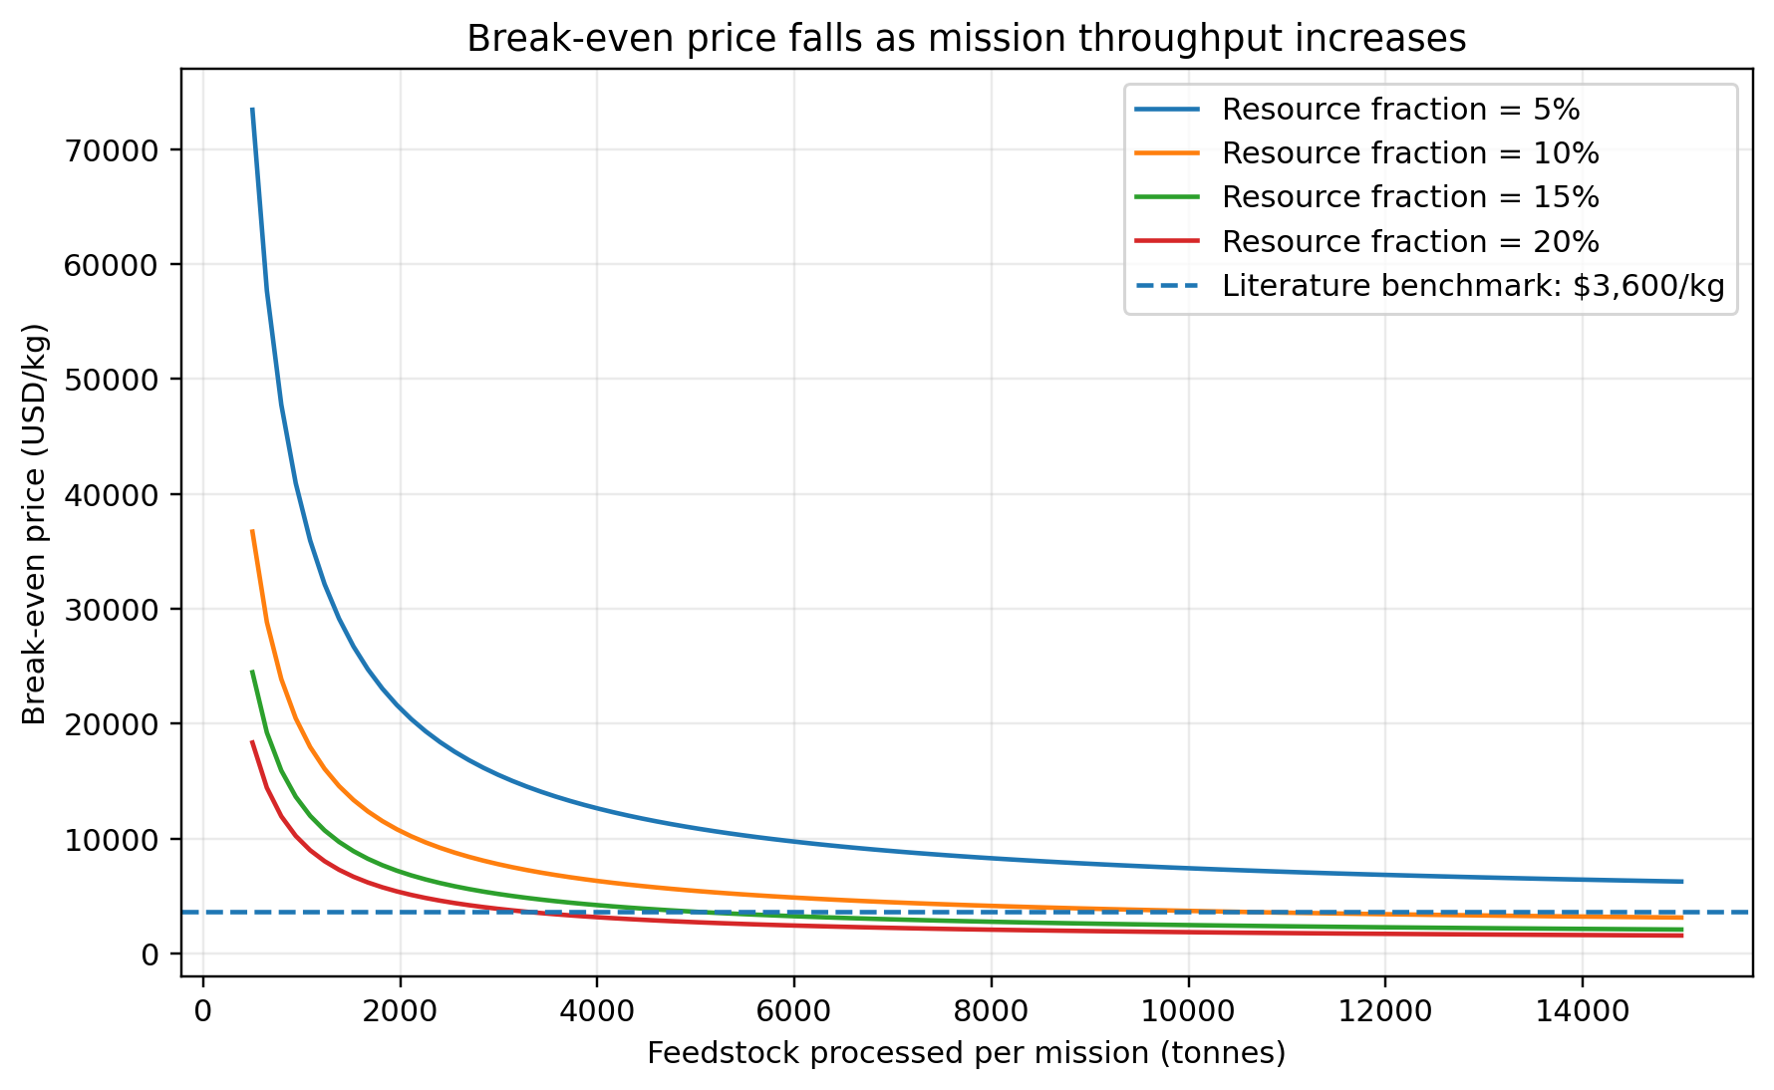
Figure 1. Modeled relationship between feedstock throughput and required break-even resource price.
Figure 1 shows the modeled relationship between feedstock throughput and the required break-even price at several resource fractions. Increasing throughput lowers the break-even price because fixed costs are distributed across a larger amount of delivered resource. The effect becomes more pronounced when the resource fraction is higher, because each tonne of processed feedstock yields more sellable resource.
At low throughput, fixed mission cost dominates the economic calculation. At higher throughput, the variable processing cost becomes a larger fraction of total cost, which causes the curve to flatten rather than fall indefinitely.
This behavior is consistent with the conclusions of Hein, Matheson, and Fries, who identified throughput rate as a key technological driver in asteroid-mining economics [4].

5.3 Resource concentration and extraction efficiency
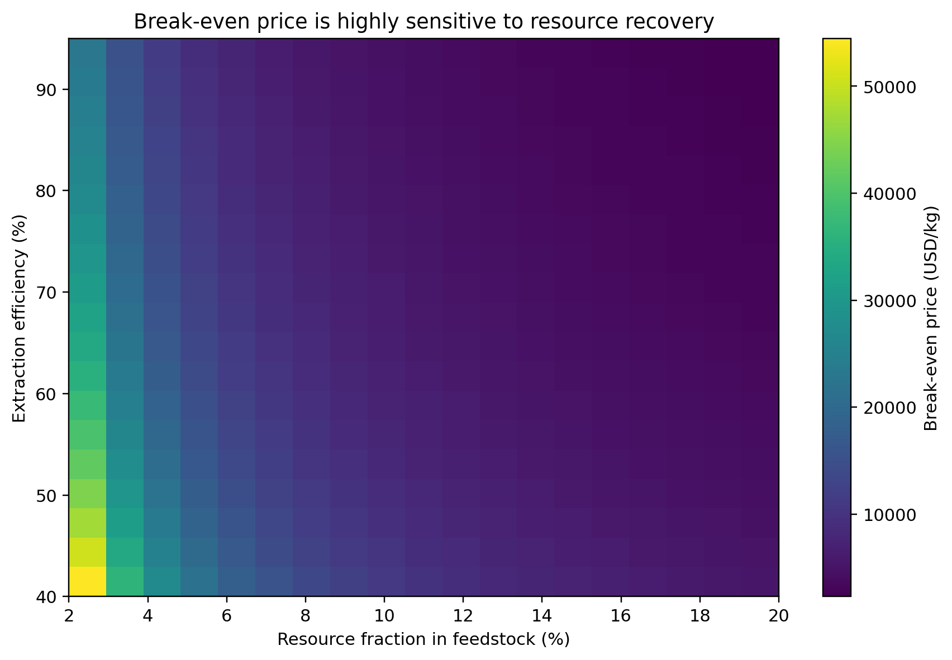
Figure 2. Modeled break-even resource price across resource fraction and extraction efficiency.
Figure 2 shows a heatmap of the break-even price as resource fraction and extraction efficiency vary. The model predicts a strong reduction in the required price when both variables improve. A resource-rich asteroid is more valuable per tonne of material processed, while higher extraction efficiency increases the fraction of that resource converted into a saleable product.
This result highlights why resource prospecting is economically important. Improving the ability to identify high-concentration, accessible deposits can increase resource output without requiring the spacecraft to carry proportionally more mass from Earth.

5.4 Sensitivity to major assumptions
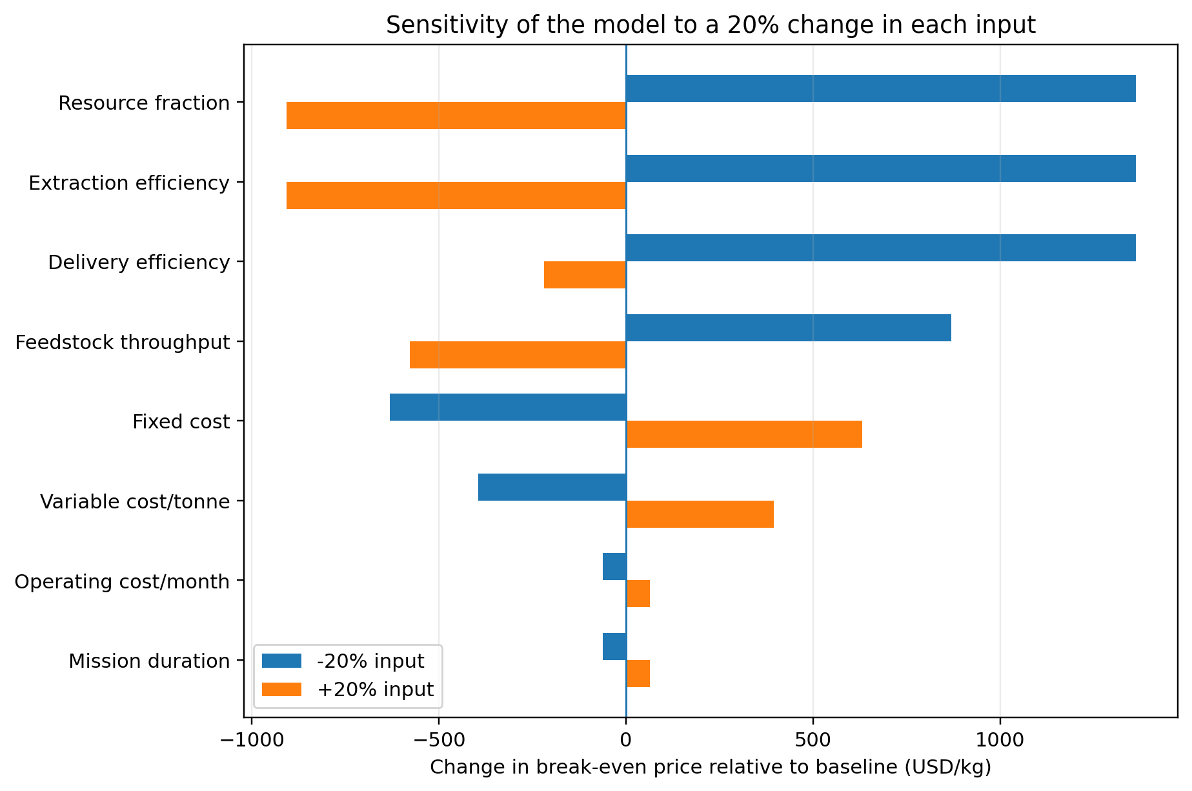
Figure 3. Local sensitivity of modeled break-even price to a 20% change in major inputs.
Figure 3 shows the effect of changing individual inputs by plus or minus 20%. Variables that increase delivered resource, such as resource fraction and extraction efficiency, reduce the break-even price when improved. Variables that increase cost, such as fixed cost and variable processing cost, increase the break-even price.
Throughput also has a significant effect because increasing the amount processed increases the number of kilograms over which fixed cost can be distributed. This is the same economic mechanism that motivates higher-throughput mining architectures in the existing literature [4, 6].

5.5 Fixed-cost sensitivity
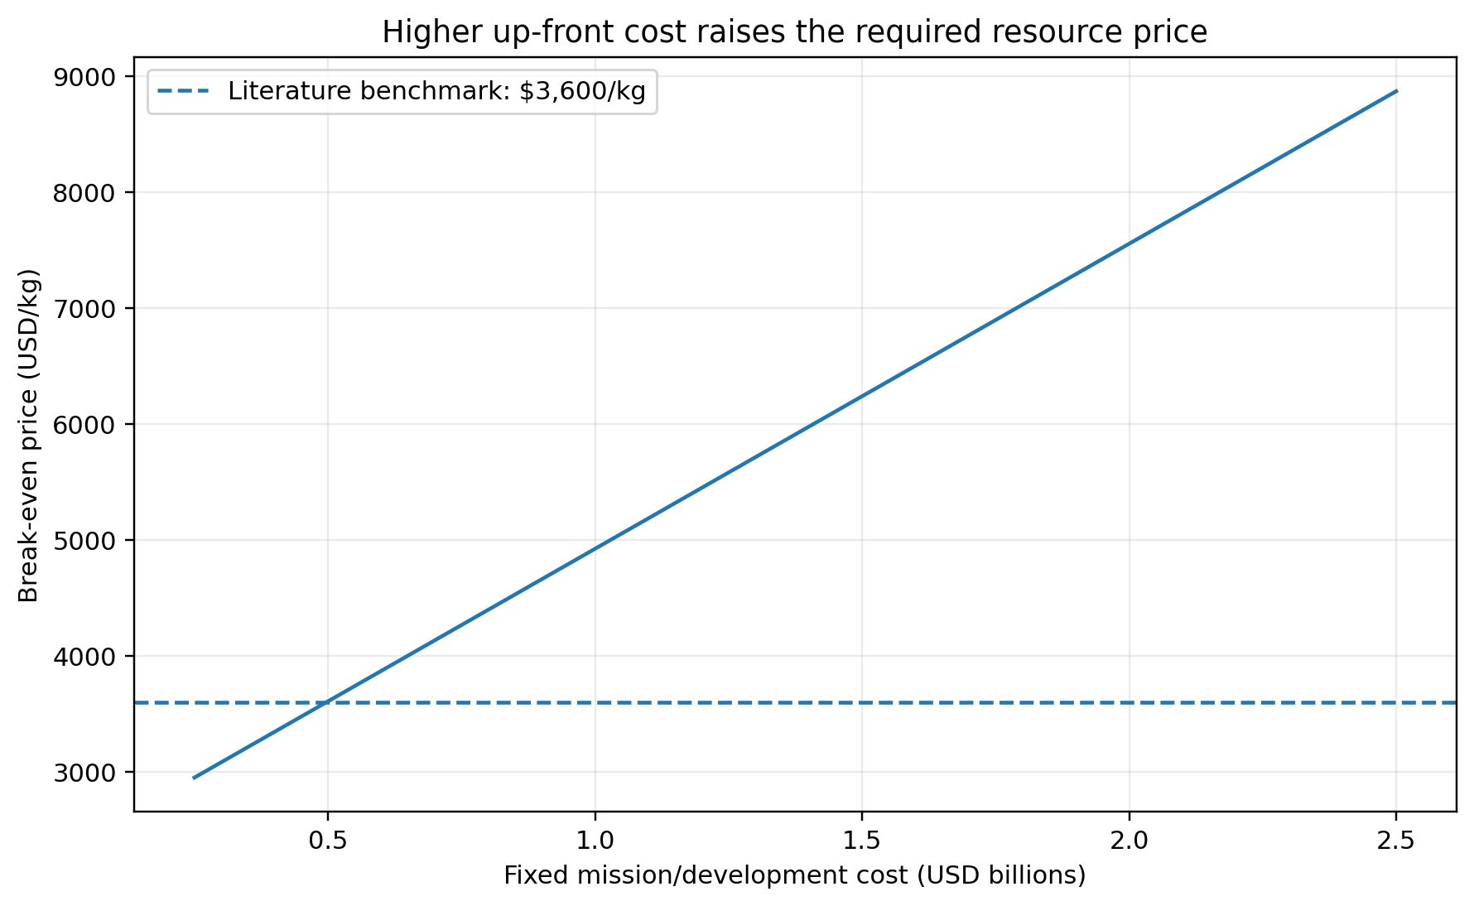
Figure 4. Modeled relationship between fixed mission/development cost and break-even resource price.
Figure 4 shows the relationship between fixed mission/development cost and break-even resource price. The relationship is approximately linear because the model divides total cost by delivered resource mass while holding the production assumptions constant.
This result emphasizes the importance of capital expenditure and technology development. A technically capable mining system may still be commercially unattractive if the initial investment must be recovered from too small a quantity of delivered product.

6. Discussion
The main result of the scenario analysis is that asteroid mining should be treated as a coupled engineering-economic system. The amount of resource contained in an asteroid is only one part of the problem. The value of that resource depends on the mass processed, the fraction that can be recovered, the cost of the mining and processing system, and the price a customer can realistically pay for the delivered product.
Three mechanisms stand out.
First, throughput matters. A high-throughput mining system can spread fixed development and mission costs across more product. This explains why previous techno-economic work has emphasized throughput, multiple spacecraft, and mission cadence [4]. The 2026 model by Dorrington and Olsen similarly investigates mission architectures in which repeated trips can change the economics [6].
Second, resource accessibility matters as much as resource abundance. A theoretical asteroid composition is not sufficient. NASA identifies location, form, concentration, and distribution as outstanding knowledge gaps for ISRU [1]. A resource that requires large amounts of excavation or energy to recover may be less valuable than a smaller deposit that is easy to access.
Third, the customer and destination matter. A kilogram of water in deep space can have a very different economic value from a kilogram of water on Earth's surface because transporting mass out of Earth's gravity well is expensive. Colvin, Crane, and Lal's work illustrates how the comparison changes depending on whether asteroid-derived propellant is delivered to Earth orbit, lunar orbit, or other destinations [5].
The model also illustrates why economic forecasts should be treated carefully. The baseline value of $5,447/kg is not a prediction of the future price of asteroid resources. It simply answers the question: if the listed cost and production assumptions were true, what price would be required to recover the modeled cost?
This distinction is important because many asteroid-mining claims rely on theoretical asteroid resource values. If a resource is estimated to be worth billions or trillions of dollars in raw in-situ material, that figure does not mean a company can sell it at that value. Revenue depends on extraction, transportation, market demand, competition, and the amount of material that can actually be delivered to a customer.
For this reason, water for in-space use may offer a particularly interesting case for future research. Water has several potential uses, including life support and propellant production, and its value can arise from the cost of avoiding Earth launch requirements. This is the economic logic explored by Colvin, Crane, and Lal [5].

7. Limitations
The model has several important limitations.
First, the baseline inputs are not a design for a real asteroid-mining mission. They are deliberately chosen notional values that allow sensitivity analysis to be performed. A future version should replace them with parameter distributions or mission-specific estimates supported by primary engineering studies.
Second, the model does not calculate orbital trajectories, delta-v, spacecraft mass ratios, propulsion requirements, power system mass, radiation exposure, thermal constraints, or communications delays. These factors can strongly influence the real cost of a mission and are treated only through the literature review rather than directly in the numerical model.
Third, the model assumes that the resource can be sold at a single price per kilogram. Real markets may have changing demand, competing suppliers, price elasticity, and different prices for different destinations or levels of purity.
Fourth, the model does not discount future cash flows. A complete economic model should account for the time value of money, financing costs, development schedules, probability of mission failure, and potential replacement or refurbishment of spacecraft.
Finally, the model represents extraction and delivery efficiency as simple percentages. Real systems may have efficiency that depends on asteroid composition, temperature, mining rate, power availability, and processing technology.

8. Conclusion
Asteroid mining is not primarily a question of whether asteroids contain valuable materials. Scientific missions have demonstrated that some near-Earth asteroids contain water-bearing minerals, carbon-rich material, and other compounds of scientific and potential industrial interest [2, 3]. The larger challenge is converting those resources into a reliable product at a competitive cost.
The literature identifies multiple interacting constraints. Suitable targets must be reachable, their resources must be characterized accurately, mining systems must operate in extremely low gravity, extracted material must be processed and stored, and transportation must be integrated with the overall mission architecture [1, 6, 7, 8]. Economically, fixed development cost, mining throughput, resource recovery, infrastructure utilization, demand, and competition from Earth-based supply all affect commercial feasibility [4, 5, 6].
The scenario model developed in this project provides a simple quantitative demonstration of these relationships. Under the baseline assumptions, a hypothetical mission processing 5,000 tonnes of feedstock produces 380 tonnes of delivered resource and requires a break-even value of approximately $5,447/kg. More importantly, the sensitivity analysis shows how that value changes when throughput, recoverable resource fraction, efficiency, and cost assumptions are varied.
The main lesson is methodological: asteroid mining cannot be evaluated reliably from the resource value of an asteroid alone. A serious assessment must connect resource accessibility, mission architecture, extraction performance, transportation, infrastructure cost, and market demand into one system-level analysis.
A useful extension of this project would be to replace the notional parameters with mission-specific data, incorporate trajectory and propulsion calculations, and use probabilistic simulations to represent uncertainty. Such an approach could move the project from a simplified educational scenario model toward a more detailed techno-economic trade study.

References
[1] NASA. (n.d.). *Overview: In-Situ Resource Utilization*. NASA. https://www.nasa.gov/overview-in-situ-resource-utilization/
[2] NASA. (2023). *NASA's Bennu Asteroid Sample Contains Carbon, Water*. https://www.nasa.gov/news-release/nasas-bennu-asteroid-sample-contains-carbon-water/
[3] NASA. (2024). *Surprising Phosphate Finding in NASA's OSIRIS-REx Asteroid Sample*. https://www.nasa.gov/missions/osiris-rex/surprising-phosphate-finding-in-nasas-osiris-rex-asteroid-sample/
[4] Hein, A. M., Matheson, R., & Fries, D. (2020). A techno-economic analysis of asteroid mining. *Acta Astronautica, 168*, 104-115. https://doi.org/10.1016/j.actaastro.2019.05.009
[5] Colvin, T. J., Crane, K. W., & Lal, B. (2020). Assessing the economics of asteroid-derived water for propellant. *Acta Astronautica, 176*, 298-305. https://doi.org/10.1016/j.actaastro.2020.05.029
[6] Dorrington, S., & Olsen, J. (2026). Parametric economic modelling of asteroid mining architectures. *Acta Astronautica, 241*, 19-47. https://doi.org/10.1016/j.actaastro.2025.11.006
[7] NASA Technology Transfer Program. (n.d.). *Regolith Advanced Surface Systems Operations Robot (RASSOR) Excavator*. https://technology.nasa.gov/patent/KSC-TOPS-7
[8] NASA Center for Near Earth Object Studies. (n.d.). *Accessible Near-Earth Objects (NHATS)*. https://cneos.jpl.nasa.gov/nhats/

Appendix A - Baseline outputs
- Feedstock processed: 5,000 t
- Resource contained under model assumptions: 500 t
- Resource recovered: 400 t
- Resource delivered: 380 t
- Fixed cost: $1.20B
- Variable processing cost: $750M
- Operating cost: $120M
- Total modeled cost: $2.07B
- Break-even price: approximately $5,447/kg
- Break-even price divided by $3,600/kg literature benchmark: approximately 1.51x

Appendix B - Interpretation of figures
Figure 1: Demonstrates the effect of throughput and resource fraction.
Figure 2: Demonstrates the joint effect of resource fraction and extraction efficiency.
Figure 3: Shows the local sensitivity of the baseline break-even price to a 20% change in each modeled input.
Figure 4: Shows the effect of fixed mission/development cost while production assumptions remain fixed.

