1. Plotting and Fitting of Binomial Distribution and Graphical Representation of Probabilities
The Binomial distribution describes the probability of obtaining exactly k successes in n independent Bernoulli trials, where each trial results in either a success with probability p or a failure with probability (1 - p). It is one of the most fundamental discrete probability distributions used in statistics.

Binomial Distribution Formula
P(X = k) = C(n,k) * p^k * (1-p)^(n-k)
Mean: mu = n*p
Variance: sigma^2 = n*p*(1-p)
Std. Deviation: sigma = sqrt(n*p*(1-p))
Where:
- n = total number of independent trials
- k = number of successful outcomes
- p = probability of success on a single trial
- (1-p) = probability of failure on a single trial

How to Implement in Excel
= BINOM.DIST(k, n, p, FALSE)
Use FALSE for the Probability Mass Function (PMF) and TRUE for the Cumulative Distribution Function (CDF).

Case 1: n = 8, p = 0.75
k (Successes) | Binomial Probability
0 | 0.00001526
1 | 0.00036621
2 | 0.00384521
3 | 0.02307129
4 | 0.08651733
5 | 0.20764160
6 | 0.31146240
7 | 0.26697206
8 | 0.10011291

Case 2: n = 8, p = 0.5 (symmetric case)
k (Successes) | Binomial Probability
0 | 0.00390625
1 | 0.03125000
2 | 0.10937500
3 | 0.21875000
4 | 0.27343750
5 | 0.21875000
6 | 0.10937500
7 | 0.03125000
8 | 0.00390625

Case 3: n = 8, p = 0.25
k (Successes) | Binomial Probability
0 | 0.10011291
1 | 0.26697206
2 | 0.31146240
3 | 0.20764160
4 | 0.08651733
5 | 0.02307129
6 | 0.00384521
7 | 0.00036621
8 | 0.00001526

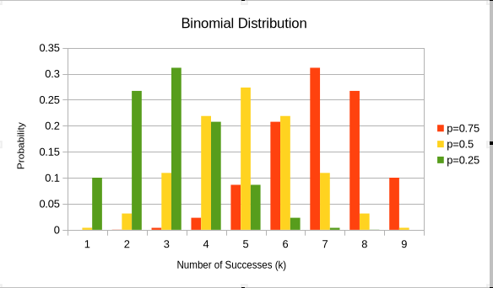

Interpretation
From the graphical representation, it is observed that when p = 0.75, the distribution is right-skewed with probability mass concentrated towards higher values of k, whereas when p = 0.25, the distribution becomes left-skewed, and when p = 0.5, the distribution is perfectly symmetric and bell-shaped around the centre.

2. Plotting and Fitting of Multinomial Distribution and Graphical Representation of Probabilities
The Multinomial distribution extends the Binomial distribution to scenarios involving more than two possible outcomes per trial. Consider an experiment that yields exactly one of k distinct outcomes per trial, with respective probabilities p1, p2, ..., pk (where pi >= 0 for all i and their sum equals 1). Given n independent trials, the random variable Xi counts how many times outcome i was observed. The vector X = (X1, X2, ..., Xk) follows a Multinomial distribution with parameters n and p = (p1, p2, ..., pk).

Multinomial Distribution Formula
P(x1, x2, ..., xk) = n! / (x1! * x2! * ... * xk!) * p1^x1 * p2^x2 * ... * pk^xk

Cov(Xi, Xj) = -n * pi * pj (where i != j)

An important property: when X follows a Multinomial distribution as defined above, each individual component Xi follows a Binomial distribution with n trials and success probability pi.

How to Implement in Excel
Multinomial Coefficient = MULTINOMIAL(X1, X2, X3)
Probability = MULTINOMIAL(X1,X2,X3) * PRODUCT(p1^X1, p2^X2, p3^X3)

Illustrative Example (Three outcome categories — Red, Green, Blue):
Parameter | 1st Case | 2nd Case | 3rd Case
Red (X1) | 3 | 4 | 2
Green (X2) | 1 | 0 | 1
Blue (X3) | 5 | 3 | 3
P_Red (p1) | 0.40 | 0.40 | 0.40
P_Green (p2) | 0.15 | 0.15 | 0.15
P_Blue (p3) | 0.45 | 0.45 | 0.45
Multinomial Coefficient | 168 | 140 | 56
Probability | 0.058212 | 0.105124 | 0.121835

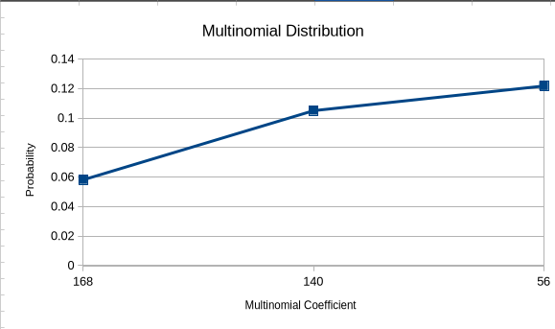

Interpretation
The graph illustrates that the multinomial probability decreases as the multinomial coefficient increases, indicating that more evenly distributed outcomes across categories tend to have lower joint probabilities. The 3rd case, despite a smaller coefficient, yields the highest probability due to a more balanced allocation aligned with the category probabilities.

3. Plotting and Fitting of Poisson Distribution and Graphical Representation of Probabilities
The Poisson distribution is a discrete probability distribution used to determine the likelihood of a specified number of events (k) occurring within a fixed interval of time or space. This distribution is governed by a single parameter lambda (lambda), which represents the average rate of occurrence of the event within the given interval.

Poisson Distribution Formula
P(k) = e^(-lambda) * lambda^k / k!

Measure | Formula
Mean | mu = E(X) = lambda
Variance | sigma^2 = V(X) = lambda
Standard Deviation | sigma = sqrt(lambda)

Where:
- P(X = k) denotes the probability of observing exactly k events
- e is Euler's constant, approximately equal to 2.71828
- lambda is the average number of events in the interval; lambda = n*p
- k is the count of events (non-negative integer)

How to Implement in Excel
= POISSON.DIST(k, lambda, FALSE)
Use FALSE for the PMF and TRUE for the cumulative probability.

Example: lambda = 8, k ranges from 0 to 12
k (Number of Events) | Poisson Probability
0 | 0.000335463
1 | 0.002683701
2 | 0.010734805
3 | 0.028626146
4 | 0.057252293
5 | 0.091603668
6 | 0.122138224
7 | 0.139586541
8 | 0.139586541
9 | 0.124076925
10 | 0.099261540
11 | 0.072190211
12 | 0.048126807

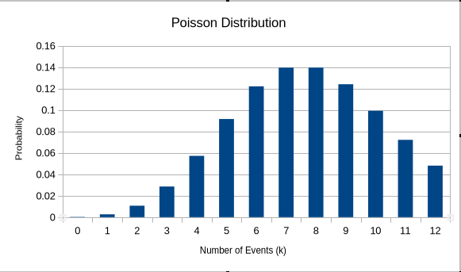
Interpretation
The Poisson distribution graph shows that probability rises steadily from k = 0 and peaks at k = 7 and k = 8 (both equal to 0.1396 for lambda = 8), then gradually declines for larger values of k, forming a right-skewed bell curve that becomes increasingly flatter as lambda grows.

4. Plotting and Fitting of Geometric Distribution and Graphical Representation of Probabilities
In a sequence of Bernoulli trials, the Geometric distribution models the number of consecutive failures before the first success is recorded. A Bernoulli trial is one that admits exactly two outcomes: success or failure. Trials continue to be repeated until a success is achieved, at which point the experiment is terminated.
The Geometric distribution is a discrete probability distribution that captures the probability of achieving the first success after a sequence of failures. Three foundational assumptions underlie this distribution:
- All trials are statistically independent of each other.
- Each trial results in exactly one of two outcomes: success or failure.
- The probability of success p remains constant across all trials.

Geometric Distribution Formula
P(X = k) = (1 - p)^k * p

Measure | Formula
Mean | mu = E(X) = 1/p
Variance | sigma^2 = V(X) = (1-p) / p^2

Where:
- k: number of failures recorded before the first success
- p: probability of success on any single trial
The symbol q = 1 - p denotes the probability of failure. The notation X ~ G(p) indicates that X is a discrete random variable following a Geometric probability distribution.

How to Implement in Excel
Probability = (1-p)^k * p

Example: p = 0.3
k (Failures before 1st success) | Geometric Probability
0 | 0.30000
1 | 0.21000
2 | 0.14700
3 | 0.10290
4 | 0.07203
5 | 0.05042
6 | 0.03529
7 | 0.02471
8 | 0.01729
9 | 0.01211
10 | 0.00847
11 | 0.00593

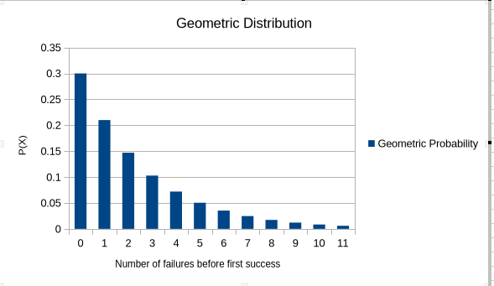

Interpretation
The graphical plot of the Geometric distribution shows a consistently decreasing pattern — the probability of the first success is highest when k = 0 (no prior failures) and declines exponentially as the number of failures increases, reflecting the memoryless property of this distribution.

5. Plotting and Fitting of Uniform Distribution and Graphical Representation of Probabilities
A Uniform distribution is characterised by a constant probability density across all values within a defined interval, because all outcomes within that range are equally probable. It is also referred to as the Rectangular distribution. The distribution is parameterised by two values: a (the lower bound) and b (the upper bound), and is denoted U(a, b).
In a Uniform distribution, every possible value within the specified range [a, b] has an identical probability of being observed. This equal-likelihood property is what distinguishes it from all other continuous distributions.

Uniform Distribution Formula
The Probability Density Function (PDF) for a continuous Uniform distribution over [a, b] is:
f(x) = 1 / (b - a) for a <= x <= b
Mean: mu = (a + b) / 2
Variance: sigma^2 = (b - a)^2 / 12

How to Implement in Excel
P = (x2 - x1) / (b - a)
For probability calculation, four inputs are required:
- a: the minimum value (lower bound) of the distribution
- b: the maximum value (upper bound) of the distribution
- x1: the lower limit of the interval of interest
- x2: the upper limit of the interval of interest

Example: a = 10, b = 30
Parameter | Case 1 | Case 2 | Case 3
x1 | 12 | 17 | 22
x2 | 16 | 21 | 26
Uniform Distribution Probability | 0.20 | 0.20 | 0.20

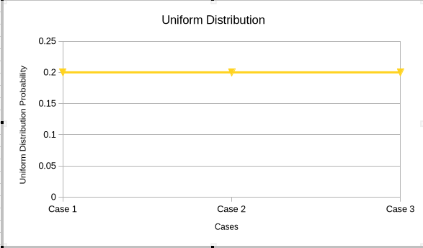

Interpretation
The graph of the Uniform distribution appears as a flat horizontal line between the bounds a and b, confirming that the probability density is constant across the entire interval. All three cases yield the same probability (0.20) since the interval width (x2 - x1 = 4) relative to (b - a = 20) remains unchanged.

6. Plotting and Fitting of Exponential Distribution and Graphical Representation of Probabilities
An Exponential Random Variable can take on any value from the set of all positive real numbers. This distribution naturally arises when modelling the waiting time before a specific event takes place. When the probability of an event occurring within an interval is directly proportional to the length of that interval, the Random Variable governing the waiting time follows an Exponential distribution.
This distribution is well-suited for modelling real-world scenarios such as:
- How long a shopkeeper must wait before the next customer arrives.
- How long a battery operates before it runs out of charge.
- How long a machine functions before experiencing a failure.

Exponential Distribution Formula
f(x) = lambda * e^(-lambda * x) for x >= 0
f(x) = 0 for x < 0

E(X) = 1 / lambda
Var(X) = 1 / lambda^2

Here, lambda is the rate parameter that controls the shape and scale of the density function. The constant e is approximately equal to 2.718.

How to Implement in Excel
= EXPON.DIST(X, lambda, FALSE)
Use FALSE for the probability density value and TRUE for the cumulative distribution function.

Example: mu = 300, lambda = 0.0033
Parameter | Case 1 | Case 2 | Case 3
x (No. of Days) | 400 | 450 | 500
Exponential Distribution | 0.000940 | 0.000800 | 0.000681

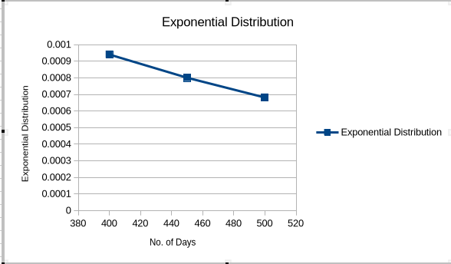

Interpretation
The Exponential distribution graph demonstrates a rapid decline in probability density as x increases — the probability of waiting a shorter duration is always greater than waiting longer, which is consistent with the memoryless property inherent to the Exponential distribution.

7. Plotting and Fitting of Normal Distribution and Graphical Representation of Probabilities
The Normal Distribution is defined as the probability density function governing any continuous random variable in a given system. Suppose f(x) denotes the probability density function for a continuous random variable X. Then f(x) >= 0 for all x in (-inf, +inf).
f(x) = (1 / (sigma * sqrt(2*pi))) * e^[ -0.5 * ((x - mu)/sigma)^2 ]
Where:
- x is the observed value of the Random Variable
- mu is the Mean of the distribution
- sigma is the Standard Deviation

Key Properties of the Normal Distribution
- Mean, Median, and Mode are all equal (Mean = Median = Mode).
- The total area under the normal curve equals 1.
- The curve is perfectly symmetric about the mean.
- Exactly half the values lie to the left and half to the right of the mean.
- The distribution is completely determined by its mean and standard deviation.
- It is a unimodal curve — it has exactly one peak.

How to Implement in Excel
Step 1: Enter your dataset into an Excel spreadsheet.
Step 2: Calculate the mean:
= AVERAGE(cell range)
Step 3: Calculate the standard deviation:
= STDEV(cell range)
Step 4: Choose a value x for which the distribution is to be evaluated.
Step 5: Apply the NORM.DIST function:
= NORM.DIST(x, mean, standard_deviation, FALSE)
Use FALSE for PDF and TRUE for the cumulative distribution function.

Example Dataset: Employee Salary Incentives (Mean = 16,000 | SD = 7,359.80)
Employee | Incentive (Rs.) | Normal Distribution Value
EMP1 | 2000 | 1.51234E-05
EMP2 | 4000 | 1.89520E-05
EMP3 | 6000 | 2.33156E-05
EMP4 | 8000 | 2.81041E-05
EMP5 | 10000 | 3.16228E-05
EMP6 | 12000 | 3.45833E-05
EMP7 | 14000 | 3.92799E-05
EMP8 | 16000 | 4.31035E-05
EMP9 | 18000 | 4.68163E-05
EMP10 | 20000 | 4.98843E-05
EMP11 | 22000 | 5.22406E-05
EMP12 | 24000 | 5.37075E-05
EMP13 | 26000 | 5.42056E-05
EMP14 | 28000 | 5.37075E-05
EMP15 | 30000 | 5.22406E-05
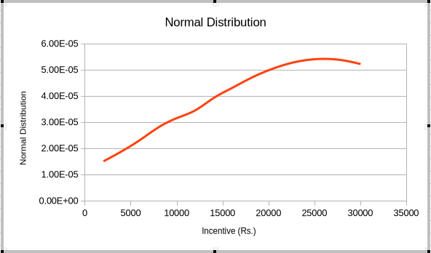
Interpretation
The Normal distribution graph for the employee incentive dataset forms a classic symmetric bell-shaped curve, peaking at the mean value (Rs. 16,000), and tapering symmetrically on both sides, confirming that most employees receive incentives close to the average with fewer extremes at the tails.

8. Calculation of Cumulative Distribution Functions for Exponential and Normal Distributions
Cumulative Distribution Functions (CDFs) give the probability that a random variable X takes a value less than or equal to a specified value x. In Excel, the CDF is obtained by setting the final argument of NORM.DIST or EXPON.DIST to TRUE.

Normal Distribution — Cumulative Values (Mean = 5,500 | SD = 3,027.65)
Employee | Incentive (Rs.) | Cumulative Normal Distribution
EMP1 | 2000 | 0.558137
EMP2 | 4000 | 0.625935
EMP3 | 6000 | 0.698279
EMP4 | 8000 | 0.770549
EMP5 | 10000 | 0.827348
EMP6 | 12000 | 0.869343
EMP7 | 14000 | 0.901242
EMP8 | 16000 | 0.924602
EMP9 | 18000 | 0.941118
EMP10 | 20000 | 0.959481

Exponential Distribution — Cumulative Values (lambda = 0.0033)
No. of Days (x) | Cumulative Exponential Distribution
300 | 0.632121
320 | 0.652071
350 | 0.683748
400 | 0.736448
420 | 0.752858
450 | 0.777100
500 | 0.811124
520 | 0.821268
550 | 0.838360
600 | 0.862070

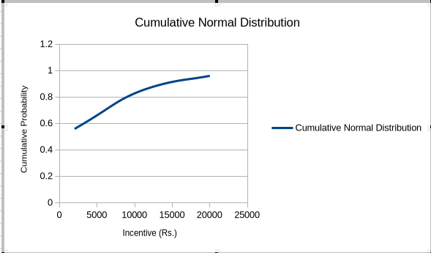

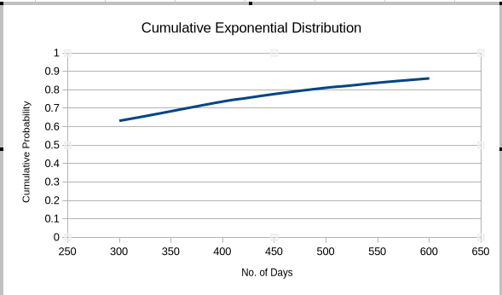
Interpretation
The CDF graphs show a consistently increasing S-shaped curve for the Normal distribution and a steadily rising concave curve for the Exponential distribution, both approaching 1 as x increases — confirming that all probability is eventually accumulated within the distribution's support.

9. Finding the Distance Between Two Distributions

Euclidean Distance
The Euclidean distance quantifies the straight-line distance between two points (or vectors) in a real-valued space. It is computed as the square root of the sum of squared differences between corresponding elements of two vectors.
Euclidean Distance = |X - Y| = sqrt[ SUM(xi - yi)^2 ] i = 1 to n
Where:
- X: First array or vector
- Y: Second array or vector
- xi: Coordinate values along the horizontal axis
- yi: Coordinate values along the vertical axis
- n: Total number of observations

How to Implement in Excel
= SQRT(SUMXMY2(array_X, array_Y))

Example: Euclidean Distance between Binomial and Poisson distributions (n = 8, k = 8, p = 0.45, lambda = 0.45)
Trial | Binomial Distribution | Poisson Distribution | Distance
1 | 0.07214904 | 0.287728051 | 0.215580
2 | 0.18660544 | 0.064743691 | 0.121860
3 | 0.25894912 | 0.008502984 | 0.250450
4 | 0.21530656 | 0.000956585 | 0.214350
5 | 0.11765016 | 6.31106E-05 | 0.117590
6 | 0.04103112 | 3.46108E-06 | 0.041028
7 | 0.00838584 | 1.97062E-07 | 0.008386
8 | 0.00076295 | 1.10972E-08 | 0.000763

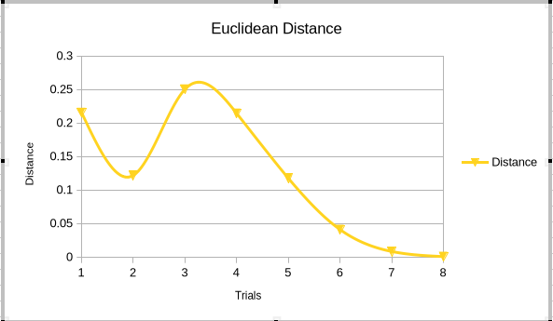
Interpretation
The Euclidean distances computed between the Binomial and Poisson distributions are largest at the lower trial numbers (especially trials 1 and 3) and decrease sharply as the trial count rises, suggesting the two distributions converge in probability mass at higher values of k.

10. Application Problems Based on the Binomial Distribution
Real-Life Case Study — Quality Control in a Manufacturing Plant:
A leading automobile parts manufacturer inspects pistons produced on an assembly line. Based on historical data, it is known that approximately 8% of pistons produced are defective (p = 0.08). A quality inspector randomly selects a batch of n = 6 pistons from the production line for inspection. Each piston is either classified as defective (success) or non-defective (failure). The manufacturer wishes to determine the probability of finding various numbers of defective pistons in the batch in order to decide whether the production process needs to be halted for recalibration.
Since each piston inspection is an independent Bernoulli trial with constant probability p = 0.08 and there are n = 6 such trials, the number of defective pistons X follows a Binomial distribution: X ~ B(6, 0.08).

Solution Table: n = 6, p = 0.08
k (Defective Pistons) | Binomial Probability
0 | 0.606355
1 | 0.318913
2 | 0.069958
3 | 0.008164
4 | 0.000535
5 | 0.000018
6 | 0.000000
Conclusion: The probability that zero pistons are defective is highest (60.64%), while the probability of finding 3 or more defective pistons is negligibly small (less than 1%), indicating the process is reasonably under control.

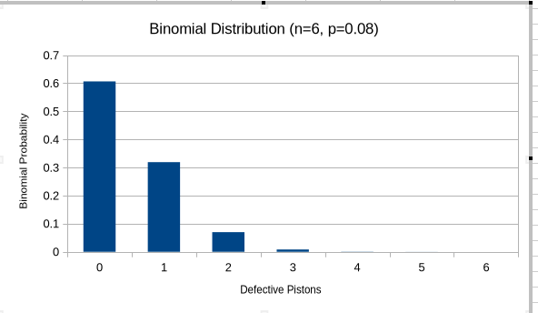
Interpretation
The Binomial distribution graph is heavily right-skewed with p = 0.08, indicating that finding no defective pistons is the most likely outcome. The probability declines sharply as k increases, suggesting that large numbers of defects are extremely rare under the current production conditions.

11. Application Problems Based on the Poisson Distribution
Real-Life Case Study — Emergency Calls at a Hospital Call Centre:
A city hospital's emergency helpline receives calls at an average rate of 4 calls per hour (lambda = 4). The hospital administration wants to estimate the probability of receiving different numbers of emergency calls during any given hour in order to plan adequate staffing levels. Since calls arrive independently and at a constant average rate, this scenario is modelled using the Poisson distribution.
Using the Poisson formula with lambda = 4, the hospital can determine the probability of receiving exactly k calls in a one-hour window, helping management decide how many operators to keep on duty at any given time.

Solution Table: lambda = 4, k ranges from 0 to 10
k (Number of Calls) | Poisson Probability
0 | 0.018316
1 | 0.073263
2 | 0.146525
3 | 0.195367
4 | 0.195367
5 | 0.156293
6 | 0.104196
7 | 0.059540
8 | 0.029770
9 | 0.013231
10 | 0.005292

Conclusion: The probability of receiving exactly 3 or 4 calls per hour is highest (approximately 19.54% each), forming the peak of the distribution. The probability of receiving 8 or more calls in an hour is below 5%, which can be treated as a low-probability surge event.

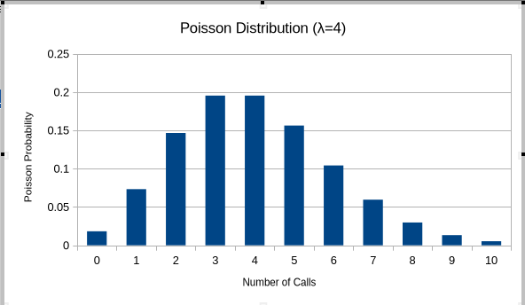
Interpretation
The Poisson distribution graph for lambda = 4 rises from near zero at k = 0, peaks at k = 3 and k = 4 (the mode equals the floor of lambda), and then gradually decreases, forming a slightly right-skewed distribution — a pattern typical of Poisson distributions with moderate lambda values.

12. Application Problems Based on the Normal Distribution
Problem Statement:
A fast-food chain is concerned about the temperature of the beverages it serves following a liability incident. The chain instructs staff to measure the temperature (in degrees Fahrenheit) of the coffee being dispensed at a randomly chosen moment during each of the 24 half-hour intervals from 8:00 a.m. to 7:30 p.m. This procedure is repeated on a subsequent day, producing 48 temperature readings.

Temperature Data and Normal Distribution Values (Mean = 160 deg F, SD = 6.10)
Temp. (deg F) | Normal Dist. Value | Temp. (deg F) | Normal Dist. Value
148 | 0.017123 | 166 | 0.016221
150 | 0.022895 | 167 | 0.012408
151 | 0.027211 | 168 | 0.009234
152 | 0.034092 | 169 | 0.006708
153 | 0.041285 | 171 | 0.003198
154 | 0.048929 | 173 | 0.001143
155 | 0.056821 | 174 | 0.000714
156 | 0.064318 | 175 | 0.000437
157 | 0.070952 | 176 | 0.000261
158 | 0.076241 | 177 | 0.000152
159 | 0.079808 | 178 | 0.000087
160 | 0.081471 | 179 | 0.000049

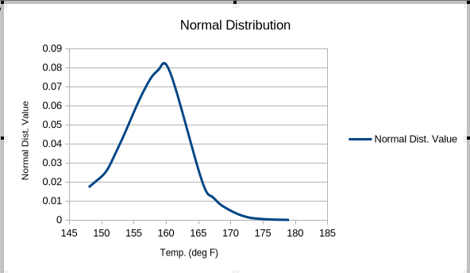
Interpretation
The Normal distribution curve for coffee temperatures peaks at the mean value of 160 degrees F and is symmetric on both sides, indicating that most coffee samples were served near the target temperature, with very few readings occurring in the extreme low or high temperature ranges.

13. Computation of Covariance and Correlation — Scatter Plots
The following key points distinguish and relate Covariance and Correlation:
- Both datasets being compared must contain the same number of observations.
- Neither dataset should be empty, and the standard deviation should not be zero.
- Covariance measures the extent to which two random variables change together.
- Correlation quantifies how strongly two random variables are linearly related.
- Covariance is essentially an unscaled measure of correlation.
- Correlation is the normalised (scaled) version of covariance.
- Covariance can range from -inf to +inf, whereas correlation ranges from -1 to +1.
- Covariance indicates only the direction of the linear relationship.
- Correlation indicates both the direction and the strength of the linear relationship.
- Covariance is sensitive to changes in scale; correlation is not.

Covariance Formula
Cov(X, Y) = SUM[ (xi - x_bar)(yi - y_bar) ] / n
where x_bar and y_bar are the sample means of X and Y respectively, and n is the sample size.

Pearson Correlation Coefficient Formula
r = SUM[(xi - x_bar)(yi - y_bar)] / sqrt[ SUM(xi-x_bar)^2 * SUM(yi-y_bar)^2 ]
Where:
- r = Pearson correlation coefficient
- xi = individual values of the x-variable
- x_bar = mean of the x-variable
- yi = individual values of the y-variable
- y_bar = mean of the y-variable

How to Implement in Excel
Correlation: = CORREL(array1, array2)
Pearson Correlation: = PEARSON(array1, array2)
Covariance (Pop.): = COVARIANCE.P(array1, array2)

Scatter Plots
A scatter plot displays the relationship between two quantitative variables within a dataset. Data points are plotted on a two-dimensional Cartesian plane — the independent variable on the X-axis and the dependent variable on the Y-axis.
Scatter plots are especially useful when:
- A large number of data points are available
- Each data point consists of a pair of numeric values
- The data is in numeric form and linear association is to be studied

Example Dataset — Study Hours vs. Marks Obtained:
Study Hours | 12 | 15 | 10 | 9 | 6 | 5 | 9
Marks | 95 | 82 | 55 | 65 | 72 | 38 | 50

Covariance = 38.142857

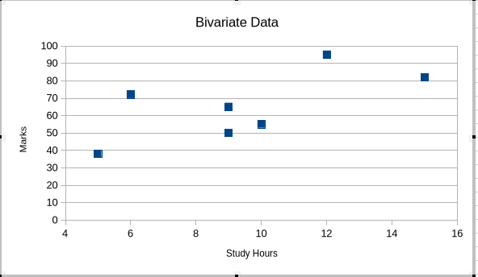
Interpretation
The scatter plot reveals a positive linear association between study hours and marks obtained — as the number of hours studied increases, the marks tend to rise correspondingly. The positive covariance value (38.14) further confirms this direct relationship between the two variables.

14. Calculation of Karl Pearson's Correlation Coefficients
x | Y1 | Y2 | Y3
3 | 75 | 68 | 12
6 | 90 | 72 | 28
7 | 78 | 63 | 18
9 | 55 | 92 | 22
11 | 64 | 83 | 14

Karl Pearson's Correlation | Value
XY1 | -0.61895
XY2 | 0.62140
XY3 | 0.02037

Interpretation
The correlation coefficient between X and Y1 (-0.619) indicates a moderate negative linear relationship, while X and Y2 (0.621) show a moderate positive relationship. The coefficient for XY3 (0.020) is near zero, indicating virtually no linear association between X and Y3.

15. Correlation Coefficient for a Bivariate Frequency Distribution
Marks \ Age Group | 17-19 | 19-21 | 21-23 | 23-25 | Total
10-20 | 2 | 1 | 1 | 0 | 4
20-30 | 3 | 2 | 3 | 1 | 9
30-40 | 3 | 3 | 5 | 6 | 17
40-50 | 2 | 2 | 3 | 4 | 11
50-60 | 0 | 1 | 2 | 2 | 5
60-70 | 0 | 1 | 2 | 1 | 4

Measure | Value
Correlation Coefficient (x-axis) | -0.18773
Correlation Coefficient (y-axis) | 0.774597

Marginal Frequency Distribution of X (Marks):
Marks | 15 | 25 | 35 | 45 | 55 | 65
Total | 4 | 9 | 17 | 11 | 5 | 4

Marginal Frequency Distribution of Y (Age in Years):
Age Group | 17 | 19 | 21 | 23
Total | 10 | 10 | 16 | 14

Interpretation
The weak negative correlation along the x-axis (-0.188) suggests little to no linear relationship between marks and the lower age boundaries, while the strong positive correlation along the y-axis (0.775) indicates that higher age groups tend to be associated with higher marks in this bivariate frequency distribution.

16. Generating Random Numbers from Discrete Distributions (Bernoulli, Binomial, Poisson)
Random numbers following discrete probability distributions can be generated in Excel using the inverse CDF approach. The process uses the RAND() function to generate a uniform random probability, which is then mapped to a discrete outcome using the inverse of the chosen distribution.

How to Implement in Excel
= BINOM.INV(1, P, RAND())
This formula returns 1 or 0, where 1 is generated with probability P. It is the standard approach for simulating Bernoulli and Binomial random numbers in Excel.

Example: Random Numbers from Binomial Distribution (n = 12, p = 0.35)
Trial | Generated Random Value
1 | 5
2 | 3
3 | 7
4 | 4
5 | 6

Interpretation
The randomly generated values from the Binomial distribution (n = 12, p = 0.35) cluster around the expected mean of n*p = 4.2, with values ranging between 3 and 7, demonstrating that the simulation accurately reflects the central tendency and spread of the theoretical Binomial distribution.

17. Generating Random Numbers from Continuous Distributions (Uniform, Normal)
For continuous distributions such as the Normal distribution, Excel uses the inverse Normal distribution function applied to a uniform random probability to generate normally distributed random numbers.

How to Implement in Excel
= NORMINV(RAND(), mean, standard_deviation)
RAND() produces a uniform random probability between 0 and 1; the mean specifies the centre; and the standard deviation defines the spread of the generated values.

Example: Random Numbers from Normal Distribution (Mean = 25, SD = 6)
Trial | Generated Random Value
1 | 22.31540842
2 | 27.16349217
3 | 19.47628134
4 | 28.35881512
5 | 24.72814895

Interpretation
The five randomly generated values from the Normal distribution (Mean = 25, SD = 6) are all reasonably close to the specified mean of 25, ranging from approximately 19.5 to 28.4, which is consistent with the expected behaviour of a Normal distribution where most values lie within one standard deviation of the mean.

18. Finding the Entropy from a Given Dataset
The entropy of a random variable represents the average amount of information, surprise, or uncertainty associated with its possible outcomes. For a discrete random variable X that takes values in the alphabet x and is distributed according to P: x -> [0, 1], the entropy H[X] is defined as:
H(X) = - SUM p(x) * log2[ p(x) ] x belongs to X
The base of the logarithm determines the unit of entropy:
- Base 2 yields entropy in bits
- Base e yields entropy in natural units (nats)
- Base 10 yields entropy in hartleys
Entropy is equivalently defined as the expected value of the self-information of a random variable.

Example: Coin Toss Entropy Calculation
Outcome | P(x) | log2 P(x) | H(x) = -P(x) * log2 P(x)
HH | 1 | 0 | 0
HT | 0.5 | -1 | 0.5
TH | 0.5 | -1 | 0.5
TT | 0 | 0 | 0

P(x) | H(x)
1 | 0
0.5 | 1
0 | 0

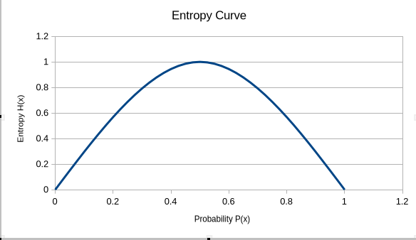

Interpretation
The entropy graph peaks at P(x) = 0.5, yielding H(X) = 1 bit, which corresponds to maximum uncertainty (equal likelihood of heads or tails). At P(x) = 0 or P(x) = 1 the entropy drops to zero, indicating complete certainty — no information is gained from an outcome that is predetermined.

References
Primary Textbook
[1] Ross, S.M. (2019). Introduction to Probability Models, 12th Edition. Academic Press / Elsevier. ISBN: 978-0-12-814346-9. Available at: https://www.sciencedirect.com/book/9780128143469/introduction-to-probability-models
Online References
[2] StatTrek (2024). Probability Distributions — Binomial, Poisson, Geometric, Exponential, Normal, Uniform. Available at: https://stattrek.com/probability-distributions
[3] Statistics How To (2024). Probability and Statistics Reference Library. Available at: https://www.statisticshowto.com
[4] Khan Academy (2024). Statistics and Probability — Random Variables and Distributions. Available at: https://www.khanacademy.org/math/statistics-probability
[5] NIST/SEMATECH (2024). e-Handbook of Statistical Methods. National Institute of Standards and Technology. Available at: https://www.itl.nist.gov/div898/handbook/
[6] Real Statistics Using Excel (2024). Statistical Distributions, Correlation, and Random Number Generation in Excel. Available at: https://real-statistics.com
[7] Microsoft Support (2024). Excel Statistical Functions Reference — BINOM.DIST, POISSON.DIST, NORM.DIST, EXPON.DIST, CORREL, MULTINOMIAL. Available at: https://support.microsoft.com/en-us/office/statistical-functions-reference-624dac86-a375-4435-bc25-76d659719ffd
[8] Scribbr (2024). Guides on Probability Distributions, Scatter Plots, and Correlation. Available at: https://www.scribbr.com/statistics/

