CE154 - Assignment 2 Report
Student Registration Number: 2402515
TASK 2 – Prepare the Website Content and Template
In preparation for the dynamic deployment, I had to ensure the template from Assignment 1 was polished and realistic. First, I addressed the file architecture, reorganising the chaotic root folder into a clean directory structure with dedicated CSS, images, and inc folders.
During the development phase, I noticed a layout bug: wrapping my "Add to Basket" buttons inside HTML form tags broke the original CSS flexbox layout, causing the buttons to shrink. I rectified this by applying display: flex; flex: 1; to the form containers, which restored the uniform, sharp design language I established in Assignment 1.
Finally, I replaced all the placeholder Lorem ipsum text. To maintain the urban contemporary art genre, I adapted the artist biography and artwork descriptions from standard contemporary art gallery exhibition catalogues. For the shop, I utilised standard boutique e-commerce phrasing. I have credited these generic sources directly within the HTML comments of my code to ensure academic integrity.
TASK 3 – Convert Static Web Pages to Dynamic PHP
To make the website efficient and scalable, I transitioned from a static HTML structure to a dynamic PHP architecture. I extracted the repeated top navigation bar and footer elements into dedicated header.php and footer.php files. By utilising the PHP include() function, I ensured that any future layout changes only need to be made in one central location.
Additionally, I implemented dynamic "on-state" navigation to improve user orientation. Instead of hardcoding the active class, I used the PHP $_SERVER['PHP_SELF'] variable in the header to detect the user's current URL. A ternary operator then automatically applies an active CSS class to the correct navigation link, providing clear visual feedback on the user's location within the site.
TASK 4 – MySQL Database for Data Management
In my Assignment 1 appraisal, I explicitly noted that a significant technical limitation of my submission was the absence of backend persistence, as my original product data relied purely on a static JavaScript array.
To solve this, I designed and implemented a MySQL database named ce154_store. I created a merchandise table containing more than the minimum 5 required items. This table successfully stores each product's unique reference ID, title, description, category, price, publication date, and thumbnail URL. To protect the database from SQL injection attacks, all dynamic inputs—such as the item IDs passed through the URL—are strictly sanitised using the $conn->real_escape_string() function before any queries are executed.
As an extra functional feature, I built a dynamic shopping basket addition system with a plus and a minus, allowing you to add and remove more of one item inside the cart, which would also show you how many items are in your cart. Rather than using a database table for the cart, I utilised PHP $_SESSION arrays. This allows the server to remember a user's selected items across multiple pages, calculate real-time subtotals, and allow users to adjust item quantities or clear their basket entirely.
TASK 5 – Deploy Your Website to CSEEMyWeb
The fully functional, database-driven website has been successfully deployed to the university server.
- Live Website URL: http://cseemyweb.essex.ac.uk/~pk24707/CE154

TASK 6 – Evaluation of your website
Unit Testing:
I conducted unit testing to ensure the new backend logic functioned correctly. For example, I tested the basket's edge cases by adding an item and then using the minus toggle to decrease its quantity to zero. The expected behaviour was for the PHP script to detect the zero value and use unset() to remove the item entirely. The test passed, and the item was successfully cleared from the session array without breaking the subtotal calculation.
User Testing: Similar to the Google Forms evaluation conducted in Assignment 1, I had a user test the new checkout flow. They noted that the dynamic quantity toggles were highly intuitive and appreciated that the subtotal and shipping costs updated automatically without manual page refreshes.
Automatic Code Evaluation:
I ran the dynamically generated PHP pages through the W3C HTML Validator to ensure no syntax errors or unclosed tags remained after the transition from static HTML. I also utilised the WAVE Accessibility tool to confirm that all dynamically loaded database images successfully pulled their respective titles to use as alt text for screen readers.
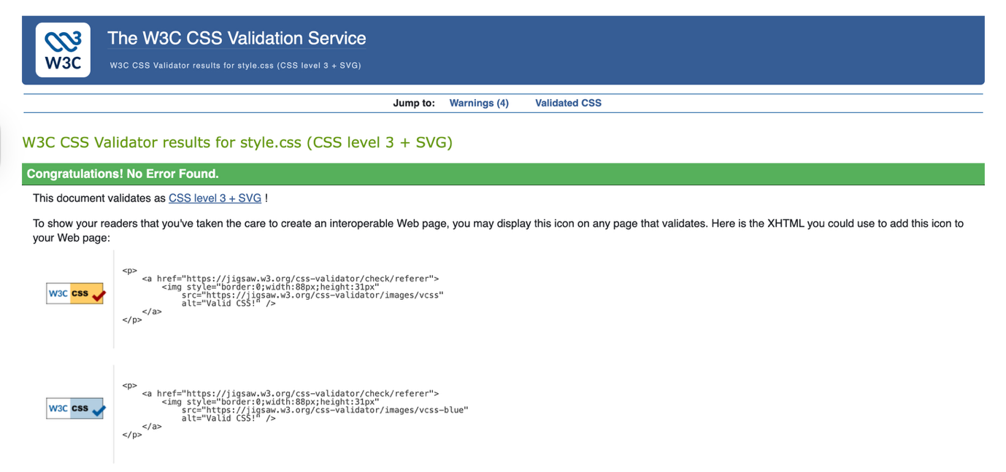
Bug Fixing Log:
- Bug: The local MySQL server refused to connect during the early development stages.
- Fix: I discovered a ghost MySQL process blocking port 3306 on my macOS environment. I used terminal commands to kill the process, which allowed the database to initialise properly.
- Bug: Duplicate "Add to Basket" buttons appeared on the merchandise item pages.
- Fix: I completely refactored the PHP logic to replace the obsolete Assignment 1 JavaScript UI handlers, ensuring only the server-side form remained.
Skill tree
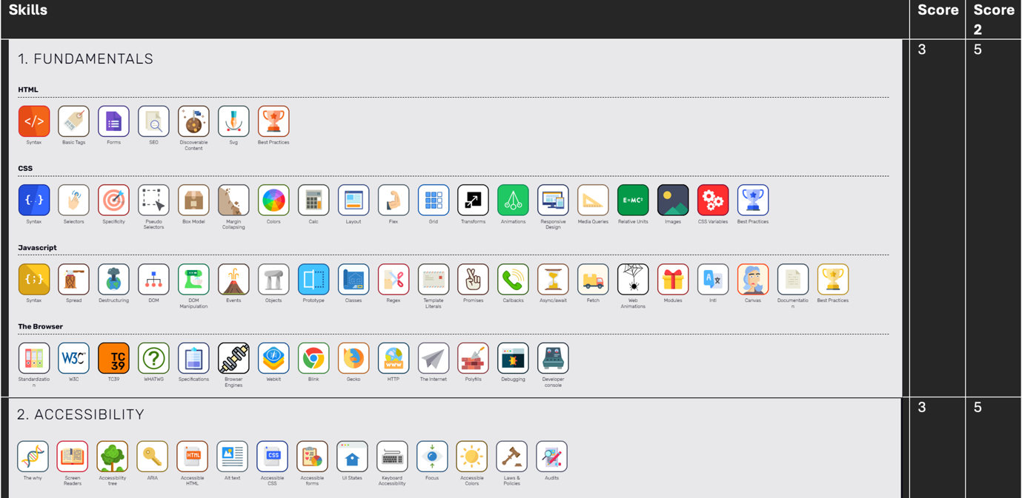
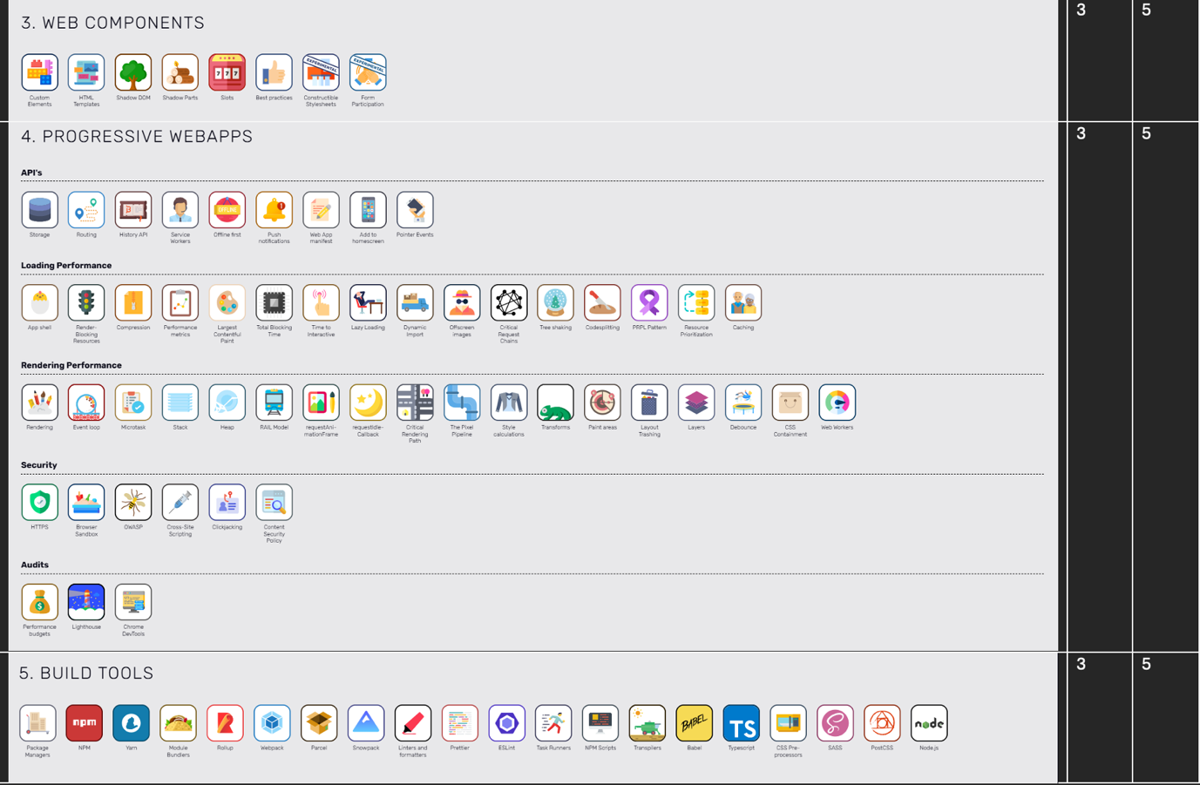
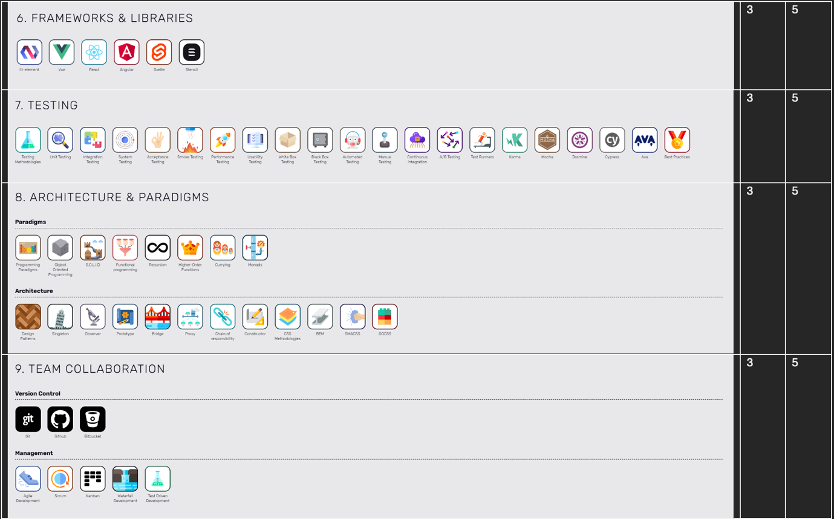
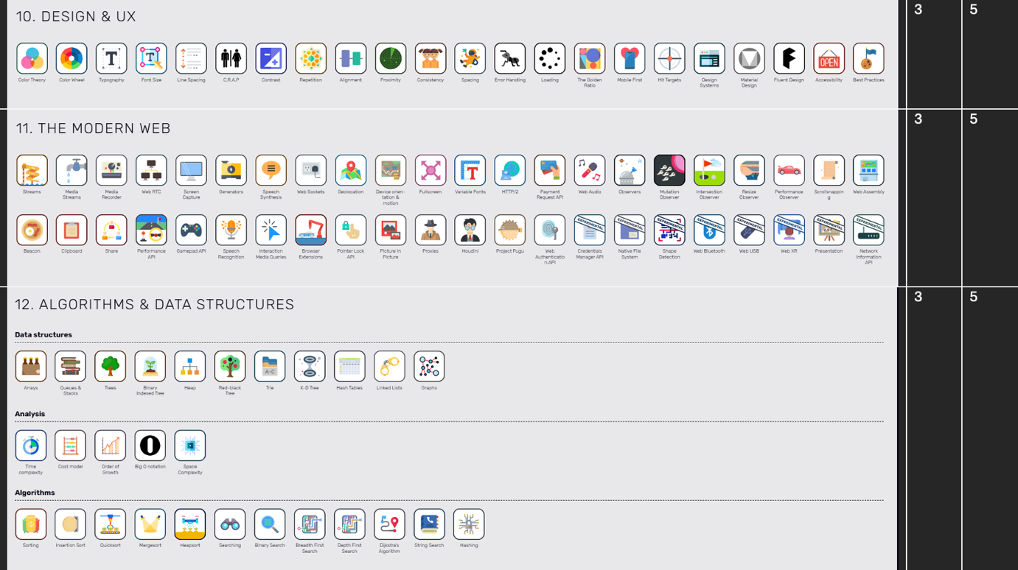
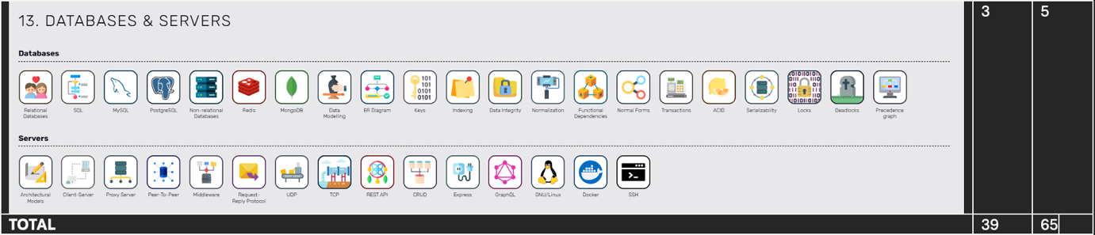

Appraisal

Building upon the foundations of Assignment 1, I am proud to have solved my previous limitations regarding backend persistence. Creating a functional session-based basket was highly rewarding, though managing the state between the database and the PHP session presented a steep learning curve. In future iterations, I would like to learn how to integrate AJAX. This would allow the shopping basket quantities to update seamlessly in the background without requiring the user's browser to execute a hard refresh on the page.

Checklist
