**Assignment-8**

**Aim:** Fade In Fade Out Effect

**Layers Used:**

**Layer 1:** Layer 1

**Layer 2:** Layer 2

**Layer 3:** Layer 3

**Layer 4:** Layer 4

**Time Frame:**

**Time Frame: 0 sec**

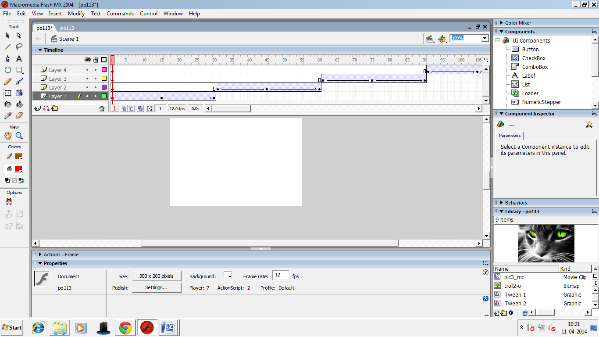

**Time Frame: 0 -15 sec**

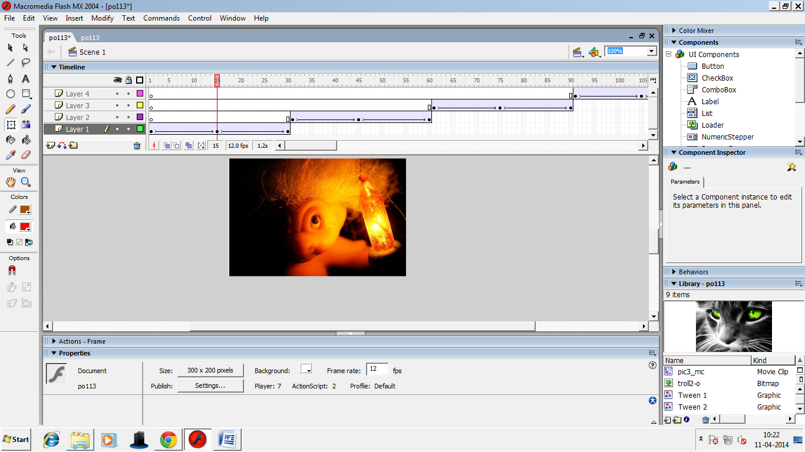

**Time frame:15-30 sec**

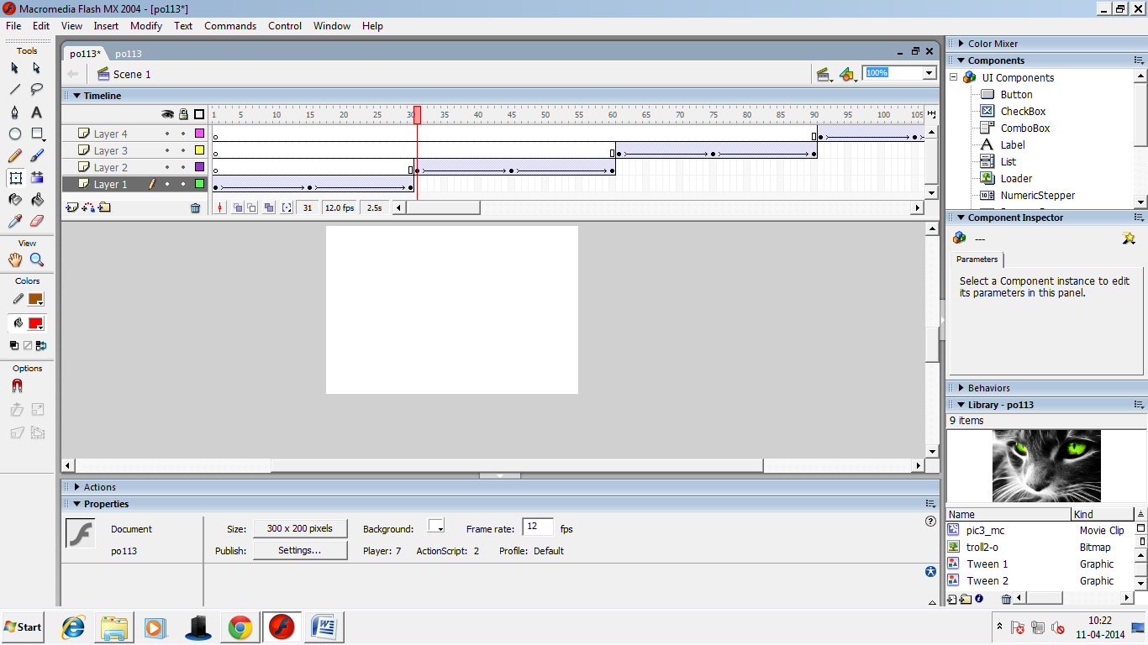

**Time frame:30 -45sec**

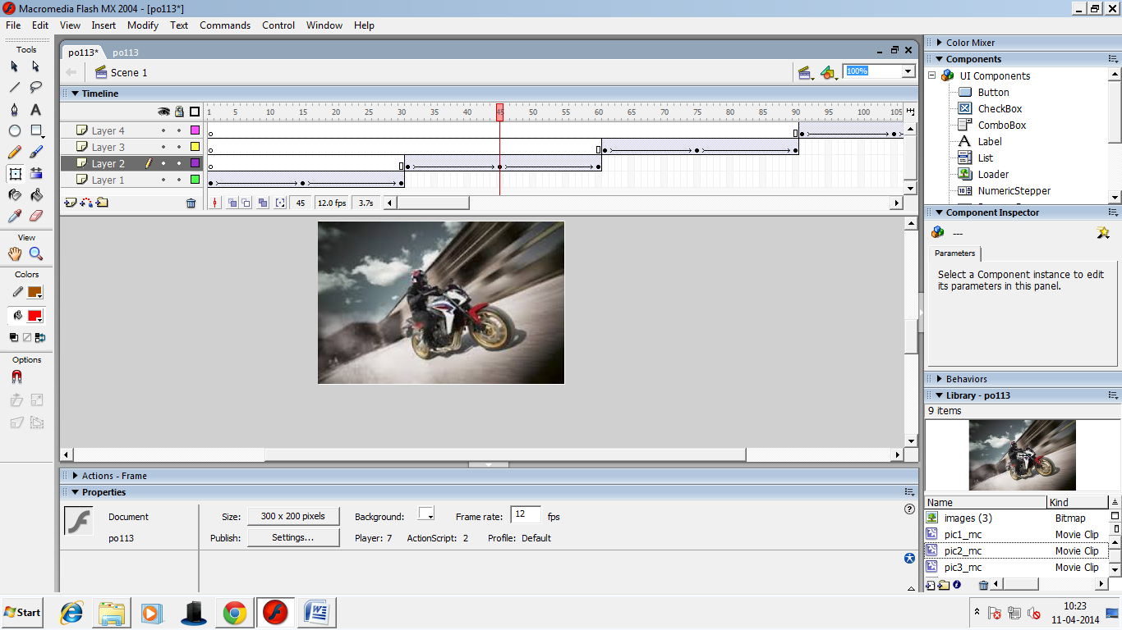

**Time frame:45-60 sec**

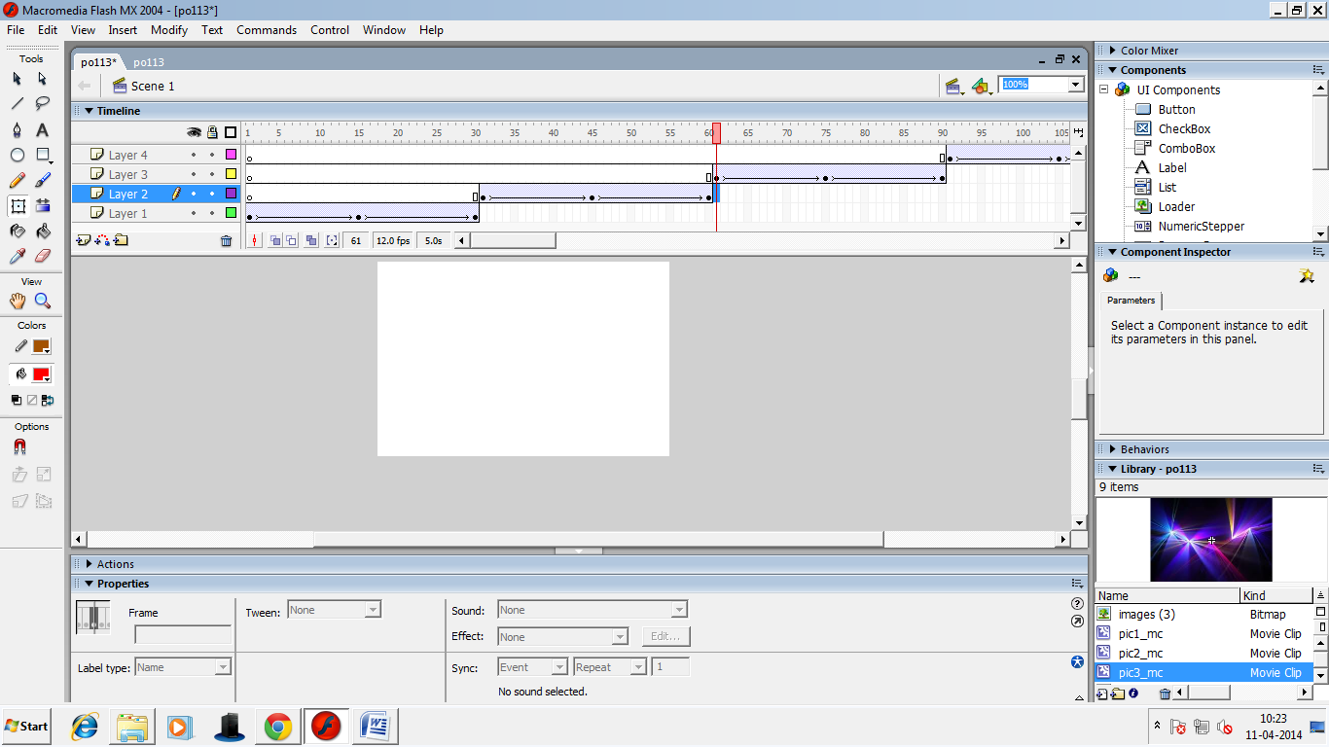

**Time frame:60-75 sec**

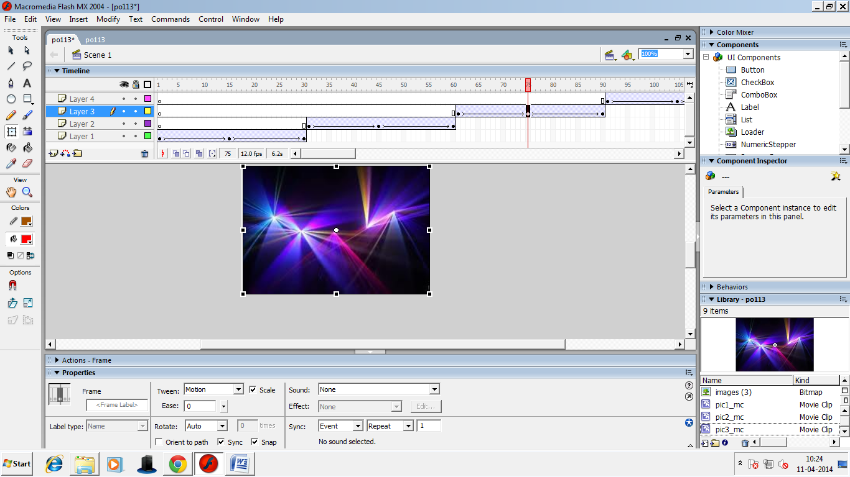

**Time frame:75-90 sec**

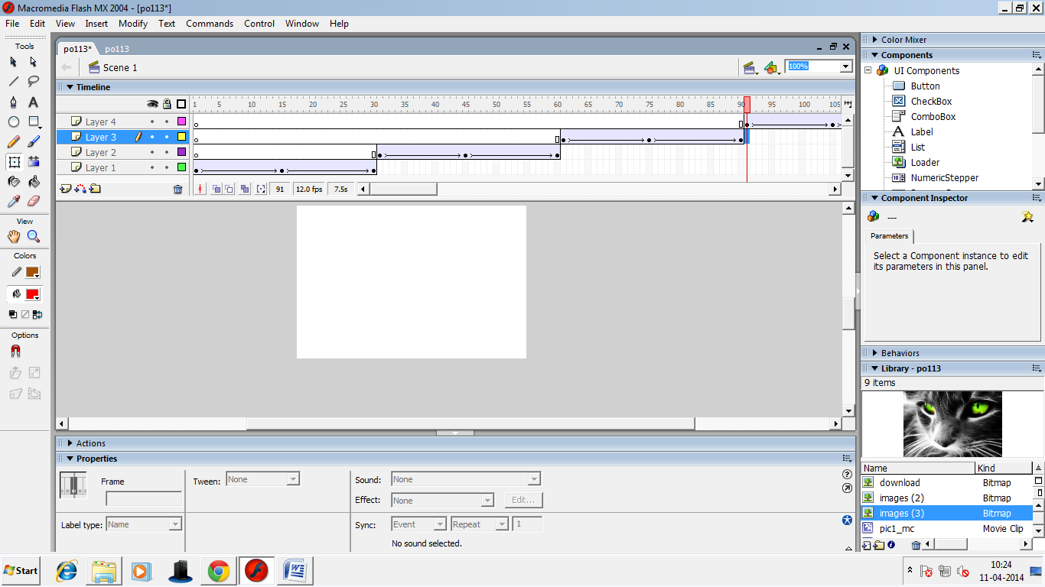

**Time frame:90-105 sec**

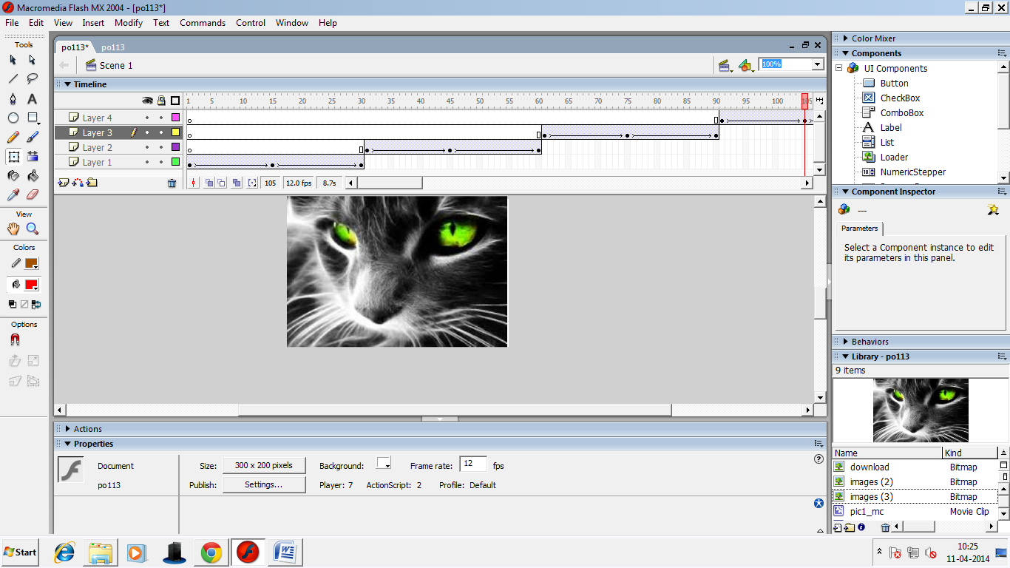

**Time frame:105-120 sec**

