## CRIMINAL IDENTIFICATION AND DETECTION

## A Micro Project Report

### Submitted by

**PANTALA ANUSHA Reg.no: 99220041072**

## B.Tech – Computer Science and Engineering,

## DATA SCIENCE



**Kalasalingam Academy of Research and Education**

#### (Deemed to be University)

**Anand Nagar, Krishnankoil - 626 126**

## March 2024



**SCHOOL OF COMPUTING**

**DEPARTMENT OF COMPUTER SCIENCE AND ENGINEERING**

# BONAFIDE CERTIFICATE

Bonafide record of the work done by PANTALA ANUSHA - 99220041072 in partial fulfillment of the requirements for the award of the degree of Bachelor of Technology in Specializa tion of the Computer Science and Engineering, during the Academic Year Even Semester (2023-24)

**Dr .V. Anusuya Devi Dr. P .Anitha**

**Project Guide Faculty Incharge**

**Associate Professor Assistant professor**

**Computer Science and Engineering Computer Science and Engineering**

**Kalasalingam Academy of Kalasalingam Academy of**

**Research and Education Research and Education**

**Krishnan kovil - 626126 Krishnan kovil - 626126**

**Dr.K. Kartheeban Evaluator Associate Professor**

**Computer Science and Engineering**

**Kalasalingam Academy of Research and Education Krishnan kovil - 626126**

# Abstract

Our project is utilizing state-of-the-art technologies to tackle the problem of computer vision for criminal identification. Our web application is seamless since we have incorporated Streamlit into our Python code that runs in a specialized Anaconda virtual interface. Building a thorough criminal record, utilizing facial recognition for image-based detection, and enabling video surveillance for instantaneous identification are the main goals. The ability of computer vision to improve crime prevention strategies is demonstrated by this project. The outcomes of the project make a contribution to the fields of database administration, interface design, and real-time surveillance for the purpose of criminal detection. We are committed to innovation and progress, therefore as we continue our technological research, we are also working toward future improvements and launches.

# Contents

1. Introduction
   1. Project Overview 1
   2. Objectives 1
      1. Scope of the Project 1
      2. Project Significance 2
2. Back Ground 3
   1. Computer Vision in Criminal Identification 3
      1. Role of Computer Vision in Crime Prevention 4
   2. Streamlit Framework for Web Applications 4
      1. Integration with Anaconda 4
      2. Setting Up the Face Virtual Interface 5
   3. Implementation 6
      1. Python Code Implementation 6
3. Project Details 7
   1. Criminal Registry 7
      1. Libraries used in Code 7
      2. User Interface for Registry 8
   2. Image-Based Criminal Detection 10
4. Conclusion and Future Work 11
   1. Summary 11
   2. Future Enhancements and Expansions  11

CONTENTS CONTENTS

1. References 12
2. Certification 13

**List of Figures**

|  |  |  |  |
| --- | --- | --- | --- |
| 2.1 | Computer Vision In Criminal Identification | . . . . . . . . . . . . . . . . . . . . | 2 |
| 2.2 | Integration With Anaconda | . . . . . . . . . . . . . . . . . . . . | 3 |
| 2.2 | Setting up the Face Virtual Interface | . . . . . . . . . . . . . . . . . . . . | 5 |
| 3.1 | Interface of Criminal Registry | . . . . . . . . . . . . . . . . . . . . | 7 |
| 3.2 | Uploading Images of Criminals | . . . . . . . . . . . . . . . . . . . . | 7 |
| 6.1 | Certification details | . . . . . . . . . . . . . . . . . . . | 11 |

**Chapter 1**

**Introduction**

## Project Overview

## The goal of the Criminal Identification and Detection App is to use cutting-edge technology to transform law enforcement. This creative idea improves criminal monitoring and detection by utilizing computer vision techniques. Easy access and control are ensured by the system's smooth integration with a web-based interface that is driven by the Streamlit library.

## Objectives

Improving law enforcement is the goal of our Criminal Identification and Detection App. It employs intelligent technology, such as sophisticated computer vision, to precisely locate offenders and maintain vigilant oversight. Because of Streamlit, the app is simple to use on the web, increasing your control and accessibility.

### Scope of the Project

1. The use of cutting-edge technology to improve law enforcement capacities is the scope of our project. This includes using advanced computer vision techniques to accurately identify and monitor illegal activity.

2. The project's scope includes utilizing state-of-the-art technology to update law enforcement capabilities. This includes using the most recent advancements in computer vision technology for efficient criminal identification and watchful surveillance.

1.2. Scope of the Project Chapter 1. Introduction

### Project Significance

Our project is very important for improving the capabilities of law enforcement. Through the use of advanced computer vision algorithms, we provide law enforcement with reliable criminal identification and strong surveillance. This increases overall crime prevention measures' effectiveness and improves public safety.

**Chapter 2**

# Back Ground

## Computer Vision in Criminal Identification

Integrating computer vision into criminal identification procedures is the focus of our project. For precise analysis and identification, cutting-edge technologies must be used. We seek to improve law enforcement's capacity by employing state-of-the-art algorithms to effectively identify those involved in illegal activity.

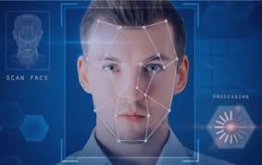We investigate the potential of computer vision to transform current approaches in the field of criminal identification. Our goal is to accomplish accurate identification and analysis by applying advanced technology. Our goal is to enhance law enforcement's capacity by applying cutting-edge algorithms, which will enable precise identification of those engaged in illegal activity.

Figure 2.1: Computer Vision In Criminal Identification

2.2. Streamlit Framework for Web Applications Chapter 2. Back Ground

### Role of Computer Vision in Crime Prevention

The critical role that computer vision plays in deterring crime is highlighted by our project. Our goal is to improve surveillance and identification capabilities by utilizing cutting-edge technology. This requires creating complex algorithms to effectively prevent crime and uphold public safety.

## Streamlit Framework for Web Applications

### We have developed our project using the Streamlit framework, which allows us to create user-friendly and intuitive web apps. When creating engaging and accessible interfaces that guarantee a flawless user experience, streamlit becomes an indispensable tool.

### 2.2.1 Integration with Anaconda Platform

### We employ a simple procedure in order to integrate our product with the Anaconda platform without any problems. To ensure compatibility and a seamless workflow, this entails setting up the required dependencies and libraries within the Anaconda environment. We take advantage of the Anaconda platform's features to execute code more efficiently and to build our project more effectively. Our project's Anaconda platform environment is unified and coherent because to this integration, which simplifies the administration of dependencies.

### 

2.2. Streamlit Framework for Web Applications Chapter 2. Back Ground

### 

### Figure 2.2.1: Integration With Anaconda

### 2.2.2 Setting up the Face Virtual Interface

We use a simple procedure to start the Face Virtual Interface for our project. This entails setting up the Anaconda prompt's virtual environment to create a distinct, isolated area where our facial recognition software may run. We avoid any interference with the underlying Anaconda interface by developing this dedicated virtual interface called "Face," which creates a controlled environment for the smooth implementation of our project.

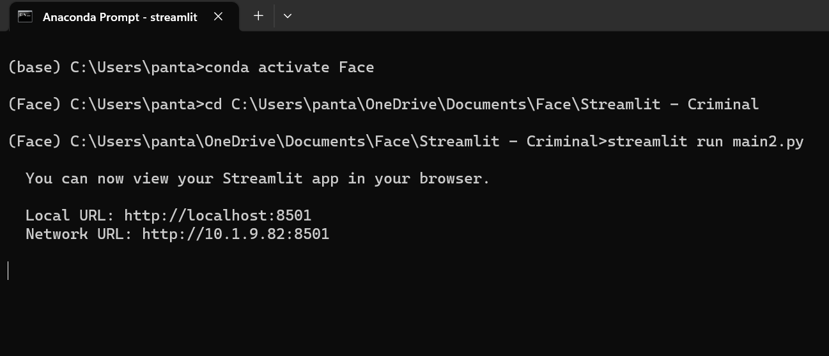  
We expedite the setup process at the Anaconda prompt while setting up the Face Virtual Interface. Our facial recognition code is isolated in this specific area, avoiding conflicts with the main Anaconda interface. This unique virtual environment, called "Face," was created to ensure a regulated and interference-free setting, which will help our project run more smoothly.

Figure 2.2.2: Setting up the Face Virtual Interface

2.3. Implementation Chapter 2. Back Ground

## Implementation

### We employ a methodical implementation methodology to bring our Criminal Identification online application to life. First, in order to guarantee a regulated environment, we make use of the Anaconda platform and create a special Face virtual interface. We incorporate the Streamlit framework for the front end of the web application within this interface. This include establishing the user interface, installing the required dependencies, and making sure our Python code connects without a hitch.

### 2.3.1 Python Code Implementation

Building a solid basis for the Criminal Identification web application is our main goal as we dive into the Python code development. Our algorithm assures reliable identification of illicit activity by utilizing cutting-edge computer vision techniques. This feature is integrated into the user interface and is available via a web browser thanks to the Streamlit framework integration.

Put more simply, the web interface created by Streamlit automatically updates or modifies any modifications made to the Python code. Any code changes whether they be enhancements or new features are guaranteed to appear and work right away in the user interface thanks to this seamless integration. The backend and frontend components remain synchronized because to this dynamic interaction between the code and web interface, which also improves user experience overall.

**Chapter 3**

# Project Details

## 

## Criminal Registry

### The core of the system is our illegal Registry, which is dedicated to organizing data about those who have engaged in illegal activity. We make sure the record-accessing and updating interface is easy to use, which encourages effective data management. The system uses safe procedures to keep information private and gives law enforcement an effective tool for following and keeping an eye on criminal records.

### We maintain track of those who are involved in criminal activity through the Criminal Registry. Because of its user-friendly design, updating and accessing records is a breeze. This guarantees effective data management, and we've put safe safeguards in place to protect the privacy of the data. With the use of this registry, law enforcement can efficiently track and monitor criminal history, making it a valuable tool.

### Libraries Used in the Code

#### import os

#### import streamlit as st

#### import cv2

#### import numpy as np

#### from PIL import Image

#### import face_recognition

#### from datetime import datetime

3.1. Criminal Registry Chapter 2. Project Details

### User Interface For Registry

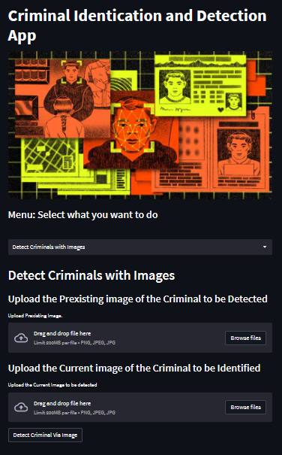

Figure 3.1: Interface of Criminal Registry

3.1. Criminal Registry Chapter 2. Project Details

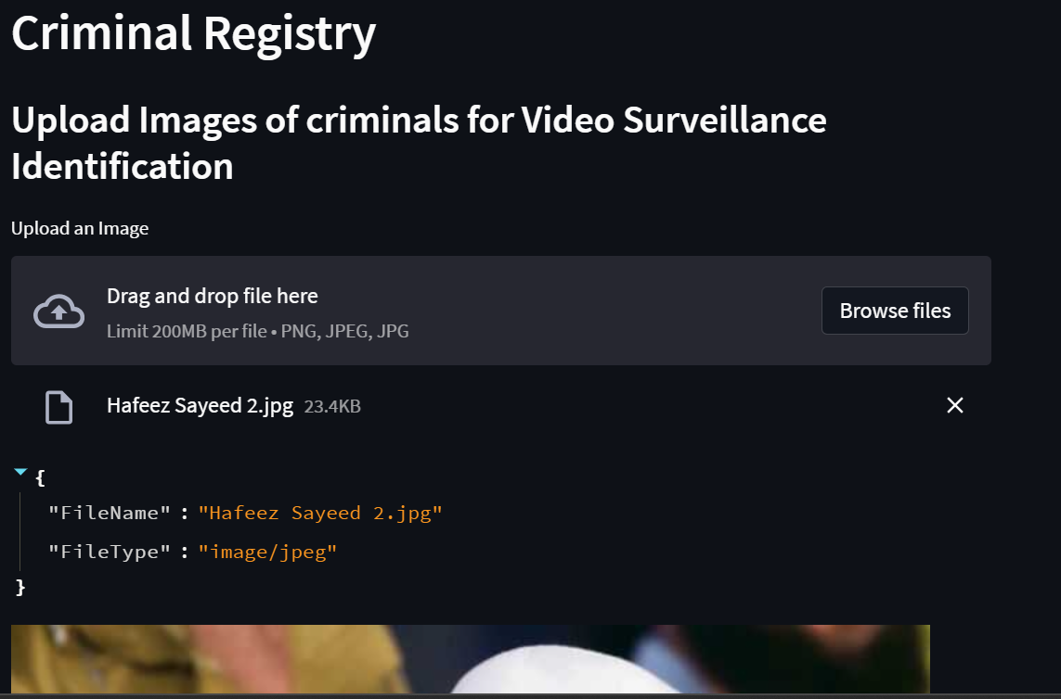

Figure 3.1.2: Uploading Images of Criminals

We focused on efficiency and simplicity when designing our Criminal Registry User Interface. It offers a smooth procedure for handling and getting access to criminal records. Law enforcement officers may simply update information and conduct searches thanks to the easy design, which ensures quick and efficient use of the Criminal Registry. This interface improves the system's general functionality and accessibility with a focus on user-friendly navigation.

Our Criminal Registry's user interface is designed to be simple and efficient. It provides a seamless way to obtain and manage criminal records. Law enforcement can easily update information and run searches thanks to the straightforward design, which guarantees the Criminal Registry is used efficiently and quickly. This design prioritizes easy-to-use navigation, which improves overall functionality and accessibility of the system.

3.2. Facial Recognition Chapter 3. Project Details

## Facial Recognition

Our project's integration of facial recognition calls for the use of sophisticated algorithms to ensure precise identification. Our top priority is a smooth interface with the Criminal Registry so that people can be identified quickly. By improving overall surveillance capabilities, facial recognition technology gives law enforcement a valuable tool for following and identifying suspects.

Implementing Facial Recognition in our project means using smart algorithms for precise identification. We ensure that it quickly and easily identifies people by integrating it with the Criminal Registry.

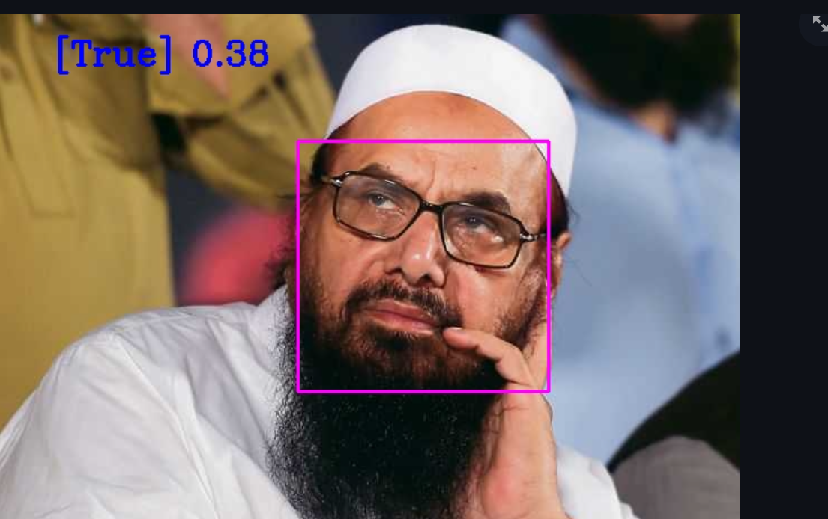

Figure 3.2: Image-Based Criminal Detection

**Chapter 4**

# Conclusion and Future Work

## Summary

## In conclusion, our project improves criminal detection and monitoring through the use of cutting edge technologies. With capabilities like facial recognition, computer vision, and the intuitive Streamlit framework, we've created a powerful app for criminal identification and detection. Through a well-thought-out interface, this application guarantees precise identification, upholds an extensive Criminal Registry, and offers a seamless user experience. It is now a comprehensive solution for law enforcement in terms of crime prevention and detection thanks to the integration with the Anaconda platform, which adds another degree of efficiency.

## 4.2 Future Enhancements and Expansions

Our initiative intends to continue expanding and improving in the future. To improve the accuracy of criminal identification, we will improve the algorithms for facial recognition. Our roadmap also calls for adding sophisticated video surveillance features to the application.

With the advent of real-time video analysis, police enforcement will be able to detect crimes before they happen. The goal is to keep our Criminal Identification and Detection App up to date with the latest technological advancements in order to meet the changing demands of law enforcement.

**Chapter 5**

# References

1. [Criminal Face Recognition System – IJERT](https://www.ijert.org/criminal-face-recognition-system)

2. [Eigenfaces vs. Fisherfaces: recognition using class specific linear projection | IEEE Journals & Magazine | IEEE Xplore](https://ieeexplore.ieee.org/document/598228)

3. [Learning-Based Computer Vision with Intels Open Source Computer Vision Library | Request PDF (researchgate.net)](https://www.researchgate.net/publication/245529767_Learning-Based_Computer_Vision_with_Intels_Open_Source_Computer_Vision_Library)

4. [Face recognition: features versus templates | IEEE Journals & Magazine | IEEE Xplore](https://ieeexplore.ieee.org/abstract/document/254061)

5. [Rapid object detection using a boosted cascade of simple features | IEEE Conference Publication | IEEE Xplore](https://ieeexplore.ieee.org/document/990517)

6[(PDF) Robust Real-Time Object Detection (researchgate.net)](https://www.researchgate.net/publication/215721846_Robust_Real-Time_Object_Detection)

7. [OpenCV Reference Manual (cornell.edu)](https://www.cs.cornell.edu/courses/cs4670/2010fa/projects/OpenCVReferenceManual.pdf)

**Chapter 6**

# Certification



Figure 6.1: Certification details