Customer Segmentation & Churn Pattern Analytics
European Retail Banking — France, Spain, Germany

1. Introduction
Customer churn is one of the largest hidden costs in retail banking, eroding lifetime value and driving up acquisition spend. This paper analyzes a 10,000-customer dataset spanning three European markets — France, Spain, and Germany — to identify which customer segments churn most, how churn differs across geography and demographics, and what a predictive model can add on top of descriptive segmentation. The goal is a clear, evidence-based foundation for targeted retention strategy, not a generic churn-rate headline.

2. Dataset Overview
The dataset covers 10,000 customers with no missing values and no duplicate customer records. Each customer record includes credit score, geography, gender, age, tenure with the bank, account balance, number of products held, credit card ownership, activity status, estimated salary, and a binary churn indicator (Exited).
Metric | Value
Total customers | 10,000
Geographies | France (5,014), Germany (2,509), Spain (2,477)
Overall churn rate | 20.37%
Missing values | None
Duplicate customer IDs | None

Five segmentation dimensions were constructed for the analysis: geography (as recorded), age bands (<30, 30–45, 46–60, 60+), credit score bands (Low <580, Medium 580–700, High >700), tenure groups (New 0–2 yrs, Mid-term 3–6 yrs, Long-term 7+ yrs), and balance segments (zero-balance, low-balance <100K, high-balance ≥100K).

3. Exploratory Data Analysis & Segmentation Findings
Churn rates vary sharply across every segmentation dimension tested, confirming that a single overall churn figure conceals substantial structure in the customer base.
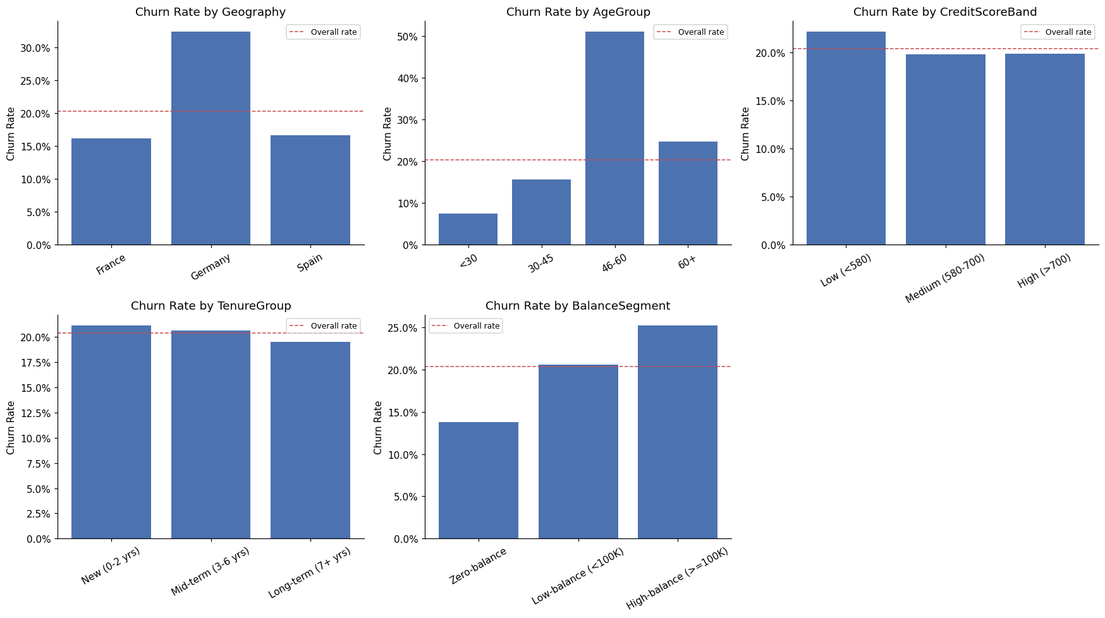
Figure 1. Churn rate by geography, age group, credit score band, tenure group, balance segment, and (implicitly) the overall rate shown as a dashed reference line.

3.1 Geography
Germany stands out as the highest-risk market at 32.4% churn — roughly double France (16.2%) and Spain (16.7%). Since Germany holds only about a quarter of the customer base, this concentration of risk in a single market is a clear priority signal rather than a marginal effect.

3.2 Age
The 46–60 age band churns at 51.1%, far above every other age group (customers under 30 churn at just 7.5%). This is the single sharpest split in the dataset and warrants dedicated investigation into what is driving mid-to-late-career customers away — whether product fit, competing offers, or life-stage financial changes.

3.3 Gender
Female customers churn at 25.1% versus 16.5% for male customers, an 8.6 percentage-point gap that persists across the segmentation and is worth incorporating into targeted retention messaging and outreach design.

3.4 Engagement (Activity Status)
Inactive members churn at 26.9% compared with 14.3% for active members — a 12.6 percentage-point engagement drop indicator. This is one of the more actionable findings: activity status is directly observable and interventable (e.g. via re-engagement campaigns) ahead of a churn event.

3.5 Product Holdings
Number of products shows the sharpest non-linear pattern in the dataset. Customers with 2 products churn at just 7.6%, while those with 3 or 4 products churn at 82.7% and 100% respectively (a small subgroup of 326 customers combined, but an extremely strong signal). This likely reflects a segment that was over-sold products, encountered service friction, or represents customers already in the process of leaving. It deserves investigation as a distinct, high-urgency segment rather than being averaged away.

3.6 Geography × Age Interaction
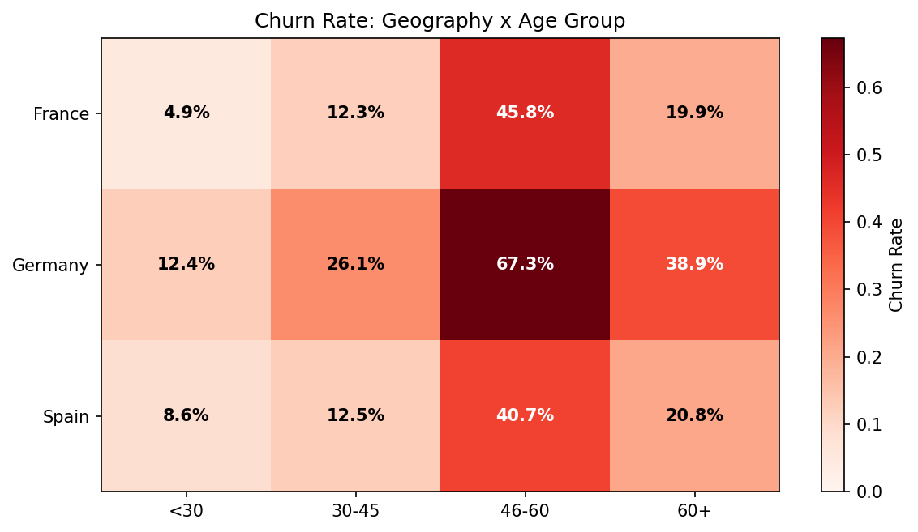
Figure 2. Churn rate heatmap — Geography × Age Group. Germany's risk is elevated across every age band, and the 46–60 spike compounds within it.
The interaction view confirms that Germany's elevated churn is not concentrated in one age group — it runs across the board — while the 46–60 age spike is itself present in every geography. The two effects compound rather than substitute for each other: German customers aged 46–60 churn at 67.3%, the single highest-risk cell in the entire dataset, nearly seven times the churn rate of under-30 customers in France (4.9%). Germany-focused retention work and age-focused retention work therefore address different, additive risk sources rather than the same underlying problem, and the Germany × 46-60 segment specifically warrants the most urgent attention.

4. High-Value Customer & Revenue Risk Analysis
High-value customers are defined as those in the top quartile by account balance or by estimated salary (computed on the full customer base). This group churns at 22.3% — modestly above the 20.37% overall rate — but because it is a large segment, high-value customers make up 47.6% of all churners. Put differently: nearly half of the revenue-relevant churn in this bank is concentrated among its highest-value customers, making this the single most consequential segment for retention economics.
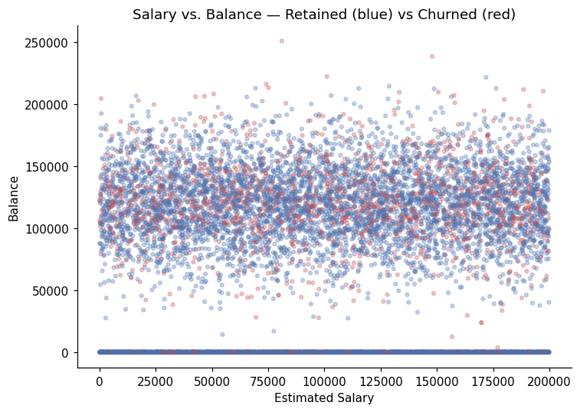
Figure 3. Estimated salary vs. account balance, retained (blue) vs. churned (red) customers. Churn is distributed across the balance/salary space rather than confined to one corner, indicating financial profile alone is not a strong discriminator without combining it with engagement and product-count signals.
This finding reframes the retention priority: rather than treating churn as a uniform 20% leakage problem, the highest-leverage intervention point is proactively identifying at-risk high-value customers before they exit, since losing them carries disproportionate balance and revenue impact relative to their share of the customer base.

5. Churn Prediction Modeling
Beyond descriptive segmentation, a supervised classification model was built to score each customer's individual churn probability, enabling proactive rather than purely reactive retention targeting.

5.1 Baseline Model Comparison
Six model families were trained and compared on a held-out 20% test set, all using class-balanced weighting to account for the ~20% churn base rate: Logistic Regression, Decision Tree, Random Forest, Gradient Boosting, XGBoost, and SVM (RBF kernel).
Model | Accuracy | Precision | Recall | F1 | ROC-AUC
Gradient Boosting | 87.0% | 79.4% | 49.1% | 0.607 | 0.870
XGBoost | 80.0% | 50.7% | 73.7% | 0.601 | 0.868
Random Forest | 81.4% | 53.2% | 71.7% | 0.611 | 0.862
SVM (RBF) | 78.8% | 48.5% | 73.5% | 0.585 | 0.856
Decision Tree | 76.2% | 45.1% | 78.4% | 0.572 | 0.842
Logistic Regression | 71.4% | 38.7% | 70.0% | 0.499 | 0.777

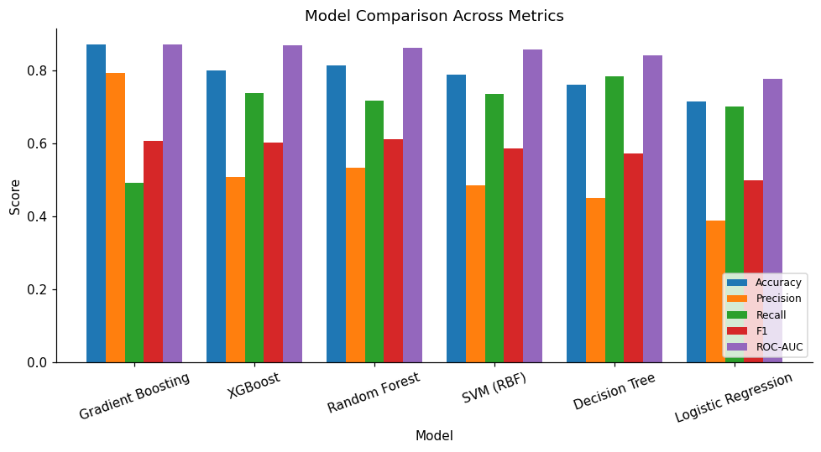
Figure 4. Model comparison across accuracy, precision, recall, F1, and ROC-AUC for all six baseline models.
With an imbalanced ~20% churn base, accuracy alone is a misleading ranking criterion — a model that always predicts "retained" would score roughly 80% accuracy while catching zero churners. Recall and ROC-AUC are the more decision-relevant metrics: Gradient Boosting leads on ROC-AUC and precision, but its recall (49%) means it misses roughly half of actual churners. XGBoost and Random Forest trade a few points of precision for materially higher recall (72–74%), which is generally the more useful trade-off for a retention program, where the cost of a missed churner (a lost customer) typically exceeds the cost of a false alarm (an unnecessary retention outreach).

5.2 Hyperparameter Tuning
The three tree-based ensembles were tuned using RandomizedSearchCV with cross-validation, scored on ROC-AUC. Tuning produced a modest, not transformative, improvement — an honest result worth stating plainly rather than overselling.
Model | Cross-Val ROC-AUC | Test ROC-AUC
Random Forest (Tuned) | 0.862 | 0.861
Gradient Boosting (Tuned) | 0.865 | 0.868
XGBoost (Tuned) | 0.868 | 0.869

Tuned XGBoost was selected as the final model, edging out the other candidates on test ROC-AUC while retaining strong recall — a better fit for a retention use case than the untuned Gradient Boosting model, which had the highest raw ROC-AUC but weaker recall.

5.3 Final Model Performance
Metric | Value
Accuracy | 80.3%
Precision | 51.1%
Recall | 76.2%
F1 Score | 0.611
ROC-AUC | 0.870

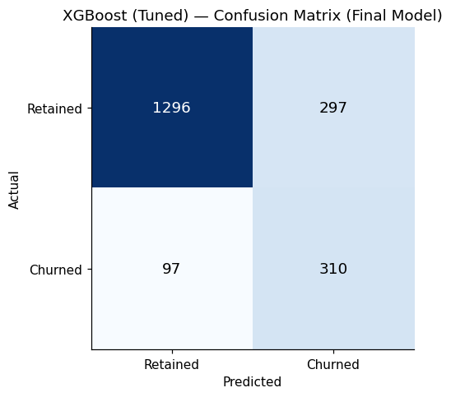
Figure 5. Confusion matrix — final tuned XGBoost model on the held-out test set (2,000 customers).
The final model correctly identifies roughly 3 in 4 actual churners (76% recall) while keeping the false-positive rate manageable, making it suitable as a screening tool to prioritize retention outreach rather than as a fully automated decision system.

5.4 Feature Importance
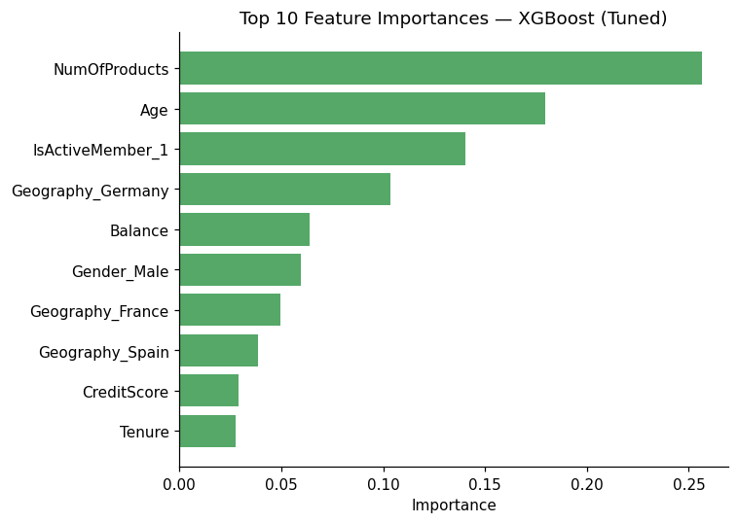
Figure 6. Top 10 feature importances, final tuned XGBoost model.
Number of products (25.7%) and age (17.9%) are the dominant predictors, followed by active membership status (14.0%) and being based in Germany (10.4%). This mirrors and validates the descriptive segmentation findings in Section 3 — the model is not surfacing a hidden driver so much as confirming, and precisely weighting, the same factors the EDA flagged, with product count and age as the two variables that matter most.

6. Business Insights
- Germany is a structurally higher-risk market (32.4% churn, ~2x France/Spain) across every age band — this points to a market-level issue (competition, product-market fit, or service quality) rather than a demographic artifact.
- The Germany × 46–60 combination is the single highest-risk segment in the dataset at 67.3% churn — nearly seven times the rate of France's under-30 customers — indicating the two risk factors compound rather than overlap.
- The 46–60 age band is the highest-risk demographic segment bank-wide (51.1% churn) and compounds with, rather than being explained by, the Germany effect.
- Customers holding 3–4 products churn at 83–100% — this small but extreme segment likely reflects over-selling, service friction, or customers already mid-exit, and should be investigated directly rather than assumed to be a data artifact.
- Inactive members churn at nearly double the rate of active members (26.9% vs 14.3%), and this is both observable ahead of time and directly addressable through re-engagement.
- Nearly half of all churn (47.6%) is concentrated among high-value customers, who represent a disproportionate share of at-risk revenue relative to their share of the customer base.
- The predictive model confirms these patterns quantitatively: product count, age, activity status, and Germany geography are the four strongest predictors of individual churn risk.

7. Recommendations
- Prioritize a Germany-specific retention review — investigate local competitive dynamics, pricing, and service quality given the consistently elevated churn across all demographics in that market.
- Treat German customers aged 46–60 as the top-priority retention segment: at 67.3% churn, this compounding risk group should be first in line for proactive outreach, relationship-manager attention, and tailored offers.
- Design targeted outreach for the 46–60 age segment, testing whether tailored product bundles or advisory touchpoints (e.g. retirement planning) reduce churn in this life stage.
- Audit the 3–4 product holder segment directly — contact a sample of these customers to determine whether over-selling, service issues, or existing exit intent explains the extreme churn rate, and adjust cross-sell practices accordingly.
- Build a proactive re-engagement program for inactive members, since activity status is both a strong predictor and a directly actionable lever ahead of churn.
- Use the churn-probability model (Section 5) to generate a prioritized retention worklist, focusing outreach capacity on high-value, high-probability customers first, where the revenue impact of retention is greatest.
- Track the engagement drop indicator and geographic risk index (defined in the accompanying dashboard) as ongoing KPIs, not one-time findings, so retention performance can be monitored over time.

8. Limitations & Future Work
- The dataset is a single-year snapshot; without a time series, it is not possible to distinguish leading indicators of churn from concurrent symptoms, or to validate whether the model's predictions hold up over subsequent periods.
- The model's precision (51.1%) means roughly half of customers flagged as high-risk will not actually churn — appropriate for prioritizing outreach, but not for fully automated decisions (e.g. pre-emptively withdrawing an offer).
- The extreme churn rate among 3–4 product holders is based on a small subgroup (326 customers) and should be validated against a larger sample before being treated as a stable structural pattern.
- No transaction-level, complaint, or customer-service interaction data was available; incorporating these would likely improve both model accuracy and the diagnostic depth of the segmentation.
- Country-level churn differences are described here but not explained; a follow-up study incorporating competitor and macroeconomic data for Germany specifically would help distinguish bank-controllable factors from market-wide ones.

