EduPro — Course Demand & Revenue Forecasting
Exploratory Data Analysis, Insights & Recommendations

1. Executive Overview
EduPro asked two predictive questions: how many people will enroll in a course, and how much revenue will it generate. This analysis answers both — but not symmetrically. Revenue is genuinely predictable from course attributes (cross-validated R² ≈ 0.97–0.98). Enrollment count is not: every model tested, at every level of aggregation (monthly, category-monthly, and course-lifetime), scored a negative cross-validated R². That is a real, well-evidenced finding about this dataset, not a modeling shortfall, and it is documented here in full — including exactly how unstable the enrollment R² is across different train/test splits, which is the clearest evidence that there is no reliable signal for it to learn.
The practical takeaway: use the revenue model for pricing and planning decisions. Treat the enrollment model as a documented negative result that motivates collecting more history and richer behavioral data, not as a working forecaster.

2. Dataset Overview
Metric | Value
Courses | 60 (12 categories × 5 courses each)
Instructors | 60
Learners (Users sheet) | 3,000
Transactions | 10,000
Date range | Jan 2025 – Dec 2025 (12 months)
Total lifetime revenue | $911,323.47
Free vs. Paid courses | 38 free / 22 paid
Paid course price range | $0.78 – $490.90 (median paid ≈ $280)

Note: an early version of the price-band feature used thresholds ($0–$30–$60) calibrated to the wrong scale for this dataset, which put 18 of 22 paid courses into a single “High” bucket. This was caught and corrected to $0–$150–$300 (Free / Low / Medium / High), which spreads paid courses across bands as 7 / 6 / 9. All results in this document reflect the corrected bucketing.

3. Exploratory Data Analysis

3.1 Monthly Enrollment & Revenue Are Remarkably Stable
Enrollments and revenue were plotted month by month across the full year of data. Both series move in a narrow band: monthly enrollments range 762–899 (mean 833, coefficient of variation ≈ 4.8%), and monthly revenue ranges $66,984–$83,353 (mean $75,944). There is no visible seasonal pattern or trend — consistent with the near-zero month-to-month autocorrelation quantified in Section 5.
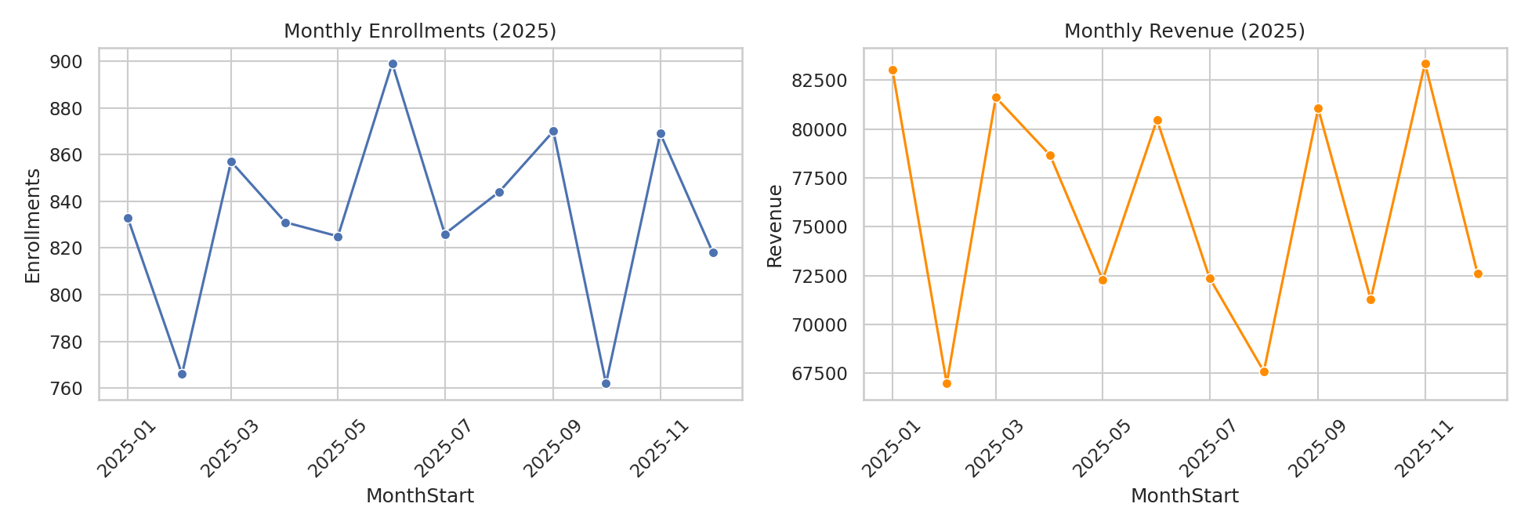
Figure 1. Monthly enrollments and revenue, Jan–Dec 2025.

3.2 Price and Rating Show Weak Correlation With Lifetime Enrollment
At the course level, CoursePrice correlates with total lifetime enrollments at r = –0.16, and CourseRating correlates at r = +0.29. Both are real but weak relationships — weak enough that, as Section 5 shows, they do not survive cross-validation once folded into a full feature set with only 60 courses to learn from.
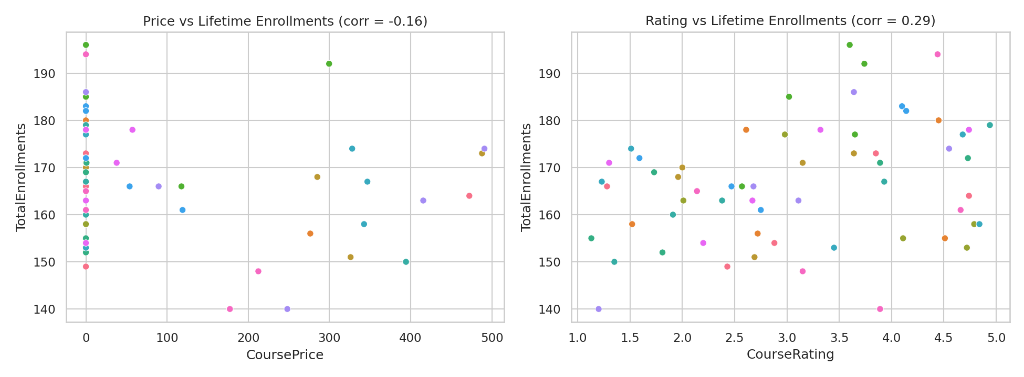
Figure 2. Course price and rating vs. lifetime enrollment, colored by category.

3.3 Revenue Is Structurally Tied to Price, Not Enrollment Variation
Two facts about the transaction data explain most of what follows in Section 6: every transaction's Amount equals that course's CoursePrice exactly (100% of 10,000 transactions), and lifetime enrollment counts across the 60 courses vary only about 7.5% around their mean (140–196 enrollments, mean 166.7). In other words, revenue in this dataset is close to a deterministic function of price — CoursePrice × a nearly-constant enrollment count — rather than something that emerges from independently varying demand.
Quantity | Value
Transactions where Amount = CoursePrice exactly | 100%
TotalEnrollments per course — mean ± std | 166.7 ± 12.5 (CV ≈ 7.5%)
TotalEnrollments per course — range | 140 – 196

4. Modeling Approach (Summary)
Three levels of granularity were modeled: (1) monthly, per-course enrollment with lag/rolling features; (2) monthly, per-category revenue with the same approach aggregated up; and (3) course-lifetime totals (enrollments and revenue) from static course and instructor attributes. Six regression approaches were compared at each relevant level — Linear, Ridge, Lasso, Poisson, Random Forest, and Gradient Boosting — always benchmarked against a naive baseline, always using cross-validation appropriate to the grain (time-respecting expanding-window CV for the monthly views, standard 5-fold CV for the cross-sectional course-lifetime view). The winning model per target was then hyperparameter-tuned, checked for train-vs-CV overfitting, and given bootstrap-based 90% prediction intervals. CourseID was excluded as a feature throughout — with only 60 courses, one-hot encoding it would let the model memorize individual courses instead of learning generalizable patterns.

5. Key Finding 1 — Enrollment Count Is Not Predictable, and the R² Instability Proves It

5.1 Every model, every grain, negative cross-validated R²
Grain | Naive baseline R² | Best model | Best model R²
Monthly, per-course | -1.10 | Random Forest | -0.11 (beats naive, still unusable)
Course-lifetime (untuned) | — | Random Forest | -0.21
Course-lifetime (tuned) | — | Random Forest | -0.17

Month-to-month enrollment autocorrelation is 0.023 — statistically zero. A course's enrollment this month tells you almost nothing about next month, which is why even a naive persistence baseline already scores R² = -1.10, and no model meaningfully beats it.

5.2 The R² itself is unstable — direct evidence of no real signal
Rather than reporting one R² number, the enrollment model was cross-validated repeatedly to show how much that number moves depending on which courses happen to land in the test fold. Within a single 5-fold split, per-fold R² ranges from -0.65 to +0.18 — it flips sign depending on the fold. Repeating the entire 5-fold CV with 20 different random splits, the mean R² itself ranges from -0.19 to +0.14 (mean -0.07, std 0.08) — meaning a differently-drawn split could easily have produced a misleadingly “positive” headline number purely by chance.
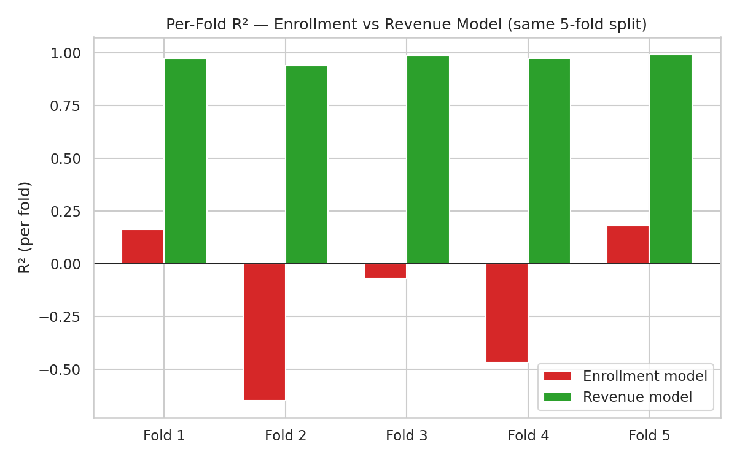
Figure 3. Per-fold R² for the enrollment model vs. the revenue model, same 5-fold split. Enrollment swings from -0.65 to +0.18; revenue stays tightly between 0.94 and 0.99.
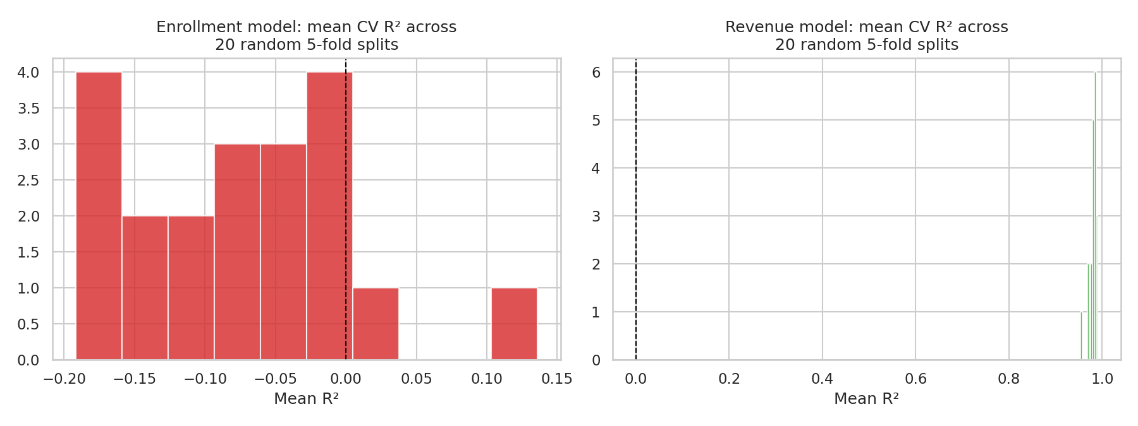
Figure 4. Distribution of mean CV R² across 20 independently-randomized 5-fold splits. The enrollment model's mean R² itself is a moving target; the revenue model's is not.

5.3 Overfitting confirms it
Fitting the tuned enrollment model on all 60 courses and scoring it on those same 60 courses gives R² = 0.56 — it looks like it's learned something. But the honest, cross-validated estimate is R² = -0.17, a gap of 0.73. That gap is the signature of a model fitting noise in a small sample rather than a generalizable pattern. The revenue model, by contrast, shows almost no gap (0.997 train vs. 0.974 CV) — see Figure 5 below.
Practical implication: feature importance extracted from the enrollment model (Figure 6, left panel) describes in-sample correlation structure only — it should not be quoted as a predictive or causal driver list.

6. Key Finding 2 — Revenue Is Predictable, Mostly Because It's Mechanical
The revenue model's cross-validated R² is 0.974 (tuned Lasso; Gradient Boosting close behind at 0.981), and — unlike the enrollment model — that number is stable: across the same 20 randomized splits used in Section 5, mean R² ranges only 0.953–0.991 (std 0.008). The train-vs-CV gap is small (0.997 vs. 0.974), so this is a genuinely reliable model, not an artifact of a lucky split.
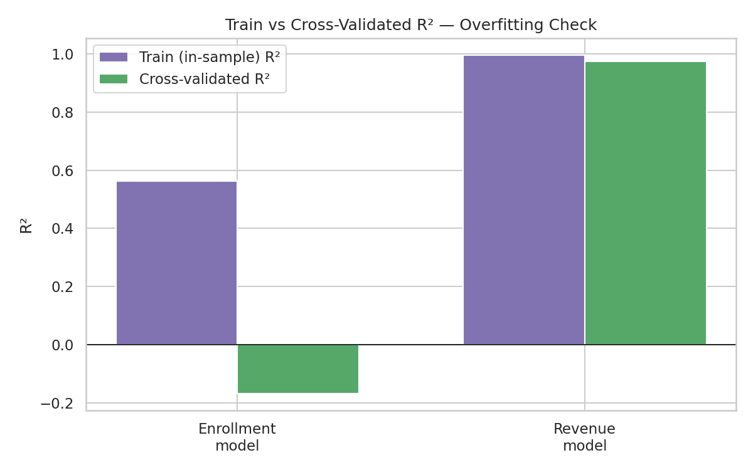
Figure 5. Train (in-sample) vs. cross-validated R² for both models. The enrollment model's large gap signals overfitting to noise; the revenue model's small gap signals a genuine fit.
That reliability comes with an important caveat established in Section 3.3: every transaction's Amount equals CoursePrice exactly, and enrollment counts vary only ~7.5% around their mean. So TotalRevenue ≈ CoursePrice × ~166, and CoursePrice is already a direct input feature — the model is largely recovering near-arithmetic structure, not discovering an independent demand-driven relationship. The feature importance chart confirms this directly: CoursePrice's importance (2.85) dwarfs every other feature (all below 0.06).
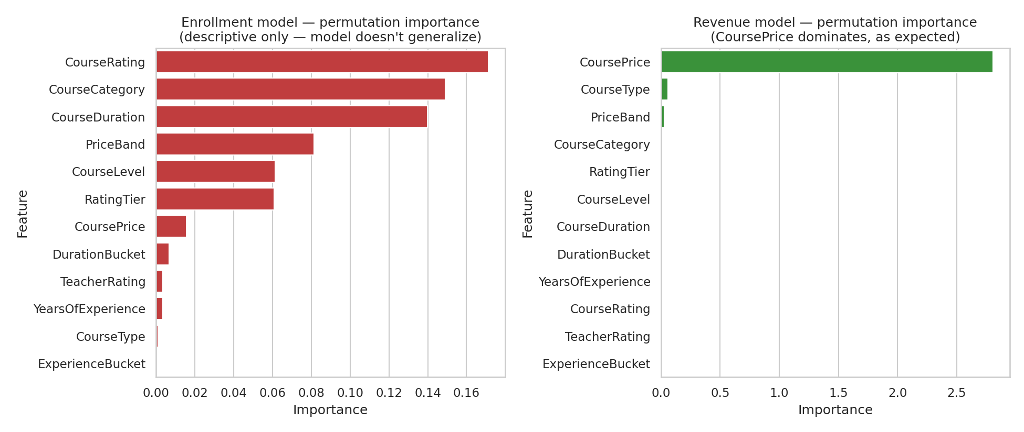
Figure 6. Permutation importance, enrollment model (left, descriptive only) vs. revenue model (right, CoursePrice dominates as expected).
This does not make the revenue model useless — revenue genuinely is price-driven in this business, and that is a legitimately useful planning fact. It should simply be described in the paper and to stakeholders as a pricing/revenue-planning result, not as a demand-forecasting breakthrough.

7. Category-Level View
Rolling the course-level revenue model's predictions up by category gives a stable, defensible revenue-by-category picture (a monthly category-revenue model was also tested directly and looked predictable at R² ≈ 0.88, but that signal turned out to be structural — driven by which courses sit in each category rather than a genuine month-to-month trend — so the course-level roll-up below is the more honest number).
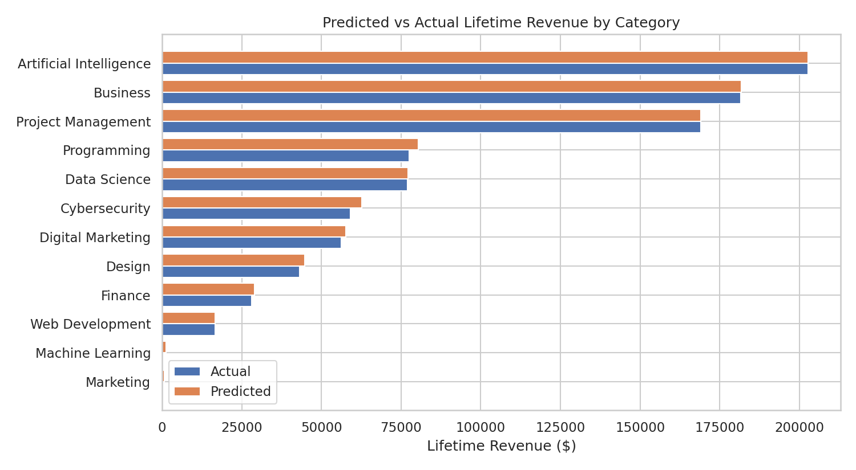
Figure 7. Predicted vs. actual lifetime revenue by category. Artificial Intelligence, Business, and Project Management lead; Data Science and Programming trail.

8. Business Insights
- Revenue is a reliable planning number today. Course price is by far the dominant lever — pricing decisions can be made with real confidence in the projected revenue impact.
- Enrollment volume cannot currently be forecast from course or instructor attributes — price, rating, duration, category, and instructor experience/rating together explain essentially none of the variation in who enrolls, at any time grain tested.
- Course rating (r = 0.29) and price (r = -0.16) show mild raw correlations with enrollment, but these do not survive rigorous validation — don't lean on them for launch decisions.
- Category performance is uneven: Artificial Intelligence, Business, and Project Management categories generate roughly 2–2.5× the revenue of Data Science or Programming, largely reflecting price differences across categories rather than differential demand.
- Monthly demand is essentially flat and non-seasonal across the one year of data available (CV ≈ 4.8% for enrollments) — there's no evident month-to-month pattern to plan around yet.

9. Recommendations

9.1 Data collection
- Extend the transaction history to 24+ months before re-attempting any time-based (monthly/seasonal) forecasting — 12 months is not enough to separate signal from noise at this volatility level.
- Capture behavioral and marketing signals not present in this dataset — traffic/impressions, marketing spend, referral source, cohort/session data — since course-level static attributes alone (price, rating, duration, instructor stats) do not explain enrollment variation.
- Grow the course catalog beyond 60 courses if course-lifetime modeling is to be pursued further; at n=60, even a well-behaved model's cross-validated R² estimate has an honest error bar of roughly ±0.08 (Section 5.2).

9.2 Modeling practice
- Report cross-validated R² as a distribution (mean ± std, or a range across repeated splits) rather than a single number, especially at small sample sizes — Section 5.2 shows how easily a single split can mislead.
- Keep using the naive-baseline comparison as a standing check before adopting any new model — it caught the lack of monthly signal immediately and cheaply.
- Any future price-band, duration-band, or similar manual bucketing should be checked against the actual data range before use — Section 2 documents one such calibration bug that was caught and fixed during this analysis.

9.3 Business use
- Use the revenue model for pricing and category-level revenue planning now — it is reliable and directly actionable.
- Do not use the enrollment model for launch, staffing, or capacity decisions — present it to stakeholders as a documented, evidence-backed negative result with a clear path (Section 9.1) to revisit once richer data is available.

10. Limitations
- Small sample size (60 courses, 12 categories × 5) limits how precisely any course-lifetime model's performance can be estimated — see the R² instability analysis in Section 5.2.
- Only 12 months of transaction history — too short to assess seasonality or genuine month-to-month trends with confidence.
- The revenue model's strong performance is partly definitional (CoursePrice is both an input feature and, combined with a near-constant enrollment count, close to the entire target) — it should not be read as evidence of a deep behavioral model of what drives revenue.
- Feature importance for the enrollment model (Figure 6, left) is descriptive of in-sample correlation only, given the model's negative cross-validated R², and should not be cited as a predictive or causal driver list.

