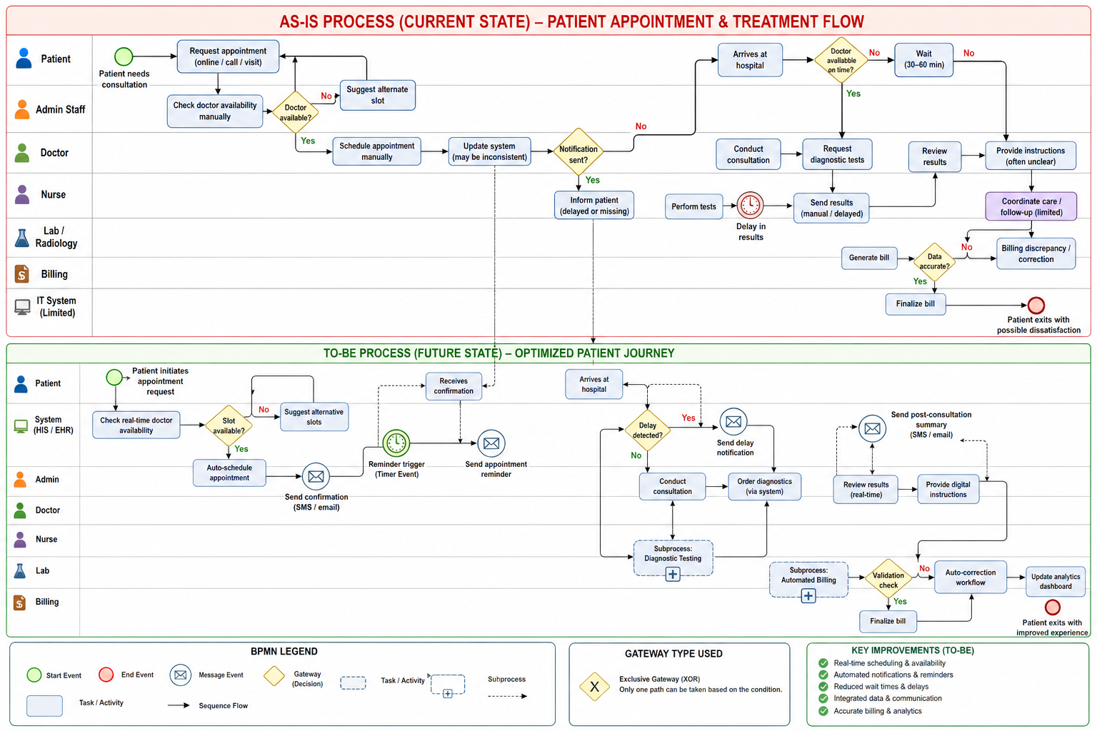
1. Introduction
This report identifies key bottlenecks in the current (AS-IS) hospital operational workflow based on stakeholder feedback, dataset analysis (appointment, resource, and feedback data), and process mapping using BPMN techniques. These bottlenecks significantly impact patient experience, operational efficiency, and resource utilization.
2. Identified Bottlenecks in the AS-IS Process
2.1 Appointment Scheduling Inefficiencies
Description:
The current scheduling system relies heavily on manual processes with limited real-time visibility into doctor availability.
Observed Issues:
- Double bookings due to system inconsistencies
- Lack of real-time availability tracking
- Delayed or missing appointment confirmations
Impact:
- Increased patient wait times
- Higher no-show rates
- Administrative workload increase
2.2 Long Patient Wait Times
Description:
Patients frequently experience delays of 30–60 minutes beyond their scheduled appointment time.
Root Causes:
- Overbooking of doctors
- Poor synchronization between departments
- Resource shortages (rooms, equipment)
Impact:
- Reduced patient satisfaction
- Inefficient patient flow
- Increased congestion in waiting areas
2.3 Lack of Real-Time Communication
Description:
There is no effective system for notifying patients or staff about delays or updates.
Observed Issues:
- No delay notifications
- Difficulty in reaching support staff
- Poor communication of next steps post-consultation
Impact:
- Patient frustration
- Mismanagement of schedules
- Increased dependency on manual follow-ups
2.4 Delays in Diagnostic Results
Description:
Diagnostic processes are not integrated with the main system, causing delays in result availability.
Observed Issues:
- Manual transmission of test results
- Lack of real-time updates from lab/radiology
- Communication gaps between departments
Impact:
- Delayed treatment decisions
- Extended patient cycle time
- Reduced clinical efficiency
2.5 Resource Allocation Constraints
Description:
Resources such as staff, equipment, and beds are not optimally managed.
Observed Issues:
- Uneven nurse-to-patient ratios
- Equipment unavailability during peak hours
- Lack of real-time resource tracking
Impact:
- Operational bottlenecks
- Staff burnout
- Delays in patient care
2.6 Data Silos and System Fragmentation
Description:
Existing systems (scheduling, records, billing) are not integrated.
Observed Issues:
- Duplicate or inconsistent data
- Difficulty accessing patient records
- Lack of centralized information system
Impact:
- Inefficient workflows
- Increased administrative errors
- Delays in decision-making
2.7 Billing Inaccuracies
Description:
Billing processes are not fully aligned with treatment and scheduling data.
Observed Issues:
- Discrepancies in billing records
- Manual reconciliation required
- Lack of integration with clinical data
Impact:
- Patient dissatisfaction
- Financial inaccuracies
- Increased administrative effort
3. Root Cause Summary
Bottleneck | Root Cause
Scheduling inefficiencies | Manual system, lack of real-time data
Long wait times | Overbooking, poor coordination
Communication gaps | No automated notification system
Diagnostic delays | Lack of system integration
Resource shortages | No real-time tracking system
Data silos | Fragmented IT infrastructure
Billing errors | Disconnected systems

4. Overall Impact on Business Objectives
These bottlenecks collectively prevent the hospital from achieving its key objectives:
- Reduced patient satisfaction
- Inefficient resource utilization
- Increased operational costs
- Delayed patient care
- Poor data-driven decision-making
5. Conclusion
The AS-IS process reveals critical inefficiencies primarily driven by manual operations, lack of system integration, and poor communication mechanisms. Addressing these bottlenecks through automation, real-time data systems, and improved inter-department coordination is essential for achieving operational excellence and enhancing patient experience.
The identified bottlenecks directly informed the design of the TO-BE process, which incorporates automation, real-time communication, and integrated systems to eliminate inefficiencies.

