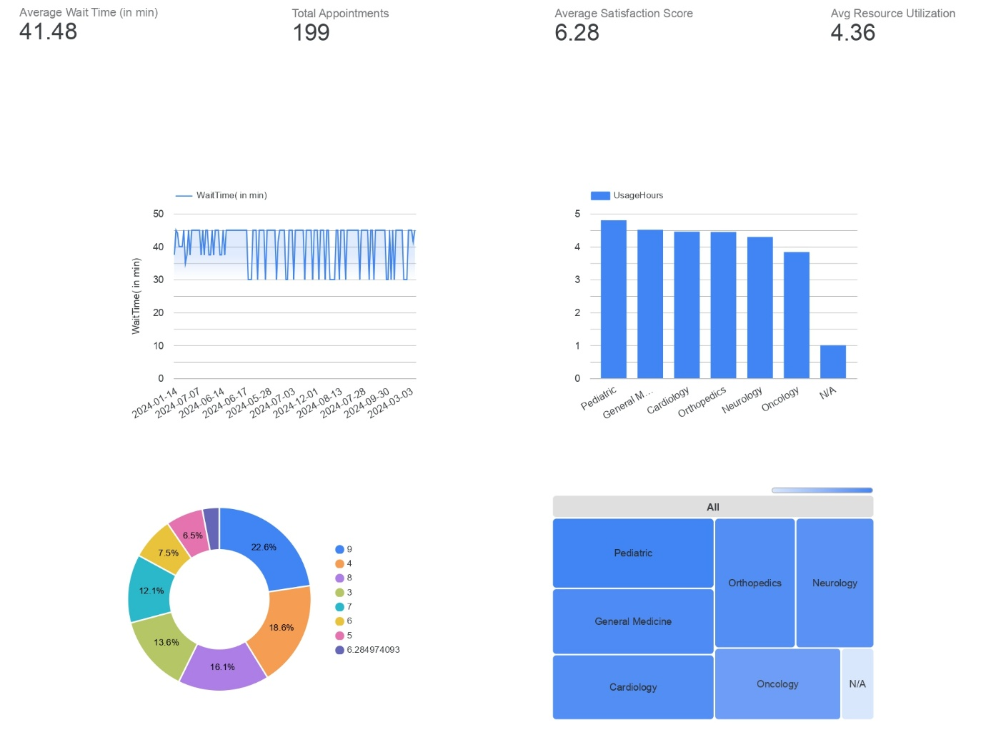

1. Datasets Used
- Appointments Dataset
  - Variables: PatientID, Date, Time, Department, Wait Time
- Feedback Dataset
  - Variables: PatientID, Feedback Score, Department
- Resource Dataset
  - Variables: ResourceID, Department, Usage Hours

2. Dashboard Design Process
The dashboard was structured into four key sections:
- KPI Overview to display key metrics
- Trend Analysis using line charts for wait time patterns
- Department Analysis using bar charts and heatmaps
- Satisfaction Analysis using pie charts
Interactive filters were added for:
- Department
- Date
- Resource Type

3. Key Findings
- Peak workload observed on Mondays
- General Medicine showed lowest satisfaction
- Pediatric & General Medicine are overutilized
- Oncology is underutilized opportunity for redistribution

4. Business Implications
- Resource imbalance affects patient satisfaction
- High wait times reduce experience quality
- Load balancing across departments is needed
- Staffing should be adjusted based on demand trends

