Change to driver.c –

Took out the “functions.h” header file since it is in a different subdirectory as driver.c. Since it is in a different subdirectory it is not accessible by driver.c. Also, there is a warning because in the makefile the driver.c is added first and creates a warning since the src folder has not yet been accessed. This can be removed by adding another function definition in driver.c, but the program works even with the warning.

1.

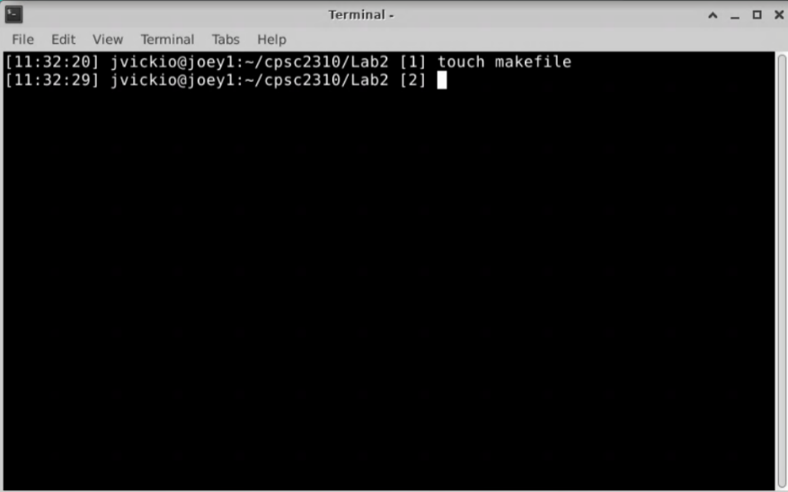

2.

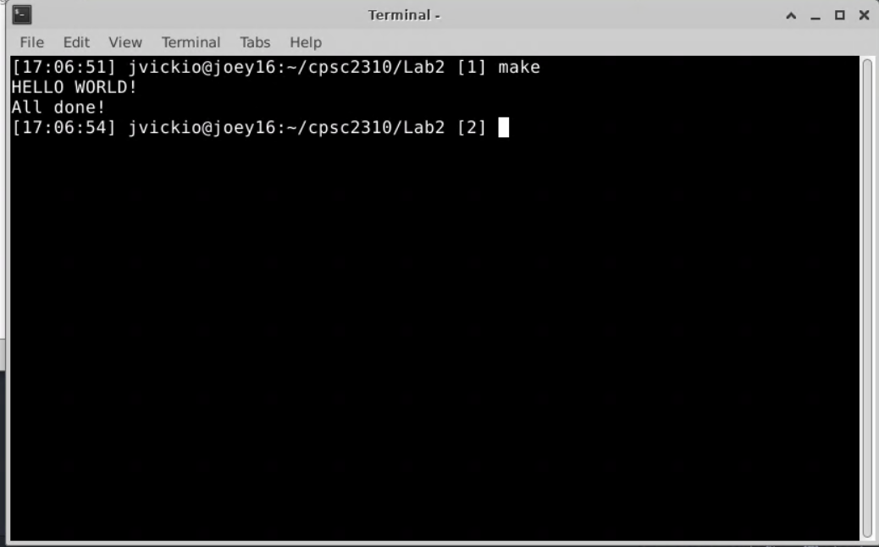

3.

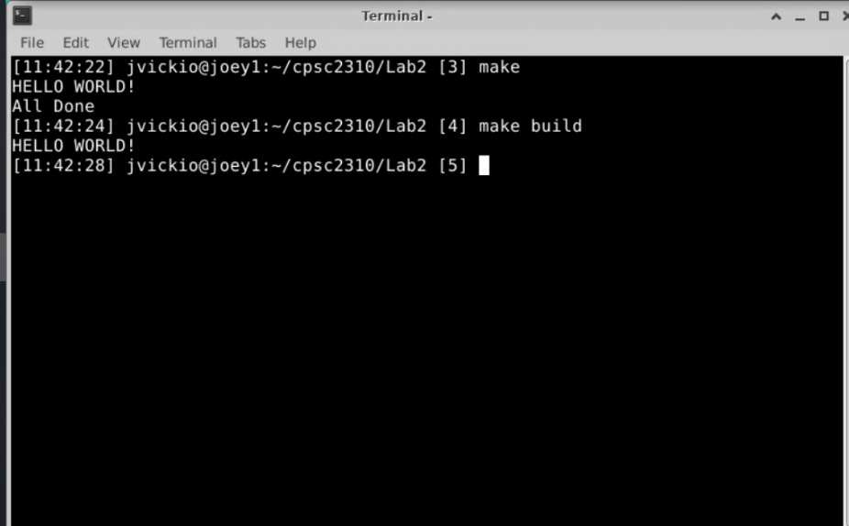

4.

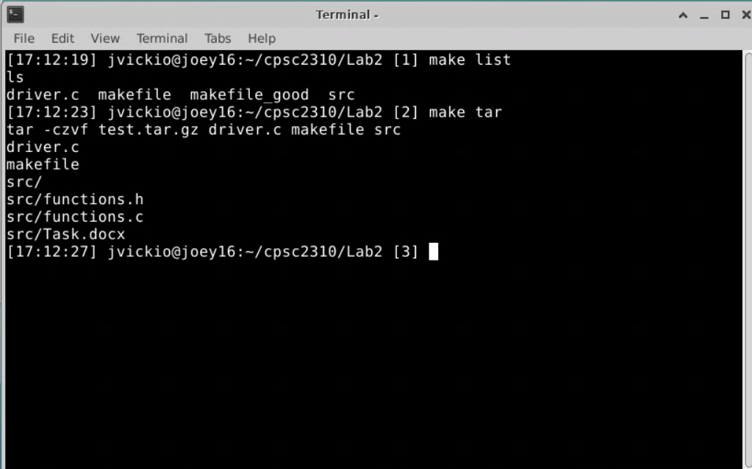

5.

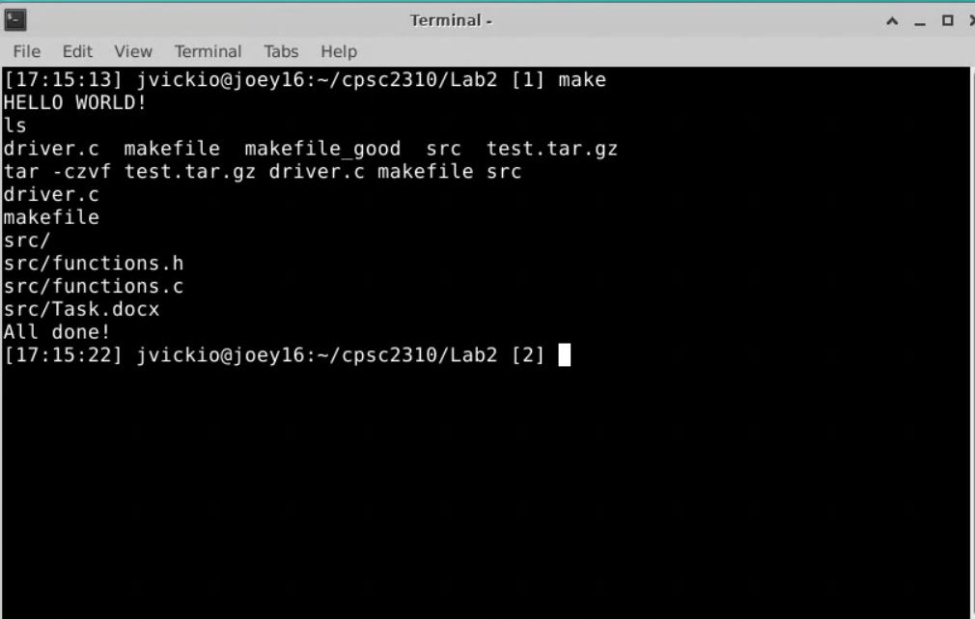

6.

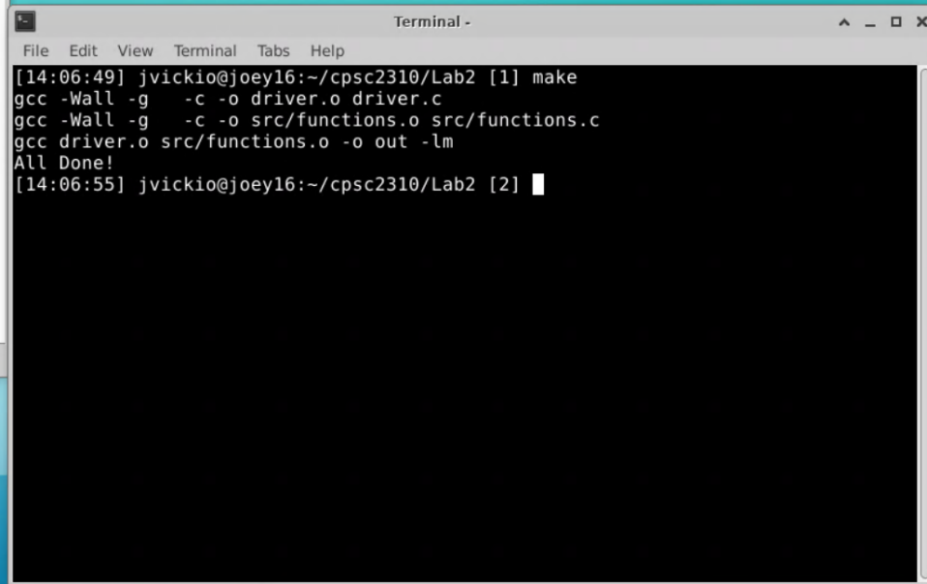

7.

