PORTFOLIOLENS AI
A review workflow for Indian equity mutual-fund holdings
THE PROBLEM | Each month, compliance teams compare a scheme's holdings with its Scheme Information Document (SID), category limits and market-cap classifications. Today the evidence sits across files and dated references. A reviewer must interpret the SID, choose the rule version, resolve securities, calculate allocations and preserve the reason for each exception. This prototype tests whether one reviewable workflow can make that work easier to repeat. The current time and error baseline has not been measured.

1 / Who has this problem?
Illustrative personas based on the assignment and product workflow; neither persona has been interviewed or validated with a practitioner.
PERSONA | JOB / GOAL | PAIN POINTS TODAY
Primary user  Compliance analyst | Run the monthly scheme check; prepare an exception list that a colleague can verify. | Manual joins across holdings, SID and cap list; hard-to-compare wording; repeated source checks; uncertainty over which rule version was used.
Decision owner  Compliance reviewer | Confirm the mandate, resolve exceptions and sign off an attributable record. | A model's unsupported verdict is not enough; ambiguous holdings can change a threshold result; old work needs evidence that can be replayed.

The job, in plain terms
CADENCE  Monthly per scheme; trade checks are a separate proposed use. Monthly frequency is an assignment assumption to validate with reviewers. | INPUTS  Holdings + SID  Month-end file, scheme wording, dated references. | COST BASELINE  Not measured  Measure analyst minutes, corrections and source lookups before claiming savings.

Why now?
Rule and market-cap references are date-sensitive, so reviewers need to reproduce the basis of an earlier decision. The PRD refers to a February 2026 SEBI update; its official text and legal effect are not verified in this prototype. That is a validation gate, not a claim that a specific control changed.

Scope
IN  India equity mutual-fund categories; holdings CSV + SID text; dated local rules and cap list; cited findings; review gates; eligibility and non-executing what-if. | OUT  Legal/investment advice; debt/hybrid schemes; live regulatory feeds; client data; return forecasts; best-buy rankings; trade execution or filing.

The month-end job: from files to accountable sign-off
STEP | REVIEWER TASK | FRICTION TO VALIDATE
1 - Assemble | Collect the holdings file, the SID in force and the review date. | Files and reference dates may not line up; input errors need to be found before review.
2 - Interpret | Identify the scheme category, stated limits and relevant SID clauses. | Wording varies; each extracted value needs a source quote.
3 - Reconcile | Apply dated rules and security classifications; calculate allocations and concentration. | A stale rule or unresolved security near a threshold can change the apparent outcome.
4 - Resolve | Investigate exceptions, document review and obtain named sign-off. | A result is hard to reproduce if source versions and reviewer decisions are not carried forward.

What a useful first release must prove
TRACEABLE | SAFE UNDER UNCERTAINTY | REPEATABLE
Follow a finding to the holding, SID clause, rule ID/version, calculation and sign-off. | Unknown holdings are not silently bucketed. If uncertainty can change the result, show a range and ask for review. | A later reviewer can inspect the same dated inputs and sources. Current storage is local; production retention is not designed.

2 / Solution: the model proposes, code decides, a human signs off
A fixed LangGraph workflow uses small agents for language tasks, version-scoped retrieval for rule context, and deterministic code for every numeric result.

Architecture at a glance
01 - INPUT  Holdings CSV + SID  User selects the as-of date | 02 - VALIDATE  Rows, identifiers, totals  Code rejects invalid files | 03 - PROPOSE  Mandate + SID quotes  LLM extracts; code checks citations | 04 - GATE 1  Confirm or correct  Reviewer approves the mandate | 05 - RETRIEVE  Date-pinned rule set  LangChain searches one version | 06 - CALCULATE  Classify + reconcile  Code calculates; model cannot decide
↓ | ↓ | ↓ | ↓ | ↓ | ↓
07 - EXPLAIN  Cited report | 08 - GATE 2  Review exceptions | 09 - GATE 3  Named sign-off | P1 - REUSE  Screen / what-if | NO ACTION  No trade / filing | TRACE  Run record
TRUST BOUNDARY | LLMs can extract, rerank and explain. They cannot change a threshold, calculate a percentage, classify an unmatched holding, or decide pass / breach.

Why this combination?
LANGUAGE + RETRIEVAL  SID wording varies, so extraction benefits from a model. Rule evidence must be inspectable: LangChain searches only the rulebook version selected by the as-of date. Optional GPT reranking can reorder IDs, never add or omit them. A vector database is unnecessary for this small local corpus. | RULES + HUMAN  Code joins identifiers, performs Decimal arithmetic and returns pass / breach / indeterminate. Unknown securities stay unknown. A named reviewer confirms the mandate, handles exceptions and signs off. Fixed graph over autonomous agent loop keeps the path reproducible.

What must stay exact; where knowledge lives
EXACT / AUDITABLE  SID quote, rule ID + threshold, source version/hash, input totals, calculated range, finding status and sign-off. | PROBABILISTIC / REVIEWED  Mandate reading, shortlist identity suggestion, rule ranking and narrative. Validate IDs/quotes; abstain or route uncertainty to a person. | KNOWLEDGE / CHANGE  SID per run; local rulebook and cap list versioned by date; engine version pinned. New source -> verify -> add version -> regression test; never overwrite old run basis.

Weakest point + rejected options
Weakest point. The rule paraphrases and synthetic cap list may be wrong; an unresolved name near a threshold can leave the result indeterminate. Official-source validation and human triage are release gates.
Rejected. One LLM verdict (memory and arithmetic are not reproducible); pure parser (SID prose varies); model-assigned cap buckets (not auditable); autonomous self-correction loop (less controlled than fixed LangGraph).

What a reviewer can use to reproduce a run
RECORD | CAPTURED IN THE PROTOTYPE | WHY IT MATTERS
Inputs | Run ID, as-of date, holdings hash and confirmed mandate with SID evidence. | Shows which submission and mandate were evaluated; local storage is not a production archive.
Rule basis | Rulebook version, effective date and SHA-256; retrieval query, method and retrieved/applied rule IDs. | Inspect the exact rule set rather than rely on model memory.
Classification | Security-master version and hash, plus holding-to-classification result. | Makes the dated market-cap join visible and exposes unresolved names.
Outcome + review | Calculated facts, findings, report, review acknowledgements and sign-off when recorded. | Separates engine output from human decision; old runs remain tied to pinned sources.

Risk register
RISK | WHY IT MATTERS | CONTROL AND OWNER
Mandate / input error | A missed SID clause or malformed holdings file can change every result. | Validate rows, IDs and totals; require a SID quote per field and reviewer confirmation at Gate 1. Unresolved fields block the run.
Security classification | A mistaken identifier or cap bucket can move allocation across a limit. | Use a dated master and deterministic identifier join. Unknown names remain review items; show their possible impact.
Outdated rule or reference | A stale rule summary or cap list can support a false finding. | Select by as-of date and pin version/hash. Compliance verifies official text and effective date before real use.
Confidentiality / liability | Holdings are sensitive; users may treat a screen as legal advice. | Use synthetic/public data until security approves access, retention and model controls. Decision support only; qualified human signs off, no trade or filing.

3 / Prototype evidence and a route to market
Screens below are from the local offline prototype on synthetic case 07. They illustrate the user journey, not a live client workflow.
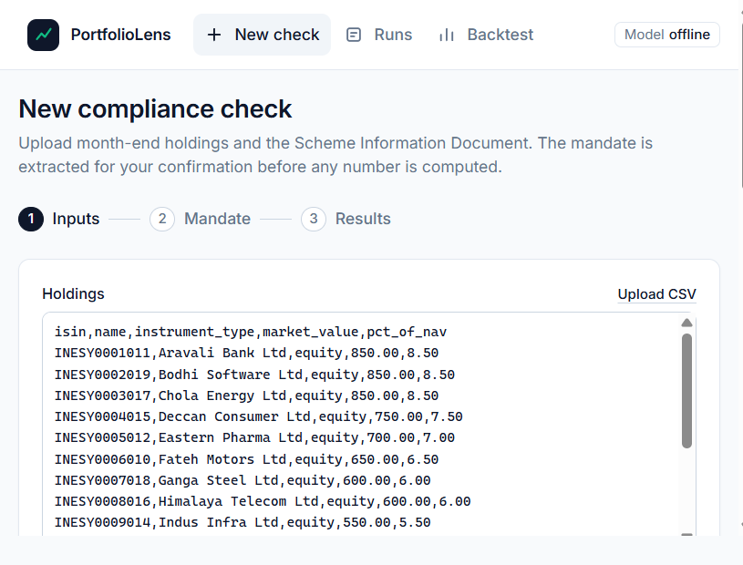  INPUT | Synthetic holdings and SID are loaded; reviewer selects the as-of date. | 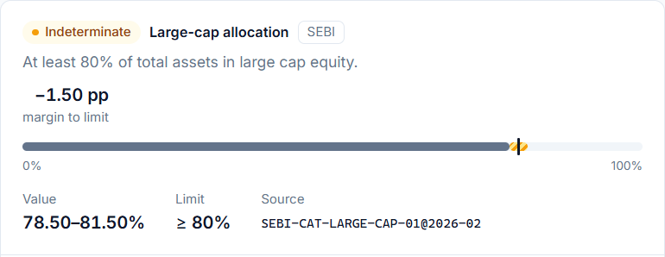  RESULT | Case 07 leaves 3% unclassified; 78.50-81.50% straddles the 80% floor, so review is required.

Case 07: why the result is indeterminate
UNCLASSIFIED EXPOSURE | POSSIBLE ALLOCATION | REVIEWER ACTION
3% of holdings have no confirmed ISIN / bucket. | Large-cap range is 78.50-81.50%; the required floor is 80%. | Because the range crosses the floor, do not force pass/breach. Resolve the name and record the review.

What the tests show and what they do not
73  automated tests  Unit, workflow, API and guard checks passed locally. | 13 / 13  engine cases  Expected outcomes matched using reviewer-corrected mandates. | 13 / 13 + 24 / 24  end-to-end + fields  Synthetic extracted cases passed; mandate field checks matched.
These are deterministic tests on 13 synthetic cases, not statistical accuracy, time savings, or legal validation. No live GPT-4o mini call has been made.
Other synthetic checks include case 02 (78% against an 80% floor: breach, -2.0 points), case 09 (invalid input rejected before calculation), and case 13 (offline parser reads an 8.5% worded cap). These are targeted examples, not broad model validation.

GTM hypothesis | earn trust before expanding
1 - DISCOVER  Interview AMC compliance analysts and reviewers. Record current minutes per check, correction rate and source lookup effort; confirm the monthly task assumption. | 2 - DESIGN PARTNER  Select one compliance team and a small set of public or synthetic schemes. Agree the evidence format, reviewer roles and baseline before shadow use. | 3 - PILOT GATE  Run in shadow mode only after source/legal review. Compare time and review outcomes; inspect every false pass, unresolved holding and unsupported citation. | 4 - EXPAND / STOP  Expand only with compliance, security and IT approval. Stop or redesign if evidence is incomplete or reviewers cannot reproduce a finding. No savings claim yet.

Pilot scorecard: measure before claiming value
MEASURE | BASELINE AND PILOT METHOD | DECISION USE
Review effort | Time the task from source lookup through exception report; record correction and lookup counts. | Compare with current workflow; do not claim savings until measured.
Safety | Use reviewer-labelled breaches, near-threshold and ambiguous cases; inspect every false pass. | An unsupported pass is a stop-and-investigate event.
Evidence quality | Check source IDs, versions, calculation facts and reviewer disposition for each finding. | Do not expand if the reviewer cannot reproduce a finding.
Before spending more: validate the task with practitioners; verify rule text with official SEBI sources; test public SIDs across varied wording; review privacy, model cost/latency and deployment controls.

Appendix / What the project adds beyond AI
This page separates the model's contribution from the product decisions and checks built around it.

Where AI helped
AI assisted with coding, test-case design and wording. In the product, model use is limited to reading mandate prose, resolving selected ambiguous identities, ranking an already-retrieved rule set, and drafting report or Q&A language.

Representative build requests (shortened)
REQUEST | WHAT IT CHANGED
"Use LangChain/LangGraph for orchestration while keeping calculations deterministic." | Led to a fixed workflow, explicit human gates and a code-owned reconciliation result.
"Add versioned SEBI retrieval as an LLM/RAG agent." | Led to date-scoped local retrieval and an audit trace; model reranking cannot add or remove applicable IDs.
"Make an editable four-page brief with architecture, tested examples, screenshots, risks and the model used." | Set the submission format. The brief labels assumptions, synthetic evidence and the mocked model trace.
These are shortened versions of the project owner's requests, not a verbatim export of the chat history.

Runtime prompt guardrails in the prototype
EXTRACT | "Support every value with a verbatim SID quote. If you cannot quote it, return null."
RETRIEVE | "Use only retrieved records. Return every rule ID exactly once; alter no threshold, date, source or text."
EXPLAIN | "Use only the supplied facts. Do not calculate; repeat only provided numbers and cite the IDs used."

What was rejected or corrected
SUGGESTION OR OBSERVED GAP | DECISION | REASON AND EVIDENCE
One model call returns the compliance verdict. | Rejected; deterministic engine owns totals, margins and status. | Arithmetic and thresholds must be reproducible and cited.
Model freely assigns market-cap buckets. | Rejected; use confirmed identifiers and a dated reference; unmatched items stay unknown. | A guessed bucket can create a false pass near a limit.
Autonomous self-correction loop. | Rejected; use fixed LangGraph steps and explicit human gates. | A reviewer must inspect what ran and approve a specific mandate.
Offline parser missed "eight and a half per cent". | Added a deterministic word-number parser and regression test. | Fixes one synthetic case; wider SID wording still needs validation.

What came from the project owner
The owner chose date-scoped retrieval that cannot drop applicable rules, one confirmed constraint set for compliance and what-if, visible ranges for unknown holdings, and human approval outside the model workflow. These choices keep rule selection, calculations and accountability inspectable; they are not practitioner-validated.

Agent call evidence | scripted test double
TRACE FIELD | SCRIPTED EXAMPLE
Request | large_cap | as of 2026-09-30 | rulebook 2026-02.
Retrieved rules | SEBI-CAT-LARGE-CAP-01 (minimum 80%); SEBI-MFREG-ISSUER-10 (maximum 10%).
Prompt + mock response | Return every ID exactly once; change no threshold, date or source. Scripted response: {"ordered_rule_ids": ["SEBI-MFREG-ISSUER-10", "SEBI-CAT-LARGE-CAP-01"]}
Validation | The same two IDs appear exactly once. Only order changed; deterministic code applies the full rule set and decides the result.
This is a mocked response from a scripted test client, not a network request or live GPT output. The RAG call and prompt are tested with mock responses; GPT-4o mini is configured but not live-validated. Full build-conversation logs are not included.

One thing to defend without AI
DESIGN CHOICE TO DEFEND | If an unresolved holding can move a portfolio across a limit, do not force a pass or breach. Show the possible allocation range, cite the rule and send the case to a reviewer. In synthetic case 07, 78.50-81.50% straddles the 80% large-cap minimum, so the status is indeterminate. This is safer than hiding uncertainty inside a guessed bucket.
Model configured: OpenAI GPT-4o mini (`gpt-4o-mini`). Source basis: assignment text, PortfolioLens PRD v0.3, repository code and synthetic test fixtures. Paraphrased SEBI rules require official-source verification.

